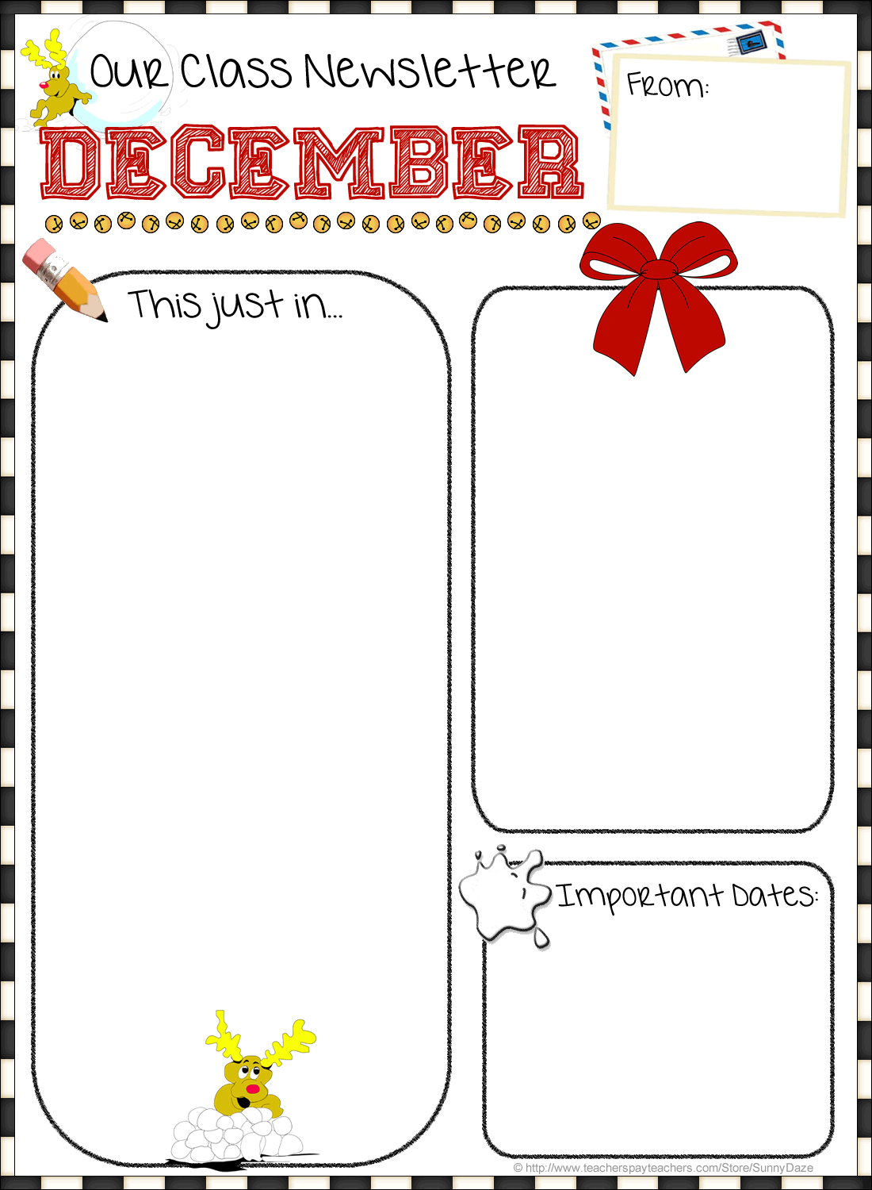

This Month’s Learning & Activities:

-December 4-7 Winter (Letter Ff, Identify the heart shape, ranking objects by size, counting objects 1-5, & combining simple shape to make a larger design.)

-December 10-14 Christmas (Letter Gg, review numbers, shape and colors.)

-December 17-18 Christmas programs

-December 19-January 7 Christmas break

**Tuition is due this week no later than the 10th please.**

Christmas program for the 4’s AM is on Monday December 17th 9:30-10:30.

Christmas program for the 4’s PM and 5’s PM is on Monday December 17th 1:00-2:00.

Christmas program for the 3’s AM is on Tuesday December 18th 9:30-10:30.

Bring your child at regular class time, go to the Parish Hall to get a seat and to sign up for helper days for next semester. After the program Santa will visit and we will have a cookie social. After Santa you are free to go.

We will start school back up on Tuesday January 8th.

Date: December 2018

-December 10th Christmas Caroling

-December 11th Christmas hat day

-December 12th Christmas shirt day

-December 13th & 14th Pajama day

-December 17th Christmas program

-December 18th Christmas program

Wee Love Preschool

TYPE CONTENT HERE…