February 18th - Lake Ouachita Results
​​
39 boats fished the first tournament of the year with Sherwood Bass Club and what an opener, 25.30 lbs for the win. This was done by the team of Jonathan Evans and Kenny Bough. 25, 5-fish limits came to the scales and the total payout for the day including Big Bass was $3100

 | 1st Place: Jonathan Evans and Kenny Bough with a weight of 25.30 lbs said their fish came of jigs fished on the main lake.
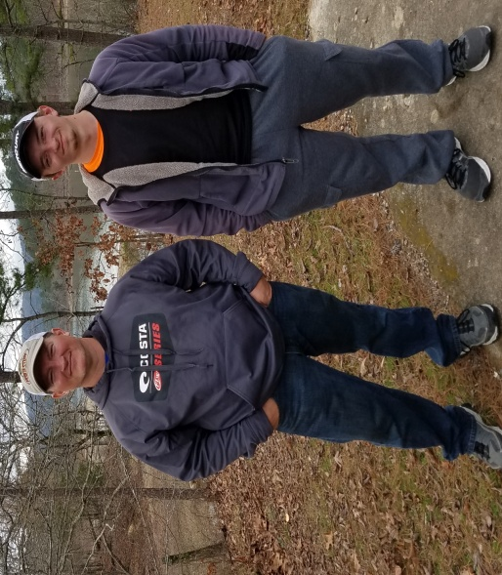 | 2nd Place went to the team of Dayton and Kelly Taylor with a weight of 15.71 lbs. They said they caught their fish on a rattletrap.
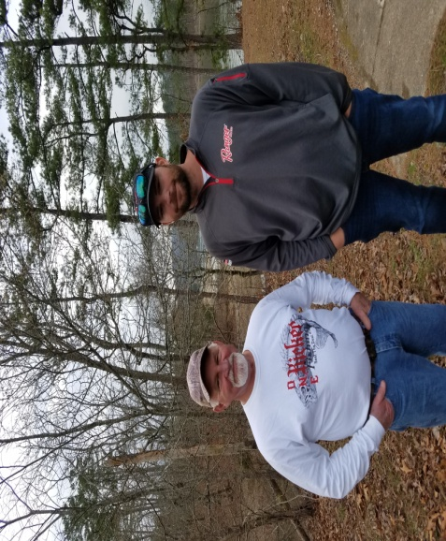 | 3rd Place was the team of Joe Kindy and Timmy Poe who also fished rattletraps for a weight of 14.65 lbs

Balance of the top ten were:
4. Reagan and Kevin Brown 14.56 lbs
5. Chris Dennis and Joy Lewis 14.00 lbs
6. Brent Barker and Anthony Wright 12.79 lbs
7. Tony Andrews and Byron Taylor 12.15 lbs
8. Rod Martinez and Kyle Wise 12.05 lbs
9. Jack Wood and Dave Hargett 11.85 lbs
10. Josh Castlebury and Brian Bean 11.64 lbs
Big Bass was a 7.20 Big Momma by Jonathan Evans and Kenny Bough
Out of the money sponsors for the day were, Penegrine 250, JJ’s Magic and Fish and Stuff.
See u in Pine Bluff at the Harbor on March 18th.

