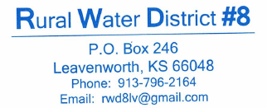
Email Billing Customer Agreement

Dear Rural Water District #8 Customers:
Rural Water District #8 wants to provide utility customers a choice for paper-less/email billing to replace the traditional billing through the US Postal Service. If you wish to convert your account, fill out the form and return it to the address listed at the top of the page.

________Yes, I want my bill emailed, each month and I understand that I should expect a bill within the first five days of each new month, and I am aware that if I do not receive an email bill at that time, then it is my responsibility to contact the water office between the hours of 8AM and 4PM, weekdays, excluding holidays, in order to get the information needed to pay my bill on time and avoid any late charges.
Name and Address: _____________________________________________________________
My Email Address is: _______________________________________________
My Service ID # is: ____________________
Bills will be sent out by both US Postal Service mail and email for the first two of months to ensure that everything is working correctly. Once RURAL WATER DISTRICT #8 is confident that everything is working correctly, paper billing will cease. If you do not begin to see your email bill within two months of sending in this letter of agreement, contact the office at (913) 796-2164

Signature: ____________________________________________________________

