Thomas L. Erickson, M.D. (520) 836-8988
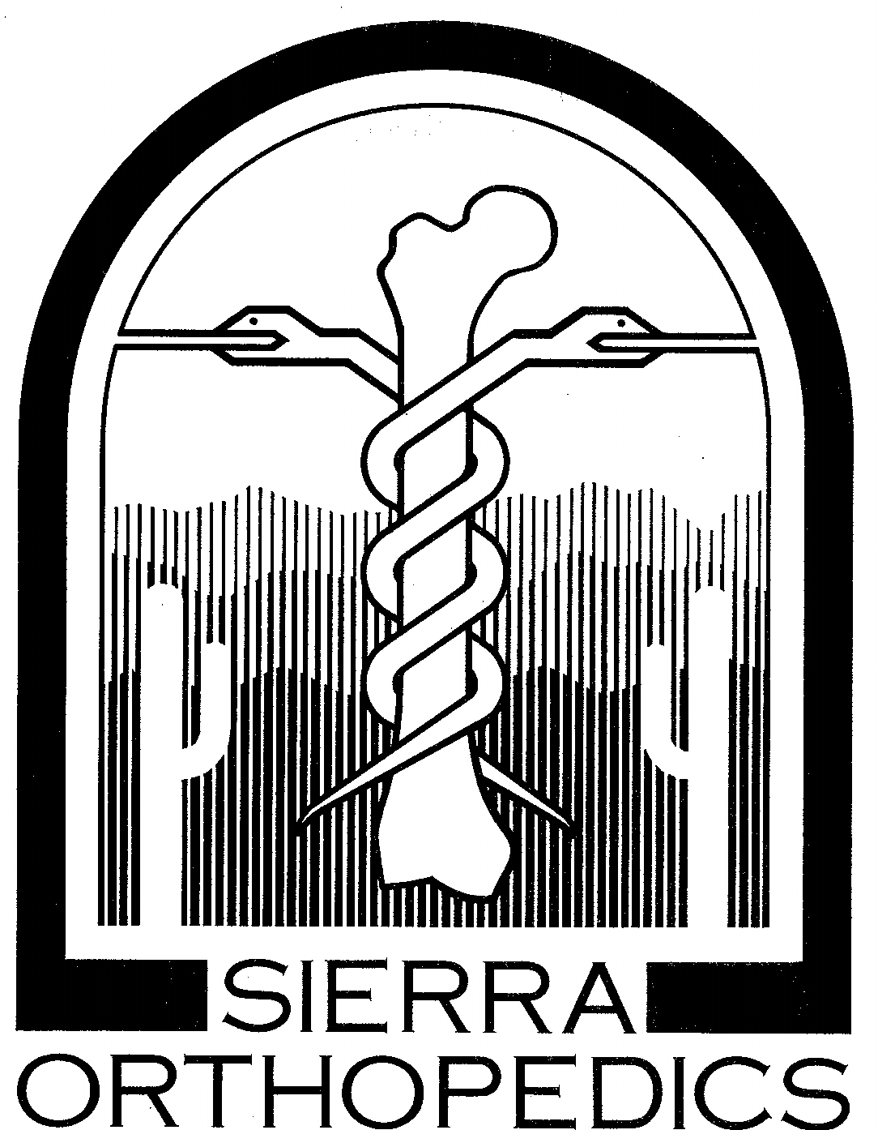
Knee Arthroscopy - Post Op Instructions

General:

Arthroscopy has allowed surgeons to precisely perform major surgical procedures through small incisions ("portals") using specialized instruments. For at least the first three (3) days, it is recommended that you maintain a low level of activity to decrease the amount of swelling and pain and to speed your recovery. Do Not operate a motor vehicle or machinery and do not make any important decisions until the effects of anesthesia and pain medications have completely resolved (usually 48 hours).

Activity:

1. Unless instructed otherwise you may put as much weight on your leg as you are able. You will be given crutches or other assistive devices to use as needed, but you may walk without them if you are able. (Note: Patients who have had micro fracture/ abrasion may be instructed to restrict their weight bearing.)

2. You may bend your knee as far as comfortable unless directed otherwise. (Meniscus repair)

3. For the first two (2) days you should spend most of the time lying in bed or on a sofa with your leg elevated with a pillow folded in half under your ankle to allow gravity to straighten your knee. Do Not put a pillow under your knee or sit with your knee bent for over thirty (30) minutes at a time. It is important to frequently stretch your knee straight to prevent permanent loss of extension.

Diet:

1. It is best to start by drinking fluids because some people become nauseated after anesthesia. You may advance to regular food as quickly as you feel able.

2. Do not drink alcoholic beverages for at least 48 hours after surgery.

3. If you become nauseated, do not eat solid foods; try to drink small amounts of clear liquid (water, 7up, or broth) frequently to avoid becoming dehydrated. If you are still nauseated 24 hours after surgery call our office.

All rights reserved Sierra Orthopedics, PC
Knee Arthroscopy - Post Op Instructions (Page 2)
Pain Control:

1. Although arthroscopic procedures generally have less pain than those performed through larger incisions there is a large variation in patients' pain perception.

2. Regional anesthesia (blocks) may decrease post-operative pain.

3. We usually inject a long-acting local anesthetic at the end of the procedure which helps decrease pain.

4. Ice should be applied for the first 48-72 hours, for 20 minutes each hour when awake.

5. Two general types of medication may be used.

A.) Anti-inflammatory meds. (Acetaminophen, Ketorolac, Naproxen, Ibuprofen, etc.) These should be taken as directed, with food. If these meds upset your stomach or you notice bloody or tarry stools stop taking them.

B.) Opiates (Oxycodone, Hydrocodone, or Codeine) These meds may cause drowsiness and will impair your ability to perform tasks or drive. Opiates often cause constipation and may cause nausea.

6. If your pain is intolerable call our office or go to an emergency room.

Care of Incisions:

1. You may remove your bandage after 48 hours. If there is no new drainage you may either leave the incision open to air or wrap your knee with an Ace bandage.

2. After 48 hours if there is no bleeding, you may shower, but do not get your incisions under water in a tub or pool.

All rights reserved Sierra Orthopedics, PC

Knee Arthroscopy - Post Op Instructions (Page 3)

3. Some bleeding is expected. If you notice bleeding or fresh blood on your bandage keep your incision covered with a dry sterile bandage and an Ace wrap.

4. If your dressing gets wet, change it immediately with dry gauze.

5. If your incisions become red and warm or if you have severe pain or fever call our office. Infection is possible but very infrequent after knee arthroscopy.

Exercise:

1. It is important to begin exercise soon after surgery to restore function. Specific exercises are dependent upon the particular surgery performed and are often directed by a physical therapist.

2. Until your first post op visit (usually one week after surgery) simple exercises to regain strength and motion are usually started. Do 10 repetitions of each exercise every two hours when you are awake.

A. Heel Slide
Laying on your back on a bed slide the heel of the operated leg toward your body to bend the knee as far as it will go without excessive pain. (If you had meniscus repair do not perform this exercise.)

B. Straight Leg Raise
Laying on your back, raise your operated leg about one foot into the air, holding the knee straight. Hold for a count of five and then lower it to the bed. (If you have a knee immobilizer brace from a meniscus repair or ACL reconstruction) you may perform this exercise in the brace.

C. Quadriceps Set
With a pillow under your ankle holding your operated knee in extension tighten your quadriceps muscle (front of thigh) to push your knee straight. Hold for count of five and relax.

3. If these exercises cause extreme pain, decrease the repetitions and frequency as tolerated.
All rights reserved Sierra Orthopedics, PC 1-15

