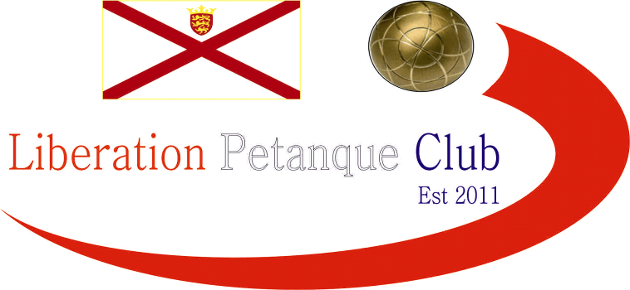

Winter 2015 / 2016

End of Season Report

Congratulations

Callum Stewart & Andrew Bellamy Burt

Premier League Doubles Champions

They won their first title to go with their JPC Doubles Open title and Liberation Doubles Open titles in 2015. This win ended Ross Payne’s 5 (yes 5) straight Doubles league titles, but will be hoping for a 4th straight Summer league title with Antony Di Santo. Colin & Steve finished 2nd, with Ross & Jake 3rd.

Congratulations

Matt Ryan & David Ibitson

Division One Doubles Champions

Winning the title after winning every singles match in the season (100% Record), well done to the pair who regain their top flight status and will surely push the top teams for the title next year. Matt Pinel & Richard Nevitt took 2nd with James Gennoe & Geoffroy Buffetrille finishing 3rd.

Congratulations

Matt Ryan

Division One Singles Champion

Matt having sealed the title early on just needed to beat Brendan Jones to make it a double of 100% records, but maybe the pressure got to him, (doubt it though) more like Brendan placed really well. James Gennoe took 2nd place 5 points adrift of Matt but 4 points clear of 3rd place Brian Harris.

Last but not least!

Congratulations

Andrew Bellamy-Burt

Premier League Singles Champion

Andrew became only the second person to hold both Summer and Winter Premier League Singles titles following in the footsteps of Toby, who could only finish 4th. Callum Stewart joined his doubles partner at the top finishing in his highest ever league position, a big contrast to the Summer, where he was relegated.

This was by 2 points on points difference over another previous Winter Champion in Keith Pinel.

Well done to everyone though, I hope you all enjoyed the season and being part of the club, I look forward to seeing you all again in the summer leagues.

Summer Season starts Wednesday 30th March at 6pm

End of season meal 19th March, please contact Dawn Buckley with your meal choices and payment.

Kind Regards

Toby Northern

Chairman

Liberation Petanque Club

Club email address - liberationpc@gmail.com

Club Website - www.liberationpetanque.co.uk

SPONSORED BY

