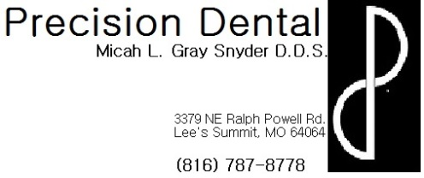
Stainless Steel Crown recommendations
- If anesthetic was used during your procedure today:
  - Not only is the tooth numb, but the surrounding soft tissue structures are as well, including lip, tongue, gums, cheeks, etc. Be very careful not to bite or suck on these soft tissues while profoundly numb. Since you are so numb you will not be able to feel how hard you are biting or sucking which can result in serious soft tissue damage.
  - Your numbness can last for several hours following your procedure, on average about 3-4, however everyone reacts to local anesthetic differently. If you wake up tomorrow morning and still feel numb please contact the office for further evaluation.
  - As the numbness wears away, your soft tissues may begin to itch or tingle. This is a normal reaction and does not indicate an allergic reaction. It is very important to be careful not to scratch or itch the area because the tissues are still numb and it is possible to do soft tissue damage by scratching or itching too hard without realizing it.
  - You may want to take a pain reliever (ex: Ibuprofen, Acetaminophen, etc.) prior to the numbness wearing away because the site of the injection may be sore like a bruise. The injection site may actually bruise and some swelling is also a normal occurrence. If you are concerned about any bruising or swelling please contact the office for further evaluation.
- If after the numbness wears away, the temporary crown feels high or like your other teeth do not touch normally, please contact the office for evaluation.
- Avoid chewing for at least one half-hour to allow the cement to set.
- Avoid eating hard or sticky foods (ex: ice, chips, chewing gum, jolly ranchers, caramels, etc.)
- If possible chew only on the opposite side of your mouth
- It is normal for your gums to be sore for several days following your procedure. It is alright to take pain relievers (ex: Ibuprofen, Acetaminophen, etc.) according to their dosing instructions on the back of the bottle to help with this discomfort.
- It is also normal to see a faint gray line at the gum line around the Stainless Steel Crown
- Brush normally but when flossing be very careful around your Stainless Steel crown. Instead of bring the floss back up toward the chewing surface to remove it from between your teeth, pull it out through the side. Your homecare is very important to maintain.
- If your teeth are sensitive to hot, cold or pressure try using sensitivity toothpaste. If sensitivity persists beyond a couple of days, please call the office.
- To reduce discomfort and reduce any swelling, rinse your mouth out 3 times a day with warm salt water for the first couple of days.
  - 1 teaspoon of salt per 8oz glass of warm water
- CALL US AS SOON AS POSSIBLE if your Stainless Steel crown comes off. It is very important for your overall mouth health for the crown to be in place. PLEASE SAVE THE STAINLESS STEEL CROWN IF POSSIBLE AND BRING IT WITH YOU TO YOUR APPOINTMENT SO IT CAN BE RE-CEMENTED.

