**Organic Chemistry**  
  
Molecules which contain **Carbon** as one or more of their atoms are called organic molecules. Carbon is an element for **ORGANIC** life. Carbon is capable of forming single and double bonds with other carbon atoms which can lead to the formation of the carbon chains and rings of carbon that are important to us. Lipids (fats) and carbohydrates (sugars) exhibit many of these carbon/carbon bonds.

The study of organic molecules is called organic chemistry. Organic molecules make up 95% of the solids in your body. The carbon-carbon covalent bonds which allow chains and rings to form serve as a foundation

to which **FUNCTIONAL** groups are attached. Functional groups determine the function of organic molecules by altering the shape, polarity or the hydrophobic/hydrophilic nature of molecule.   
  
Smaller organic molecules called **MONOMERS** serve as building blocks to make larger molecules called **POLYMERS**.   
a. Polymers are *created* through **CONDENSATION SYNTHESIS.**b.Polymers are ***b****roken down* via **HYDROLYSIS**.  
<http://resource.rockyview.ab.ca/t4t/bio20/mm/m7/hydrolysis/Bio20_Hydrolysis_Final.swf>

**ENZYMES are molecules which act to** facilitate these two processes by allowing then to occur using **less time and less energy**.  
<http://bcs.whfreeman.com/thelifewire/content/chp06/0602001.html>

# Let’s look at different types of organic macromolecules…

**Proteins:**   
 Protein are polymers composed of strings of monomers called **amino acids**. Amino acids are also commonly called peptides. They exhibit three functional groups: an acidic group (-COOH),an amine group (-NH3), & a functional “R” group. There are 20 different functional “R” groups…hence 20 different amino acids. Some amino acids are considered “essential” because they are not made by the body and so must be part of the food we eat. Here’s a picture of the 20 different amino acids and their structures. Notice how all of the R groups (highlighted in color) look different.  
  
  
  
  
  
It is the **sequence of amino acids determines the protein’s function (!!)**

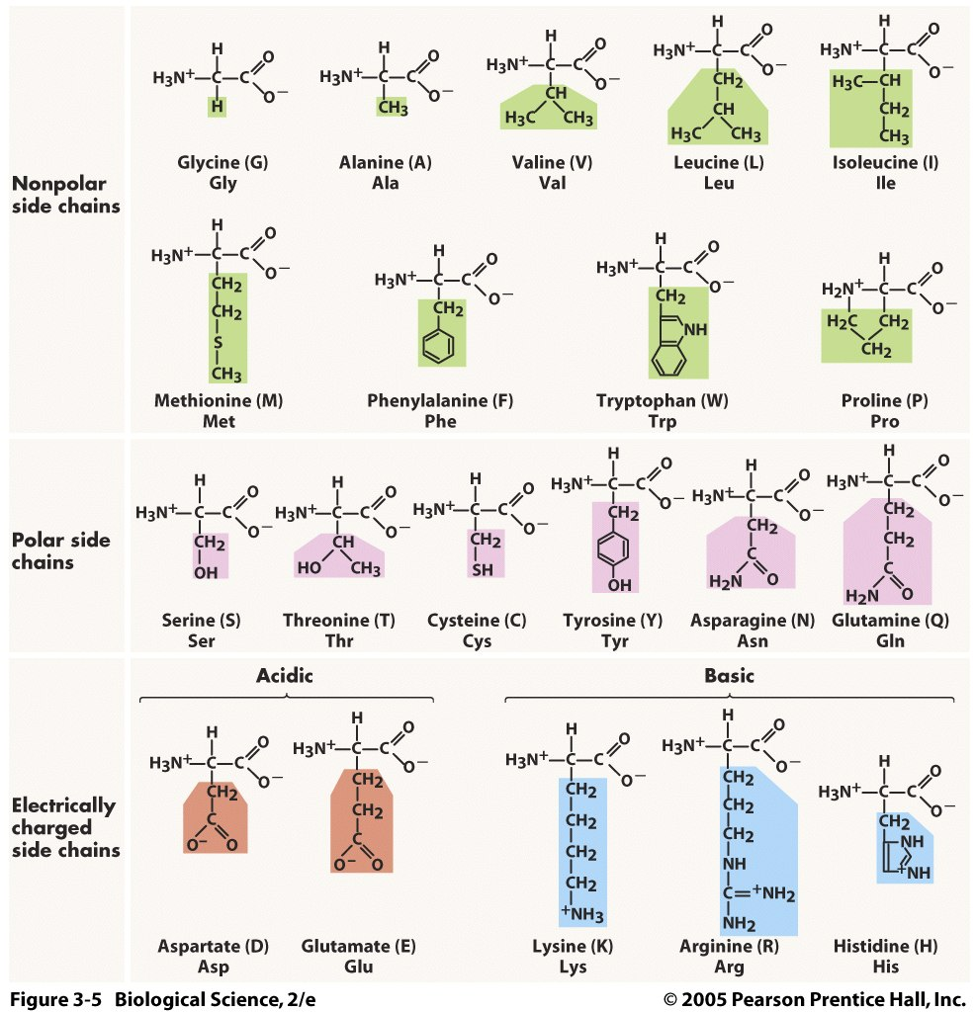

Amino acids are joined together by covalent bonds. The resulting polypeptide (*many* peptides) then folds as the “R” groups interact with one another. The unique, 3D structure (shape) of the polypeptide determines what the function of this polypeptide, now called a protein, will be.  
 ***so the* STRUCTURE (SHAPE) DETERMINES the FUNCTION**  Denaturing of proteins via heat or changing the pH will alter the shape and therefore its function. Proteins have many functions. They may be enzymes, hormones, used for structural support, in cellular transportation, in muscle movement and for heat production.  
  
  
  
How can you make sure you get all of the essential amino acids your body needs to make the necessary proteins?  
 <http://www.mayoclinic.org/healthy-lifestyle/nutrition-and-healthy-eating/in-depth/how-to-eat-healthy/art-20046590>

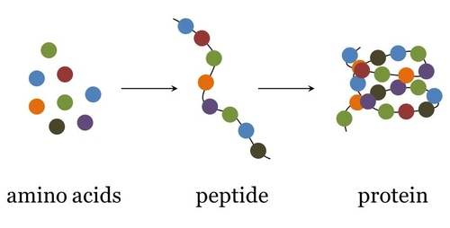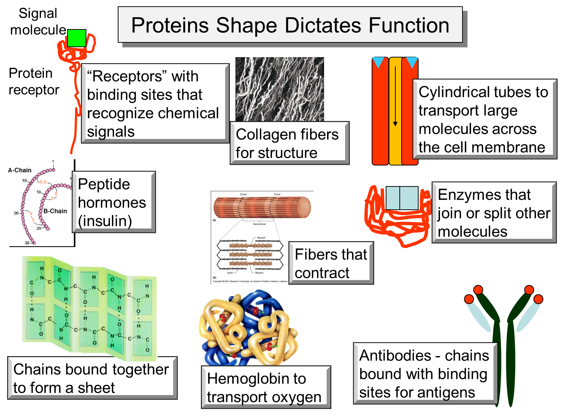

**Carbohydrates**:   
 Carbohydrates probably make up the bulk of y our diet and may be:   
 a. **Monosaccharides:** simple sugars Glucose & Fructose (**fruit sugar**)

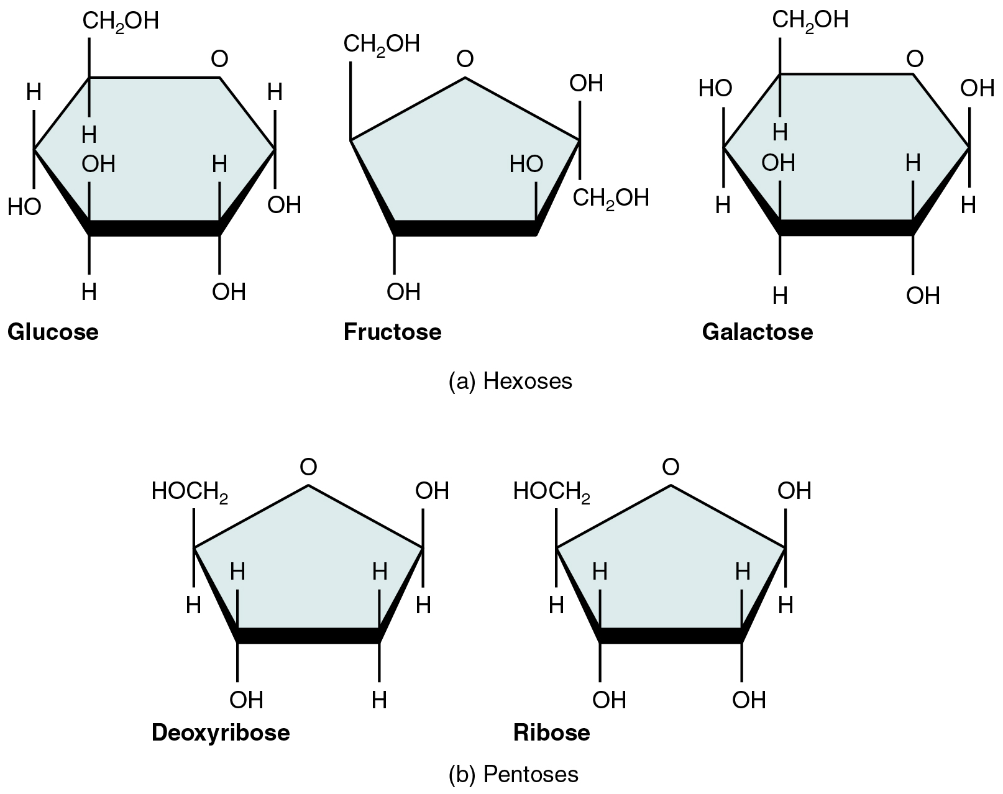

b. **Disaccharides:** two monosaccharide monomers linked together

ex.:Lactose = galactose+glucose  
 Maltose = glucose+glucose  
 Sucrose=glucose +fructose **(table sugar)**   
   
  
   
  
c. **Polysaccharides**: complex polymers with multiple monosaccharide   
 monomers linked together   
 ex: Starch = (plant) chain of glucose monomers with side chains  
 (**potatoes, pasta etc**)  
 Glycogen =(animal) highly branched chain of glucose  
 Cellulose = (plant) straight chains of glucose   
 Chitin = (animal AND fungus) N-acetylglucosamine…  
 basically cellulose with an amino group attached  
  
   
 **Lipids (Fats):**  
**Triglycerides** are polymers made from one glycerol monomer and 3   
 fatty acid monomers.   
   
Triglycerides may be: **1. Saturated** (“saturated” with H so no C=C bonds)   
 **2**.**Unsaturated** (not “saturated with H so has C=C bonds)  
Triglycerides are non-polar when assembled, insoluble in water,   
provide insulation and store energy.  
Which is “better” for you to eat and why??

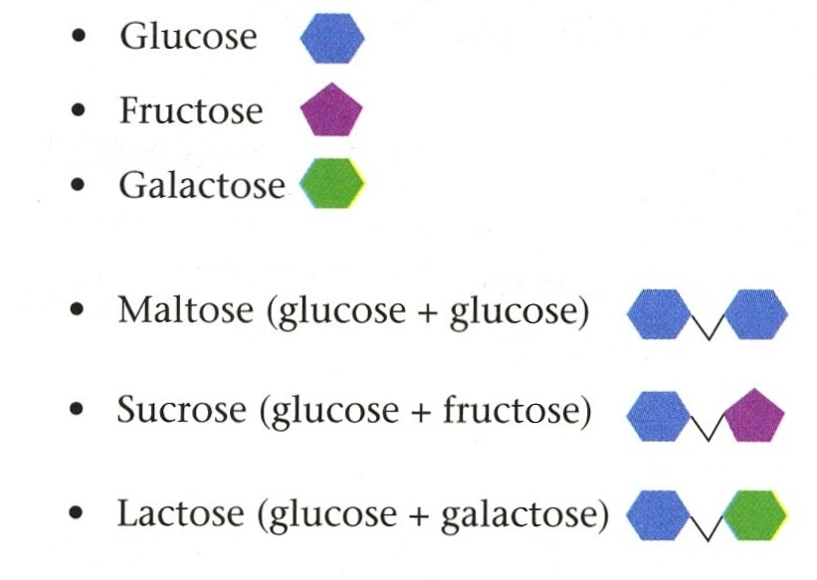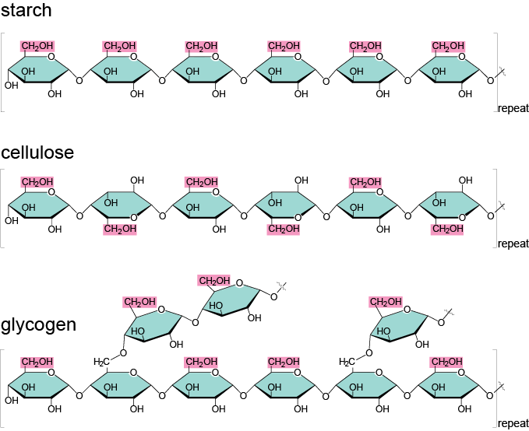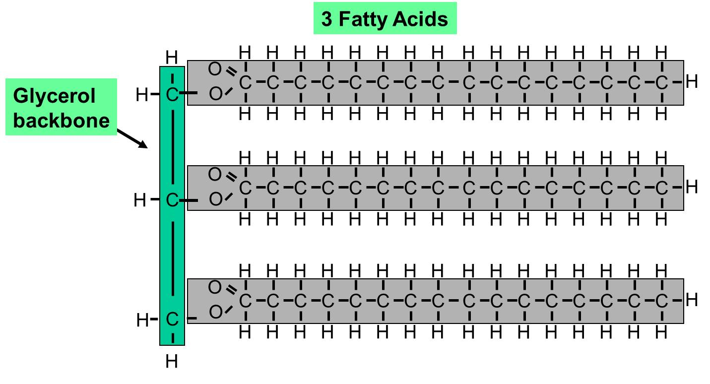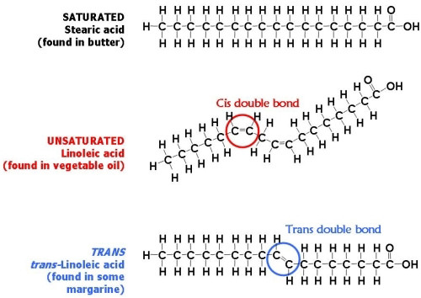

<http://www.mayoclinic.org/healthy-lifestyle/nutrition-and-healthy-eating/in-depth/fat/art-20045550>

In addition, there are other lipids such as cholesterol, steroids (estrogen, testosterone), fat-soluble vitamins (such as vitamins A, D, E, and K) and waxes.

**The rest is just for fun…!  
Let’s talk a bit more about nutrition.   
Sugar:**  
How sweet it is…  
Americans consume too much added sugars from all sources. Estimates reveal added sugars represent 16 percent of calories (that’s an average of 300 to 400 calories) or 21 teaspoons of added sugars per day. These calories offer no nutritional value. According to the U.S. government’s 2010 [Dietary Guidelines](http://www.health.gov/dietaryguidelines/2010.asp), roughly 45 percent of added sugars come from regularly sweetened soda and energy, sports and fruit drinks, 15 percent from grain-based desserts (that’s cookies, cake, doughnuts, pastries, etc.) and 15 percent from a mix of other foods.  
  
**And artificial sweeteners?**  
Ordinary table sugar is sucrose, which consists of two smaller sugars, fructose and glucose.  
Artificial sweeteners, however, are high-intensity sweeteners. These are compounds with many times the sweetness of sucrose, common table sugar.

In the United States, six intensely-sweet sugar substitutes have been approved for use:  
stevia  
aspartame  
sucralose  
neotame  
acesulfame potassium  
and saccharin.  
  
Artificial sweeteners represent a $1.5-billion-a-year business,  
In last five years, 3,920 products containing artificial sweeteners were launched in the U.S.  
Last year alone, over 1600 artificially-sweetened products were launched.   
This represents an 8% increase per year or $189 million in 2012.  
Are they safe? Are they regulated?  
  
The US Food and Drug Administration regulates as food additives (with the exception of Stevia, which is exempt under FDA's GRAS policy due to its being a natural substance in wide use well before 1958, and has been approved by FDA).   
  
**What are these artificial sweetners?**  
The three primary compounds used as sugar substitutes in the United States are saccharin (e.g., Sweet'N Low), aspartame (e.g., Equal, NutraSweet) and sucralose (e.g., Splenda, Altern).  
  
1. **Saccharin** (sweet n low…pink packet)  
Saccharin was the first artificial sweetener and was originally synthesized in 1879 by Remsen and Fahlberg.Its sweet taste was discovered by accident when the scientist licked his fingers after working in the lab. It had been created in an experiment with toluene derivatives. A process for the creation of saccharin from phthalic anhydride was developed in 1950, and, currently, saccharin is created by this process as well as the original process by which it was discovered. It is 300 to 500 times as sweet as sugar (sucrose) and is often used to improve the taste of toothpastes, dietary foods, and dietary beverages. The bitter aftertaste of saccharin is often minimized by blending it with other sweeteners.

1960 study showed that high levels of saccharin may cause bladder cancer in laboratory rats.

In 1977, Canada banned saccharin due to the animal research but the US Congress stepped in and placed a moratorium on such a ban. The moratorium required a warning label and also mandated further study of saccharin safety.

Subsequently, it was discovered that saccharin causes cancer in male rats by a mechanism not found in humans. At high doses, saccharin causes a precipitate to form in rat urine. This precipitate damages the cells lining the bladder (urinary bladder urothelial cytotoxicity) and a tumor forms when the cells regenerate (regenerative hyperplasia). According to the International Agency for Research on Cancer, part of the World Health Organization, "Saccharin and its salts was (sic) downgraded from Group 2B, possibly carcinogenic to humans, to Group 3, not classifiable as to carcinogenicity to humans, despite sufficient evidence of carcinogenicity to animals, because it is carcinogenic by a non-DNA-reactive mechanism that is not relevant to humans because of critical interspecies differences in urine composition." Hmmmm…  
  
  
2. **Aspartame** (blue packet: Equal) is currently the most popular artificial sweetener in the U.S. food industry, as the price has dropped significantly since the Monsanto Company patent expired in 1992. However, sucralose may soon replace it, as alternative processes to Tate & Lyle's patent seem to be emerging. According to Morgan Stanley, this can mean that the price of sucralose will drop by thirty percent.[11]

Aspartame was discovered in 1965 by James M. Schlatter at the G.D. Searle company (later purchased by Monsanto). He was working on an anti-ulcer drug and accidentally spilled some aspartame on his hand. When he licked his finger, he noticed that it had a sweet taste. It is an odorless, white crystalline powder that is derived from the   
two amino acids = aspartic acid and phenylalanine.   
People with the rare genetic disorder phenylketonuria (PKU) should avoid aspartame because their bodies are deficient in the enzyme that breaks down phenylalanine. If they consume foods or beverages containing significant amounts of phenylalanine, it can build up in their bodies and can cause mental impairment and possibly brain damage. Newborns are routinely checked for PKU.  
Aspartame is 200 times as sweet as sugar and is used almost exclusively in cold food not in baking because it breaks down into two amino acids when heated.When eaten, aspartame is metabolized into its original amino acids. Because it is so intensely sweet, relatively little of it is needed to sweeten a food product, and is thus useful for reducing the number of calories in a product.  
Lots of research has not produced any data to suggest it is unsafe or causes cancer. Aspartame has been deemed safe for human consumption by over 100 regulatory agencies in their respective countries,[19] including the UK Food Standards Agency, the European Food Safety Authority (EFSA)[21] and Canada's Health Canada.

3. **Sucralose** (Splenda: yellow packet)  
Sucralose is a chlorinated sugar that is about 600 times as sweet as sugar. It is produced from sucrose when three chlorine atoms replace three hydroxyl groups.It is used in beverages, frozen desserts, chewing gum, baked goods, and other foods. Unlike other artificial sweeteners, it is stable when heated and can therefore be used in baked and fried goods. About 15% of sucralose is absorbed by the body and most of it passes out of the body unchanged. The FDA approved sucralose in 1998.

Most of the controversy surrounding Splenda, a sucralose sweetener, is focused not on safety, but on its marketing. It has been marketed with the slogan, "Splenda is made from sugar, so it tastes like sugar." Sucralose is prepared from either of two sugars, sucrose or raffinose. With either base sugar, processing replaces three oxygen-hydrogen groups in the sugar molecule with three chlorine atoms.

The "Truth About Splenda" website was created in 2005 by The Sugar Association, an organization representing sugar beet and sugar cane farmers in the United States, to provide its view of sucralose. In December 2004, five separate false-advertising claims were filed by the Sugar Association against Splenda manufacturers Merisant and McNeil Nutritionals for claims made about Splenda related to the slogan, "Made from sugar, so it tastes like sugar". French courts ordered the slogan to no longer be used in France, while in the U.S. the case came to an undisclosed settlement during the trial.

There are few safety concerns pertaining to sucralose and the way sucralose is metabolized suggests a reduced risk of toxicity. For example, sucralose is extremely insoluble in fat and thus does not accumulate in fatty tissues; sucralose also does not break down and will dechlorinate only under conditions that are not found during regular digestion (i.e. high heat applied to the powder form of the molecule).  
  
  
4**. Stevia** (truvia)  
Stevia tablets as sold in health food stores in Germany (EU) in September 2010 (while Stevia is still technically "illegal"). Note the German description reads "Stevia is not a comestible [food] following current European Union regulations", while the French description simply says "Stevia" (which is legally sold as food in France).

Stevia has been widely used as a natural sweetener in South America for centuries and in Japan since 1970. Due to its unique characteristics of zero glycemic index and zero calories, it is fast becoming popular in many other countries. In 1987, the FDA issued a ban on stevia because it had not been approved as a food additive. After being repeatedly provided with a significant amount of scientific data proving that there was no side effect of using stevia as a sweetener from companies such as Cargill and Coca-Cola, the FDA gave a "no objection" approval for GRAS status to Truvia in December 2008.   
  
Others:  
1. Cyclamate banned due to its link to bladder cancer although it still can be found in Europe.  
In the United States, the U.S. Food and Drug Administration (FDA) banned the sale of cyclamate in 1970 after lab tests in rats involving a 10:1 mixture of cyclamate and saccharin indicated that large amounts of cyclamates causes bladder cancer, a disease to which rats are particularly susceptible. Cyclamates are still used as sweeteners in many parts of the world, including Europe.  
2. Lead acetate (historic)  
Lead acetate (sometimes called sugar of lead) is an artificial sugar substitute made from lead that is of historical interest because of its widespread use in the past, such as by ancient Romans. The use of lead acetate as a sweetener eventually produced lead poisoning in any individual ingesting it habitually. Lead acetate was abandoned as a food additive throughout most of the world after the high toxicity of lead compounds became apparent.  
  
3. Mogrosides  
More recently, mogrosides (typically extracted from monk fruit) have been used in commercial products after the FDA granted some of the compounds GRAS status in 2010. As of 2011, it is not (yet) a permitted sweetener in the EU, although it is allowed as a natural flavor at concentrations where it does not function as a sweetener. Some of the products incorporating it are Nestlé's Milo in Asia and certain Kellog cereals in the US. It is also the basis of McNeil Nutritionals's tabletop sweetener Nectresse in the US. As of 2012, the New Zealand company BioVittoria provides more than 90 percent of the global supply of monk fruit extract; its main manufacturing facility for the product is in Guilin, China.  
  
4. Sugar alcohols are made from adding hydrogen atoms to sugars. They don't contain ethanol, so they're not related to alcoholic beverages. They can occur naturally in foods such as fruits and berries. Sugar alcohols have about one-half to one-third fewer calories than regular sugar, because they convert to glucose more slowly. They don't usually cause sudden increases in blood sugar, so can be used in moderation by diabetics**.** Maltitol and sorbitolare often used, frequently in toothpaste, mouth wash, and in foods such as "no sugar added" ice cream.   
  
**Are artificial sweeteners linked to weight gain?**Animal studies have indicated that a sweet taste induces an insulin response in rats.  
The release of insulin causes blood sugar to be stored in tissues (including fat). In the case of a response to artificial sweeteners, because blood sugar does not increase there can be increased hypoglycemia or hyperinsulinemia and increased food intake the next time there is a meal. Rats given sweeteners have steadily increased calorie intake, increased body weight

A 2005 study by the University of Texas Health Science Center at San Antonio showed that increased weight gain and obesity were associated with increased use of diet soda in a population-based study. The study did not establish whether increased weight gain leads to increased consumption of diet drinks or whether consumption of diet drinks could have an effect on weight gain.  
In the early '80s, the American Cancer Society's study of 78,694 women found that after one year 2.7% to 7.1% more regular artificial-sweetener users gained weight compared to nonusers. The San Antonio Heart Study followed 3,682 adults over eight years on the early '80s. Those who consumed more artificial sweeteners had higher BMIs, and the more that they consumed, the higher the BMI.

In some studies where they replaced sugar-sweetened beverages with artificial sweetened ones, no difference in weight loss was shown. The possible cause of this could be that artificial sugar actually increases sugar cravings. The theory is that our bodies sense the sweetness of the food and expect the calories. When you consume the artificial sweetener without the calories, your body continues to crave the calories so you end up eating more calories later on.   
In rat studies, rats fed diets with artificial sweeteners ate more calories all day then those fed meals with sugar. There may also be a connection a with a complex food reward pathway that drives our desire to eat. The sweetness without the calories interferes with the normal process of this pathway causing an increased craving for sweets.

A final possibility for the relationship between artificial sweeteners and weight gain is the impact that high amounts of sweet taste has on how much we need to feel satisfied. Artificial sweeteners are hundreds to thousands of times sweeter than sugar. It has been found that repeated exposure to a flavor trains flavor preferences. Think of how your tastes buds get used to new flavors when you makes changes in your diet. When people cut back on their intake of salt or fat there will be a preference for lower levels of these in their diets after several weeks. Anyone who gets used to skim milk will tell you that whole milk tastes too strong for them. The same is true for salty foods. The difference with these and cutting back on sugar is that artificial sweeteners are put in place of sugar so you never get the chance to get used to consuming less of that taste.  
Artificial sweeteners, however, throw a wrench into this process. By eating and drinking foods and beverages that use artificial sweeteners (and therefore have lower calories), we may be retraining our bodies to no longer associate sweetness with higher calories. That means that when we eat or drink foods sweetened with real sugar, our bodies miscalculate the true calories associated with that food. As a result, we consume more calories.

**What about high fructose corn syrup?**  
HFCT comprises any of a group of corn syrups that has undergone enzymatic processing to convert some of its glucose into fructose to produce a desired sweetness.  
High-fructose corn syrup is produced by milling corn to produce corn starch, then processing that starch to yield corn syrup, which is almost entirely glucose, and then adding enzymes that change some of the glucose into fructose. The resulting syrup (after enzyme conversion) contains approximately 42% fructose and is HFCS 42. Some of the 42% fructose is then purified to 90% fructose, HFCS 90. To make HFCS 55, the HFCS 90 is mixed with HFCS 42 in the appropriate ratios to form the desired HFCS 55.   
By culinary terms, sugars are crystalline solids, not liquids. To call high fructose corn syrup "sugar" would be dishonest and misleading.While it may or may not make a difference in the health of those buying the product, it would be inappropriate for the FDA to set a precedent allowing companies to misleadingly rename ingredients to make them more appealing to consumers.  
  
Another issue also makes the proposed renaming inappropriate**.** A product called corn sugar already exists, and it isn't high fructose corn syrup -- it's dextrose. Dextrose is a solid crystalline sugar refined from corn and containing only glucose, whereas high fructose corn syrup is a combination of glucose and fructose. The difference is nutritionally quiterelevant, since some   
people are instructed to use only dextrose as a sweetener and could encounter problems when using a product containing "corn sugar" when it, in fact, contains HFCS.  
  
We need to discuss NAFLD or non-alcoholic fatty liver disease which is a growing concern, especially among the vulnerable Hispanic population. Perhaps most alarming is that NAFLD, traditionally a disease of middle age, has become increasingly prevalent in childhood, where studies show that ~38% of obese Hispanic children and adolescents have liver fat levels in the range of clinically diagnosed NAFLD. NAFLD is the most common cause of fatty liver disease in the U.S., which can lead to cirrhosis, permanent liver damage and liver cancer. Adding insult to injury, NAFLD is also associated with the development of type 2 diabetes and influenced by genetics. Multiple studies have shown that Hispanics are genetically predisposed to fatty liver disease with a recent study identifying the PNPLA3 gene, which is linked with over 2-fold higher liver fat content. Almost 50% of Hispanics carry this gene as opposed to around 20% of other populations. Furthermore, the impact of this gene is manifested in children as young as 8 years of age.

Beyond genetics, fatty liver disease has another accomplice – dietary sugars, specifically fructose. Most fructose is quickly converted into fat in the liver, and when consumed in abundance, that sugar-turned-fat is stored in the liver, potentially leading to NAFLD. It is important to note that fructose is also known as “fruit sugar” because it naturally occurs in most fruit. Fructose in this form is housed in fiber-rich flesh, which serves as a sort of antidote to the negative effects of fructose breakdown. However, fructose is most commonly found as high fructose corn syrup (HFCS) and normal table sugar, which is not encased in a friendly fiber flesh, making it more likely to to wreak havoc on livers. This type of fructose is added to everything from breads, cookies, and chips to soda, yogurt, and sports drinks.  
  
Here are some sources to consider when discussing HFCS vs cane sugar…  
<http://www.princeton.edu/main/news/archive/S26/91/22K07/>

<http://www.foodpolitics.com/2012/09/hfcs-vs-sugar-and-vice-versa-eat-less-of-both/>

<http://www.huffingtonpost.com/rebecca-cooper-ma-mft-cch-ceds/sugar-addiction_b_2058308.html>

<http://well.blogs.nytimes.com/2008/07/24/does-fructose-make-you-fatter/>

<http://science.howstuffworks.com/innovation/edible-innovations/sugar2.htm>

**FATS:**  
What about fats, specifically transfats?  
  
Trans fats are made by a chemical process called partial hydrogenation. Liquid vegetable oil (an otherwise healthy monounsaturated fat) is packed with hydrogen atoms and converted into a solid fat. This made what seemed an ideal fat for the food industry to work with because of its high melting point, its creamy, smooth texture and its reusability in deep-fat frying.  
  
The largest scale application of hydrogenation is for the processing of vegetable oils (fats to give margarine and related spreads and shortenings). Typical vegetable oils are derived from polyunsaturated fatty acids (containing more than one carbon-carbon double bonds). Their partial hydrogenation reduces most but not all, of these carbon-carbon double bonds. The degree of hydrogenation is controlled by restricting the amount of hydrogen, reaction temperature and time, and the catalyst.[18]

Hydrogenation converts liquid vegetable oils into solid or semi-solid fats, such as those present in margarine. Changing the degree of saturation of the fat changes some important physical properties such as the melting range, which is why liquid oils become semi-solid. Solid or semi-solid fats are preferred for baking because the way the fat mixes with flour produces a more desirable texture in the baked product. Because partially hydrogenated vegetable oils are cheaper than animal source fats, are available in a wide range of consistencies, and have other desirable characteristics (e.g., increased oxidative stability/longer shelf life), they are the predominant fats used as shortening in most commercial baked goods.  
  
Hydrogenation is the chemical process by which liquid vegetable oil is turned into solid fat. Partially hydrogenated oils contain trans fatty acids, or trans fats, which are thought to be more harmful than saturated fats. Trans fats raise levels of bad cholesterol and lower levels of good cholesterol. You can read more on this in my profile of trans fats.  
  
Hydrogenated fats were seen as a healthier alternative to saturated fats: using stick margarine was deemed better for you than using butter, yet numerous studies now conclude that trans fats are actually worse. True, saturated fats raise total and bad (LDL) cholesterol levels. Trans fats do the same, but they also strip levels of good (HDL) cholesterol, the kind that helps unclog arteries. Trans fats also increase triglyceride levels in the blood, adding to our risk of cardiovascular disease.

Basically, the more solid the fat, the more it clogs our arteries.Many margarines and spreads are now available with low or zero levels of trans fats, but they are less suitable for cooking and baking. There is also a trans-fat-free shortening, too. Food manufacturers scrambled to reduce or remove trans fats in time for the January 2006 labeling deadline, when trans fats had to be listed on nutrition facts labels. But some have found it a struggle to produce workable, economic alternatives.  
  
There are two reasons why foods containing hydrogenated oils may be labeled trans-fat free, or list 0g trans fats on the label. First, items that list partially hydrogenated oils in the ingredients but contain less than 0.5g of trans fats per serving are considered by the government to be trans-fat free. A good example of this would be commercial peanut butter, which contains a tiny amount of partially hydrogenated oil to prevent separation. The problem with this definition, though, is that if you eat more than the stated serving size, those fractions of a gram add up, and you are most certainly consuming trans fats. Second, products that contain fully hydrogenated oils are trans-fat free. Let's take a closer look at hydrogenation.

When liquid vegetable oil is fully hydrogenated, however, almost no trans fats remain. The resulting fat is even more solid, taking on a hard, waxy consistency, even at room temperature. Full hydrogenation increases the amount of saturated fat, although much of it is in the form of stearic acid, which is converted by the body to oleic acid, a monounsaturated fat, which doesn't raise levels of bad cholesterol. This makes fully hydrogenated fats less harmful than partially hydrogenated fats.  
  
  
Here are some articles of interest concerning trans fats (partially hydrogenated oils):  
  
<http://www.heart.org/HEARTORG/GettingHealthy/FatsAndOils/Fats101/Trans-Fats_UCM_301120_Article.jsp>

<http://www.mayoclinic.com/health/trans-fat/CL00032>  
  
<http://well.blogs.nytimes.com/2012/12/31/what-you-think-you-know-but-dont-about-wise-eating/?ref=transfattyacids>

**Protein or amino acid supplements or additives:**Most amino acid supplements are sold as anabolic agents to help in body-building; arginine and ornithine are two constituents frequently promoted as ‘natural steroids’ (a distinctly misleading name since they are chemically very different from steroids). Since amino acids are the building blocks of protein, the main component of muscle, it is not surprising that many people believe that, by taking extra amino acids, they can develop larger muscles. But it is important to note that a muscle grows only in response to extra physical demands placed on it. Excess amino acids not needed for growth or repair of body tissues are broken down and excreted as urea, converted into glucose and used as an energy source, or converted to body fat. **T**here is some evidence to support the use of amino acid supplements when there is a natural stimulus to increase muscle bulk, for example during the initial stages of training. There is no scientific evidence, however, to support claims that amino acid supplements improve strength, power, muscle growth, or work capacity. Most nutritionists state emphatically that a normal, healthy person eating a well-balanced diet does not need amino acid supplements. Overconsumption causes health risks. Unbalanced amino acid mixtures or single amino acids may be toxic. If amino-acid supplements are used as the basis of a high-protein, low fat diet they can be downright dangerous because they can cause abnormal heart rhythms.

There are loads of other “diets” which claim to assist in weight loss or to promote a healthier lifestyle. From high protein to gluten free (for non-celiac sufferers) to the paleo diet, many diets simply cannot substitute for a well-balanced diet rich in fruit, fiber and vegetables and low in processed/packaged foods.