THE HOWLING DAWG
NOVEMBER 2013
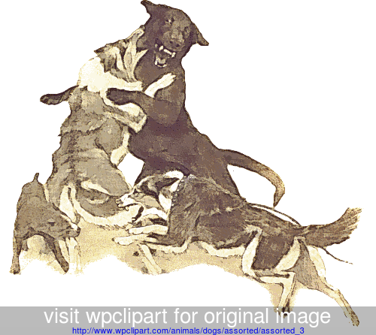
"it has been a fight all year"

16th Georgia Volunteer Infantry Regiment, Company G
"The Jackson Rifles"

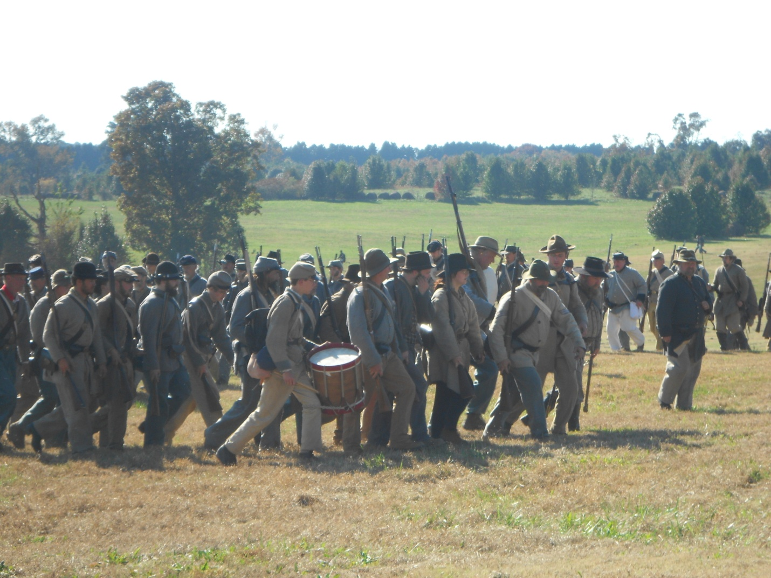
photo: Amy Thompson
THE ATLANTA CAMPAIGN 2013
It had been a long, busy, but rewarding year as most of the 16th Geo. traveled north toward McDonough on November 1, meeting south-bound rain about half way. The weekend, however, proved dry and pleasantly cool, so much so that we awoke to some patches of ice on Sunday morning. It seems we were re-creating the Battle of Utoy Creek, as part of the Atlanta Campaign. Overall numbers were disappointing to the point that no one had to tell us so and the scenarios were painfully predictable but we had a "large" time because we were all together. We had a turnout of 15, plus Sgt. Joe Johnson and 4 more men of the 39th Geo.
-1-

IN CAMP AT THE NASH FARM - NOVEMBER 2013
(many thanks to Amy Thompson and Brenda Dobson for photo contributions)
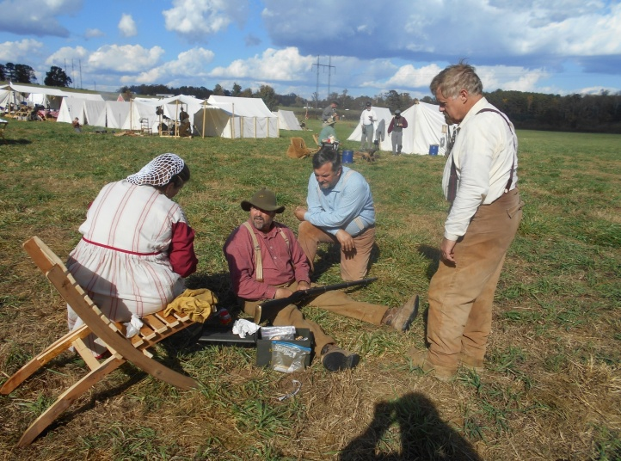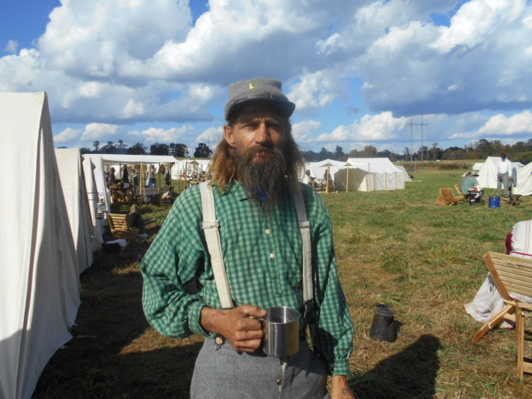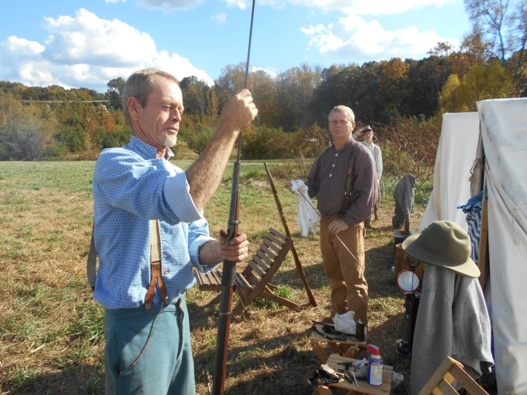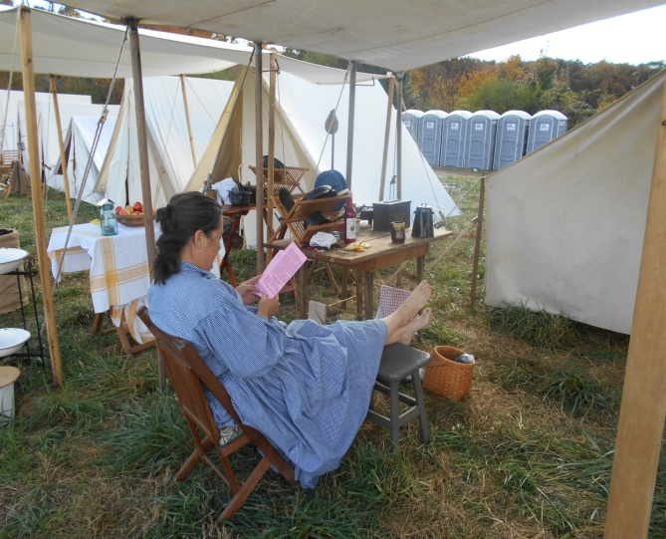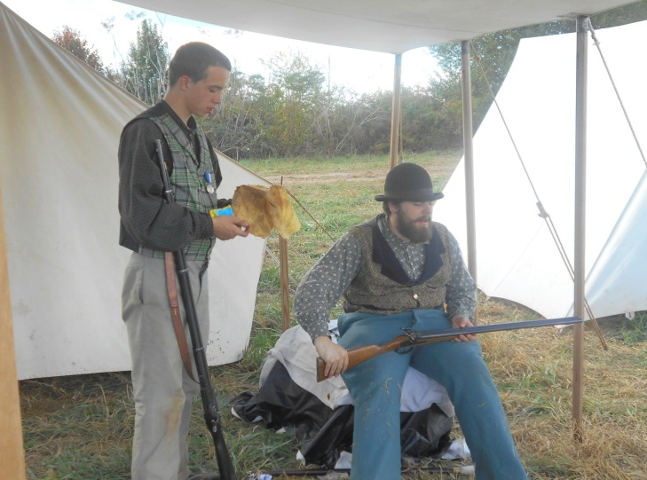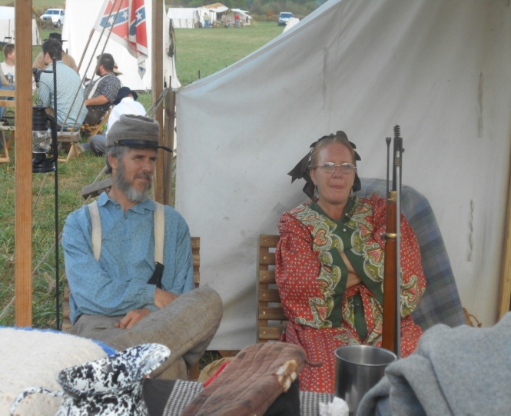
"No man that warreth entangleth himself with the affairs of this life; that he may please him who hath chosen him to be a soldier." II Timothy 2:4
-2-

MORE NASH FARM - NOVEMBER 2013
(many thanks to Amy Thompson and Brenda Dobson for photo contributions)
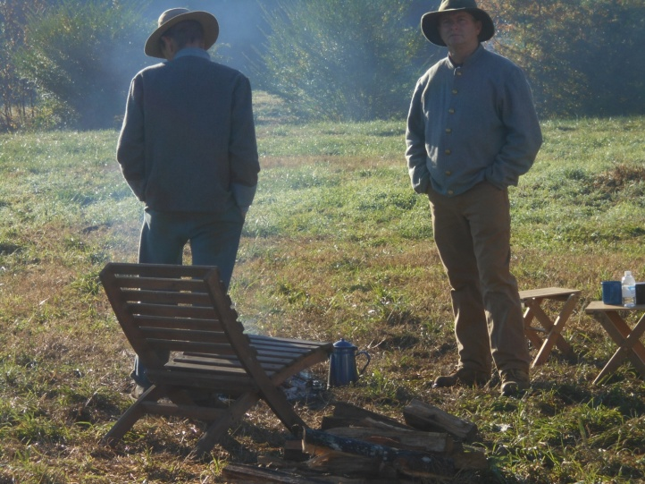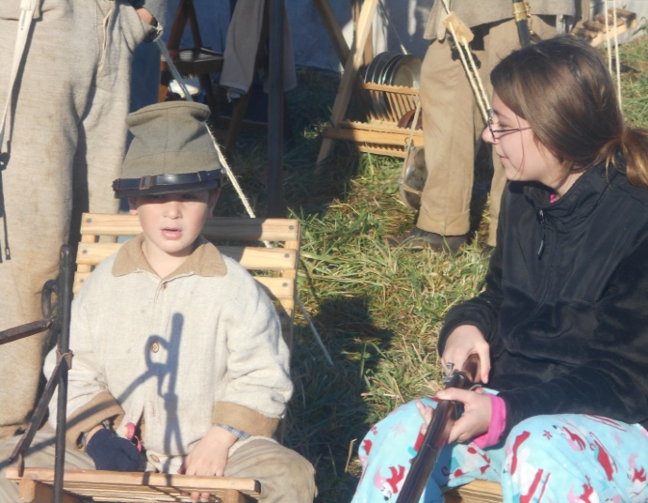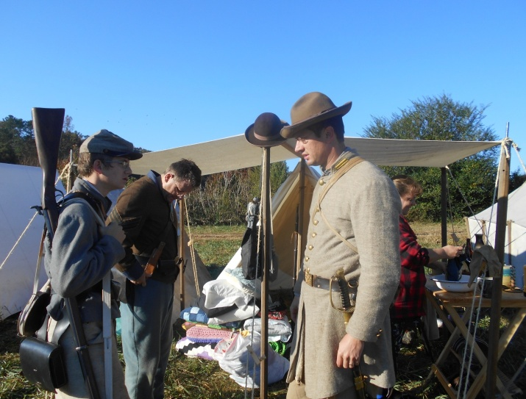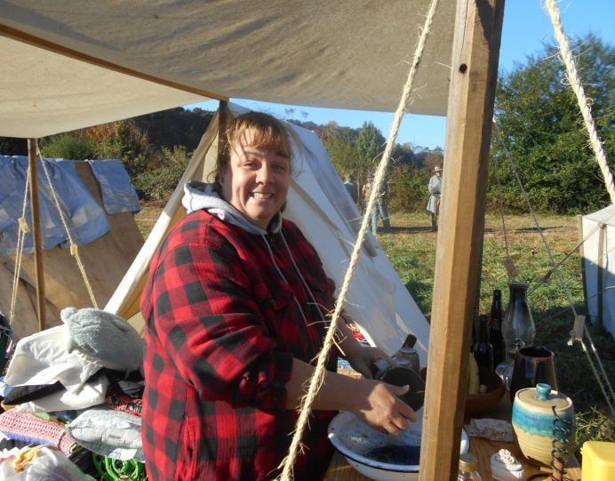
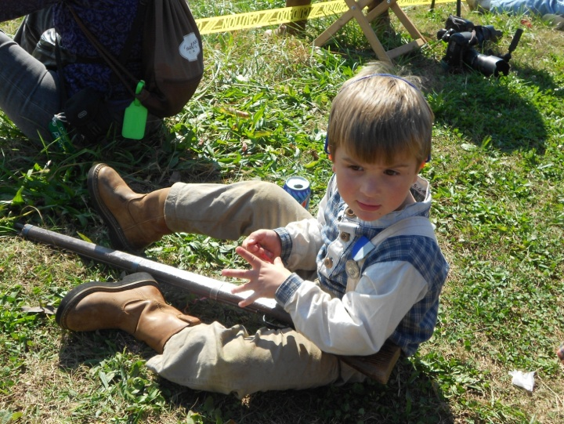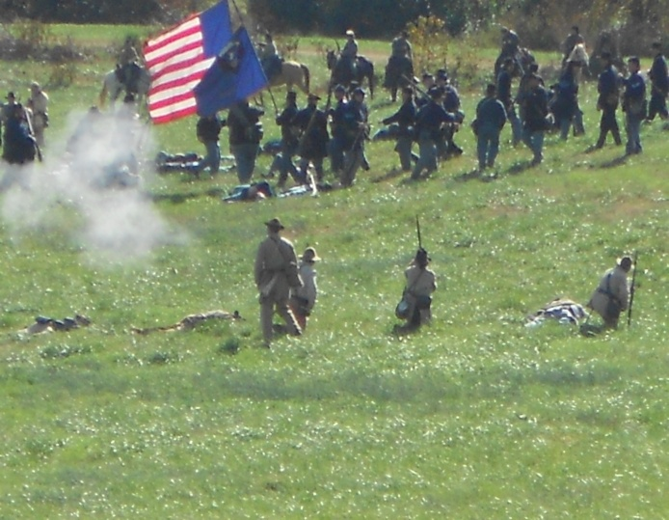
"…endure hardness, as a good soldier of Jesus Christ." II Timothy 2:3
-3-

NASH FARM - NOVEMBER 2013
(many thanks to Amy Thompson and Brenda Dobson for photo contributions)
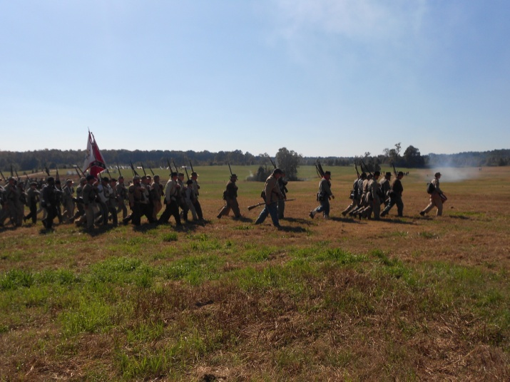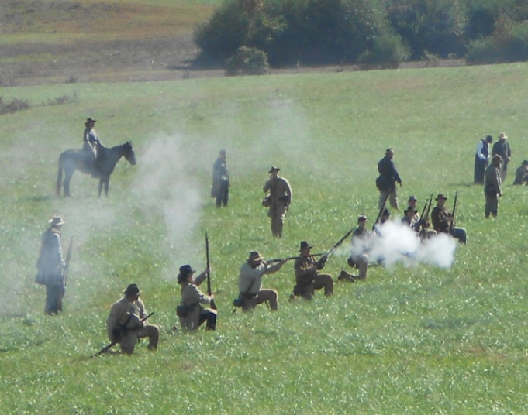
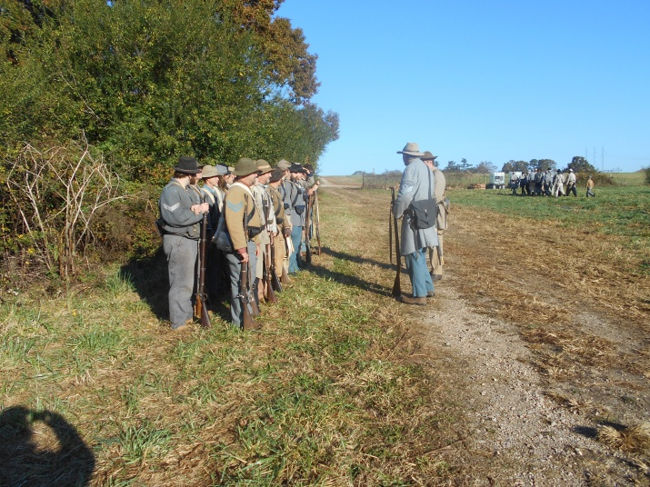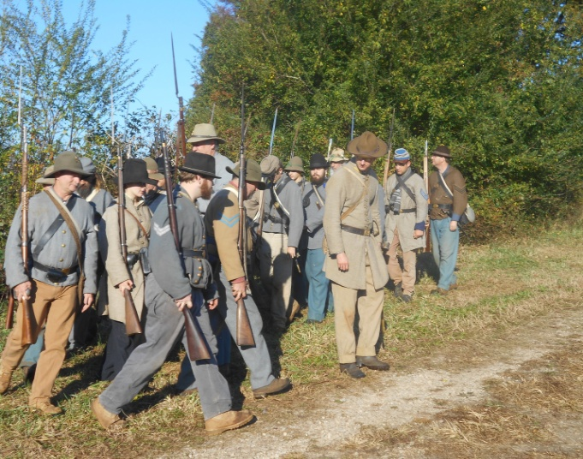
Lt. Colonel Larry Bacon asked that his compliments be passed on to the 16th/39th Georgia for their service during The Atlanta Campaign, November 1-3, 2013
-4-
AND A LITTLE MORE NASH FARM - NOVEMBER 2013
(many thanks to Amy Thompson and Brenda Dobson for photo contributions)
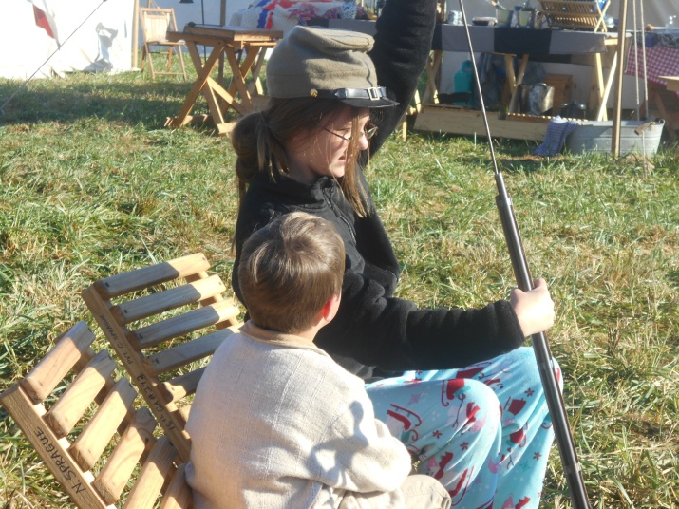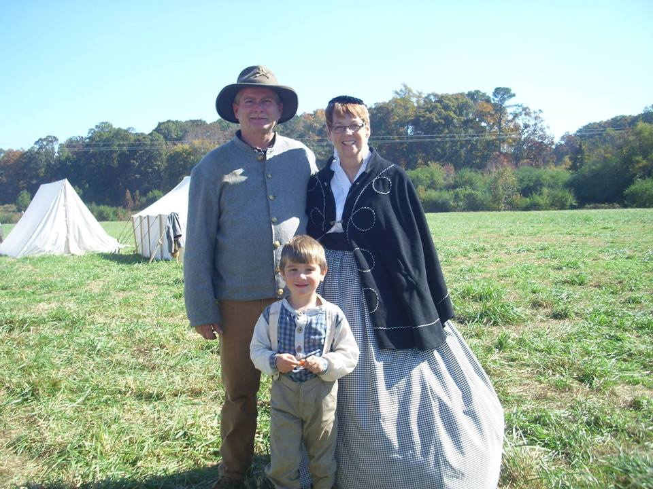
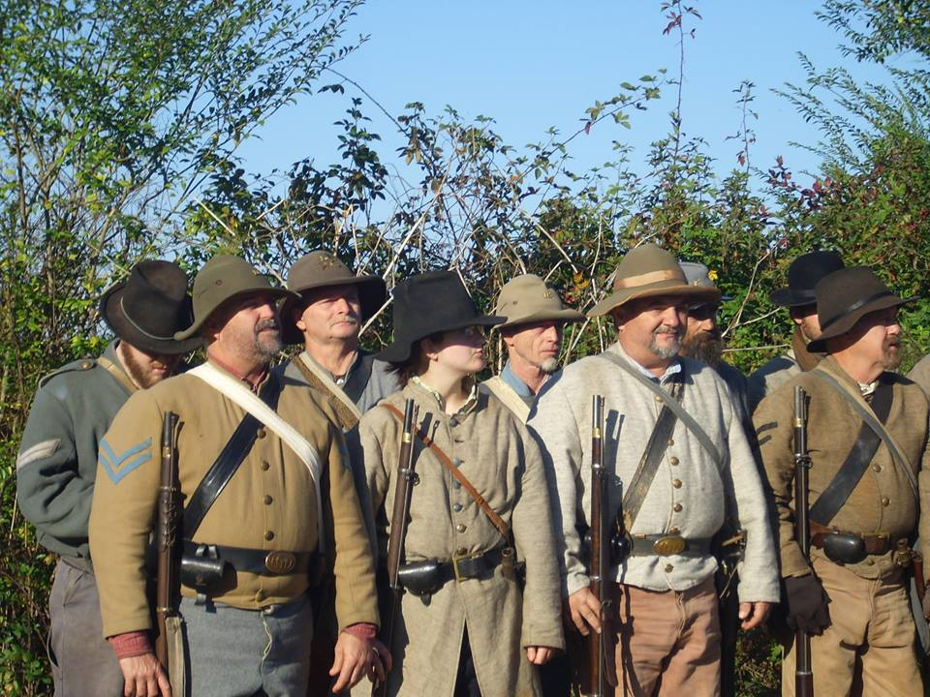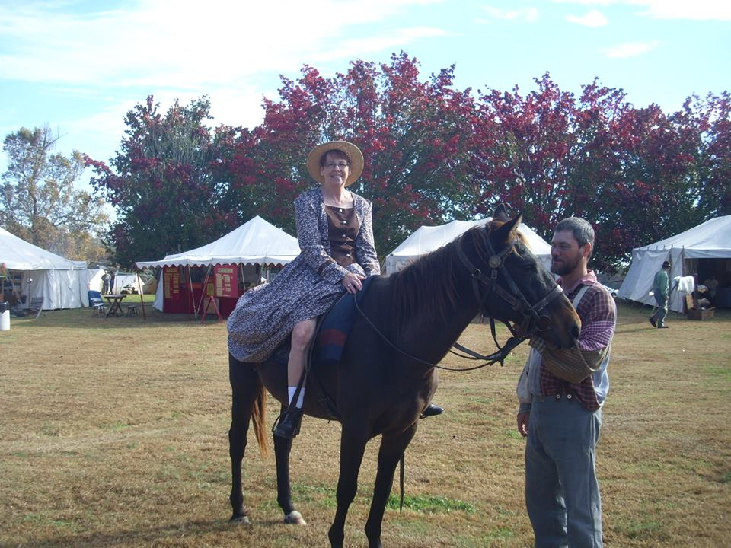
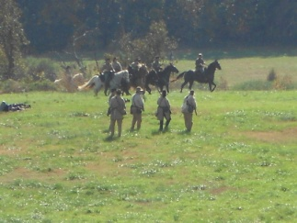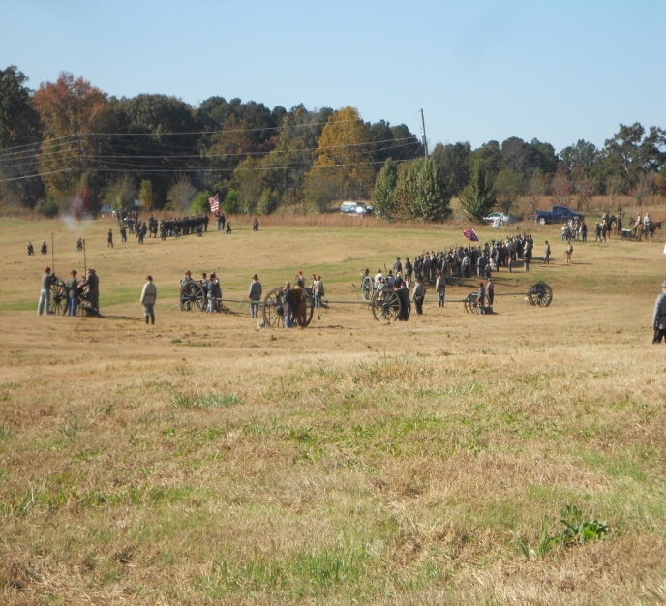
"No day should be lived unless begun with a prayer of thankfulness and an intercession for guidance…" - General Robert E. Lee
-5-
NOT JUST A SOUTHERN THING, ANYMORE

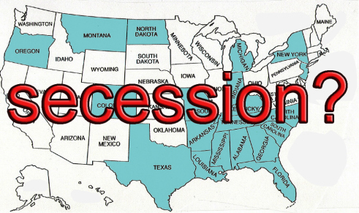
Eleven of Colorado's 64 counties were expected to vote Tuesday, November 5 on proposals to secede from the state, the Denver Post reported. The secession movement gained traction there this summer, when county commissioners from rural areas met to draw up plans for a 51st state they called "North Colorado."The 51st state initiative is rooted in the divide between Colorado's rural population and the state legislature in Denver. Those counties that are considering secession have been put off by state lawmakers' support for policies like stricter gun control and raising renewable energy standards. Any effort for the counties to secede from the state would first require voter approval, followed by a green light from the state legislature, the governor and U.S. Congress. Critics of the secession initiative point out that it's unlikely lawmakers would approve the split. - Catherine Thompson

*****
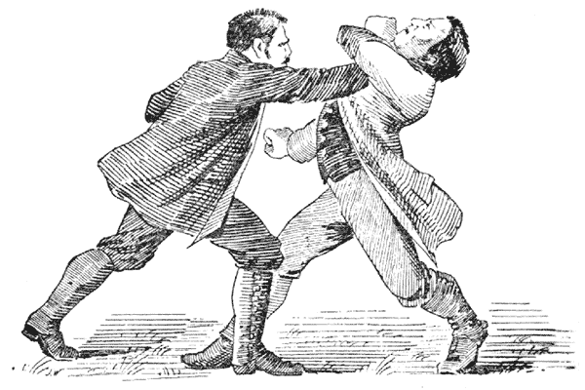
AN ECONOMIC ROOT
Mr. Southern man planted his long rows of cotton in the fertile land and for the long, hot summer; when time came he shipped it to market, some to Europe and some to the textile plants up North. Mr. Northern man made shirts from the cotton and offered them for sale to the South.
"Naw, sir, but thank you, anyway," said Mr. Southern man, "we make a right many shirts and such ourselves or import them from Europe. To tell you the truth they are of a finer quality. I think I will pass."
"That is just not right at all - not fair," fumed Mr. Northern man. If you don't trade with me I will slap a tax on every bale of cotton you ship out."
"You cannot do that," protested the Southern man."
"We can, too," countered the North and we will."
"I just believe I would fight you on that," Mr. Southern man solemnly declared.
AND THEY DID, 1861-1865.
-6-
NEVER UNDERESTIMATE HOW MUCH WE ARE HATED
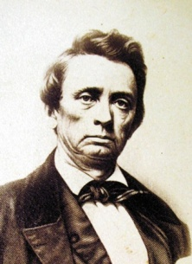
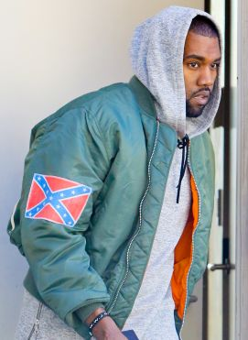
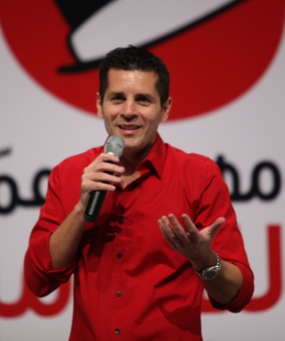
A recent CNN editorial naming the Confederacy as traitorous and lying about the reason for Secession was written by Dean Obeidallah, an American comedian of Palestinian-Italian descent - a Muslim. No one that I know really cares what he thinks, but he serves as a poster boy for the same vicious, ignorant bias that is alive and well and constantly aimed at Southerners today, as it was at our ancestors a century and a half ago. Obeidallah writes, "You can debate whether the Confederate flag is a symbol of racism. But the one thing you can't dispute: The Confederate flag was flown by traitors to the United States of America who slaughtered more than 110,000 U.S. soldiers. I know some will take issue with my calling the Confederacy a band of traitors, but let's be blunt -- that's what they were. They broke from the United States and created their own nation, calling it the Confederate States of America. They issued their own currency, elected their own president and Congress, raised an army and went to war with the United States of America, firing the first shot at Fort Sumter. What's even more troubling about the so-called Confederate flag we see so often is that it was not the official flag of the Confederacy. It's worse than that. The flag commonly referred to as the Confederate flag was actually the battle flag of the Army of Northern Virginia. Why is that worse? Because this was the flag carried on battlefields by Confederate troops during the War as they killed U.S. soldiers. And yet people still proudly display the Confederate flag." Even rapper Kanye West is selling souvenirs with Confederate flags emblazoned on them during his new tour (although many say that he doesn't mean to honor the Confederacy). However, the unqualified rantings of a stand-up comedian or the disrespectful flag flaunting by a inconsequential rapper of our time, pale in comparison to the venom that was spewed in the Reconstruction era. For example, William Gannaway "Parson" Brownlow (August 29, 1805–April 29, 1877) was an American newspaper editor, minister, and politician. He served as Governor of Tennessee from 1865 to 1869 and as a United States Senator from Tennessee from 1869 to 1875. He wrote: "If I had the power I would arm every wolf, panther, catamount and bear in the mountains of America, every crocodile in the swamps of Florida, every negro in the South, every devil in Hell, clothe them in the uniform of the Federal army, and turn them loose on the rebels of the South and exterminate every man,
-7-

woman and child, south of Mason and Dixon's line. I would like to see negro troops under Ben Butler crowd every rebel into the Gulf of Mexico, and drown them as the devil did the hogs in the Sea of Galilee. I am one of those who believe the war ended too soon. We have whipped the South but not enough. The loyal masses constitute an overwhelming majority of the people of this country and they intend to march again on the South and intend that the "second war" shall be no child's play. The "second army" will, as they ought to, make the entire South as God found the earth, without form, and void."
In a modern defense, Patrick Buchannan recently noted that CNN’s Roland Martin declared that honoring Confederate ancestors is "a recognition of American terrorists". This was the back wash of hysteria that seized Obamaville on hearing that Governor Bob McDonnell had declared Confederate History Month in the Old Dominion. So loud was the howling that in 24 hours McDonnell had backpedaled and issued an apology that he had not mentioned slavery. Slavery was not the cause of the War - Secession was - as well as Lincoln’s determination to drown the nation in blood if necessary to make the Union whole again. Lincoln never denied this fact. "As for 'terrorists,'", Buchannan pens, "no army fought more honorably than Robert E. Lee’s Army of Northern Virginia. Few deny that. The great terrorist in that war was William Tecumseh Sherman, who violated all the known rules of war by looting, burning and pillaging on his infamous March to the Sea from Atlanta to Savannah. Sherman would later be given command of the war against the Plains Indians and advocate extermination of the Sioux.“The only good Indian is a dead Indian” is attributed both to Sherman and General Phil Sheridan, who burned the Shenandoah and carried out Sherman’s ruthless policy against the Indians. Both have statues and circles named for them in Washington, D.C. If anyone thinks Sherman a hero, he might study what happened to the slave women of Columbia, S.C., when Uncle Billy’s boys in blue arrived to burn the city. What of the Sons of Confederate Veterans, at whose request McDonnell issued his proclamation? What racist deeds have they perpetrated of late? They tend the graves of Confederate dead and place flags on Memorial Day. They contributed to the restoration of the home of Jefferson Davis, damaged by Hurricane Katrina. They publish the Confederate Veteran, a magazine that relates stories of the ancestors they love to remember. They join environmentalists in fighting to preserve Civil War battlefields. They do re-enactments of Civil War battles with men and boys whose ancestors fought for the Union. And they defend the monuments to their ancestors and the flag under which they fought. Why are they vilified? Because they are Southern white Christian men none of whom defends slavery, but all of whom are defiantly proud of the South, its ancient faith and their forefathers who fell in the Lost Cause."

-8-

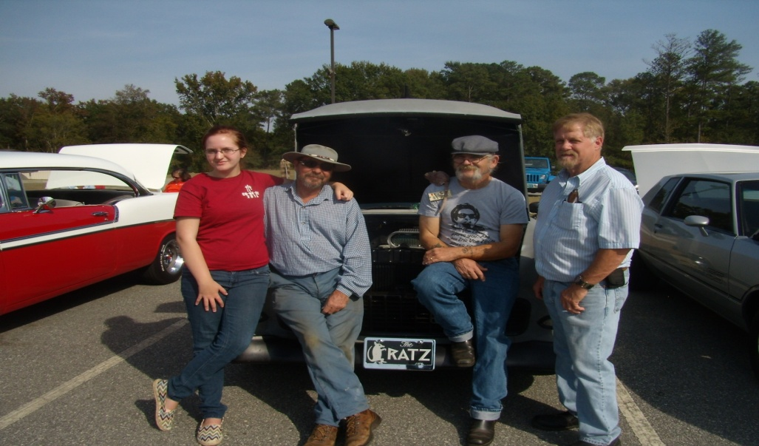
photo: Brenda Dobson
CAR SHOW AND FISH FRY AT MACON EVANGELISTIC CHURCH
Macon Evangelistic Church is no longer located at the site of the "Gettysburg in Georgia" (1996 & 1998) after moving during the summer to Hartley Bridge Road. That did not stop Dawgs of the 16th Georgia from tracking down the location and showing up for an antique car show and fish fry on the afternoon of October 27 Pictured are Kellie Banks, J.C. Nobles, Beezer Banks and Wayne Dobson.
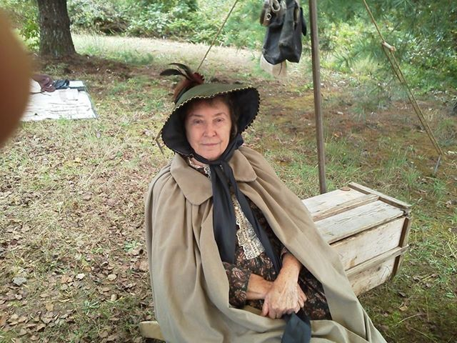

BARBARA PORTER YOUNG
May we introduce the mother of Georgia Volunteer Battalion Chaplain, Reverend Joey Young. Her grandpa, Russell Porter, was born in 1828 and was in the 16th GA Co. D. Captured at Farmville, Virginia a few days before the Surrender. He was later released, but would NEVER sign an oath of allegiance to the Union. He was 62 years old when her dad (Brother Joey's grandpa) was born in 1890. Brother Joey's grandpa was 47 when Barbara Porter Young was born, which skips a lot of years and makes her a direct granddaughter.
-9-
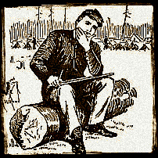
THE LETTER:
The captured Yankee letter posted below describes the plunder, pillaging, looting and murder by Sherman's barbarians that invaded Georgia and South Carolina in 1864-1865. Note the reference to shooting the bobbing heads of blacks. The "official" Yankee version of history is that they drowned trying to swim the river or creek. The History Channel program a couple of years ago on Sherman's March repeated the lie that they drowned. This letter was researched in the 1870's by the Southern Historical Society and determined to be genuine. - Courtesy of: James W. King--SCV Camp Commander Albany GA. : jkingantiquearms@bellsouth.net
"Camp near Camden, S. C., Feb 26, 1865.
My dear wife,
I have no time for particulars. We have had a glorious time in this State. Unrestricted license to burn and plunder was the order of the day. The chivalry [meaning the Honorable & Chivalrous people of the South] have been stripped of most of their valuables. Gold watches, silver pitchers, cups, spoons, forks, &c., are as common in camp as blackberries.
The terms of plunder are as follows: Each company is required to exhibit the results of its operations at any given place--one-fifth and first choice falls to the share of the commander-in-chief and staff; one-fifth to the corps commanders and staff; one-fifth to field officers of regiments, and two-fifths to the company. Officers are not allowed to join these expeditions without disguising themselves as privates. One of our corps commanders borrowed a suit of rough clothes from one of my men, and was successful in this place. He got a large quantity of silver (among other things an old-time milk pitcher) and a very fine gold watch from a Mrs. DeSaussure, at this place. DeSaussure was one of the F. F. V.s of South Carolina, and was made to fork over liberally. Officers over the rank of Captain are not made to put their plunder in the estimate for general distribution. This is very unfair, and for that reason, in order to protect themselves, subordinate officers and privates keep back everything that they can carry about their persons, such as rings, earrings, breast pins, &c., of which, if I ever get home, I have about a quart. I am not joking--I have at least a quart of jewelry for you and all the girls, & some #1 diamond rings and pins among them.
General Sherman has silver and gold enough to start a bank. His share in gold watches alone at Columbia was two hundred and seventy-five. But I said I could not go into particulars. All the general officers and many besides had valuables of every description, down to embroidered ladies' pocket handkerchiefs. I have my share of them, too. We took gold and silver enough from the damned rebels to have redeemed their infernal currency twice over. This, (the currency), whenever we came across it, we burned, as we considered it utterly worthless. I wish all the jewelry this Army has could be carried to the "Old Bay State". It would deck her out in glorious style; but, alas! it will be scattered all over the North and Middle States. The damned niggers, as a general rule, prefer to stay at home, particularly after they found out that we only wanted the able-bodied men, (and to tell the truth, the youngest and best-looking women). Sometimes we took off whole families and plantations of niggers, by way of repaying secessionists. But the useless part of them we soon manage to lose; [one very effective was to "shoot at their bobbing heads as they swam rivers" after the army units crossed over], sometimes in crossing rivers, sometimes in other ways.I shall write to you again from Wilmington, Goldsboro', or some other place in North Carolina. The order to march has arrived, and I must close hurriedly. Love to grandmother and aunt Charlotte. Take care of yourself and children. Don't show this letter out of the family. Your affectionate husband, Thomas J. Myers, Lieut.

P.S. I will send this by the first flag of truce to be mailed, unless I have an opportunity of sending it at Hilton Head. Tell Sallie I am saving a pearl bracelet and ear-rings for her; but Lambert got the necklace and breast pin of the same set. I am trying to trade him out of them. These were taken from the Misses Jamison, daughters of the President of the South Carolina Secession Convention. We found these on our trip through Georgia."
(The letter was addressed to Mrs. Thomas J. Myers, Boston, Massachusetts)
-10-

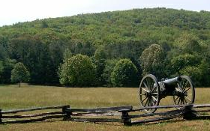
MORE LAND AT KENNESAW
The Trust for Public Land announced the addition of land to the Kennesaw Mountain National Battlefield Park in a recent statement to The Associated Press. The trust said the addition means the site northwest of Atlanta will be preserved and protected from future development. The trust partners with the National Park Service and other groups to conserve land for public use. The land being added to the 3,000-acre park was the site of fierce fighting, especially around Nodine's Hill, during the last major battle before Union soldiers reached Atlanta. The land, known as Hays Farm, includes remnants of Union entrenchments, rifle pits, and cannon placements
PRAYERS AND ANSWERS
On October 23rd, Frank Foulke (96th PVV) wrote to Wayne: "Thank you for your continued prayers. We were just to the surgeon today for my one month check-up. He is very confident things are going well and is very upbeat. Will return in 30 days for further tests to make sure the rest of the aorta and associated plumbing is OK. The only restrictions I have is no driving for three months and no lifting over five pounds. Bette and I walk at least three times a day and I have exercises from a physical therapist. Each day I can see some improvement in my stamina and appetite. A crazy thought occurred to me recently - I had always said I wanted to live to the age of 100. Perhaps this reprieve is part of God's plan..... Whatever, I accept his help and appreciate it. Again, thank you for your prayers. Yours, along with my many "prayer partners" here in our (RV) park have been heard!!" Also, keep in prayer for Mark "Watch Dog" & Brittany Thompson for recent physical needs.
PICTURES FROM THE PAST
DUKE AT ATLANTA, 1991 & J.C. AT THE CLINTON HAUNTED BARN, 1989

-11-

BOOKS
James D. Bulloch: Secret Agent and Master Mind of the Confederate Navy
By Walter E. Wilson, Gary L. McKay Price: $55.00
http://astore.amazon.com/souhernewvie-20/detail/0786466596
James Dunwoody Bulloch will never be as famous as Robert E. Lee, but maybe he should be. Authors Walter Wilson and Gary McKay have written a biography of this largely unknown Confederate naval hero. For those who are familiar with Bulloch and have already read his memoirs entitled The Secret Service of the Confederate States in Europe, there is a great deal of additional information in this new book. The final chapter alone is worth the price of the book. Bulloch, through his influence on Teddy Roosevelt and others, had a profound effect on the future of naval warfare. I have always said that the history of the Confederate Navy is so exciting that Hollywood couldn’t make it up. Authors Wilson and McKay have written a book that proves my point.

The Lost Colony of the Confederacy (Williams-Ford Texas A&M University Military History Series) By Eugene C. Harter Price: $19.95
http://astore.amazon.com/souhernewvie-20/detail/1585441023
The Lost Colony of the Confederacy is the story of a grim, quixotic journey of twenty thousand Confederates to Brazil at the end of the American Civil War. Although it is not known how many Confederates migrated to South America-estimates range from eight thousand to forty thousand-their departure was fueled by bitterness over a lost cause and a distaste for an oppressive victor. Encouraged by Emperor Dom Pedro, most of these exiles settled in Brazil.

For young Confederates - Confederate Alphabet
By Rickey Pittman Price: $12.74
http://astore.amazon.com/souhernewvie-20/detail/158980760X
Confederate Cemeteries, Volume 1
By Mark Hughes Price: $35.50
http://astore.amazon.com/souhernewvie-20/detail/078842050X
Over 200,000 Confederate soldiers died during the War, but no one has ever compiled a listing of their names. The Confederate Cemeteries series fills that void. Using heretofore unpublished cemetery rosters, long out-of-print books, unpublished manuscripts.
Confederate Cemeteries, Volume 2
By Mark Hughes Price: $44.50
http://astore.amazon.com/souhernewvie-20/detail/0788423452
The second book in the Confederate Cemeteries series, lists the names of over 10,500 Confederate soldiers that died during the War. The vast majority of the burials listed are Confederate soldiers that died during the war.

-12-

When a Devil Wages War
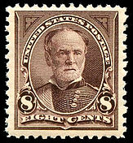
In 1911 the United States Postmaster released a new stamp with the image of W.T. Sherman upon it. The petition (below) to withdraw the stamp from circulation notes that “Sherman observed the laws of civilized war only when he had a hostile army to fear.” Without that fear of retaliation, he waged war upon helpless women and children. The 1895 Sherman stamp is pictured.
“Petition to the Postmaster General by the Citizens of Texas:
We, the citizens of Huntsville, Tex., respectfully petition the Postmaster General to place on sale in this State no stamps or postal cards bearing the likeness of W.T. Sherman. We are loyal citizens, we love our country, we wish to forget the past differences and bitterness; but there are two things which no true Southerner will ever forget or cease to teach his children to remember. These are the deeds of W.T. Sherman and the period of Reconstruction.
There were enough brave and chivalrous Union generals in the Civil War to furnish subjects for stamps, and we object to the face of a ruffian who made war on women and children being placed among the faces or Washington, Franklin, Jefferson . . . and other honorable men and forced upon our children when we have done nothing to deserve insult.
Sherman observed the laws of civilized warfare only when he had a hostile army to fear. When Hood was defeated the people were helpless and defenseless, he set his bummers upon them and boasted of it. Union armies were not bad unless they had bad leaders. Among civilized people war is not hell unless a devil wages it.
If this man’s face is forced before us in this way, we shall be forced to teach in public those lessons in history which we teach by the fireside, even if those with goods to sell preach that all should be forgotten.
If W.T. Sherman’s face must be held up to view, send it to those who love his character and celebrate his victory in song, but not to those whose homes he robbed, whose daughters he insulted, whose sons he murdered, and whose cities and homes he burned.”Sherman’s Picture on U.S. Postage Stamps, Confederate Veteran, June 1911, pg. 272)

IN SYMPATHY
William Charles "Charlie" Ragan Jr.
October 30, 1925 - October 15, 2013

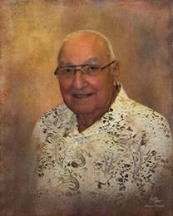
William Charles "Charlie" Ragan, Jr. 87, passed away on Tuesday, October 15, 2013 in a local hospital. Funeral services were held at 2:00PM on Saturday, October 19, 2013 in the Chapel of Macon Memorial Park Funeral Home with the Rev. Steve Waldorf officiating. The family greeted friends from 1:00PM to 2:00PM prior to the service on Saturday. To those who wish, memorial contributions may be made to: Al Sihah Shrine Temple, 222 Mecca Drive, Macon, Georgia 31206 for the Children's Hospital. Mr. Ragan was born in Ft. Lauderdale, Florida to the late Charlotte Elizabeth "Lottie" Joyner Ragan and William "Bill" Charles Ragan. He was the co-owner of Ragan Park (Recreation), and worked at the Naval Ordinance Plant, Macon Custom Signs, U.S. Postal Services and the Macon Centreplex for 45 years. Mr. Ragan was a member of Riverside Methodist Church. He was a Shriner, an active member of the Masons, Scottish-Rite, ROJ, Macon Motorboat Club and TPA. Mr. Ragan served in the U.S. Navy during World War II. He was preceded in death by his daughter: Nancy Ragan Whitten. Mr. Ragan is survived by his caring and loving wife of 69 years: Lillian Pollock Ragan; son: Ronnie Ragan; grandchildren: Chuck (Angela) Ragan and Dixie (Lee) Curtis; great-grandchildren: Whittney and Will Butler, Coby Cromer and Ragan Curtis; sister-in-law: Grace P. Reeves; and special niece: Carol S. Reeves.
-13-
THE CAMP OF THE UNKNOWN SOLDIER # 2218
Camp # 2218 of Clinton, Jones County, Georgia, held what was very likely their last meeting at Chevy's Café on Hwy. 49 in Jones County, on October 24, 2013. On that evening, the Camp enjoyed an address by Judge Advocate Ethan Bloodworth, concerning General Patrick Cleburne. The November meeting will be held at the Griswoldville Commemoration on November 23rd and there will be no December meeting. On January 27, 2014, plans are to begin meeting at FIREFLIES restaurant on the Gray Hwy. (kind of across from Old Clinton BBQ) when we will celebrate the lives, service and legacy of General Robert E. Lee and Thomas J. "Stonewall": Jackson. Keynote speaker will be Camp 2218 Commander J.C. Nobles. More details will follow. We would also like to note that Compatriot M.L. Clark of Camp 2218 celebrated his 86th birthday on October 17. Please visit our new website at scvcamp2218.com
HEADSTONE DEDICATION - NOVEMBER 16
A Headstone Dedication is scheduled for Saturday, Nov. 16, 2013, 1 PM, at Bluewater Baptist Church, 2664 US Hwy. 441 South at Scotland Rd., Dublin, Georgia. The service is for Private Anderson Augustus Fountain who is buried in the church cemetery. All able-bodied men in uniform and ladies of period dress are encouraged to attend. Col. J. C. Nobles will conduct the honor guard and we also will have two cannon crews. We will provide seating for those unable to stand throughout the service. Pastor Gene Hemingway has graciously opened the doors of the church so you can change and participate. Please email me if you can help us out. The church will need a head count in order to provide refreshments afterwards. Looking forward to serving with you. Kim M. Beck, Commander, 4th Brig., GA Division SCV
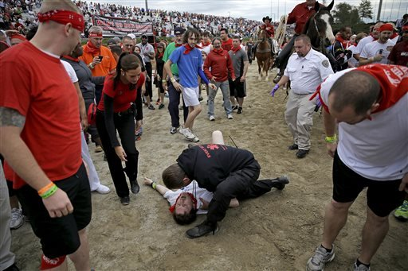
Bryant Knight, of Macon, Ga., is tended to by a medical official after being run over by a charging bull during the Great Bull Run at the Georgia International Horse Park, Saturday, Oct. 19, 2013, in Conyers, Ga. Bryan holds the office of Surgeon in Camp 2218.
On November 6, Bryant reported: "I had my first follow-up appointment today. The x-rays look good, and the bones are still in their proper place. I won't need surgery. I'll have to use crutches until late January, and it's illegal for me to drive a car until then, too. I can't go back to work just yet, but it shouldn't be much longer. Running the pharmacy on crutches will be tough, but I'm confident I can handle it. I'll start another round of physical therapy after I come off the crutches."Keep the prayers coming for him. He may try to come out to Griswoldville if he's not working part-time.
-14-

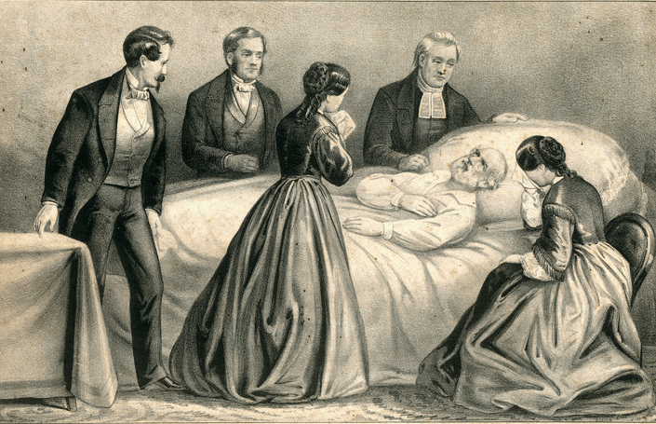
General Robert E. Lee’s Last Days

“The end was now drawing near, yet the General uttered no complaint. He was meeting the last enemy as he had met Grant at Appomattox, without parade or ostentation. An incident of these last days should be preserved. It was related by Mrs. Tabb Bolling Lee. This former Petersburg belle had been in the habit of rising at a late hour, anywhere perhaps from ten to noon. Now, on her first visit to her husband’s people, she was horrified to learn that breakfast would be ready at seven o’clock and each member of the household was expected at family prayers promptly at 6:45. The first morning, the new arrival jumped into her clothes and hastened down to the parlor to find that the General had finished the “lesson” and was well into the “prayers.” As she slipped in and knelt by his side she felt his arm about her. Without interruption the prayer went on and was concluded. Next morning the new daughter did not get down to prayers at all, but did manage to be on hand at breakfast. After the meal the General approached and quietly remarked that no day should be lived unless it was begun with a prayer of thankfulness and an intercession for guidance. “And now, my child,” he softly concluded, “unless you get down to morning prayers your old father will give you no more kisses.” The punishment was adequate. Thereafter the new daughter was on time for prayers. The evening of September 28 was raw, damp and unseasonably cold. At that unpropitious hour the vestry of Grace Church met in the unheated building. After presiding at an extended session the General walked up the hill to his home. Tea awaited him. Slowly moving to his pace at the head of the table, he stood, as was his custom, to ask the blessing. His tongue failed to function. The summons had come. From the couch, in the recess window of the dining room, where they laid him, he did not again move. The physicians treated him for venous congestion of the brain, and, at first, held out hope for recovery. The symptoms were favorable. He was not paralyzed and could move his arms, legs and body, though with pain. He was entirely conscious. Sometimes he spoke. He answered questions, but in monosyllables. His mind was clear and seemed independent of his body. One day the doctor, seeking to cheer him, referred to Traveler. The General must make haste and get well; Traveler was lonely and was looking for him. The sick man shook his head and closed his eyes. During the final days there was no death-bed scene, no posing, no sadness of farewell. Silence filled the sorrowing chamber. Toward the end chilliness set in. Powerful restoratives were then administered. The intellect was dimmed. The poise and self-restraint of a life-time vanished. The dying man was on the battle field again, astride his war-horse. “Strike the tent!” he exclaimed, as a great storm swept the valley. “Tell Hill he must come up!” At nine o’clock on the morning of October 12 the heart ceased to beat, and a great gentleman, please God, was dead.”
(Robert E. Lee, A Biography, Robert W. Winston, William Morrow & Company, 1934, pp. 411-413)
-15-

GRISWOLDVILLE BATTLE COMMEMORATION
Honoring those that
Served at the battle of Griswoldville and
environs, November, 1864

The Jarrell Plantation Historic Site and the 16th Georgia Volunteer Infantry,
Co. G, "The Jackson Rifles", and The Camp of the Unknown Soldier, Camp # 2218, of Clinton, Jones County, Georgia, cordially invite one and all to
the 9th annual
Griswoldville Battle Commemorative Service

Saturday, November 23, 2013

A living history program will begin at 9:30am with the commemoration at 12:00 noon.

Guest speaker

Alan Richards

of the 16th Georgia Infantry, Co. G and the Logan E. Bleckley SCV Camp #1998

For more information, contact:
John Wayne Dobson @ 478-731-5531
waynedobson51@yahoo.com
Brenda Dobson @ 478-396-4838
brendadobson61@yahoo.com
Gary Thomas @ 478-986-5172
Gary.Thomas@dnr.state.ga.us

*****

GPS: 32°52′00″N 83°28′10″W
Directions: From Macon at the junction of U. S. 80 and U. S. 129 (near I-16 Exit 2 and Macon Centreplex), take U.S. 80 east to Georgia 57; at junction with Jeffersonville Rd. bear left on Georgia 57 (Irwinton Rd.). Road name changes to Kenneth W. Birdsong Hwy. Turn left onto Battlefield Dr., at the end of the road turn left onto Old Griswoldville Rd., right onto Baker Rd. Battleground Memorial and parking are on the left. From Griswoldville go south on Henderson Rd. (named Ridge Rd. also) then left onto Old Griswoldville Rd., left onto Baker Rd., Battleground Memorial and parking are on the left.
------------------------------------------------------------------------------------------------------------
From Macon, take U. S. Hwy 80 east, go 2.3 miles, turn left onto Ga. Hwy 57 (Kenneth W. Birdsong Hwy.) and go 4.9 miles, turn left onto Battlefield Dr., at 0.5 miles turn left onto Old Griswoldville Rd., go 2.5 miles and turn right onto Baker Rd., the parking area for the Battlefield is about 1/3 mile on the left. All of the roads are paved. The battlefield is at 32.86690N, 83.46648W.
-16-

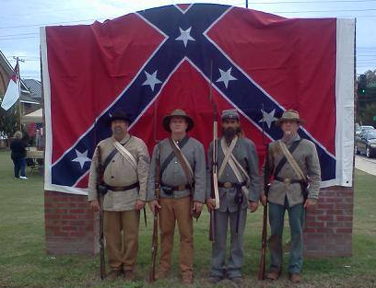
This picture was taken at the (ComSouth) Comfest in Cochran, Ga. 19 Oct 13. SCV Camp Logan E. Bleckley 1998 set up a living history camp in front of the Confederate Monument. Camp /16th GA Co. G, 1st Squad members present were (left to right) Corporal Alan "Cookie" Richards, Private Dan Williams, Private Jeff White and Private Frank Williams. Also participating were Sue White, Sheri Williams, and Bobby Duskin. The Marque was broken so we draped it with something that does work. The Confederate Battle Flag The group was also asked to be a part of a Boy Scout Memorial Service in front of the Court house. It was
a fine Dixie Day!
*****
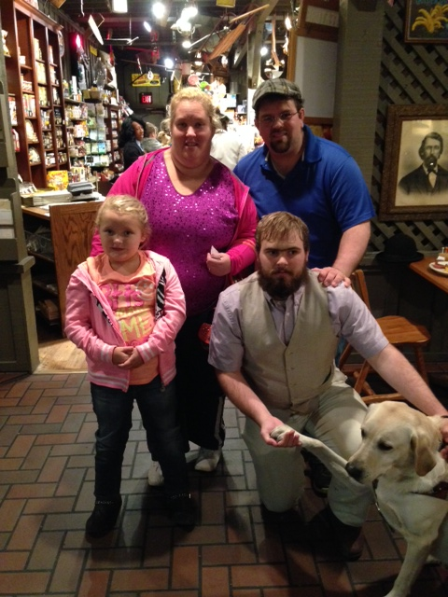
Private Ethan Bloodworth and his faithful dog, "Hawk" recently ran into Honey Boo Boo and family at the Cracker Barrel.
-17-
UPCOMING EVENTS
2013
NOVEMBER 23 - HEADSTONE DEDICATION AT DUBLIN, GA (SEE PAGE 14)
NOVEMBER 23 - GRISWOLDVILLE 149th ANNIVERSARY COMMEMORATION
DECEMBER 14 - A CANNONBALL HOUSE CHRISTMAS - Join us for an Old Time Christmas Celebration at The Cannonball House on December 14th, 2013 at 6:00 p.m. Enjoy an evening of family fun and excitement as we make crafts, sing carols, read the Christmas Story and have fun. We expect a visit from Father Christmas and look forward to the opportunity to take part in period dancing. With warm cider and fresh baked cookies, certain to please, we welcome you to bring your family and celebrate the holidays with us. ALL (EVERYONE) Adult admission is $6 with children under 12 admitted free. For more information please call Earl or Brenda @ 478-745-5982.
2014
JANUARY 11 - WINTER DRILL - ONE DAY ONLY DRILL AT EARL COLVIN'S 478-214-0687
FEBRUARY 14-16 - 150TH OLUSTEE, FLORIDA
MARCH - 14-16 - MANASSAS, GA - 14-16; POC TOMMY WALLACE 912-557-6649
APRIL 26 - CONFEDERATE MEMORIAL DAY
APRIL - OLD CLINTON WORKDAYS - DATES TO BE ANNOUNCED
MAY 2-4 - WAR DAYS- 150TH SUNSHINE CHURCH & GRISWOLDVILLE
MAY - 150TH BATTLE OF RESACA, GA
MAY - OLD SOLDIER'S DAY AT ERVIN GARNTO'S (in 2012 it was on May 26th)
JULY 26 - OCMULGEE NATIONAL MONUMENT LIVING HISTORY
SEPTEMBER 19-21- BATTLE OF ATLANTA AT NASH FARM
SEPTEMBER - SCV SALUTE TO VETERANS IN DUBLIN, GA (last year 15th)
OCTOBER 3-5 ANDERSONVILLE (1st weekend)
OCTOBER - BATTLE @ IRWINVILLE - POC - LEE MURDOCK @ 478-986-5290.
NOVEMBER 22- GRISWOLDVILLE MEMORIAL - SPEAKER: PASTOR JOHN WEAVER
NOVEMBER CANNONBALL HOUSE APPARITIONS (in 2013 it was the 9th)
NOVEMBER-DECEMBER - CHRISTMAS @ RICHLAND CHURCH
DECEMBER - CHRISTMAS AT THE CANNONBALL HOUSE
*****
16TH GA Co. G. “Jackson Rifles”
Brig. Gen. Herbert Burns - 478-668-3598
Capt. Wm.―Rebel Bradberry–404-242-7213
1 Lt. Noah Sprague – 706-491-9755
1st Sgt. Kevin Sark – 478-731-8796
2nd Sgt. Nathan Sprague – 478-320-8748
Adjutant John Wayne "Duke Dobson 478-731-5531
1st Corp. Alan "Cookie" Richards 478-308-9739
2nd Corp. Chas."Goodtime" Whitehead 478-986-8943
3rd Corp. Lee "Pappy" Curtis -478-365-6785
Lead Chaplain – Joel Whitehead, Jr. - 478-986-8798
Hon. Chaplain Ronnie ―Skin Neal – 478-994-0958
Assistant Chaplain – Charles Hill – 770-845-6878
Treasurer - Pvt. Earl Colvin – 478-214-0687
Honorary Colonel J. C. Nobles - 478-718-3201
Musician - Landon Allen - 478-294-9870
Musician - Jacob Thompson – 478-214-0687
Musician - Aaron Bradford – 302-668-8029
Musician - Oliver Lummus – 302-668-8029
Musician Al McGalliard - 478-986-4827
ON FACEBOOK:"JACKSON RIFLES" - MORE THAN 2,000 FRIENDS . All 2011-12 issues of The Howling Dawg are available @ (scvcamp1399.org), thanks to Steve Scroggins and some at scv2218.com as well, courtesy of Al McGalliard.
-18-

WHY I DON'T PLAY OR SING THE BATTLE HYMN OF THE REPUBLIC
There is a way which seemeth right unto a man, but the end thereof are the ways of death. - Proverbs 14:12 & 16:25
I wish churches would stop singing The Battle Hymn of the Republic.
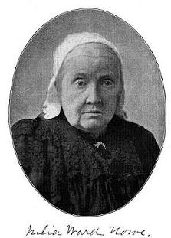
It was not written by a Christian and is not about the Second Coming of Christ. Some call it a hymn and it is found in many American hymnals but it is actually a 19th century political song. The lyrics were re-written by Julia Ward Howe using the music from the song "John Brown's Body" after she visited a Union Army camp in November 1861. Mrs. Howe, a Unitarian and an adherent of Transcendentalism, was paid five dollars when it was originally published in the Atlantic Monthly.
I, personally, feel that Unitarians had quite a lot to do with the initiation and vicious prosecution of the War. They are basically are a religious sect that does not believe in the Holy Trinity and they reject the deity of Jesus. From Howe's unique theological perspective. the propagandist song attempts to link the judgment of the wicked at the end of time (Revelation 19) with The War Between The States, however, the theology contained therein is not Biblical, nor does the song’s history commend it to be sung by Christians. She incorporated these assumptions into verses one and two:
*The War was to be viewed apocalyptically
*The Union Army was God’s Army, dispensing His wrath on the Confederacy
*God dwelt in the Union camps and their fires were alters to Him
*The Union Army is even to be equated with God’s Word (“His sword”)
Versions sung in many churches (and in many church hymnals) leave out the third verse which specifically equates the Gospel with the Union Army’s bayonets and swords and portrays them as crushing the serpent's head (the Confederacy). The final verse declares:
In the beauty of the lilies, Christ was born across the sea,
With a glory in His bosom that transfigures you and me.
As He died to make men holy, let us die to make men free,
While God is marching on.
Apart from the obvious ambiguity of saying that Christ was “born among the lilies,” these lyrics betray the fundamental rejection of the deity of Christ common to Unitarians. Christ died “to make men holy”; that is, He lived and died nobly, that we might follow His example. Yet it remains for man (through government and social action) to “make them free” through the death associated with war. Even changing “die” to “live” (as some hymnals do) does not avoid the social element of the “gospel” being presented.
This song has little to commend it to the Christian who takes seriously the Word of God and the orthodox doctrines derived from it. While one of the underlying issues, slavery, in that War was characterized by the North as a moral one and not economic, it is arrogantly assumed that right won the day. The Battle Hymn of the Republic interjects the grace of God, the judgment of God, and the Gospel of God into the conflict in such a way as to significantly blur the importance to sinful humanity. As Christians in this great nation, we may indeed celebrate our freedoms and honor those by whom such freedoms were purchased. However, as Christians, our greatest freedom does not yet await another’s living or dying, but was purchased for us by Jesus Christ once for all. - John Wayne Dobson
-19-
INDISPUTABLE FACTS !!!
100% CASUALTIES AT GETTYSBURG
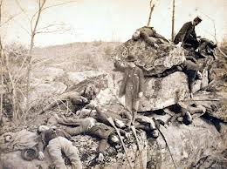
On May 4, 1861 almost the entire student body and many professors formed ranks on the grounds in front of the Lyceum as they left Ole Miss and enlisted in the Confederate Army. This body of students and professors formed Company A of the 11th MS Infantry, and were part of Lee's Army of Northern Virginia. Mississippi seceded from the Union on January 9, 1861 and this body of men answered the call of their state faithfully as they served in some of the most bloody battles of the War between the States, including Gettysburg, where this company, called the University Greys, suffered 100% casualties. Every single soldier was either killed or wounded. The most well known of these men is a young student named Jeremiah S. Gage. As Gage was dying he asked to write his mother; he told her that he died like a man, and that he was sorry that she and his sisters were "... robbed of my worth whatever that may be ..." Gage's Dad had died and he was the man of the family. The ROTC cannon used today at Ole Miss is named for Mary (Mollie) Wendel, the betrothed of Jeremiah S. Gage.
VETERANS, TOO
Congress declared in 1958 that Confederate Veterans are American Veterans, and as such are entitled to the same benefits and respect as every other American Veteran. Therefore, the Confederate Flag is a venerated symbol by the United States Congress, and the Confederate Soldier," an American Veteran". Yet Congress and the Supreme Court turn their backs on the law of the land.
THE SOLDIER'S FLAG
The Confederate Battle Flag never flew over any Confederate Government. It is the SOLDIER'S Flag, and the one the soldiers carried into battle. Although the design was incorporated into other flags, it was never a "national flag" of the Confederacy.
KKK
In the early part of the 20th century, a hateful, racist organization known as the KKK marched with the U.S. Flag. Shortly after that, they stole the Confederate Battle Flag and wrapped their hate in it. For far too long, evil people have lied and misused the honorable flag of Confederate veterans.
CONFEDERATE INDIANS
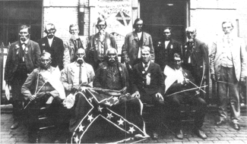
The majority of American Indians who fought in the War Between the States, joined the Confederate States of America against the Union largely because the Northern Federal Government could not be trusted, breaking every treaty they ever made and placing, themselves above their very own laws.
-20-
APPARITIONS AT THE CANNONBALL HOUSE
On the evening of November 9th, the 3rd annual Candlelight Apparitions at The Cannonball House was presented. This year's theme featured Macon's Hospitals during the War Between the States and utilized more than a 20 person cast, from the ranks of the 16th Georgia and the Cannonball House staff. (photos: Brenda Dobson)
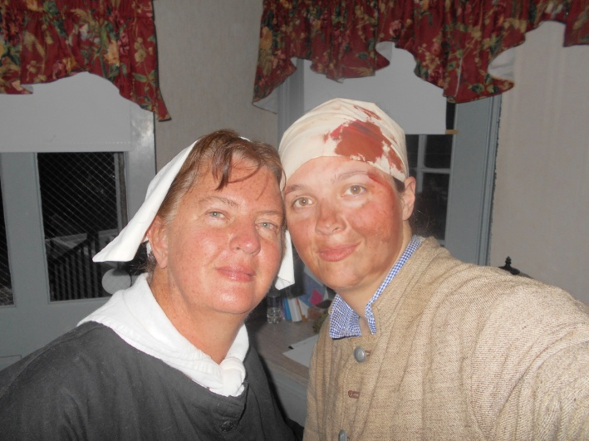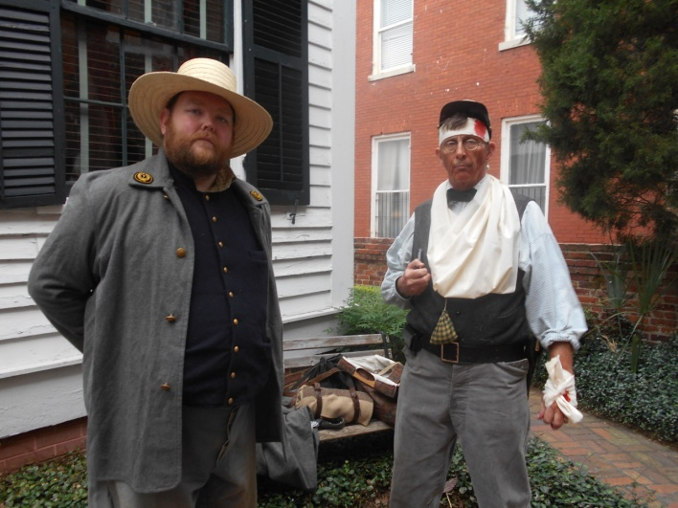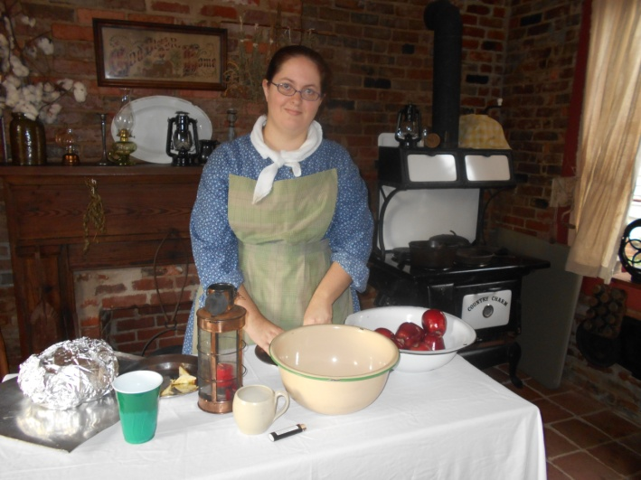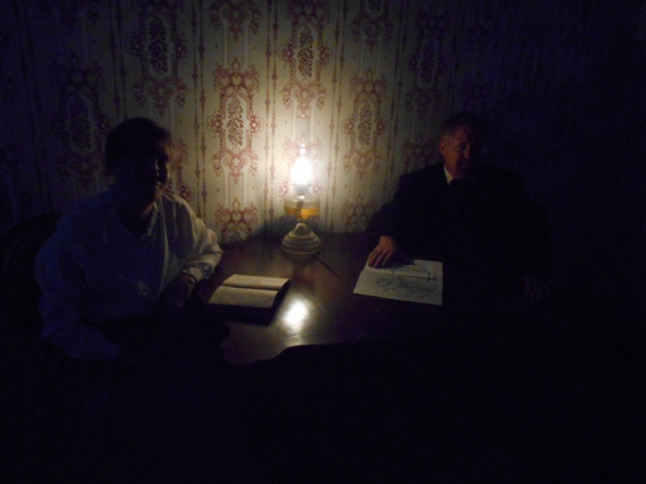
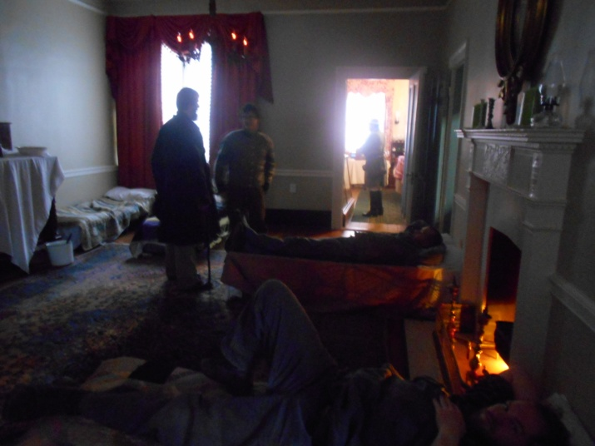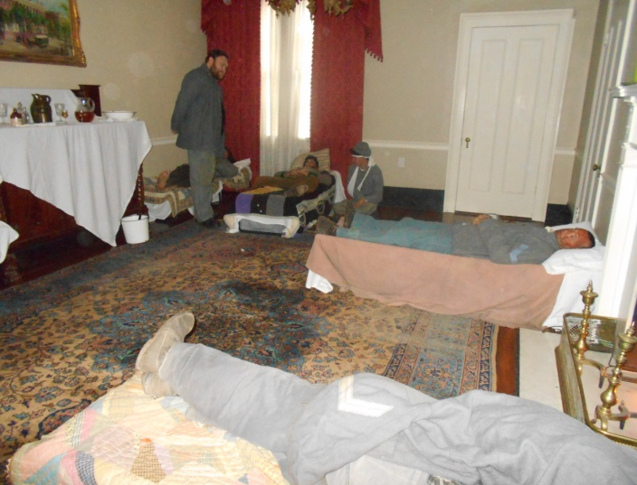

-21-

MORE APPARITIONS
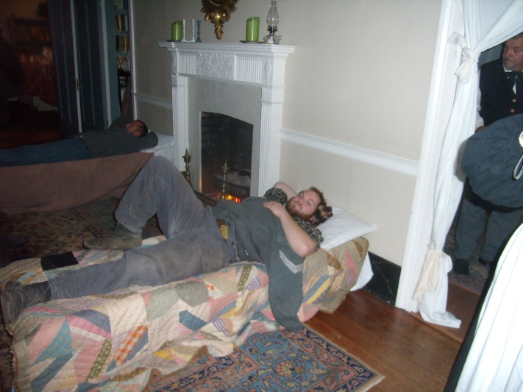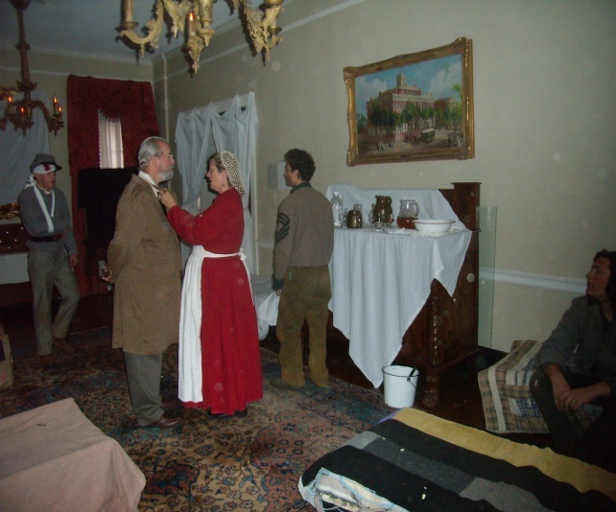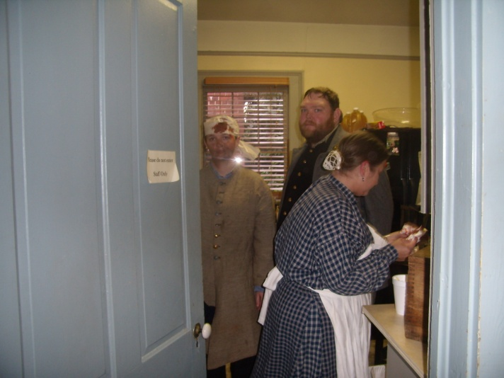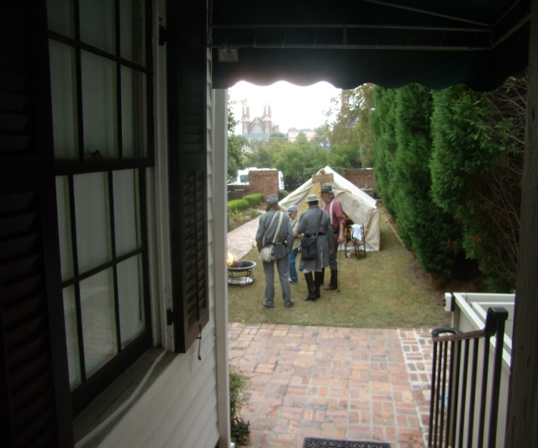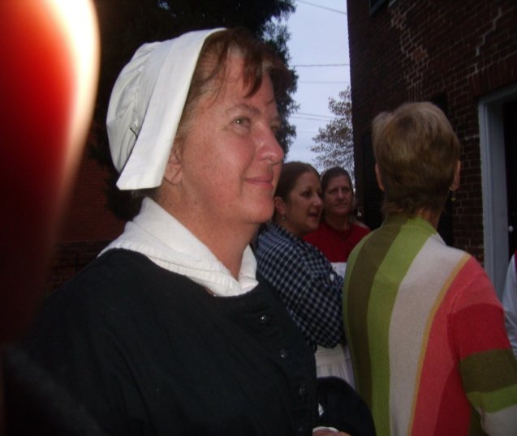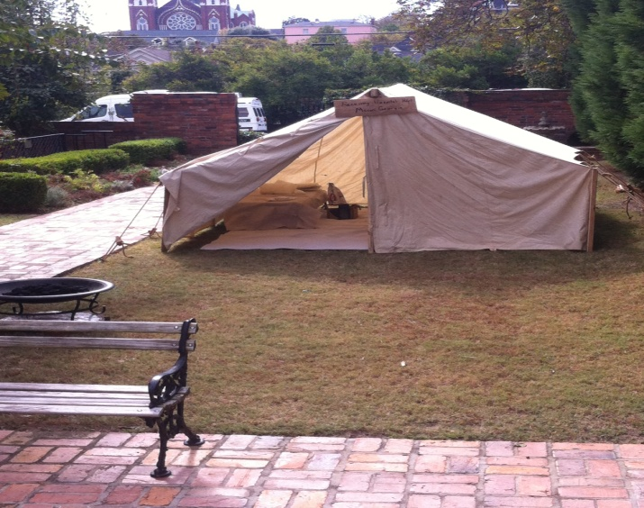
-22-

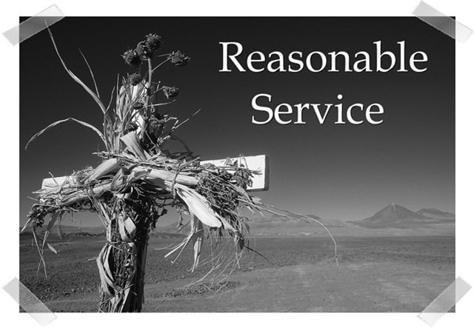
YOUR REASONABLE SERVICE
"I beseech you therefore, brethren, by the mercies of God, that ye present your bodies a living sacrifice, holy, acceptable unto God, which is your REASONABLE SERVICE." - Romans 12:1
Romans 12:1-2 is a familiar passage of scripture to anyone who has been around my home church, Macon Evangelistic, for any length of time. Pastor Gary Berrier quotes it often. However, these two verses say so much about our Christian walk that some of the individual words can get lost in the shuffle. Like "SERVICE" - the local church runs on it and there are many attractions that can siphon it off. It is fashionable, these days, to go to "Christian" weekend factional retreats" that extract enormous amounts of time and energy from the participants. Some contend that these resources of time and people rightfully belong to the local church and some congregations clearly suffer from this drain. I sure feel this way! Other pastimes such as sports and hobbies can have an equally devastating effect, including War Between the States re-enacting. In the early 90's the Lord asked me to take a personal inventory of my time. I pondered if I was I spending too much time in my beloved historical avocation? I rarely make vows or promises but I solemnly assured God that if He wanted me to stop or scale back my re-enacting lifestyle (not a hobby), I WOULD ! I meant it, too. Well, the first thing I knew God brought the re-enactment world to the front door of Macon E with the "Gettysburg
in Georgia" events of 1996 and 1998. There is modest doubt this was a ministry and perhaps one of the more effective outreaches we have ever undertaken. Although we have not seen tents and cannons on the doorstep of Macon E in a long time, Brenda and I are now able to help with the music ministry at the re-enactments I attend. It is not uncommon to see souls saved at every venue. Enough about me - let's get back to the local church - to Macon E, specifically. I have always said that I wanted my membership to be in a small, local church. How
-23-

small? Well, I do not want to go anywhere that I do not know everyone and everyone does not know me. I have family and friends who attend mega churches. I honestly believe they are actually in hiding there so as avoid their "REASONABLE SERVICE". That word, "reasonable" has been known to cause consternation for worshipers. Who decides what is "reasonable" for you? Does a pastor determine how and where you should serve; is it a consensus of the Board or is it solely a matter to be determined by you and God, alone? How much is enough "service" and just what amount is "reasonable"? I mean when you get saved, God calls you to serve. We have all heard the story of the man who made a list of things he was going to do in service for our Lord and God told him to scrap it and simply turn in a sheet of paper with his name at the top - God would make the list of what He wanted done. Often as not the typical Christian experience goes like this: a person gets saved and the Holy Spirit prevails upon him to regularly attend Sunday morning worship services; then God mentions that there are meetings on Sunday nights and Wednesday nights as well. Okay, the new Christian says, " I can do that". God now says, I expect tithes and offerings to which the obedient new convert agrees readily. Perhaps the pastor gets into the act and mentions that the grass needs cutting, the buildings need cleaning, a bit of plumbing and carpentry work here and there, we need a volunteer for this and one for that and after a time, you would be a great asset to the Board. Then one day you consider that you could have your mail forwarded to the church since you spend most of your time there. Nothing wrong with that - nothing wrong with burning out for the cause of Christ, but I believe God called us to shine on brightly, not burn out! I have known Christians to leave the church because they felt overwhelmed by having too many duties to perform. They began to loathe the services they performed - they got "weary in well doing." Appeals to the pastor fell on deaf ears until these gifted and valuable folks just left; quit altogether and went off to warm a pew among the congregation of a mega church somewhere (not Tony Evans, for sure). I once heard a young missionary candidate say, "Jesus Christ died to save sinners and we should, too; or at least die trying." So, what is "reasonable service". When is enough, enough? "There are three things that are never satisfied, yea, four things say not, It is enough: The grave; and the barren womb; the earth that is not filled with water; and the fire that saith not, It is enough." (Proverbs 30:15-16). Other than that, there never seems to be a limit as to what we can or should do for God. "Here, Lord, I give myself away, tis all that I can do." In an ideal congregation everyone would have a job and no one would be over burdened to the brink of failure, but what congregation is perfect? Even the prophet, Isaiah wondered what his "reasonable service" should be: "Then said I, Lord, how long? And HE answered, 'Until the cities be wasted without inhabitant, and the houses without man, and the land be utterly desolate, and the Lord have removed men far away, and there be a great forsaking in the midst of the land.'" (Isaiah 6:10-12).
ALL ON THE ALTER - TO GOD THAT IS REASONABLE SERVICE !
-24-

