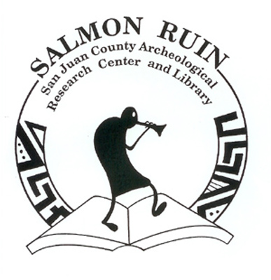
San Juan County Museum Association Membership Form

We hope you enjoyed your experience here at the Salmon Ruins Site, Museum, and Research Facility. We are proud to represent the San Juan County Museum Association, and we have many exciting plans and ideas to implement in the near future! We continue to celebrate many major accomplishments over the past years in our management, operation and preservation of Salmon Ruins and the other treasures of the Four Corners. There is always more to explore and do!

The San Juan County Museum Association manages and operates the Site, Museum, Research Center and Library here at Salmon Ruins. The Association is a non-profit organization dedicated to educating the public about the preservation of archaeological, historical, and cultural resources in the Four Corners area. Your support is essential to the work and success of our efforts to preserve the past for the future.

If you would be proud to be part of our team and our work, we invite you to join Salmon Ruins as a member!

I want to help support Salmon Ruins by becoming a member!

Your membership directly supports:

Stabilization of the Salmon Ruins
Preservation of the Salmon Homestead
Expansion of our research library and archives
Research and preservation of other local sites
Updating displays and developing new exhibits

Membership benefits include:

A 10% discount in our amazing gift shop
Free admission to the grounds and museum
Our newsletter, The Outlier
Discounted “Journey Into the Past” tours
Library privileges

Name:
Address: City: State:
Zip Code: Phone: Email:

Yearly Membership Categories

- Individual $15
- Family $25
- Business/Institution $50
- Patron $100

- Student $10
- Senior Citizen (60 and over) $10
- Senior Couple $20
- Non-Profit Organization $35
- Reciprocal (with another organization) $30
- One-Time Payment Lifetime Membership $ 500
- I am also including an additional tax-deductable gift of: $

Credit Card Information:
Credit Card Type: Account Number:
Expiration Date: Signature: Today’s Date:

- I want to get more involved and live nearby. Please let me know about volunteer opportunities!

If you have any other questions or comments, please call us at 505-632-2013.

Mail this form and your contribution to:
San Juan County Museum Association
P.O. Box 125
Bloomfield, NM 87413

Find us on the web: http://salmonruins.com/ Email: srmuseum@sisna.com
Be our Facebook friend, and share us with your friends: https://www.facebook.com/salmon.ruins

