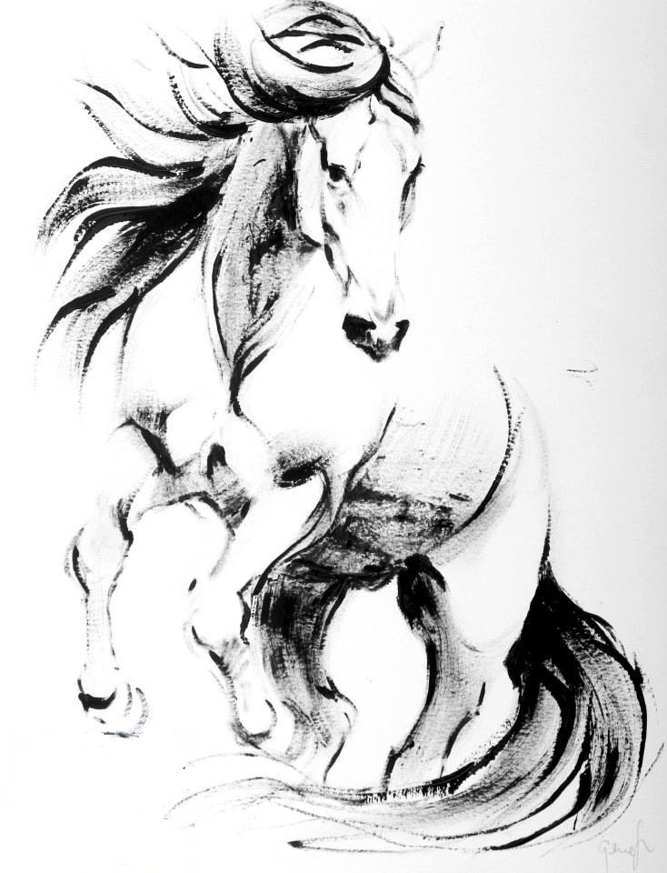
Transitions Equestrian Center
Lease Agreement

Lessee:  Name: Transitions Equestrian Center LLC.  Melissa Ashcraft  Address: 2525 E. 850 N. La Porte, In 46350  Email: Transitionshorses@gmail.com  Website: TransitionsEquestrianCenter.com  Phone # (219) 778 - 9592 | Lessor:  Name: _____________________________  Address:___________________________  ________________________________  Email:_____________________________  Phone #____________________________

This agreement is entered into by ____________________________ (Lessee)
and _____________________________ , Lessor is Transitions Equestrian Center.
Lessor warrants that he is the owner of the horse, ______________________ agrees to lease said horse to ___________________ and____________________________ (lessee) for the amount of $________ a month, subject to the following terms of this Agreement; and Whereas, Lessee warrants that she/he agrees to lease said horse subject to the following terms and conditions; The parties agree as follows:

- Term
The term of this lease shall commence on _____________, and terminate on __________________; unless the parties agree in writing to continue the term of this lease in which case the new term shall be attached hereto, signed and dated by both parties hereto, and these same terms and conditions shall apply thereto.
Lessee shall have the option to return the horse to Lessor prior to the end of the lease term, provided, however, all lease fees hereunder are fully paid up and current through the time the horse is returned to Lessor. Lessee agrees to pay for a full vet check before or directly after the lease is finished. Lessee also agrees that the horse was loaned to him/her in perfect condition or has been warned of any issues. If after the vet check if something is wrong with the horse the Lessee will take full financial responsibility to restore the horse back to its original condition. Lessee also understands that as the owner of the horse, the Lessor may cancel and end this lease at anytime she wishes for any reason.

2. Description.
The lease covers the horse described below:

Name: __________________________________________ Age:________ Gender: ________

Color: _____________________________ Breed:_____________ Reg No#:____________

Brands or Markings: _____________________________________________________________

_____________________________________________________________________________

Location: Transitions Equestrian Center
2525 E. 850 N. La Porte, In 46350

3. Lease Payment Fees:
Lessor to lease horse to _______________________ with the understanding and agreement to the following conditions and rules:
Lessor will pay for:
• Normal annual shots ( such as west nile, rhino etc.)
• Teeth floating

Lessee will pay for:
• Monthly or weekly Lease payment of $____________
• Lease is for the following months ____________________________________
• Lease payments will be paid by the 1st of every month
• Shoes and other Farrier work – trims, shoes, pads etc.
• Costs for back, neck and hip adjustments with Lessor every three months or as needed
• Coggins, BEFORE THE HORSE IS ALLOWED TO LEAVE CURRENT STABLEING FACILITY
• Any or all transportation costs
• Any or all horse show fees or costs
• If horse is being boarded, ridden on trail, clinic or show lessee or ridden while Lessor is not present Lessee agrees to pay for any or all vet and medical needs horse may need such as leg injuries, any cuts, scrapes medicine etc.

I __________________________ as the Lessee have understand that the Lessor is responsible for all natural injures and conditions while being used by the lessee. I as the Lessee am accountable for all unnatural injuries and medical issues, that may accrue while I am personally using the said horse and agree to all cost agreement above.

Lessee: ___________________________________ Date: _________________

Lessor: ___________________________________ Date: _________________

4. Limitations and Use of Horse
Lessee covenants, warrants, and agrees NOT to use the horse for any purpose other than those set forth below:

• Lessee agrees besides monitored lessons, NO ONE but the Lessee and the following names are allowed to ride or handle the said horse _____________________ ,_____________________.

5. Special Rights of Lessee __________________________________________________________________________________________

____________________________________________________________________________ _____________

- Feed and Facilities/Instructions for Care.
Lessee agrees to follow all usual and customary practices for care of horse.

7. Transportation
Lessee shall assume all transportation costs relating to the leasing of said horse hereunder. In the event Lessee shall assume the responsibility and custody the transportation of said horse she shall provide all usual and customary care in transportation of said horse including, but not limited to the following special instructions:

8. Ownership Registration
Lessor warrants that she has good and clear title to said horse free from any liens or encumbrances. The animal included in this lease shall remain the sole property of lessor, and the lessee shall have no right, title, or loan to any other party of said animal except as stated here.

9. Covenant Not to Encumber
Lessee agrees not to encumber said horse with any lien, charge, related claim and to hold Lessor harmless there from.

10. Risk of Loss and Insurance
A. Lessee assumes risk of loss or injury to said horse, except to the extent caused by an act of Lessor’s agent, contractors, or employees. The lessor shall not be held responsible for loss, damage, injury, claim, demand, cost and expense (including legal expense) arising out of or connected with the use, stabling or actions for the leased animal whether under control and supervision of the lessee or not. The lessor will not be responsible for any accident or injury to any person or animal that comes in contact with the above named animal, during the term of this lease.
B. Lessee has been advised on equine insurance and will make the decision of obtained insurance at their own risk. If you chose to obtain insurance at her/his own expense maintain in full force and effect during the term of this Lease policy or policies of mortality and loss of use insurance written by an insurance carrier acceptable to Lessor. A binder of said insurance shall be provided to Lessor prior to Lessee taking delivery of the horse; and, a copy of the said policy must be mailed, registered mail, to Lessor within a month of Lessee’s taking delivery of the horse. If for any reason said animal must be put down, the lessor shall accept the insurance as adequate compensation and hold no further claims against the lessee. In the above situation proper Veterinary care must be utilized and the lessor must be notified immediately.
- The liability under said policy shall be no less than $ 2,000.00 payable to Lessor as sole beneficiary.

11. Options
A. Lessee does have the option to renew this Lease for an additional _______ months if a request is made in writing 30 days prior to the expiration of the term of this Lease, however, the horse is available for Lease.
B. Any such exercise of option, if any, shall be confirmed in writing by the parties hereto and dated, and attached hereto. Any option period term shall have the terms and conditions and agreements herein are hereby included by reference as part of said option set forth therein in attachment.
C. In the event Lessor places the horse up for sale, Lessee shall have the right of first refusal to purchase said horse within 1 month of the expiration of said Lease for a price not to exceed $_________.
During said 1 month period Lessee shall be fully bound by all terms and conditions of this Lease.

12. Default
Upon material breach of this agreement by one party, the other party may terminate same; provided, however, notice of said material breach is sent certified mail to the party in breach setting forth said breach.
Upon material breach of this agreement, Lessor reserves the right to remove such horse without incurring any additional responsibility to Lessee. Lessee shall be responsible to pay Lessor any reasonable costs incurred in removing such horse and such costs shall be due and payable to Lessor by Lessee hereunder. In the case of a default by one party, the other party shall have the right to recover mediation, arbitration, attorney fees and costs incurred as a result of said default.

13. Assignment or Transfer
This Agreement shall not be assigned or transferred by either party hereto without the prior written consent of the other party. Any such assignment or transfer shall be set forth in writing, dated, and signed by both parties.

14. Captions and Headings
Any captions or headings used in this Agreement are for descriptive purposes only and are not to be considered terms of this Agreement.

15. Agreement
This Agreement constitutes the entire Agreement between the parties. Any modifications or additions must be in writing and signed by all parties to this Agreement. No oral modifications will be considered part of this agreement unless reduced to writing and signed by all parties before a notary.

16. Law
This Agreement shall be governed by the laws of Indiana.
Any legal action must be brought in the county of United States, provided however, the parties agree to required Mediation and Arbitration of any disputes relating to this transaction.

Signed this ______ day of ___________, 20_____  Lessee: _________________________________ | Signed this ______ day of ________________, 20_____  Lessor:_______________________________________

