

**Welcome to the Imagine Academy Program!**

Here are some simple steps to help you access the many program benefits included with your membership. Below you will find brief descriptions and instructions to help you to get started with your curriculum resources immediately.

**Create a Microsoft Account:**

If you do not have a Microsoft account or Office 365 organizational account, go to <https://signup.live.com> and complete the fields to create your account with an existing email address, or by creating a new email address. **Important: Do not use your work/school email address to create a Microsoft account.** Please use a personal email address or create a new @outlook.com address.

**Sign into Imagine Academy Member Site:**

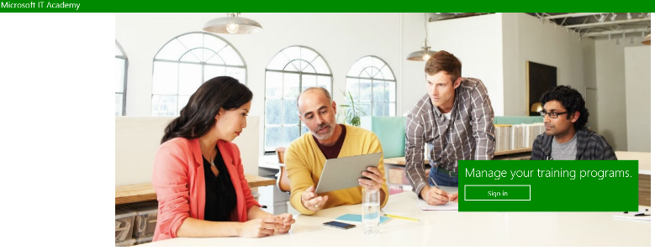

* Go to <https://member.imagineacademy.microsoft.com/>
* Click **Sign in**
* Select the appropriate Sign-in option – Work or School (same as Office 365) or Personal (same as Microsoft account)
* Enter your User name and password and click **Sign in**

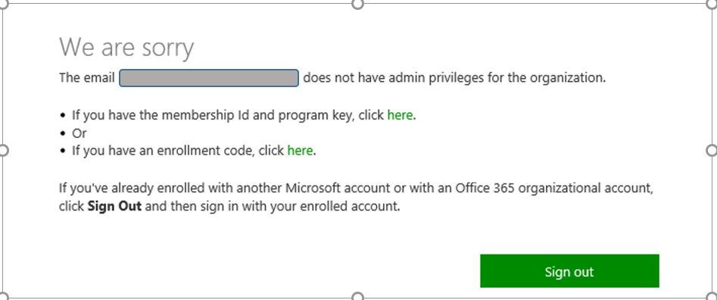

* Click **“here”** to enter your id and key; then copy and paste your keys into the fields and **submit**

**Note** – the Member ID and program key are unique to each school and can be shared among staff to gain access to the curriculum resources and program benefits. **Important** - The Member ID and program key should ***never*** be given to students.

Welcome to the Imagine Academy Member Site! From here you will be able to access and review your curriculum resources, download and print posters and marketing materials, and learn more about your benefits.

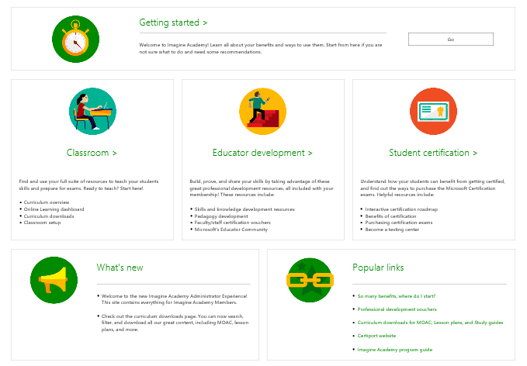

Review curriculum options

The Imagine Academy has many curriculum resources allowing you the freedom to choose the solution that best fits your needs. We recommend **starting with just one** of the resources and then adding in others as you get comfortable. Here are a few sample recommendations:

* Classroom / Instructor-led (Microsoft Office or MTA): Use MOAC, **or** Lesson Plans + Online Learning
* Independent Study / Professional Dev. / Workforce Dev. / Library: Use MOS Study Guides + Online Learning

**Note** – Materials vary based on program of study and language.

# Curriculum Resources

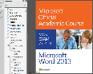 MOACis a comprehensive digital textbook solution that prepares learners for Microsoft Office (MOS) and Microsoft Technology Associate (MTA) certifications. MOAC includes a full e-Book, plus instructor resources such as projects, test banks, solution files, instructor guides and presentations. The new 2016 Office courses are now available in a OneNote version as well as the PDF. **Teacher Pick**

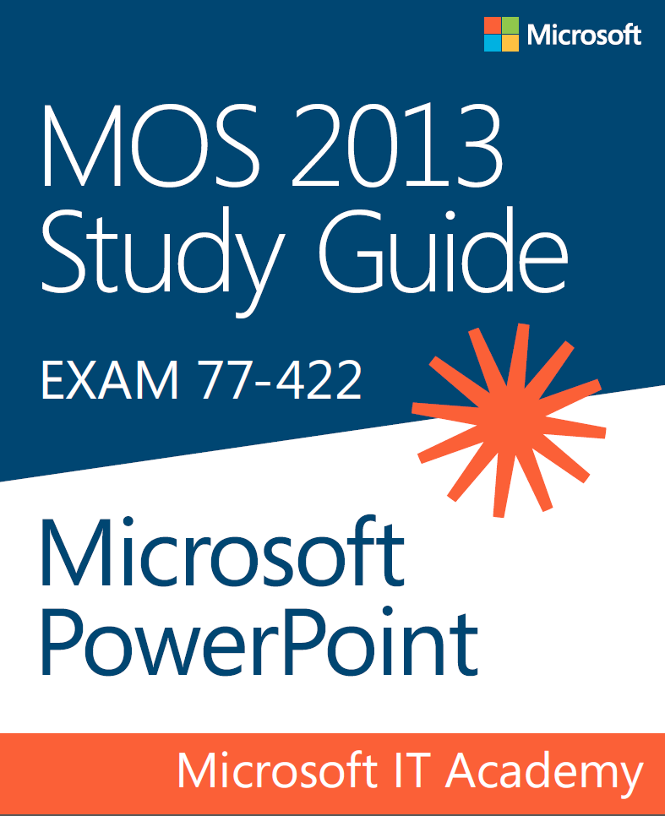 MOS Study Guides provide a digital book and practice files for Microsoft Office Specialist exam preparation. The study guides are designed for independent study and do not include solution files or instructor resources. These are a great resource for virtual learning, professional development and for students studying independently for exams.

Lesson Plans offer an alternative curriculum solution to MOAC or Study Guides. Lesson plans map to Common Core standards and provide customizable classroom guides for teaching on the particular programs. Lesson plans are available in multiple languages, and include student projects and instructor resources and are best used in conjunction with Online Learning.

* 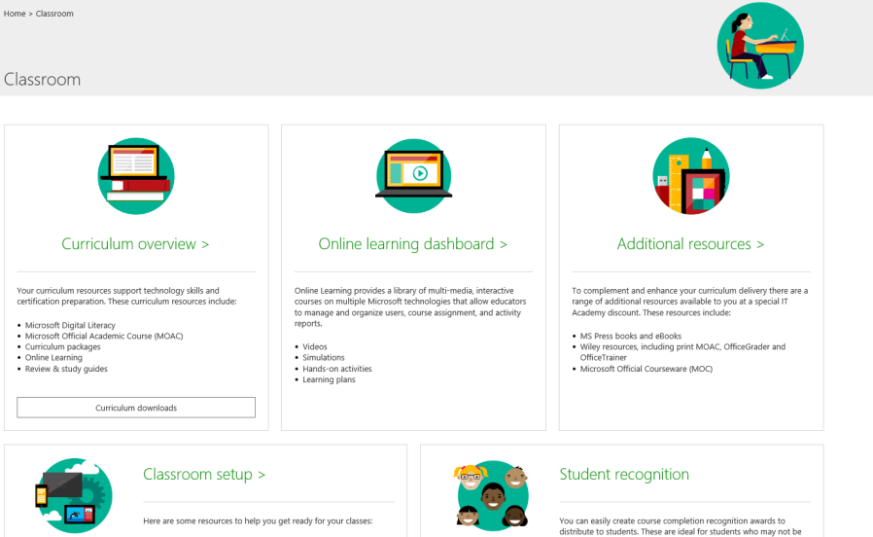**Steps to access the MOAC, Lesson Plans and MOS Study Guides:**
  1. From the Member site home page, click **Classroom**
  2. Click **Curriculum downloads** in the Curriculum Overview section
  3. Use the search filters to find your selected curriculum
  4. Download materials

**Note:** For MOAC be sure to download the **e-book* (student textbook)** and the **instructor resources (full curriculum kit),** then make the e-book and the Data Files available to your students in a secure location. *For 2016, the OneNote folder contains both the PDF and OneNote versions of the e-book.

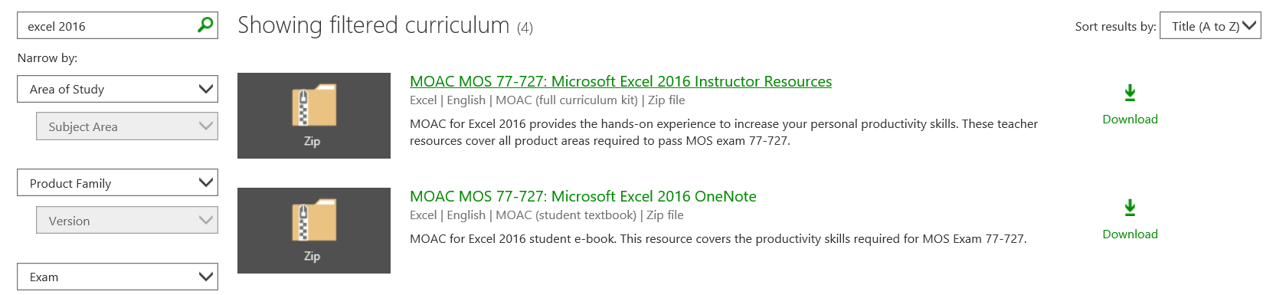

 Online Learning provides over 250 multi-media, interactive courses that work anywhere with broadband access. Online Learning is an ideal tool for self-paced learning and professional development and/or can be used for independent study or supplemental coursework for students.

* **Steps to access Online Learning:**

1. From the Member site home page, click **Classroom**
2. Click **Online learning dashboard**
3. From here you can manage your online learning courses, assign Learning Plans, invite users, view reports and more
4. View the [online learning video series](https://www.youtube.com/watch?v=G9HvsWa8nTw.) for help getting started

**Important Note**- Students will need a Microsoft account or Office 365 account to access the Online Learning.

Digital Literacy is a great place to start! Whether you are new to computing or have some experience, Digital Literacy helps develop a fundamental understanding of technology. The courses teach and assess basic computer concepts and skills ranging from mouse and keyboard to building your first app. The resources include Online Learning courses for self-paced study, and educator resources to facilitate a blended instructor-led classroom experience. Digital Literacy includes a certificate test. There are two ways to assign Digital Literacy – either directly or through the Imagine Academy Online learning portal.

* **Steps to access Digital Literacy**

1. To access Digital Literacy directly - visit <http://www.microsoft.com/digitalliteracy> (recommend Version IV for latest content)
2. To assign through the Online learning – go to the Member site home page, click **Classroom,** then **Curriculum Overview** and scroll down to Digital Literacy to download instructor resources
3. Assign the courses through the Online Learning *(see Online Learning steps above)*

Computer Science Microsoft Imagine Academy now includes Computer Science curriculum! Offerings range from one hour building blocks to semester and year-long courses. Here are two samples of what’s available, but follow the **Steps to access** below to see a full list of resources. There are also search features to help filter results and topics in **the Curriculum downloads** and **Online learning** pages.

**Creative Coding through Games and Apps (CCGA)** is a semester-long introduction to programming course that maps to CSTA standards. Students gain hands-on experience designing, programming and publishing mobile games and apps. Includes full course materials. Click here for a brief [CCGA Overview](http://aka.ms/creativecodingeval).

**CS50 AP** is a Harvard-inspired, challenging journey that prepares students for the AP CS Principles exam. Content covers programming as well as real-world problem solving and algorithm building. The units are released on a rolling basis and are available through the CS50 AP Wiki: [http://cs50.wiki/This+is+CS50+AP](https://na01.safelinks.protection.outlook.com/?url=http%3a%2f%2fcs50.wiki%2fThis%2bis%2bCS50%2bAP&data=01%7c01%7cnacho%40microsoft.com%7c15fb9c9cd0aa4bd27cf508d31ab0d86c%7c72f988bf86f141af91ab2d7cd011db47%7c1&sdata=urzXyyeIbATu%2f3tBKlsKSFE4wahN68CmXJqBY07121k%3d).

* **Steps to access Computer Science Resources**

1. From the [Member site](https://member.imagineacademy.microsoft.com/) home page, click **Explore New Learning Paths**
2. Click **Computer Science** and expand titles to see descriptions and resources available

# **Next Steps**

* Take the Introduction to Microsoft Imagine Academy course and earn a badge plus points toward becoming a Microsoft Innovative Educator: <https://education.microsoft.com/GetTrained/msia> (the full course should only take between 15-30 minutes)
* View the brief tutorial videos linked below to get a sense of the program benefits and site navigation
* Update and prepare your labs - share the **IT Director Guide** with your IT Staff (document is located on the **Member site** in the **Getting Started** tab under **Review IT Requirements**)
* Plan your course:
* Select your exam
* Select your primary curriculum (see sample recommendations above)
* Supplement with additional resources if or as needed

**Note:** for core Office exams, you can view a list of resources for each exam objective in the **Exam Resource Mapping** document (available in the **Getting started resources** link below)

* **Get Certified!** To request one of your free Microsoft (MOS), Microsoft Technology Associate (MTA), or Microsoft Certified Educator (MCE) professional development exam vouchers, follow these steps:
* Click **Educator development** on the Member site home page
* Click **Request your voucher** next to the exam you wish to take
* Click **Take exam at any Certiport testing center** and you will be taken to the Certiport site
* Complete the Certiport form and click **Submit**
* Promote program value to students, school administrators and parents (Go to **Marketing** page in the **Member site** for posters and flyers)
* Contact Customer Support with questions

# **Resources**

**Customer Support**

For help with program benefits, contact customer support at 1-800-508-8454 or [acadsupp@microsoft.com](mailto:acadsupp@microsoft.com). Customer support hours are 8:30am ‑ 8:30pm EST / 5:30am – 5:30pm PST.

**Imagine Academy Member Site:** <https://member.imagineacademy.microsoft.com/>

**Imagine Academy Get Started Videos (full view):** <http://aka.ms/Aue3bf>

**Introduction to Microsoft Imagine Academy course:** <https://education.microsoft.com/GetTrained/msia>

**Direct links to videos:**

1. [What Is Microsoft Imagine Academy](https://www.youtube.com/watch?v=i73LDxuPunA)
2. [Empower your students with Imagine Academy](https://www.youtube.com/watch?v=rIzHCmsByZY&index=2&list=PL5HofQtu_3wyT4mvXMBJ6223XLvEDxn0Q)
3. [Imagine Academy – Online Learning Intro](https://www.youtube.com/watch?v=G9HvsWa8nTw)
4. [Imagine Academy – Managing Users](https://www.youtube.com/watch?v=-7Tbh_jKduE)
5. [Imagine Academy – Managing Groups](https://www.youtube.com/watch?v=CNOjGHGNQ_E)
6. [Imagine Academy – Learning Plans](https://www.youtube.com/watch?v=PURkXeqJI3E)

**Facebook:** <http://aka.ms/imagineacademyfb>

**Twitter:** <http://aka.ms/imagineacademytw>

**Getting started resources:**

<https://onedrive.live.com/redir?resid=855CA41E93B3DBB7!132&authkey=!ADMQV9d6s-vp3Kc&ithint=folder%2cone>

Use this link for get started guides, Imagine Academy presentations, resource mapping, and other helpful program information.

*Last modified April 17, 2017*