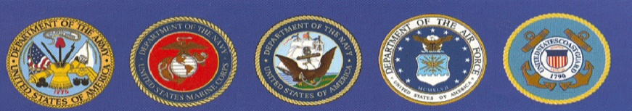
EBBETTS PASS VETERANS MEMORIAL DISTRICT
“Honoring Those Who Have Served”
P.O. Box 175, Murphys, CA 95247

MINUTES
REGULAR BOARD MEETING
October 4, 2022

CALL TO ODER: 7:00 by Redman
Directors Present: Redman, Carlon, Palmer, Padou
Employees/Guests Present: Rocco, Yeadon, Fischer
APPROVAL OF MINUTES of the Regular Board Meeting of September 6, 2022. Padou motioned to approve the minutes as submitted. 2nd by Palmer. Board Approved.

PUBLIC COMMENTS: 0
CORRESPONDENC:0

OLD SCHOOL HOUSE: 0

MEMORIALS: Currently 1,255 bricks on the walls. Room for 174 more.

CARETAKER REPORT BY YEADON: Regular maintenance

VETERAN’S DAY CEREMONY: Deb updated board on progress of confirmation of event details.

COMMUNITY EVENTS INVOLVEMENT: Michelson School Veteran’s Flag Ceremony. 11/10 @ 8:15 am.

FINANCIAL / BUDGET By Megan Fischer: Revised budget sent by county to be signed. Padou motioned to approve the revised budget. 2nd by Carlon. Board Approved.

OPEN FORUM led by Board Chairman: Elliott’s vacancy on the board to be posted in 3 places in the community. Any new board members terms will start December 2.

ADJOURN PUBLIC MEETING: 7:27 by Redman

The next meeting is scheduled for November 1, 2022 @ 7 pm @ EPVMD Hall.

