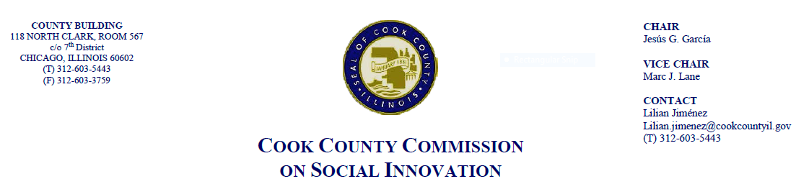July 19, 2018, 4 P.M.
69 W. Washington, 22nd Floor Conf. Rm. B
MINUTES

- Call to Order

The Cook County Commission on Social Innovation convened via an in-person meeting to discuss committee updates and hear from a guest speaker. The meeting was chaired by Chairman Garcia. The meeting was open to the public and took place from 4:12 p.m. to 5:25 p.m.

Commission Members Present:
- Chair García
- Vice Chair Marc Lane
- Carrie Thomas
- Wendy Raymer
- Jay Stewart
- Valerie Leonard
- Christyn Henson
- John Yonan
- Marc Loveless
Commission Staff Present:
- Victoria Moreno
- Alma Anaya
- Aneesa Patwary
Public Speakers:
- Mark Armstrong from the Chicago Urban Fine Arts Community voiced concerns about a construction company in his neighborhood that isn’t hiring from the local community.
- Mark Kramer, a recently retired high school principal, wants training for unemployed and underemployed within the South Suburbs to ensure better lives.

Meeting Notes and Decisions Made:
- Approval of the Minutes
  - Because the Commission did not have quorum, the minutes from the last meeting were not approved.
- Guest Speaker: David Robinson, “A New Industrial Policy Discussion for Cook County: Inclusion and Industry 4.0”
  - We should care about industrial policy because global competitors are already moving in this direction (ex. Germans, Chinese, Basque Country)
  - Manufacturing is important because only sector that can build middle class and reduce poverty. It builds social capital and a strong base and is the only sector that can solve the environmental crisis.
  - Growing crisis in our communities: lower life expectancy for black men on the south side as well as 37% not working or in school. Shooting and murders highest in decades
  - Dated industrial policy: blind faith in the private sector and weak governments that "got out of the way". Manufacturing impacted by short term thinking
  - Another challenge is the skills gap. Cannot afford to move off-shore or sacrifice time and money to establish expensive training programs. Have to rely on the quality of local education and local government to provide the first tier of advanced skills training.
  - Inclusion and Industry 4.0 includes recognizing the essential role of manufacturing in planning rubric, closing the succession gap, willingness to embrace new technology, and government doing a better job.
    - Young people, older youth, returning citizens, vets of color can secure solid middle class careers; Significant tax revenues; Supports all sectors; Model for rebuilding communities; Can help reduce symptoms of poverty like violence
  - What can the County do? It can recommend that the full County Board take this idea up for discussion and debate, introduce resolution supporting the concept of socially inclusive industrial planning policy and supporting HB5062 and help change “manufacturing is dead” narrative
Post Presentation Discussion
- Comm. Leonard: How can we include the community in the comprehensive planning process? There are more than 130 manufacturing partners that they work and encourage them to work with community partners. Local officials must be more aggressive.
- Chair Garcia: City colleges and workforce development are a small step towards something like this. Vice Chair Lane: Building blocks to get where we should go; real demand on elected leaders to move resources to support to and grow local programs whether they be apprenticeships and local leadership programs within high schools to change narrative that public service is cool.
- Comm. Henson: Consideration should be before high school. Start not with the educators but the youth. Comm. Thomas: not focusing on just one part of college and job training, but all of it. Reiterated idea of starting earlier; trainer community not limited to just CBS.
- Vice Chair Lane: Comm. Loveless and Comm. Thomas will work with Comm. Dickson to spearhead David Robinson’s vision for the commission’s eventual consideration.
- Committee Updates
  - Vice Chair Lane – Dropbox and contributing more substantively
  - Presentation of draft resolution on worker cooperatives, will be meeting with Jay Stewart soon. Comm. Raymer - encourage everyone to come to next commission meeting because will have resolution on worker cooperatives, will be meeting with Jay Stewart.
  - Comm. Kim on Human Capital Committee - rubric for inclusive employment. Comm. Thomas: tool to evaluate inclusive employment policies. There was a meeting where they narrowed extensive questions they decided were priority. Requested feedback by 7/31.
  - Comm. Leonard – working on Chief Equity Officer which would work with Commission and Executive/Legislative branch. Mentioned an intern in charge of looking at other government units throughout the U.S. and globally, anticipating feedback from private interest
  - Comm. Yonan – Metra made service cuts, committee made mobility study in South Suburbs. Comm. Henson – Is there room to push transportation as an entrepreneurial venture and not just a government initiative? Comm. Yonan: Bedford Park is not easily serviced
- Adjourn
  - Meeting was adjourned at 5:25pm.

