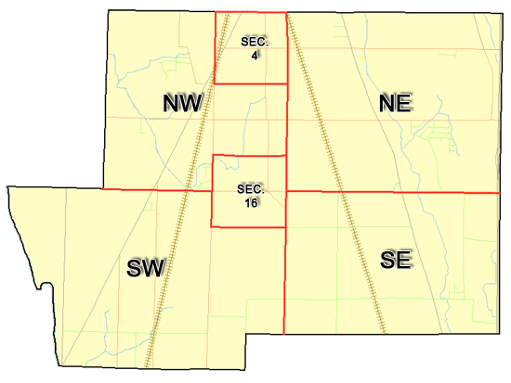 | Pleasant Township  Zoning Commission Minutes  1035 Owens Rd W.  Marion, Ohio 43302
Meeting called by: | Scheduled | Type of meeting: | Regular Monthly
Chairperson: | Mr. Holler | Secretary: | Stephanie Barkley
Timekeeper: |  | Date: June 15th,2023 | Time 7:30 pm
Call to Order by: | Mr. Holler Moment of silence followed by the pledge to the flag.
Roll Call: | Jack Dean, Harry Holler, Tom Leib, Dwight Williams, Joe Thompson, Tyron Canterbury  Stephanie Barkley
Minutes: | Read and approve minutes from previous meeting.  Motion to approve minutes by: Mr. Williams Seconded by Mr. Leib: All approved
Attendees Address Board: Have sign in sheet on desk by door.
Type in attendees and addresses: see attached.
.
----- Agenda Topics -----
Business
Zoning Reports: | Zoning Inspector goes over reports and provides copy to board.
Unfinished:
New:
Announcements: | Next meeting will be July 20th ,2023
Adjournment: | Motion to adjourn by: Mr. Williams and seconded by Mr. Canterbury all in favor all approved

Pleasant Township
Zoning Commission Minutes

1035 Owens Rd W.
Marion, Ohio 43302
Business Notes:

 | Discussion:
 | Conclusions:
 | Action items: |  | Minutes signed by: | Date approved:
 | Provide copy of approved minutes to Zoning |  | Chairperson:
 | Inspector. File original in township office. |  | Secretary:
Other Information
Trustees Present: |  | Mr. Creasap
Zoning Inspector: |  | Mr. Baker
Special Guests:

Minutes
The Pleasant Township Zoning Commission met for their regularly scheduled monthly meeting June 15th ,2023 at the Pleasant Township Senior Centre Zoning Commission Board Members were present: Mr. Dean, Mr. Leib, Mr. Thompson, Mr. Williams, Mr. Canterbury and Mr. Holler, and Secretary Miss Barkley and trustee Mr. Creasap, zoning inspector Mr. Baker.
- Minutes were read from the May 18th^{h},2023 regularly scheduled Zoning Commission meeting. There were no corrections to be made. A motion to approve the minutes was made by Mr. Leib and second by Mr. Thompson motion carried.
- Mr. Tom Baker Pleasant Township Zoning Inspector present the report for May. There were 7 permits. After discussion with some of the with ongoing issues with township Mr. Holler made a recommendation to ask Mr. David Stamolis from the prosecutor’s office to come to the next meeting to discuss some ongoing questions that we have for him to answer. The zoning board made a list of questions to have Mr. Stamolis answer. Mr. Holler is going to forward on the questions to Mr. Stamolis to have answers available during our next meeting.
4. There being no additional business for discussion Mr. Williams made motion to adjourn, seconded by Mr. Thompson and all Members in attendance agreed and the meeting was adjourned. The next Board Meeting will be held on July 20th ,2023 at 7:30 PM.

