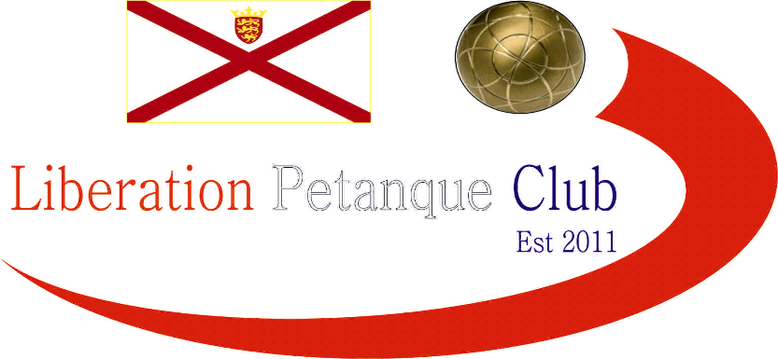

# C:\Users\tjame\AppData\Local\Microsoft\Windows\INetCacheContent.Word\FullSizeRender (6).jpgC:\Users\tjame\AppData\Local\Microsoft\Windows\INetCacheContent.Word\FullSizeRender (6).jpgWinter 2016-2017 Season

# Week 5

# 3rd December 2016

# Christmas Doubles Open

# In Aid of

# Jersey Childrens Charity

# [http://nebula.wsimg.com/854312a56bc5deae43e500746c50787f?AccessKeyId=C6E923731F1A482DD910&disposition=0&alloworigin=1](http://www.jerseychildren.co.uk/)

# Sponsored By Sponsored By

# 

# Liberations 2nd Charity tournament of the year played this time at Millbrook Park with the Winter weather easing up for a beautiful sunny day. 15 teams took park playing in groups of 5 and therefore 4 matches each.

# Organiser Callum with regular doubles partner Andrew and favourites to win the competition lost 3 out of the 4 matches in the first half of the day.

# Brian Harris & Paul Le Moine were one of three teams to win all four matches including handing out a fanny certificate to Chris & Jake Romeril 13 – 0 one of Jersey’s top doubles teams!

# Ross Payne playing with Mike Fennel also won all four, which included a 13 – 4 win over Stephen Leathem & Matthew Scholefield to win the group. Stephen & Matthew had earlier handed out a certificate to Andy & Lorna Limbrick 13 – 0. Matt Pinel & Richard Nevitt won Group A also with four wins.

# Teams were then split into the main and the plate competition.

# The plate saw a midday recovery for Callum & Andrew who beat Andy & Lorna Limbrick 13 – 10 in the final.

# The main competition saw Brian & Paul, Ross & Mike, Matt & Richard and James & Geoffroy move through to the semi finals.

# Semi Finals

# Ross & Mike 9 v 13 Matt & Richard

# Brian & Paul 5 v 13 James & Geoffroy

# 3rd Place went to Brian and Paul beat Ross & Mike 13 – 3.

# The final was a close affair but yet again Geoffroy was on the losing team in a final as missed chances by James & Geoffroy saw Matt Pinel & Richard Nevitt win the competition 13 – 11.

# Well Done to everyone taking part raising money for a great charity Jersey Childrens Charity.

[](http://www.jerseychildren.co.uk/)

***NEXT WEEK***

**Singles League - Premier League - 10.00am**

* **Division 1 - 11.00am**

**WEBSITE** [**www.liberationpetanque.co.uk**](http://www.liberationpetanque.co.uk)

**EMAIL** [**liberationpc@gmail.com**](mailto:liberationpc@gmail.com)

**Kind Regards**

**Report Editor**

**Liberation Petanque Club**

# CLUB SPONSORED BY

# http://nebula.wsimg.com/135a1bd6338e1b589a50cdec98bd84d1?AccessKeyId=C6E923731F1A482DD910&disposition=0&alloworigin=1