

# Winter 2017-2018 Season

# Week 8

# 30th December 2017

# Doubles League

# 

# Well a first for Liberation Petanque Club playing in between Christmas and New Year. Just 5 matches played though, four in the Premier League and one in Division 1.

# League leaders and current champions Jake & Ross took on Brigitte & Alice who were just 2 points behind but with 2 matches in hand, so had a good chance to move into contention with a win. The real question though, was Ross going to rediscover some form to help himself and Jake to the win. According to Super 6 responses a win was the likely outcome.

# 

# It was however a close affair with Brigitte & Alice taking the first game 13 – 12. But the champions came back to gain a valuable draw.

# Joint favourites for the title though are now Andrew & Callum and James & Geoffroy, both on 4 points from two matches prior to today.

# Andrew & Callum took on Cassie & Alex who had beaten Toby & Matt in the previous fixture to also move them to four points from two matches. Could Cassie & Alex gain another big scalp? Again Super 6 responses gave no chance of a Cassie & Alex win.

# 

# How wrong was everyone, as they took their second big scalp of the season with a fine win to move them into contention for the title.

# James & Geoffroy played Keith & Sue who had just one point from two matches having lost to Colin & Steve in their last match and now look relegation candidates. Anything but a win for James & Geoffroy would result in a lot of unhappy Super 6 players as everyone predicated a win.

# 

# James & Geoffroy though did not disappoint as Keith & Sue scored just 12 points losing 13 – 5, 13 – 7.

# James & Geoffroy then took advantage in the title race as they won a catch up match against Alex & Cassie to move three points clear at the top of the table.

# Toby and Matt sitting third despite some poor performances needed to beat Alan & Craig to regain any hopes of a title win. Alan & Craig lost their only matches played to date to Ross & Jake, but it was close. Anything but a win for Toby & Matt would result in a lot of unhappy Super 6 players despite the quality of the opposition.

# 

# Alan & Craig built in big lead in the first game before being pegged back, but they eventually took the first game. Toby & Matt though don’t give up easily as they won the second game comfortably.

# The only division 1 match played was between title rivals Matt & David and Brian & Paul. This was going to be a close affair with Super 6 confirming those suspicions. However Matt and a resurgent David Ibitson won easily 13 – 5, 13 – 6 to keep their 100% record.

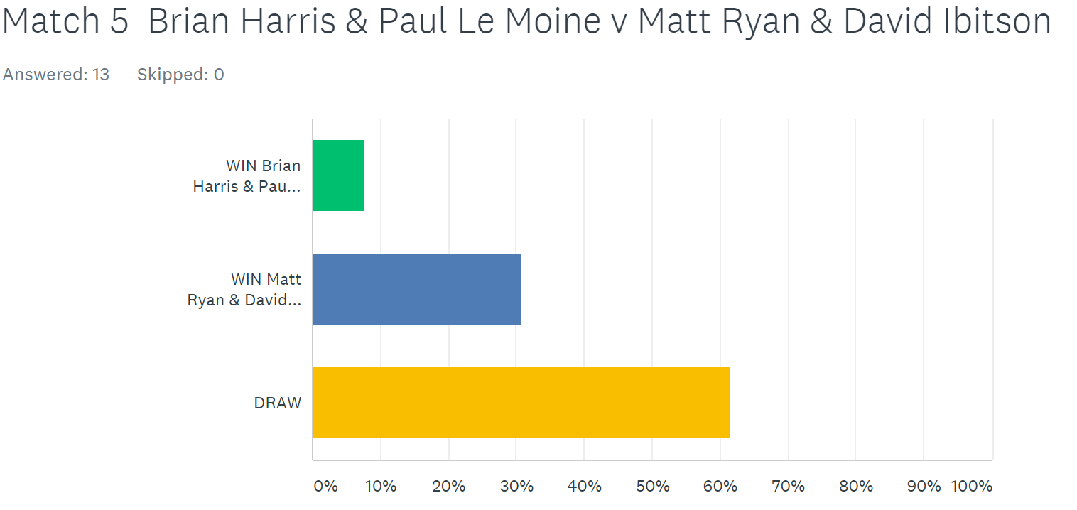

HAPPY NEW YEAR TO EVERYONE

BEST WISHES TO YOU AND YOUR FAMILIES IN 2018

***COMING UP***

Inaugural Super Sevens Cup - Saturday January 27th

***NEXT WEEK***

**Singles League – DOUBLE FIXTURE WEEK for Premier League Only**

**WEBSITE** [**www.liberationpetanque.co.uk**](http://www.liberationpetanque.co.uk)

**EMAIL** [**liberationpc@gmail.com**](mailto:liberationpc@gmail.com)

**Kind Regards**

**Report Editor**

**Toby Northern**

**Liberation Petanque Club**

# SPONSORED BY

# http://nebula.wsimg.com/135a1bd6338e1b589a50cdec98bd84d1?AccessKeyId=C6E923731F1A482DD910&disposition=0&alloworigin=1