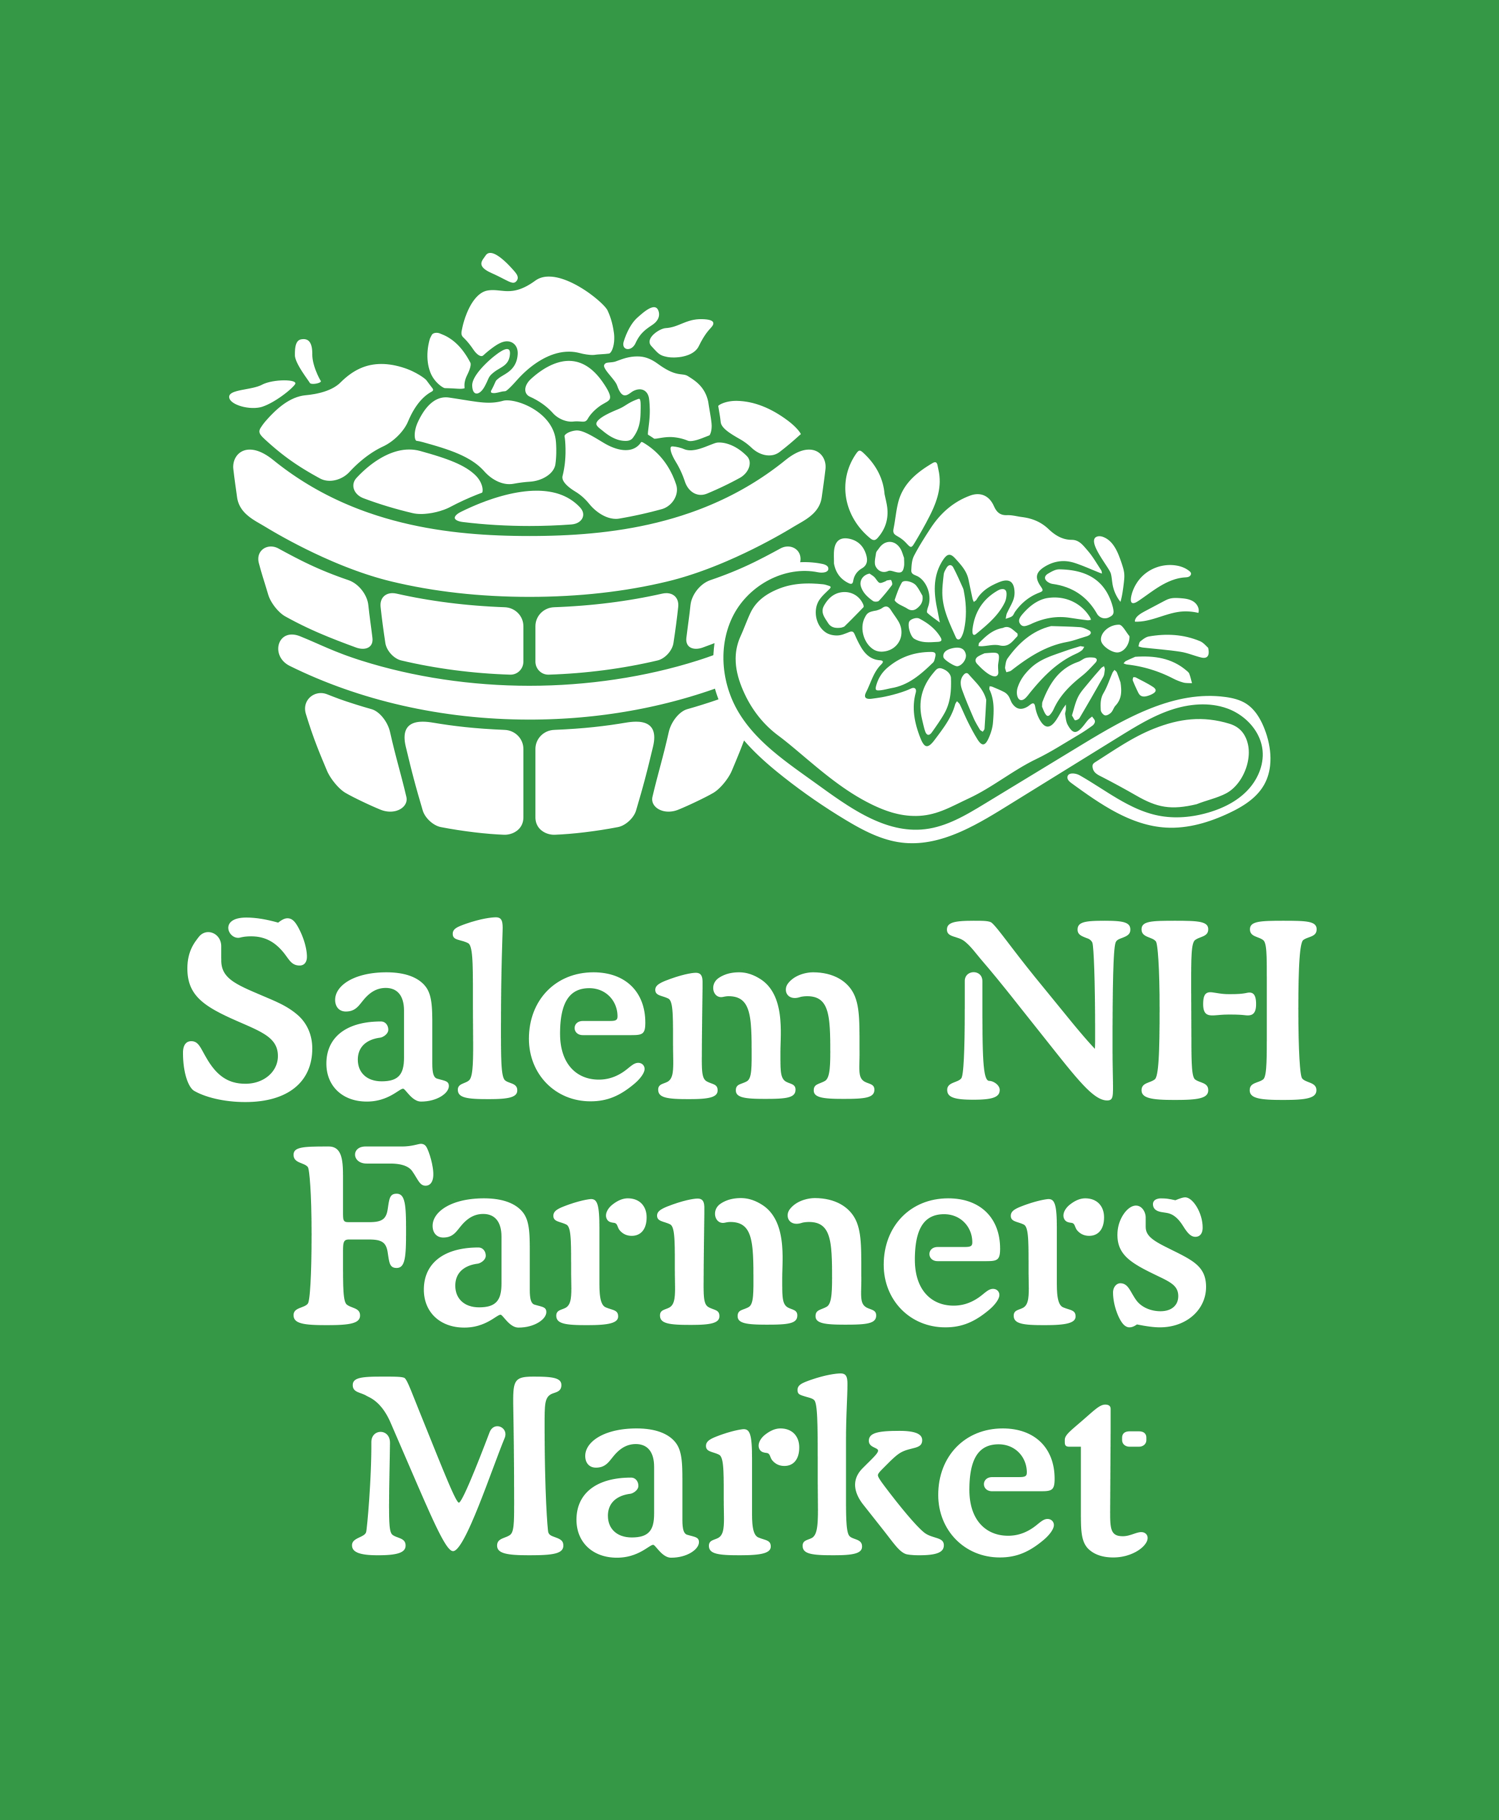

Salem NH
Farmers Market
2017 Summer
Application

Hosted at
Salem Market Place
224 Broadway (Rt. 28)
Salem NH 03079
info@salemnhfarmersmarket.org

Mission of the Salem NH Farmers Market
The mission of the Salem NH Farmers Market is to provide communities with a wide variety of fresh, local, and specialty foods, goods and products. Through community involvement, we strive to educate all about the nutritional, economic, environmental and social implications of eating seasonally and locally.
Market Information & Required Application Documentation
Salem NH Farmers Market will be sponsoring a Winter Market hosted at Fisk School Main Street, Salem. The Summer Market runs from May 7, 2017 through October29, 2017. Interested vendors must supply the following:
- Registration form (Completed and Signed)
- Registration fees
- Food or any Applicable Licenses
- Commercial Insurance
  - All vendors must carry General Liability insurance in the amount of $1,000,000 per Occurrence and $2,000,000 General Aggregate.
  - Salem NH Farmers Market needs to be named as additional insured with waiver of subrogation as shown on the sample certificate.
- Please also include any other commercial insurance policies that you may already carry.
(For example)
  - Commercial Automobile Liability
  - Commercial Umbrellas
  - Workers Compensation Insurance (If you have employees)
* Please submit any of these 3 things if you have them, but they are not required.

For any insurance questions you may have please contact the market’s insurance agent, Natasha Rufe at (603) 898-6320 x457.

Health Regulations
For prepared food vendors, detailed information on Salem’s Health Regulations can be obtained by contacting the Health Officer.
Brian Lockard, CFPM
Health Officer
blockard@ci.salem.nh.us
Phone: (603) 890-2050

Advertising and Marketing
By default all vendors will be listed on the Salem NH Farmers Market website with a link to the Vendor website, Facebook page or other location as entered above. We ask that you provide a link to Salem NH Farmers Market from your website (www.salemnhfarmersmarket.org) and promote your presence at Salem NH Farmers Market on Facebook, website and other social media sites you use. Like our page at facebook.com/salemnhfarmersmarket.

Membership Fees
- Each vendor is subject to a non-refundable, seasonal membership fee of $30 per season.
- The weekly table fees are $25 per space and are paid on the day of the market.
- We also offer a discount of $100 when you pre-pay your table fees for the whole season. (That’s like 4 weeks for free!) (You will still be responsible for the $30 seasonal fee.)
  - The pre-pay, full season single space table fee is $475.
  - You may also prepay for a full season double-space at $950. (This one-time fee is non-negotiable and cannot pro-rated to a single space fee once the season has begun.)
Salem NH Farmers Market reserves the right to change table fees at any point during the season. If you prepaid your table fee for the season then you will be locked in at the original price.
Mail application and payment to:
Salem NH Farmers Market
Attn: Market Applications
PO Box 213
Salem, NH 03079

Make checks payable to Salem NH Farmers Market.
Salem NH Farmers Market Application
Please fill in all information; missing information may cause delays in approving applications.
Number of Booths requested: _______________
Total amount enclosed: $_________________
- $30 (Seasonal fee only)
- $505 (Seasonal fee, plus prepaid, full season, single space table fees)
- $980 (Seasonal fee, plus prepaid, full season, double space table fees)
Do you need access to electrical outlets?
□ Yes □ No
Please note that booths with access to electricity are limited.
Vendor attendance at the market will be verified via email each week. Response to this email is used when comprising the vendor list for our weekly newsletter and is needed to prepare our weekly layout.
Vendor Name:
* Payee Name:
Contact Name:
Email Address:
On site contact:
Business Phone:
Contact or Cell Phone:
Mailing Address:
City: |  |  |  | State: |  | Zip Code:
Website:
Facebook:
*This is the name that your vendor token payment checks will be made out to. This could be your personal name or your business name. For more information please see the “Vendor Reimbursement” section on page 7 in the current Market Vendors Policies and Procedures Guide.
Please accurately list and describe the items/goods/commodities that you will be selling.

Vendor Acknowledgment
I hereby accept the terms and conditions as set forth by Salem School District and Salem NH Farmers Market and agree to abide by all said policies. In addition, I the vendor participating in the Salem NH Farmers Market, to the fullest extent permitted by law, shall protect, indemnify, save, defend and hold harmless Salem School District, including its officials, volunteers, employees and agents, from and against any and all liabilities, obligations, claims, damages, penalties, causes of action, costs and expenses, including reasonable attorney and paralegal fees, which Salem School District or its officers, officials, volunteers, employees and agents may become obligated by reason of any accident, bodily injury, personal injury, death of person, or loss of or damage to property, arising indirectly or directly in connection with or under, or as a result of this agreement, but only to the extent caused in whole or in part by any negligent or wrongful act or omission of the vendor and/or its officers, members, directors, volunteers, employees, subcontractors and/or agents.
I also hereby attest that I have read and will abide by the Salem NH Farmers Market Policies & Procedures Guide.

Participant’s Name: _________________________________________________________________

Participant’s Signature: ______________________________________________________________

Date: ___________________________________

You will be notified once your application has been approved by the SNHFM Board of Directors.
Vendors cannot be approved until all paperwork has been completed and submitted.
To guarantee consideration for the opening winter market on May 7, 2017 you must have submitted you application by Monday April 17, 2017.

Thank you for your help and consideration, we look forward to
your membership in the Salem NH Winter Farmers Market!

