ACUSHNET YOUTH SOCCER ASSOCIATION
Acushnet, MA P.O. Box 30089
PLAYER REGISTRATION $120 (Non-Refundable)
June 9th a $25 late fee applies.
Like us on FACEBOOK FALL 2019
www.Acushnetyouthsoccer.com www.mayouthsoccer.org

***Please PRINT clearly***

NAME: ______________________________________ D.O.B.:____________________ GENDER: M / F
ADDRESS: ____________________________________ PHONE: _______________________________
CITY: ________________________________________ STATE: ___________ ZIP CODE: ___________
MOTHER: ___________________________________ FATHER: _________________________________
PHONE: ____________________________________ PHONE: __________________________________
**MUST HAVE AN EMAIL: .
- Please check here if you are new to the fall program.
- Check here if you DO NOT want us to use your child's photo on our site.
MEDICAL CONDITIONS/ALLERGIES: _______________________________________________________________________
PHYSICIAN: ______________________________________________ PHONE: ________________________________
EMERGENCY CONTACT: ____________________________________ PHONE: ________________________________
PARENTAL APPROVAL AND MEDICAL RELEASE
Recognizing the possibility of physical injury associated with soccer in consideration for Mass Youth Soccer accepting my child to the Acushnet Youth Soccer, I hereby release, discharge and/or otherwise indemnify Mass Youth Soccer, its affiliated organizations, including, but not by way of limitation, the of fields and facilities used for Acushnet Youth Soccer, against any claim by me or on my behalf of my child as a result of my child’s participation at Acushnet Youth Soccer and or being transported to or from any practice or competition associated with the Acushnet Youth Soccer which transportation I hereby authorize. My child has received a physical examination by a physician and has been found physically capable of participating in soccer. I hereby give my consent to have an athletic trainer, emergency medical technician and/or Doctor of Medicine or dentistry provide my child with medical assistance and/or treatment and agree to be financially responsible for the reasonable cost of such assistance and/or treatment.

__________________________________________ _____________________________
SIGNATURE OF PARENT DATE
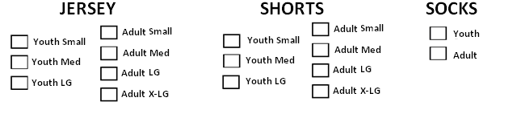

------------------------------------------------------------------------------------------------------------------------------------INTIALS: ________ Raffle Tic # _________ *OFFICIAL USE ONLY* 1st: $120 2nd: $230 3rd: $340 4th: $450

DATE: ____________ CHECK #: ________ CASH: ________ CREDIT CARD: _______ TOTAL AMOUNT: _________

