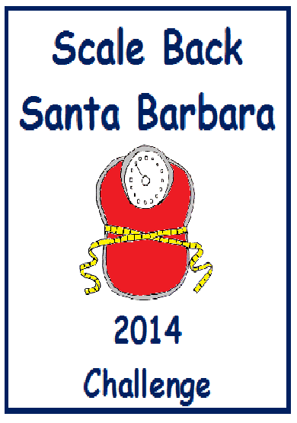

Weight Loss Involves Knowing the… NUMBERS.
About having an idea how many calories you consume
and/or burn a day.
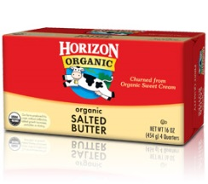
One Pound = 3,500 Calories
One pound of fat is about the size of one pound of
butter.
To lose 1 Pound a week, you must
cut and/or burn
an extra 500 Calories a day.
(500 Calories a Day x 7 Days = 3,500 Calories
= 1 Pound Lost Per Week)

