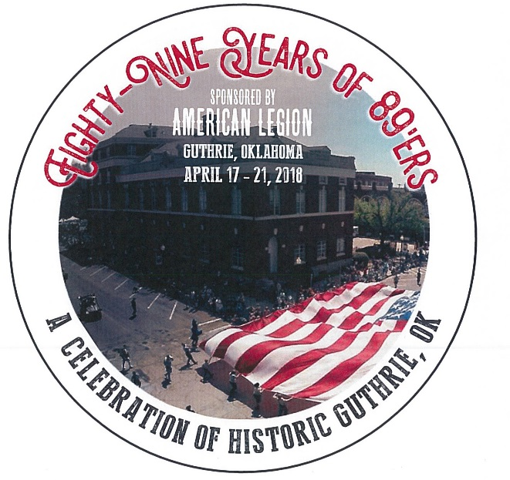
Oklahoma ‘89er Day Celebration Levels
2018 Sponsorship Levels
Theme “89 Years of ‘89ers”
April 17-21, 2018

Golden Budckle Level $5,000 (one only)
This top level sponsor will be given the onor as PARADE sponsor. Sponsors’ name and logo is recongnized in all media dn advertising produced by the event, a entry in the parade supplied by Sponsor. Recongnition at all events and actvities such as the Chuck Wagon Feed, Old Time Baseball game, Queen Appearances, Classic Car Show, and other planned events.
- 10 Tickets to Chuck Wagon Dinner
- 6 Tickets to the Bull Riding Event
- Vendor Booth Space
- 6 Carnival Passes
- Promotional Opportunity during the Celebration to be approved
- VIP Reception honoree prior to the Parade
- Signage at all events provided by the sponsor
- Plaque thanking you for the Sponsorship

Silver Buckle Level $2,500 (non-exclusive)
This is our Celebration event sponsor. Sponsors name and logo is recognized in all media and advertising Produced by the event. Float entry in parade supplied by Sponsor. Recognition is given at all events. A 2’ x 5’ banner is displayed at a prominent location.
- 6 Tickets to Chuck wagon Dinner
- 4 Ticket to the Bull Riding event
- Vendor booth space
- 4 Carnival Passes
- Invitation to the VIP Reception prior to the Parade
- Signage at various locations provided by the sponsor
- Plaque thanking you for your Sponsorship

Bronze Level $1,000 (non-exclusive)

This is a supporting sponsor level. Sponsors name and logo is recognized in all media nd advertising produced by the event. Recognition is given at all events. A 2’ x 2’ banner is displayed at a prominent location.
- 2 Tickets to Chuck wagon Dinner
- 2 Ticket to the Bull Riding event
- Vendor booth space
- 2 Carnival Passes
- Invitation to the VIP Reception prior to the Parade
- Signage at various locations provided by the sponsor
- Plaque thanking you for your Sponsorship

Pewter Level $500 (non-exclusive)
- Choice of 2 tickets to one of our events
- Initiation to the VIP Reception prior to the Parade
- Name listed in media and advertising
- Thank you Plaque

Contributor Level- Any dollar amount to in-kind contribution
- Name listed in media
- Thank you certificate

To become a sponsor please contact the American Legion office at 405-282-2589 and leave a message for Jerry Ball
Our mailing address is '89er Celebration, P O Box 69, Guthrie, OK 73044
​Email all question to: lebronpost58@lebronpost58.org

