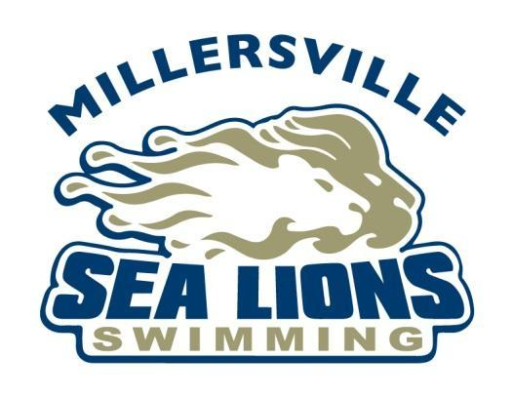

2024 Millersville Sea Lion Swim Team Sponsorship Form

Summer is not far away, and we are anxious for the Sea Lion swimmers to dive into a new season. The team’s purpose is to offer the children of the Millersville area the opportunity to develop and enhance their own swimming abilities, learn the importance of teamwork and sportsmanship and enable them to participate in a sport they love. Sponsorship donations by our neighborhood businesses, friends, families, and community members are crucial to maintain quality coaching, equipment, and general operations while keeping the cost to swimmers at affordable levels. Would you consider being a Millersville Swim Team sponsor this year?

- Family and Friends: $25 to $99: Your name will be announced at the end of the season swim team party, thanking you for your support.

- Silver: $100 to $249: Your name/company name will be posted on the website and announced at the end of the season swim team party, thanking you for your support.

- Gold: $250 to $499: A 2’ x 3’ banner will be made using your company’s logo (please email your logo to millersvilleswimteam@gmail.com). Your name/company will be read at each home meet. Your name/company name will be posted on the website and announced at the end of the season swim team party, thanking you for your support.

- Platinum: $500 and above: A 4’ x 8’ banner will be made using your company’s logo (please email a high resolution file of your logo to millersvilleswimteam@gmail.com) and displayed at the Millersville Lions Club Pool for the entire 2024 pool season. Your name/company will be read at each home meet. Your name/company name will be posted on the swim team’s website and announced at the end of the season swim team party, thanking you for your support.

(Please detach below and return it with your payment)
- - - - - - - - - - - - - - - - - - - - - - - - - - - - - - - - - - - - - - - - - - - - - - - - - - - - - - - - - - - - - - - - - - - - - - - - - - - - - - - - - - - - - - - - - - - - - - - - - - - - -
Sponsorship Level ____________________________________________________________________
Family Name (for Family and Friends sponsors) or Organization/Company Name _________________________________________________________________________________________
Telephone ___________________________________________________________________________
Address ___________________________________________________________________________
E-mail address ___________________________________________________________________________
Donation Amount $_____________________

Name to be announced at the picnic and home meets: _______________________________________

Make check payable to: Millersville Sea Lions Swim Team

Please return this form with payment to:
Brandy Basile
1001 Keystone Drive
Lancaster, PA 17603

Thank you for your support! See you at the meets!
Millersville Swim Team Parent Board
www.millersvilleswimteam.org

