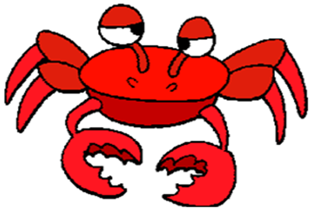
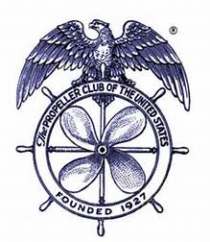
TACOMA PROPELLER CLUB
ANNUAL CRAB FEED
TUESDAY, MARCH 5, 2019
FOSS WATERWAY SEAPORT
705 DOCK STREET
5:00 – 9:00 PM

Last year was such a success we’re going to do this every year!
Get your tickets now . . . only 200 will be sold and there will be no tickets sold at the door!

Dungeness Crab, Clam Chowder, Salads, and Rolls

$50.00 *** Deadline for tickets is February 19, 2019 *** $60.00 after this date
No Host Bar *** “Crab Toss” for Wine *** Dessert Dash *** Awesome Raffle

TICKET FORM
Must be received or postmarked by February 19, 2019

Number of tickets:____________

Name:_____________________________ Email:___________________________________________

Phone:_____________________________ Credit Card:______________________________________

Expiration Date:_____________________ Security Code:_____________________ Zip:____________

SPONSORSHIP FORM
(see attached for benefits)

_____ Dungeness Crab - $800.00 Company Name:_________________________________

_____ King Crab - $500.00 Company Name:_________________________________

_____ Snow Crab - $300.00 Company Name:_________________________________

_____ ***EVENT*** - $3000 .00 Company Name:_________________________________

Email form to tacomapropellerclubap@gmail.com OR
Mail form and check payable to Tacoma Propeller Club to
P. O. Box 453, Tacoma, WA 98401

Must be 21 years of age or older - No minors allowed

