TEAM BEER PONG RULES

TABLE SETUP
Arrange ten 16 oz. cups in a pyramid-like formation as the diagram shows on each side of a table. Fill each cup to the midway point; all cups must be filled with WATER.

GENERAL GAMEPLAY

Team Beer Pong is unique in that your team will strategically form ‘mini teams’ to beat your opponent. A Team Beer Pong match will consist of 3 games and 1 bonus round.

STANDARD ROUND
- All three ‘mini teams’ will be playing simultaneously against their opponent.
- Each ‘mini team’ will be provided 2 ping pong balls.
- A minimum of 2 women must compete in a match.
- A game of rock, paper, scissors will be played at each table to decide which team will go first.
- The match will be won by the team that wins the ‘Best of 3’ series. Game = 6 points.
- Total possible points = 36

BONUS ROUND
- Each team will line up at a table (this is your full team, not your ‘mini teams’.
- At each table, there will be a single cup. All 6 team members will have 1 shot to sink the cup.
- The ball should be removed each time a cup in sunk.
- Each team will earn 1 bonus point for every shot they make.
- Total possible points = 6

RULES

Once a ball lands in a cup, the shooting team has the option to ask for the cup to be removed. If they don’t ask, the ball will remain in the cup.

If both teammates hit the same cup, 3 cups are removed and the balls are rolled back.

If both teammates hit different cups, those cups are removed and the balls are rolled back.

The team that successfully hits all of the opponent’s cups wins the game.

ELBOW/WRISTS RULE
When shooting, players must keep their elbows behind the edge of the table. If a wrists rule is in effect, players must keep their wrists behind the edge of the table. Breaking this rule results in the shot not counting. If the shot is made, the infracting player may step back and re-shoot the ball.

RE-RACKING
Twice per game, each team can request the cups to be rearranged at the start of their turn. If you get balls back after making shots, it is still considered your turn and you may not get a re-rack. If requested, last cup may always be pulled back and centered.

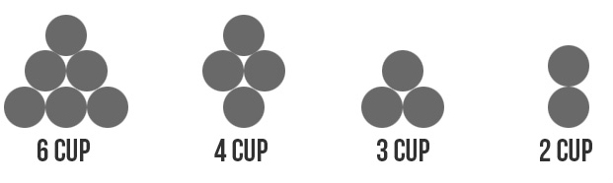

BOUNCING
If a ball hits the table and then goes into a cup (even by accident), the cup that the ball goes into is removed, as well as another cup of the defending player’s choice. If there are only 2 cups remaining, the bounce only counts as one cup.

FIXING CUPS
At any time in the game, a player may ask for the cups to be fixed. This is not to get confused with racking. This is simply putting the cups back to where they would have been had they not slid or been knocked out of position.

FINGERING / BLOWING
Not allowed.

ON TABLE ROLLBACKS
After shooting, if the ball rolls back to the shooter without hitting the floor (you may also grab it mid-air), they can shoot it again behind the back. The shot counts as one cup if made.

ON FIRE
After a player hits two cups in a row, they can call “heating up.” If they make their third shot they can announce that they’re on fire and they shoot until they miss. If the player fails to announce that they’re heating up, they cannot call on fire.

ISLAND CUP
Each player, once per game can call a specific cup if it is not touching any other cup. If the called cup is hit, the defending team pulls the hit cup along with an additional cup of their choosing. If the shooter calls a specific cup and hits another, the ball is pulled out and the unintentionally hit cup remains on the table.

REBUTTAL
After the last cup is hit each player from the losing team has a chance to hit the remaining cups. Each player shoots until they miss, the order in which this is done does not matter. If there are re-racks left over they may be used now. Once both players miss and there are remaining cups, the game is over. If the players manage to hit all remaining cups the game goes into a 3 cup overtime.

OVERTIME
Three cups are placed back into a triangle shape and the would-have-been winners shoot first. There are no racks permitted on overtime.

