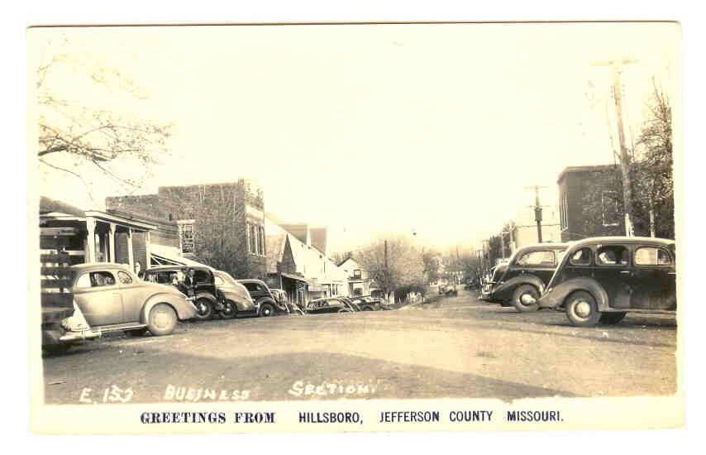
The Greater Hillsboro
Chamber of Commerce

Hillsboro Homecoming & Festival
“Hillsboro Heritage Days!”
May 17th Golf Tournament at Raintree Golf Course
May 18th & 19th Hillsboro Homecoming & Festival Events
Dear Chamber Member & Supporter:
The Hillsboro Homecoming and Festival Committee, has been meeting to plan a great festival for 2018. There is still time to join to the committee and bring ideas and suggestions. The format for this year’s event will be very similar to that of Homecoming/Festivals of the recent past with the addition of the Armed Forces Day events which will be located at the Jefferson County Administration Building. This year our theme will be “Hillsboro Heritage Days” This year is the Bicentennial of Jefferson County. In honor of the County Bicentennial Celebration Hillsboro will be celebrating its Heritage! Antique cars, Wagons, 1800’s era themed clothing, Settlers, Farmers, Old time sports teams, Civil War Warriors, Mountain Men, and Indian’s may make an appearance at this year’s parade! A partial list of the tried-and-true activities are listed below which will take place on Main Street and the surrounding area.

- Chamber Golf Tournament (Thursday, May 17th)
- Main stage Bands on Friday and Saturday evenings
- Carnival (Friday evening and all day Saturday)
- 5-k Run, Car Show, Parade, Idol Contest and much more (Saturday)
- Rotary Prayer Breakfast Saturday morning
- Kid’s Korner Activities Saturday
- Numerous vendors, including food, crafts and businesses
- Beer sales provided by the Hillsboro Community Civic Club
- Washer pitching tournament

Since there is no admission charge, the Chamber is again asking for your help in underwriting the involved expenses. We will have Sponsor Sheets (listing the names of the Festival Benefactors) and event programs posted on attractive A-frame signs at several prominent locations on the grounds. We have partnered with the Leader to offer great advertising opportunities for our members and to help promote the festival. This year we will again focus on Online Social Media Advertising as well as utilize our website www.hillsborochamberofcommerce.com for advertising of the festival and highlight our sponsors for the event!

It truly takes the community to put on a great festival. Please consider volunteering time to help with festival. Volunteers are needed to help with clean up and running of events on the main stage and other areas and just overall supervision and presence of chamber members. The more volunteers we have the less work for all chamber members. Contributing four hours of time during the festival will be greatly appreciated. If you are interested in volunteering please complete the attached form.

We hope we can count on you to be as generous this year as you have been in the past. This is the largest fundraiser of the year for the chamber and helps ensure that we can continue to our efforts to support the community and promote businesses in the greater Hillsboro area. If you can lend a hand with a monetary donation and/or physical labor during setup and cleanup, everyone on the Chamber's Executive Board, the Festival Committee, and all of the attendees will appreciate it. We look forward to seeing you during the festival!
Thank you,
Mandy Alley- Chamber Administrator & Festival Chair
Marissa Newman- President & Festival Co-Chair
Jessie Richards- Vice President Stephanie Robben- Secretary
Sara Sucharski-Festival Committee Debbie Colletti-Festival Committee

SPONSO RSHIPS

Help support the Hillsboro Homecoming & Festival by joining us as an event sponsor!

Gold Level - $550
- Largest of the festival sponsor ads, full color advertisement in the featured festival section of the Leader Newspaper to run the week before the festival. (Limited ads available)
- Recognized as a Fletcher Level Sponsor on the back of all festival t-shirts (more than 300 shirts) and on festival supporter banner listed on the main stage. Larger Print
- Banner displayed on main stage during the festival weekend events.**
- Listed on website as a Fletcher Level Sponsor for the Festival.
- Online Social Media advertising

Silver Level - $350
- Smaller size of the festival sponsor ads, full color advertisement in the featured festival section of the Leader Newspaper to run the week before the festival. (Limited ads available)
- Recognized as a Covered Bridge Level Festival Sponsor on the back of all festival t-shirts (more than 300 shirts) and on festival supporter banner listed on the main stage. Medium Print
- Banner displayed on festival grounds during the festival weekend events**
- Listed on website as a Covered Bridge Sponsor for the Festival
- Online Social Media advertising

Bronze Level - $100
- Company name listed as a sponsor in the featured festival section of the Leader Newspaper to run the week before the festival.
- Listed under Level Sponsorship on the back of all festival t-shirts (more than 300 shirts) and on festival supporter banner listed on the main stage. Smaller Print
- Listed on website as a Sponsor for the Festival
- Online Social Media advertising

Friends of the Festival- $50
- Listed as a Friend of the Festival in the featured festival section of the Leader Newspaper to run the week before the festival.
- Listed as a Friends of the Festival on the back of all festival t-shirts (more than 300 shirts) and on festival supporter banner listed on the main stage.
- Listed on website as a Friend of the Festival Sponsor for the Festival
- Online Social Media advertising

I would like to contribute__________________ in kind donation or $________________
- Listed as a festival donor on the back of all festival t-shirts (more than 300 shirts) and on festival supporter banner listed on the main stage.

NOTE: **Banners are to be supplied by the advertiser and should be in the Festival Committee’s possession at least one week before the event.

I would like to help the chamber as a: Sponsor Volunteer Both

Organization/Business Name:
Contact Name: Contact Phone Number: ( ) ______
Name of donor (as you would like it to appear in advertising):
Address:
City: State: Zip:
Email:_______________________________________________________________________________

Authorized Signature:

Amount enclosed: $

If you are able to volunteer please report to the main stage on Main Street for the time you have selected. A committee member will be in touch to give you more details before the festival.

Friday Events; 8pm-Midnight- clean-up.

Saturday Events; 12pm-4pm

Saturday Events; 4pm-8pm

Saturday Events; 8pm-Midnight – clean up

Sunday morning clean up; 8am on Main Street

- Please provide finished, camera-ready artwork for your ad – attach artwork or email to, Leader Advertising department or send to chamberoffice@sbcglobal.net
- Payment is due with this form
Contact Mandy Alley, Festival Chair- Greater Hillsboro Chamber of Commerce 636-789-4920

Please return completed form (front & back) by April 27, 2018
All Forms received after April 27, 2018 will not be guaranteed advertising on the
t-shirts or placement in the Leader Advertising. Thank you for your support!
Attn: Hillsboro Festival
Greater Hillsboro Chamber of Commerce
PO Box 225
Hillsboro, MO 63050

