SPECIAL MEETING

OCTOBER 8, 2020

A Special Meeting of the Town Board of the Town of Hampton, County of Washington and the State of New York was held at the Town Hall and via Zoom, 2629 State Route 22A, Hampton, New York on the 8th day of October, 2020.

Due to the Corona Virus, occupancy inside the Town Hall is limited at this time. Supervisor O’Brien did provide a link to join the meeting via Zoom.

PRESENT: David K. O’Brien-----------Supervisor

Tamme Taran----------------Councilwoman

Donald Sady-----------------Councilman

Andrea Sweeney------------ Councilwoman

Michael Pietryka------------Councilman

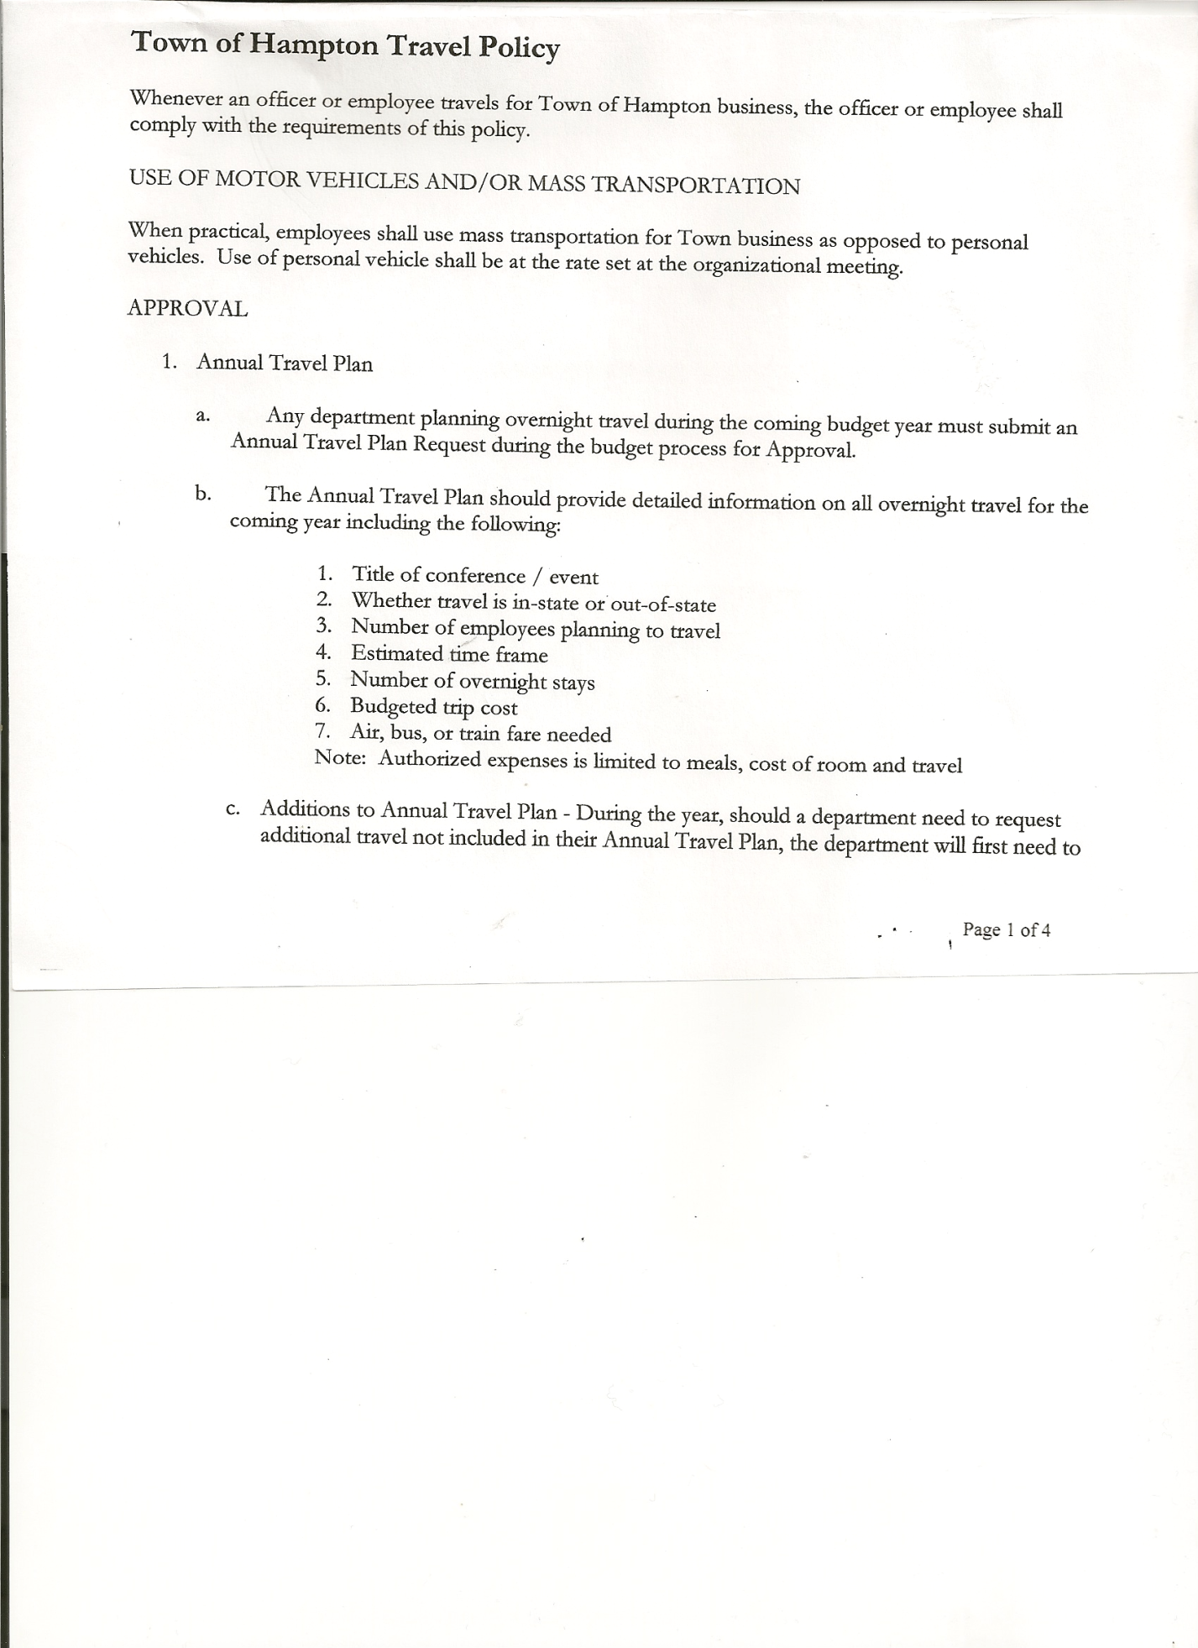 Rebecca Jones---------------Town Clerk

Camilla Shaw----------------Tax Collector/Deputy Town Clerk

Herbert Sady, Jr.-------------Highway Superintendent

Kim Perry--------------------Bookkeeper/Budget Officer

Also present: Artie Pratt and Leonard Reed

The Special Meeting was called to order by Supervisor O’Brien at 7:33pm, followed by the Pledge of Allegiance. Location of Fire Exits were given. Quorum of board members present.

Town Clerk Jones read the Legal Notice of the Special Meeting (copy attached), which was published in The Post-Star on 10/01/2020

Discussed, reviewed and modified **Tentative Budget**.

**RESOLUTION NO. 74-2020**

**ADOPTION OF TENTATIVE BUDGET**

On a motion of Councilman Sady, seconded by Councilwoman Taran, the following resolution was ADOPTED:

By Roll Call Vote: Supervisor O’Brien AYE

Councilman Sady AYE

Councilwoman Taran AYE

Councilwoman Sweeney AYE

Councilman Pietryka AYE

RESOLVED, that the 2021 Tentative Budget be adopted and becomes the 2021 Preliminary

Budget for the Town of Hampton.

**RESOLUTION NO. 75-2020**

**PUBLIC HEARING ON HAMPTON FIRE DISTRICT NUMBER 1**

On a motion of Councilman Sady, seconded by Councilwoman Taran, the following resolution was ADOPTED:

By Roll Call Vote: Supervisor O’Brien AYE

Councilman Sady AYE

Councilwoman Taran AYE

Councilwoman Sweeney AYE

Councilman Pietryka AYE

TOWN BOARD MEETING

OCTOBER 8, 2020 PAGE 2

RESOLVED, to set the Public Hearing to discuss the proposed contract between the Town on behalf of the Town of Hampton Fire Protection District Number 1 and the Hampton Volunteer Fire Company for October 29th, 2020 at 7:10pm.

**RESOLUTION NO. 76-2020**

**PUBLIC HEARING ON HAMPTON FIRE DISTRICT NUMBER 2**

On a motion of Councilman Sady, seconded by Councilwoman Taran, the following resolution was ADOPTED:

By Roll Call Vote: Supervisor O’Brien AYE

Councilman Sady AYE

Councilwoman Taran AYE

Councilwoman Sweeney AYE

Councilman Pietryka AYE

RESOLVED, to set the Public Hearing to discuss the proposed contract between the Town on behalf of the Town of Hampton Fire Protection District Number 2 and the Hampton Volunteer Fire Company for October 29th, 2018 at 7:12pm.

**RESOLUTION NO. 77-2020**

**PUBLIC HEARING ON PRELIMINARY BUDGET FOR 2021**

On a motion of Councilman Sady, seconded by Councilwoman Taran, the following resolution was ADOPTED:

By Roll Call Vote: Supervisor O’Brien AYE

Councilman Sady AYE

Councilwoman Taran AYE

Councilwoman Sweeney AYE

Councilman Pietryka AYE

RESOLVED, to set the Public Hearing on the Preliminary Budget for 2021 for October 29th, 2020 at 7:15pm.

**RESOLUTION NO. 78-2020**

MOTION BY: Councilman Donald Sady

SECONDED BY: Councilwoman Tamme Taran

**RESOLUTION INTRODUCING PROPOSED LOCAL LAW**

**TO OVERRIDE THE TAX LEVY LIMIT ESTABLISHED IN GENERAL MUNICIPAL LAW SECTION 3-c**

**WHEREAS**, pursuant to Section 10 of Municipal Home Rule Law, the Town Board of the Town of Hampton (the “Town”) has the authority to adopt local laws; and

**WHEREAS**, pursuant to General Municipal Law Section 3-c, the Town Board of the Town of Hampton has the authority to adopt a budget that requires a tax levy that is greater than the tax levy limit for the coming fiscal year by adopting a local law by a vote of sixty percent (60%) of the total voting power of the Town Board of the Town to override such limit for such coming fiscal year only; and

TOWN BOARD MEETING

OCTOBER 8, 2020 PAGE 3

**WHEREAS**, a proposed Local Law has been prepared by the Town Attorney, a copy of which is attached hereto; and

**WHEREAS,** the Town Board is desirous of proceeding with the review and consideration of this proposed Local Law.

**NOW, THEREFORE BE IT RESOLVED** that the proposed Local Law is hereby accepted for introduction to the Town Board. A public hearing shall be scheduled for the consideration of the proposed Local Law to be held by the Town Board on October 29, 2020 at 7:25p.m. at the Town Hall located at 2629 State Route 22A, Hampton, New York. Copies of the Local Law shall be available at the Town Clerk’s office for review; and be it further

**RESOLVED,** that the Town Clerk is directed to post and publish a notice of said public hearing in the Manchester Newspapers (The Granville Sentinel/The Whitehall Times)at least five (5) days before the hearing; and be it further

**RESOLVED**, that the consideration and proposed adoption of this Local Law is an action under the New York State Environmental Quality Review Act (SEQRA). The Town Board hereby declares that this action is a Type II action pursuant to 6 NYCRR 617.5(20) and (27) and declares that the action does not have a significant impact on the environment and the action is hereby precluded from further environmental review; and be it further

**RESOLVED**, that this resolution shall take effect immediately.

DATED: October 8, 2020 Supervisor O’Brien AYE

Councilman Sady AYE

Councilwoman Taran AYE

Councilwoman Sweeney AYE

Councilman Pietryka AYE

**RESOLUTION NO. 79-2020**

**PUBLIC HEARING-PROPOSED LOCAL LAW TO OVERRIDE TAX CAP**

On a motion of Councilman Sady, seconded by Councilwoman Taran, the following resolution was ADOPTED:

By Roll Call Vote: Supervisor O’Brien AYE

Councilman Sady AYE

Councilwoman Taran AYE

Councilwoman Sweeney AYE

Councilman Pietryka AYE

RESOLVED, to set a Public Hearing for October 29th, 2020 at 7:25pm on the proposed Local Law regarding overriding the Tax Cap.

TOWN BOARD MEETING

OCTOBER 8, 2020 PAGE 4

**RESOLUTION NO. 80-2020**

**SPECIAL MEETING**

On a motion of Councilwoman Taran, seconded by Councilman Sady, the following resolution was ADOPTED:

By Roll Call Vote: Supervisor O’Brien AYE

Councilman Sady AYE

Councilwoman Taran AYE

Councilwoman Sweeney AYE

Councilman Pietryka AYE

RESOLVED, to set a Special Meeting to be held on Thursday, October 29th, 2020 at 7:30pm.

**RESOLUTION NO. 81-2020**

**TOWN HALL USE**

On a motion of Councilwoman Taran, seconded by Councilman Pietryka, the following resolution was ADOPTED:

By Roll Call Vote: Supervisor O’Brien AYE

Councilman Sady AYE

Councilwoman Taran AYE

Councilwoman Sweeney AYE

Councilman Pietryka AYE

RESOLVED, to approve the request from Herb Sady to use the Town Hall on Saturday, November 7th, 2020 for his granddaughter’s 1st birthday party.

**RESOLUTION NO. 82-2020**

**MEETING ADJOURNED**

On a motion of Councilwoman Taran, seconded by Councilman Sady, the following resolution was ADOPTED:

By Roll Call Vote: Supervisor O’Brien AYE

Councilman Sady AYE

Councilwoman Taran AYE

Councilwoman Sweeney AYE

Councilman Pietryka AYE

RESOLVED, that the meeting adjourned at 8:52pm

Respectfully submitted,

Rebecca S. Jones, RMC

Town Clerk

Assisted by Camilla Shaw,

Deputy Town Clerk