GRAND CENTRAL OYSTER BAR BROOKLYN’S SEAFOOD PAELLA RECIPE, FRESH INGREDIENTS AVAILABLE DAILY AT RETAIL MARKET:

Brooklyn's Grand Central Oyster Bar presents the freshest seafood in the borough both on its daily menu, and at its retail market for the home chef wishing to concoct a culinary delight. Executive Chef Jason Korz presents his seafood paella recipe as a menu special (priced at $21.95) from time-to-time, and ‎encourages visitors to take home a batch of clams, oysters, shrimp and calamari from the market to whip up their own version. Here's information on the Grand Central Oyster Bar Brooklyn in Park Slope, and the recipe:

Located at 254 Fifth Avenue in Park Slope, the 20-foot retail fish market offers the freshest shellfish and seafood on a daily basis, seven days a week. Franchise owners Jonathan Young, a longtime Brooklyn resident, and Bruce Fox report that the market offers a selection of shellfish including oysters, mussels, shrimp and clams. There will also be a lobster tank for crustacean lovers, and a wide-variety of fresh fish selections, all delivered daily. "We only buy the freshest seafood product available, and because of our commitment to freshness, the menu will change daily,” say Young and Fox. “All items on the menu will also be the product sold in our market. Our fresh seafood market will fill a void in the community.” The 20-foot seafood market and display are housed in front of the open kitchen. The three-building space also includes a bar and lounge area, as well as a main dining room within the 5,000-square foot space. The 150-seater is a "neighborhood restaurant that pays homage to the original Oyster Bar with an added Brooklyn flair," say the owners. For more information visit www.oysterbarbrooklyn.com, and for reservations call 347-294-0596 or email info@oysterbarbrooklyn.com.

Grand Central Oyster Bar Brooklyn Easy Spanish Style Seafood Rice

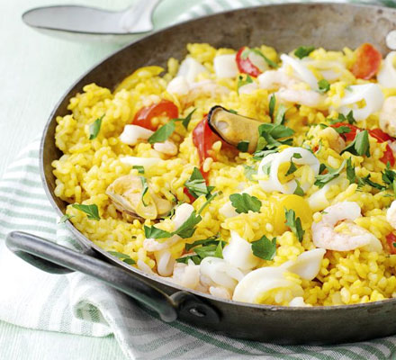

Ingredients

- 1 tbsp olive oil
- 1 onion, finely chopped
- 1 red and 1 yellow pepper, deseeded and sliced
- 2 garlic cloves, sliced
- 2 cups paella rice
- 3 ½ Cups hot vegetable stock (we used Kallo very low salt stock)
- pinch saffron
- 1 pint of Grand Central Oyster Bar New England Clam Chowder
- 1 cup of Seafood Mix (I.E. Baby Shrimp, Calamari, Shucked Oysters)
- juice ½ small lemon
- small handful flat-leaf parsley, roughly chopped

Method
- Heat the oil in a large saucepan and soften the onion for 6-7 mins. Add the pepper and garlic, cook for 2 mins more, then stir in the paella rice and cook for 1 min, stirring to coat.
- Pour in the stock, add the saffron and bring to the boil. Cook, uncovered, at a gentle bubble, for 20 mins, stirring occasionally until the rice is tender.
- Stir in the seafood and lemon juice and cook for 2 mins or until piping hot and completely cooked through. Serve in warm bowls scattered with the parsley.

