ISSUE
January 2023

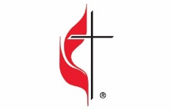
In This Issue
Pg 1, Pastor’s Corner Pg 5, 6, 7, 8, 9 Did You Know
Pg 2, 3, Save the Dates Pg 10 Calendar for January 2023
Pg 4 Bible Studies & Small Groups Pg 11 Church Information

As I am writing this Pastor’s Corner the new year 2023 is fast approaching. Instead of looking back on 2022, I look forward to 2023 with hope. The hope I speak about of is found in the hymn “My Hope is Built” UMH 368. My hope is built on nothing less than Jesus’ blood and righteousness. I dare not trust the sweetest frame but wholly lean on Jesus’ name. On Christ the solid rock I stand all other ground is sinking sand. If 2022 has showed us anything, it is this that God fulfills his promises in a baby born in a manger who came to set us free from our sins and death. God reveals himself to us in his son Jesus Christ, Anyone who has seen me has seen the Father. How can you say, ‘Show us the Father’? John 14:9b. What promises do you hope God will fulfill for you that are in the scriptures? Which promises of Jesus Christ does the Holy Spirit remind you of, so that you will remain strong in your hope and faith?
I believe in 2023 the words of Jesus Christ, By their fruit you will recognize them. Do people pick grapes from thornbushes, or figs from thistles? Likewise, every good tree bears good fruit, but a bad tree bears bad fruit. A good tree cannot bear bad fruit, and a bad tree cannot bear good fruit. Every tree that does not bear good fruit is cut down and thrown into the fire. Thus, by their fruit you will recognize them. (John 7:16-20) and ,But the things that come out of a person’s mouth come from the heart, and these defile them. For out of the heart come evil thoughts—murder, adultery, sexual immorality, theft, false testimony, slander. (Matthew 15:18-19) will be fulfilled again just as they were in 2022.
We need to ask ourselves this question as we begin 2023, “What kind of fruit did I produce last year, what were the words that came out of my mouth?” In 2023 I believe the words of Jesus Christ, “Blessed are you when people insult you, persecute you and falsely say all kinds of evil against you because of me. Rejoice and be glad, because great is your reward in heaven, for in the same way they persecuted the prophets who were before you.” will be fulfilled more than in all the previous years as the time for Christs return draws even closer. May God bless you this year with the faith of all the prophets who came before you.

Mid-Michigan District United Women in Faith
2023 Epiphany Celebration
Saturday, January 7, 2023
Epiphany Celebration
When: | Where:
Saturday , January 7, 2023 | Carson City UMC
Registration: 9:30 am | 119 Elm Street
Begin Promptly at 10am | Carson City, Michigan
End by Noon
Cost: $5.00

God's Plan: Women in Ministry

Pastor Ian McDonald, of Carson City UMC, came into the ministry after working for 29.5 years with the Michigan Department of Corrections where he rose from the rank of officer to Inspector. Pastor McDonald received his License to Preach from the East Ohio Conference in 2010. He was approved as Licensed Local Pastor by the Detroit Annual Conference in 2012 and was appointed to God’s Country Cooperative in July of 2012. Pastor McDonald’s first appointment was a three-point charge which included Grand Marais UMC, McMillan UMC and Germfask UMC, a 90 mile circuit on Sundays. He served at this appointment from 2012 until 2019 when he was appointed to Carson City UMC. Pastor McDonald completed his Course of Study at Duke Seminary in July of 2017
Registration Information

Name_____________________________________ Church/Unit________________________________

Email______________________________________ Telephone_________________________________

Unit/District office or mission coordinator position:______________________________________________

Check payable to Mid-Michigan District UMW or UWF $_________________

Send registration by January 1, 2023 to Audrey Putman, 1931 Loraine Avenue, Lansing, MI 48910.

Mid-Michigan District United Women in Faith
2023 Spiritual Growth Retreat
Join Jesus in the Journey: How can we Love our neighbors?
When: | Where:
Fri – Sat, May 12 – 13, 2023 | St. Francis Retreat Center
Registration: 3:00 pm | 703 E. Main Street
Begin Promptly at 4:30pm | DeWitt, Michigan
Ingathering: Art Kits-Latinx Ministries
Offering: Crayons, coloring books, markers, chalk,
The Latinx Ministries glue sticks, watercolor paint sets, tape,
construction paper, scissors, pencils.

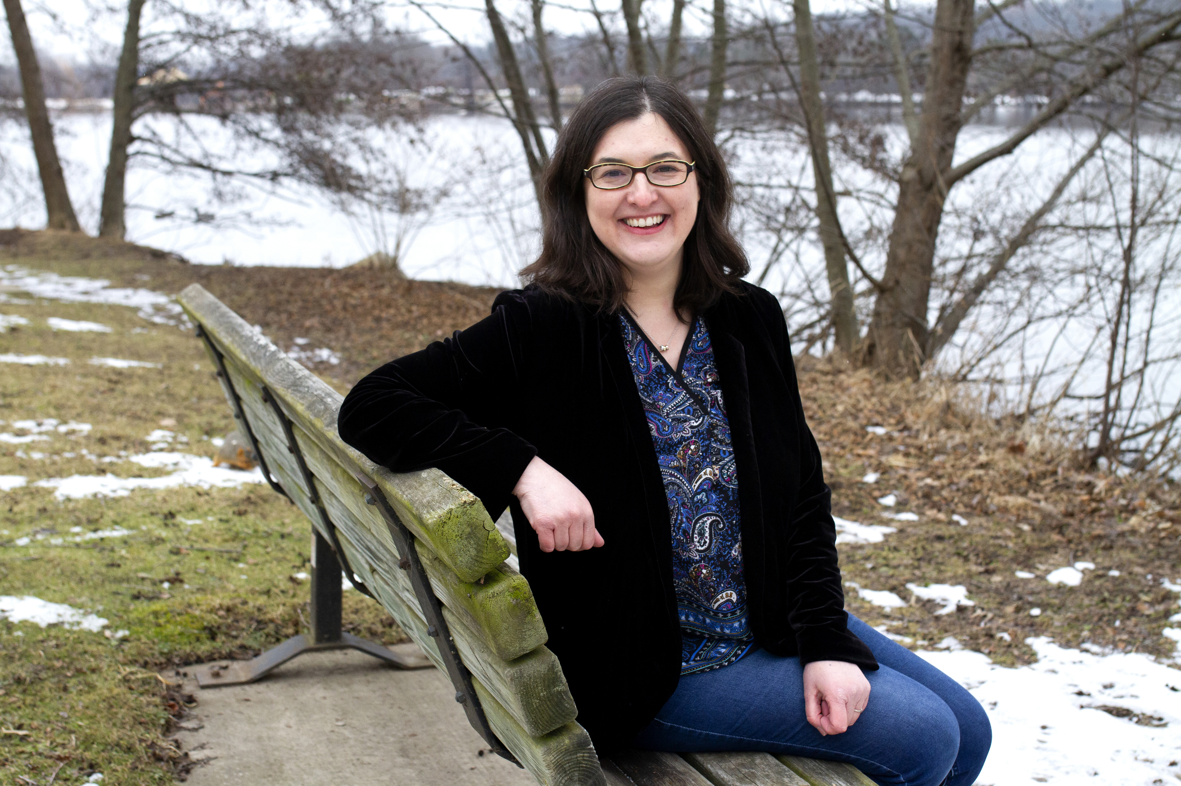
Sonya Luna is the Latinx Ministries Coordinator for the Michigan Conference of the United Methodist Church. She served as a General Board of Global Ministry missionary with the National Plan for Hispanic/Latino Ministries for the Michigan Conference from 2008 to 2020. She works with churches and leaders to support migrants on their journeys. She has a Bachelor of Arts in Human Development and Social Relations from Kalamazoo College and a Graduate Certificate in Non-profit Management from Eastern Michigan University. Sonya is a member of First United Methodist Church of Ypsilanti and is involved in the United Methodist Women at her church. She serves on the Board of Justice for Our Neighbors – Michigan(JFON), a nonprofit organization that provides free immigration legal services. She has lived in Mexico and has traveled to Costa Rica and Puerto Rico. She likes studying about Latin America and hopes to travel to South America one day. Sonya enjoys learning about different cultures, quilting, cooking, reading, and creating art.
Registration Information
Name________________________________ Church/Unit___________________________

Email________________________________ Telephone_____________________________
Costs: Commuter(includes meals): $50.00
Double occupancy: $95.00
Single occupancy: $129.00

Check payable to Mid-Michigan District UMW or UWF $_________________
Special Needs/Diet: Please Specify_________________________________________________

Send registration to: Audrey Putman, 1931 Loraine Avenue, Lansing, MI 48910
Last day for registration: May 5th

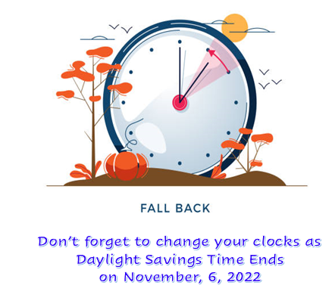
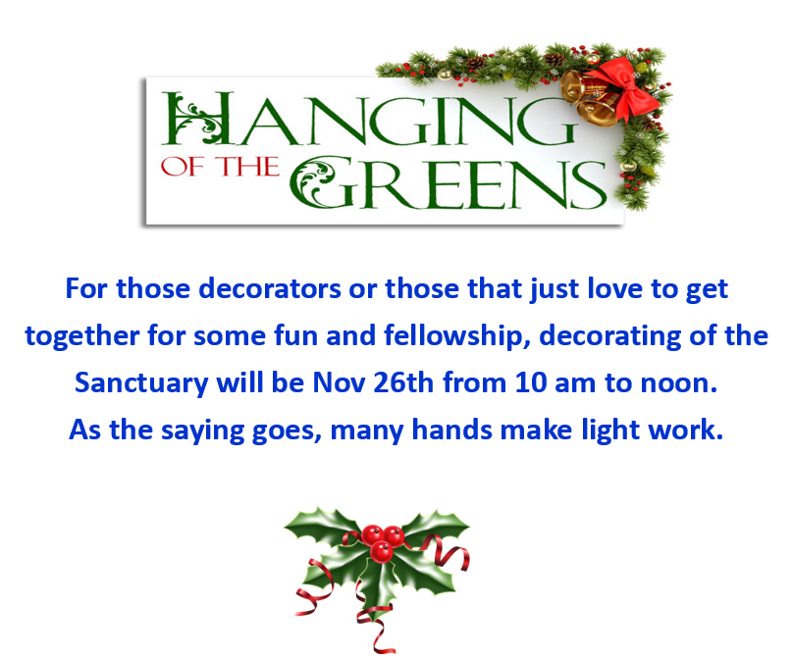

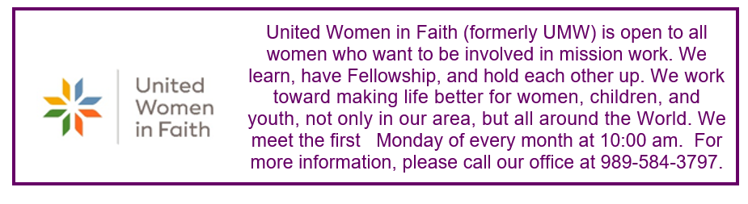

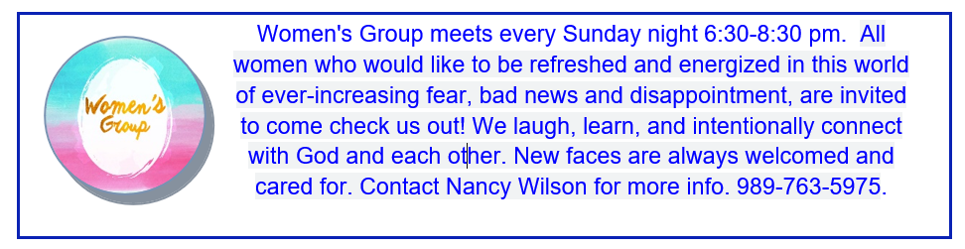

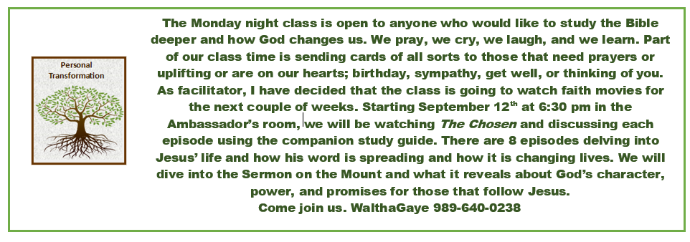

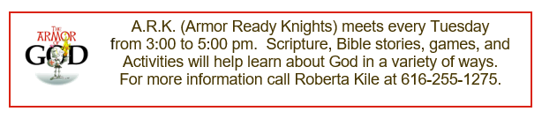

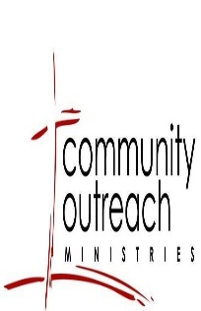

Funds were used for three families this Christmas. Please note, the Community Outreach Fund is a ministry we desire to use throughout the year, not just at Christmas. If you see a need in our community anytime during the year, please reach out to Pastor Ian.

Six Special Sundays by WalthaGaye Leavitt
The United Methodist Church celebrates six special Sundays with an offering each year. They were designed to create unity and make clear that the commitment of the church is to all people of God. It is also to give the opportunity to everyone to contribute to special programs approved and supported by the church. These donations also make sure that we bless as many people as possible in sustainable and integrative ways.
We are called to make an impact in communities where our brothers and sisters in Christ lack resources or tools to reach their God-given potential. Our gifts are part of building the beloved community through faith-based volunteer programs, community development and programs that work with at-risk people. Each o God’s children are important.
I saw an article that suggested that we do something in the community around those Sundays. For instance- January 15 is Human Relations Day. How about going into the school and cleaning desks or helping a teacher decorate or collect items needed for the next few months. The Personnel Transformation class is cleaning the Sunday School classrooms . Let us be a visible presence in the community- maybe not Carson City, but in surrounding areas. This is my challenge to you. If stuck for an idea- call or text me- I have plenty…989-640-0238.
UMCOR (United Methodist Committee on Relief) is 3/19
NAMS (Native American Ministries Sunday) is 4/23
PWJS (Peace with Justice Sunday) is 6/4
World Communion Sunday is 10/1
UM Student Sunday is 11/12
DO a small project…write it up for the newsletter and see what others have done. Get creative. Jesus would.

From the desk of Susan Henry-Crowe, General Secretary of Church and Society, UMC:
For many people around the world this is an especially welcome Christmas season. We can more comfortably gather with our families and loved ones. The isolation and loneliness of the past two COVID-related years are giving way to gatherings, in-person Christmas services, children hugging and laughing with excitement. Humbly, at the same time, we remember there are those in many countries and communities who cannot gather, sing together, pray together, and eat Christmas meals together. Recent outbreaks of COVID and flu, the expense of traveling, dangerous weather conditions, living in places without homes to gather and other factors will make gatherings impossible for many this year.
Woefully, we are mindful of some of the similarities of the First Christmas and Christmas 2022. There was occupation, conflict, crossing country borders, no room in the inn, poverty, and oppression. As we gather this Christmas may our prayers include those living in the midst of war, those without power and food, those with corrupt leaders oppressing their countries, those at border crossings and unable to cross, those where no inn is possible, those who are freezing or in heat ravaged regions of the world.
Saint Oscar Romero, the Catholic Archbishop in El Salvador, who was killed by an assassin as he celebrated Mass on March 24, 1980, had a meditation that is poignant and relevant this 2022 Christmas:
No one can celebrate
a genuine Christmas
without being truly poor.
The self-sufficient,
the proud, those who look
down on others because
they have everything,
those who have no need,
even of God … for them, there
will be no Christmas.
Only the poor, the hungry,
those who need someone
to come on their behalf,
will have that someone.
That someone is God Emmanuel,
God-with-us. Without poverty
of spirit there can be no
abundance of God.
May we acknowledge our deep need of the One who comes to fill our poverty of spirit and hunger. May this One who comes on our behalf inspire us with humility, gratitude, and out-reaching love.

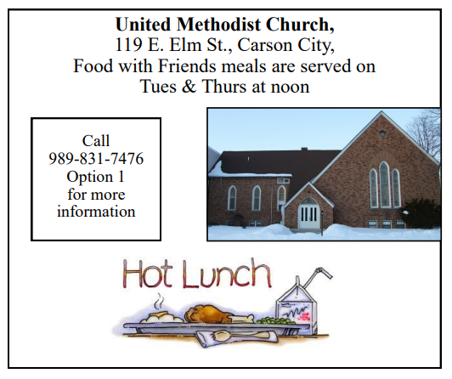
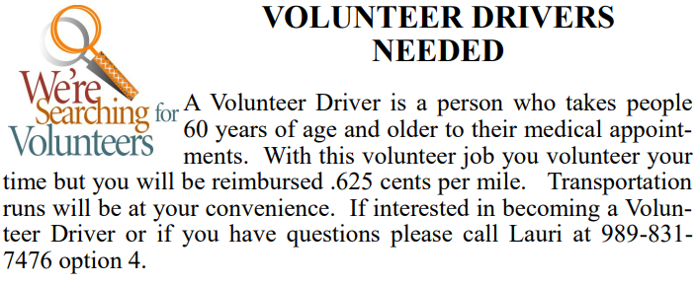
FOR COMMISSION ON AGING:

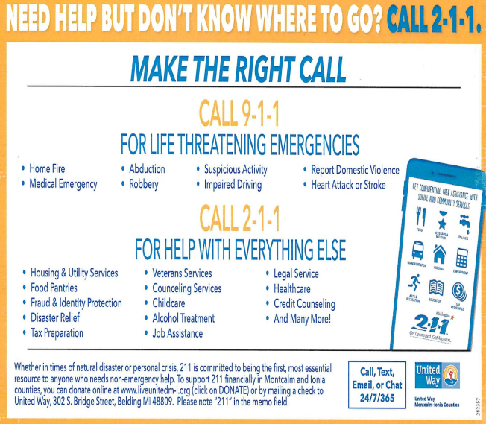

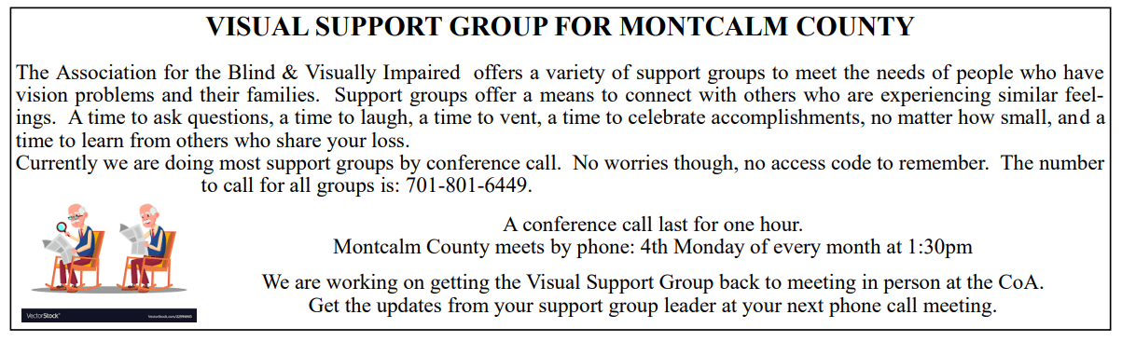
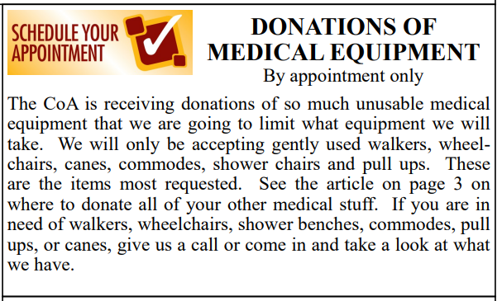
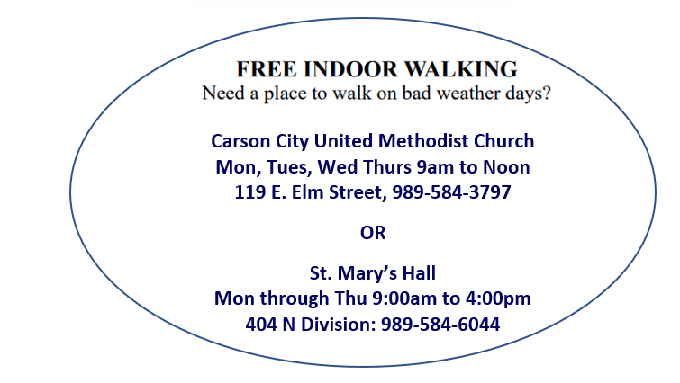

Schedule’s subject to change – contact office for more information”
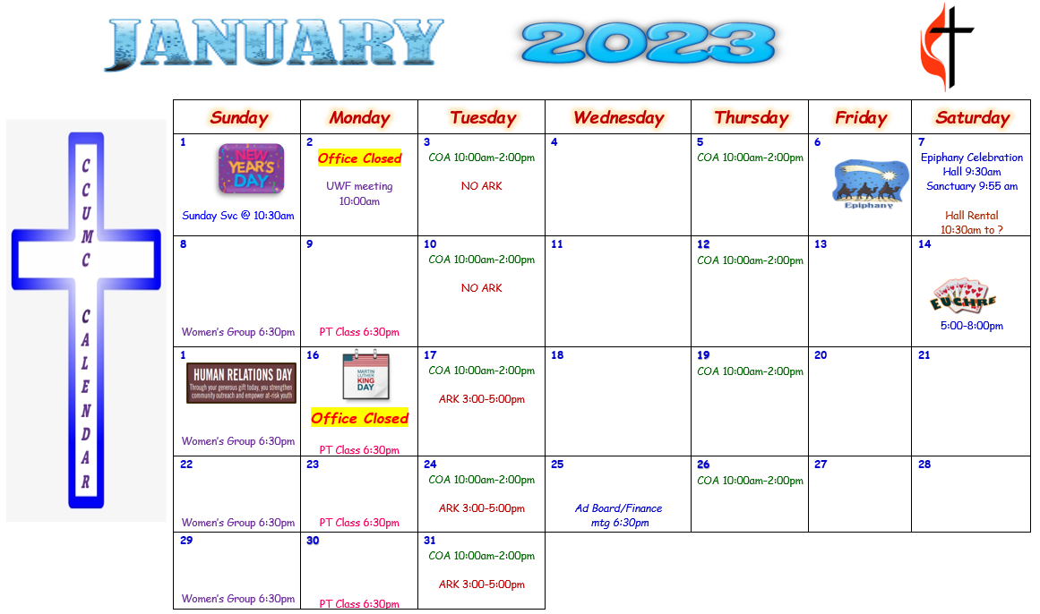

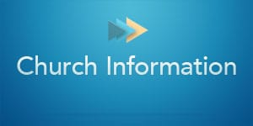
Stay connected! Follow us on:

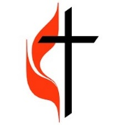
Join Us Each Sunday

Worship Services 10:30 am

(masks are optional)

Carson City United Methodist Church
Phone: 989-584-3797
Email: carsoncityumc@gmail.com
Website: carsoncityumc.com
Office Hours: Monday to Thursday, 9:00 am-Noon
After hours by appointment
Pastor: Ian McDonald (906) 322-5318
Secretary: Bonnie Seaman (989) 763-1674

Online giving available: Website: http://www.carsoncityumc.com/donate.html

Weekly Sunday Bulletin now available on our website
at www.carsoncityumc.com

