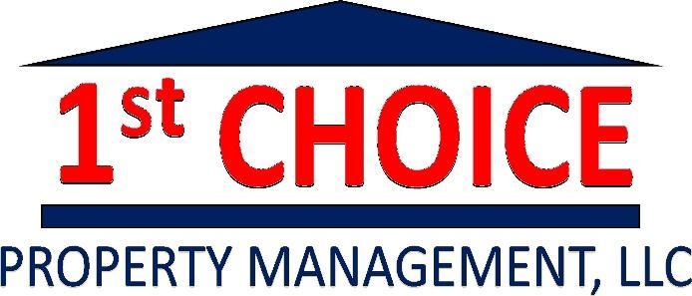
IMPORTANT REMINDERS:
RENT DUE:
Rent is due on the first to the fifth of every month unless housing manager approves differently. Please contact Hannah Roell if you are going to be late on any rent. If you do not contact Hannah, you will be charged the late fees $50 late fee and an additional $5 a day after.
PARKING PASS:
New parking passes will be handed out to tenants who are living in apartments. You may hang them in your rearview mirrors or lay them on your dash where they are visible. This allow us to keep track of current tenants, better parking, and to be able to get rid of vehicles who are not currently renting the property.
EMERGENCY:
In an emergency, you may contact the numbers listed below. Try calling the office first. Leave a message with your name, number, and problem if no one were to answer.
Hannah Roell: (740)-591-5713 Bernie Roell: (610)-906-9056
PLUMBING:
All waterlines have shut-off valves. If there is a water leak, locate the shut-off valve to shut off the water line closest to leak. If you cannot locate the shut-off nearest to water leak, there is main water shut-off near the hot water tank.
SEWER BACKUPS and FLOODING:
If plumbing is overflowing, locate the nearest shut-off valve to shut off water. By shutting off the water line, it allows to help stop the water flow, which supplies water in the sewer lines.
ABSOLUTELY NO GREASE:
DO NOT pour oils, fats, or grease down the drains. If you do so, tenant will be
ELECTRICAL:
All the breakers or fuses are located in the main electrical panel. If there are sparks, a tripped breaker, or any other immediate electrical issues, locate the main panel and flip the breaker. If there is an issue to where it creates a dangerous situation or there’s no electric, please call emergency number.
NO HEAT:
Sometimes gas heaters will have a pilot light that will need relit. There will be instructions on the unit to be able to light again. Please contact emergency number if you are not able to relight or if you have an electric unit.

