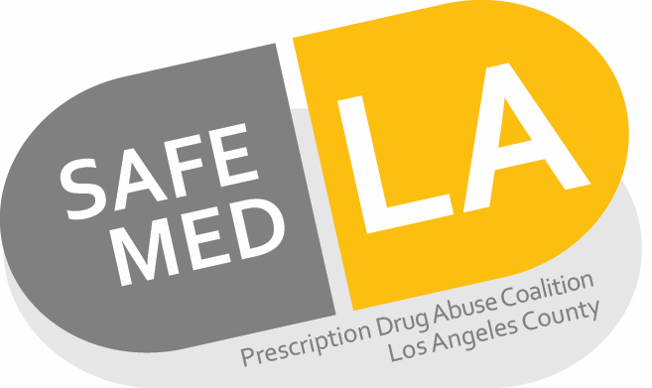

Pharmacy Practice Action Team
News Updates and Resources

FDA Updates

Prescription Opioid Cough and Cold Medicines: Drug Safety Communication – FDA Requires Labeling Changes
- Posted January 11, 2018
- FDA is requiring safety labeling changes for prescription cough and cold medicines containing codeine or hydrocodone to limit the use of these products to adults 18 years and older because the risks of these medicines outweigh their benefits in children younger than 18. FDA is also requiring the addition of safety information about the risks of misuse, abuse, addiction, overdose, death, and slowed or difficult breathing to the Boxed Warning, the most prominent warning, of the drug labels for prescription cough and cold medicines containing codeine or hydrocodone
- https://www.fda.gov/safety/medwatch/safetyinformation/safetyalertsforhumanmedicalproducts/ucm592053.htm

FDA, FTC warn companies for selling illegal, unapproved opioid cessation products using deceptive claims

- Posted January 24, 2018
- The U.S. Food and Drug Administration and the Federal Trade Commission today posted joint warning letters to the marketers and distributors of 12 opioid cessation products, for illegally marketing unapproved products with claims about their ability to help in the treatment of opioid addiction and withdrawal.
- The FDA and FTC issued joint warning letters to 11 companies for their products: Opiate Freedom Center (“Opiate Freedom 5-Pack”), U4Life, LLC (“Mitadone”), CalmSupport, LLC (“CalmSupport”), TaperAid (“TaperAid” & “TaperAid Complete”), Medicus Holistic Alternatives LLC (“Natracet”), NutraCore Health Products, LLC (“Opiate Detox Pro”), Healthy Healing, LLC (“Withdrawal Support”), Soothedrawal, Inc. (“Soothedrawal”), Choice Detox Center, Inc. (“Nofeel”), GUNA, Inc. (“GUNA-ADDICT 1”), and King Bio, Inc. (“AddictaPlex”).
- https://www.fda.gov/NewsEvents/Newsroom/PressAnnouncements/ucm593602.htm

FDA Drug Safety Communication: FDA limits packaging for anti-diarrhea medicine Loperamide (Imodium) to encourage safe use

- Posted January 30, 2018
- To foster safe use of the over-the counter (OTC) anti-diarrhea drug loperamide, the U.S. Food and Drug Administration (FDA) is working with manufacturers to use blister packs or other single dose packaging and to limit the number of doses in a package. We continue to receive reports of serious heart problems and deaths with much higher than the recommended doses of loperamide, primarily among people who are intentionally misusing or abusing the product, despite the addition of a warning to the medicine label and a previous communication. Loperamide is a safe drug when used as directed.
- https://www.fda.gov/Drugs/DrugSafety/ucm594232.htm

For a list of local retail pharmacies for in-store purchase of Narcan

Go to: https://www.narcan.com/
Click ‘How to Get’
Search by your zipcode

