CENTER DIRECTOR: DEANA DILLON

ACTIVITIES COORDINATOR: DIANE CAIN

TELEPHONE: (614) 837-3020 / FAX: (614) 833-6471
HOURS: MON-FRIDAY 8:30 a.m. - 4:30 p.m.
WEB PAGE: http://pickeringtonseniorcenter.org
EMAIL: DDillon@pickeringtonseniorcenter.com

A NOTE FROM DEANA
DUES FOR 2024 MEMBERSHIP
VIOLET TOWNSHIP - $15.00
OUTSIDE OF VIOLET TOWNSHIP - $20.00

Remember: Membership is free for anyone who turned 90 before January 1, 2024.

THANK YOU
I would like to thank our President and board members for the opportunity to be your director. Thank you all for all your kind words, and support. Thank you to Nancy for everything you have done for our center and for the training you have given me over the years, it will be put to good use, and you will be missed. Looking forward to you joining us in some of our daily activities.
Please stop in the front office and welcome our new Activities Coordinator, Diane, to our team!

$10.00 CLUB
We appreciate any contributions made to the Center. The money donated helps with funding the many activities we have for the members and with purchasing items needed for the kitchen, office, and other supplies.

We welcome the following new members:
John & Susan Arduini, Theresa Atkinson,
Bob & Pat Blades, Linda Dalgarn, Ron Drenner,
Sherry Fisher, Donald Greene Sr., Donald Haley,
Janet North-Liu, Phylis Mack, Bob & Jeannie Mauger, Roy Rutter, Cyndy Snyder, Phylis Mack,
Marilyn Ward, and Kathy Wesel.

HEAL2TOE FOOT CARE SERVICES
THURSDAY/ APRIL/18th & 25 ^{th} / 9:00 a.m.
Tonia is a State of Ohio Registered Nurse. She charges $35.00 for the following:
- 30-minute treatment – Trim, thin & file nails
- Corns & callouses filed & buffed smooth.
- All tools are sterilized for each patient.
- Payment due at time of service – Self-pay only
- No Medicare or Insurance will be billed.
To schedule an appointment at the center call:
HEAL2TOE FOOT CARE SERVICES (614) 686-3646

BOOK CLUB
THURSDAY/ APRIL 25TH
Our Book Club meets in our library. For the month of April, we will be reading “Happiness Falls” by Angie Kim. The book for May is “Where the Crawdads Sing “by Delia Owens. New
Members are always welcome. If you have questions, please give Carole Pruiksma a call,
614) 558-2190.

VOLUNTEER FOR THE OF MONTH APRIL

Our Center would like to honor, Sonny Schewe.
Sonny helps with pancake breakfast, clean up after parties, and Euchre Tournaments. Just a few of the things she helps out with. Enjoy your reserved parking space for the month of April and your $15.00 gift card. Thanks for all your help!

STRENGTH CLASS
MONDAYS AND WEDNESDAY/10-11A.M.
Come join us in our strength classes lead by Kelley Deibert. The focus is on building upper and lower body strength, stretching, and improving your balance. If you have weights, please bring them with you.

LINE DANCING - MONDAYS / 11:15-noon.

A new 12-week session will begin April 10th through July 3rd. Classes are on Mondays from 11:15a.m - 12:00p.m. Payments of $12.00 are due upon registration. A pay-per class option of $1.00 per class will be offered this session for those that can’t commit to the full 12 weeks. You can get a registration form in the office. For additional information contact Instructor, Marilyn Morgan, mnm@columbus.rr.com.

WATERCOLOR CLASS
EVERY MONDAY FROM 1-3 P.M.
Join Jenene Warmbier for adventures in watercolor painting. No previous training or talent necessary, just the desire to express yourself with “Paints and Brushes.” You can stop in the office and get a list of supplies you will need for the class. Jenene is a great teacher.

CORN HOLE
EVERY TUESDAY/ 11 A.M.
We play Cornhole every Tuesday. We have a tournament on the last Tuesday of each month.
January Winners were, Donna Bowers and Doug Hoek and February winners were, Bill Dunnette
and Dave McVay.

TUESDAY AFTERNOON MATINEE
APRIL 9th / 1:15p.m.
Join us for our Classic Movie. For the month of April, we will be showing “Dreamer,” starring Kurt Russell and Dakota Fanning. We supply movies, snacks, popcorn, and bottled water. You can use our chairs or bring your own folding chair.

BINGO
TUESDAY / APRIL 23 / 1:00p.m.
We willl be playing Bingo on the 4th Tuesday of April. There will be no potluck this month.

EUCHRE
EVERY WEDNESDAY / 12:30 P.M.
Come in, join your friends. We start playing at 12:30 p.m. The cost is only $2.25, which includes the games and the loner pot. Please be here at least 10 minutes ahead of time to get signed up so we can start on time at 12:30.

CRAFT GROUP
EVERY WEDNESDAY / 10 a.m. – noon.

Our craft group offers fun activities for our members, but also raises money for our Center. The most important fundraising activity they participate in is our Breakfast with Santa, which is usually held on the first Saturday of December.

DUPLICATE BRIDGE - Wednesdays 9:30 a.m.

BRIDGE - THURSDAYS 12:30P.M.
We’re looking for more members to play Bridge. Anyone interested in joining us, please call the Center and give your name and phone number. The cost to play either Bridge or Duplicate Bridge is $1.00 per week.

TITLE BOXING
THURSDAY / APRIL 4th, 11th & 18th
Maria Manzo from Title Boxing will lead the class at our Center from 9:00 to 9:45a.m. Sessions are around the Rock Steady Boxing curriculum which increases the neuroplasticity of the brain to help produce healthy brain cells. The exercises are designed to improve quality of life, have fun, and get results - all at the same time! You can purchase a bag and gloves for $30.00 at the class.

CHAIR VOLLEYBALL
We play Chair Volleyball every Thursday at 11:30a.m. It is led by Darie Wilson if you have any
questions, please give Darie a call, 740-358-6394.
It is a fun game and is played with a beachball.

CREATIVE WRITING GROUP
EVERY WEDNESDAY / 1:00p.m.
Our writing group meets every Wednesday @1:00p.m. in our craft room. This is a chance to share what you’ve written or would like to write and get feedback, tips, and ideas from others in a relaxed & fun setting. Your writing can be poetry, fiction, or non-fiction.

SOCIAL EUCHRE
EVERY FRIDAY / 11a.m.
This is a relaxed paced Euchre game where you can meet and play cards non-competitively. If you like to play cards for fun and you don’t mind teaching others when needed, then please join us.

PICKLEBALL
EVERY FRIDAY/ 10:30a.m
Join us for Pickleball every Friday @10:30am. They would love for more players to join the group.

STAYING HEALTHY IN YOUR HOME

The Violet Township Fire Department, Truro Township and the City of Whitehall Division of Fire are collaborating with Mt. Carmel Health Systems to develop a Community Paramedic program to further improve the health and welfare of the communities. The program was launched in January of 2019. For more information you can contact Lt. Postage at (614) 778-5561 or by email para@violet.oh.us

GAME ROOM
Our Game Room is open all day. We have a shuffleboard and a dart board.

PICKERINGTON FOOD PANTRY

MOST NEEDED ITEMS
Personal hygiene products - soap - paper towels -
toilet paper - toothpaste - toothbrushes – juices - condiments - tomato (paste, sauce or diced) - baking and pantry staples (flour, sugar, salt, baking soda and spices) - peanut butter and jelly – bread - butter. We have a collection container in our Center’s library. Please try to help the Food Pantry so they can help people in need. A big thank you to the people who have been donating for years.

LUNCHEONS
We will be bringing our monthly luncheons back starting in May. More details to follow.

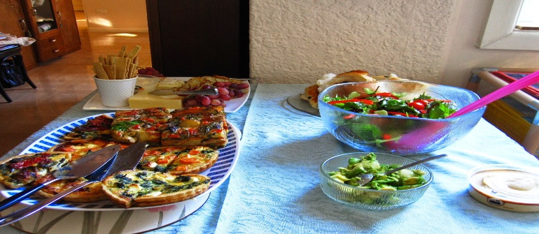
This Photo by Unknown Author is licensed under CC BY-NC-ND

TRIPS FOR 2024

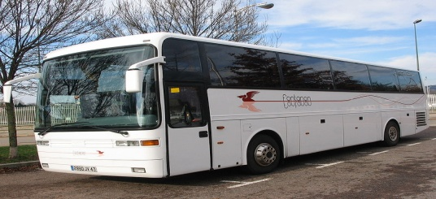

LACOMEDIA DINNER THEATRE
THURSDAY, APRIL 18TH
WEST SIDE STORY

The motorcoach will leave the Center at 8:00 a.m.

*MORE TRIPS WILL BE LISTED IN NEXT MONTHS NEWSLETTER

HAPPY EASTER
A celebration of love
Is what Easter is all about.
God expressed His love to man
In a way we can never doubt.
For God so love the world
That He gave His Son to die
To satisfy the penalty for sin
For people like you and I.
Who can love like that,
Who will pay such a high cost
To save mankind from sin
So that none need be lost?
Oh, the depth of the father's love,
Who gave his son to pay man's debt.
It surpasses all understanding
And is not something you can forget.
Because God so love the world
Jesus became a living sacrifice
So we could see what love looks like
And so we could have eternal life.
This Photo by Unknown Author is licensed under CC BY-SA
NOTES FROM DIANE

(1) Phyllis DeLooff, Joann George, Betty Luidhardt, Carol Pruiksma, Linda Thompson, Wayne Woodruff (2) Chuck Berry, Deborah Donley, Diane Heimberger, Eric Yruegas (3) Clover Rogers, Martha Stebelton (4) Carol Aurnou, Jan Homes, Nancy Huffman, Rick McGlone, Suzanne Salisbury, Linda Smith (5) Bonnie Brusco, Sunny Cook, Alberta Levengood, Mylinda Weber (6) Marge Kondash, Jerry Parker, Jeanne Postage (8) Diane Federer, Krista Pfeifer, Helen St.Cyr, John Nestor, Paulette Payne, Alice Tuttle (9) Sally Varvel (10) Tom Jones, Janet Marshall, Dick Smith (11) Linda Houchard, Patricia Walker (12) Phyllis Bichard, Mark Boggs, Norma Copley, Claudia Cox, Judy Myers, Carol Monhollen (13) Tammy Cozart, Patti Sayler (14) Carole Pope, Wilma Frank, Ken Hettinger (15) Cynthia Alexander, Rose Brothers, Diana Kantz, Rosemary Mans (16) Jonda Sims (17) Deanna Monroe, Sue Knorr, Scott Stewart, Theda Sweigart, Freda Sweigart, Elizabeth Woodruff (18) Christy Barber, Jackie Montgomery (19) Marcella Hoover, Teresa Pitts (20) Rita Chrisman, Melissa Stiles (21) Martha Fischer, Sharon Pletcher, Doloris Shepard (22) David Fortner, John Hunter, Dean Sigman, Christine Stortecky (23) Jaqi Eringman, Robin Hite, Pamela Ravn, Shirley Robbins (24) Donna Easley, Nancy Knoll (25) Irma Carmichael, David Carr, Melba Oard (26) Judy Curtis, Jane Narotski, Mike Sabatino (27) Sharon Kay, Betty Lofton, Theresa Pugh, Jenny Quigley, Janice Thomas, Kim Washington (28) Marlene Tedrick, Alice Young, Chris Zang (29) Deborah Little, Steven Tedrick (30) Bill Cook, Ed Drobina, Jeanette Perkins, Joann Smith, Alfrieda Stiles, Doug Wise.

MEMBERS KNOWN ILL
RuthAnn Marshall – Stroke, rehab
Robin Hutchinson – Pneumonia
JoAnn Smith – Broken hip
Jim Lehman – Pneumonia

MEMBERS IN SORROW
Barbara Diewald
Marge Klott (Nancy Lee’s Aunt)

CONGRATULATIONS
Ruth Ann Garand on her first great grandson, Simon.

HAVE A HAPPY & BLESSED EASTER

“PICKERINGTON SENIOR CITIZENS CENTER”

