Dear Congregation,
As many of you know, we are in the process of searching for our next Pastor at Christ Lutheran Church in Stockton. The call committee is quickly learning that there are many forms to complete and questions to answer during this process and we are hoping for some input from anyone who is interested in helping.
We would like to discuss some of these questions and the overall characteristics for our next pastor and goals for our church during a potluck following worship on Sunday, November 12th in the Fellowship Hall. All are welcome to attend. You may bring your completed surveys to the meeting, send them to church, or drop them off in the basket located in the back of the church. Please complete as much or as little of the survey as you feel necessary. If you have any questions, please reach out to one or more of the members of our call committee listed below:
Nicole Haas 815-238-5141
Darcie Raab 815-275-0300
Steve Jordan 815-541-8286
Cindy Bonnet 815-541-8426
John Curtiss 815-266-2346
Melissa Harbach 815-291-8987

Goals:
What are the primary goals of our church?

Energy:
What is our congregation really excited about right now?

Trends:
What are 3 trends or changes within the congregation which have occurred in the last three to five years?

Page 2
Mission:
What are the top few mission priorities which, if accomplished, hold the most promise for the continued development of this ministry?

Assets:
What are the top few assets of our congregation and how can we continue to leverage these assets to help our congregation thrive?

Obstacles:
What obstacles must we overcome to be able to accomplish this?

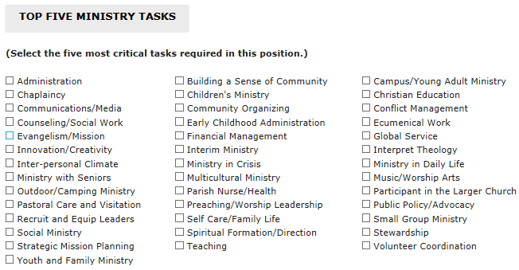

Thank you so much for your help during this process. Again, should you have any questions, please contact any member of the call committee.

