Coding Step ILT Training Outline
This outline contains 6 Lessons for a total of 120 training minutes.
Lesson 1: Welcome – 10 minutes

Slide 1 | 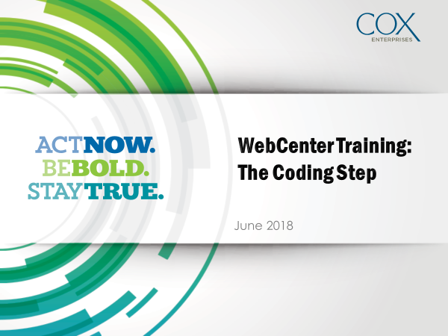
Pre-Lesson: Trainer | 1. Have PPT slide deck ready to go and projected: CODING (9 slides)  2. Ensure all participant materials are ready  - Tent cards and markers  - BINGO cards  - 3 Flipcharts (Requests, I-285 and Agenda)  - Scenario cards  - Small prizes (candy bar, flash drive, etc.)  3. Have flipcharts complete and hanging on the wall
Pre-Lesson: Participants | Materials: Tent card and markers; BINGO Cards  -Have participants fill out names on tent cards as they are getting seated into the training classroom.  -Ensure each participant has a BINGO card and tell them to read it over and choose a square for introductions.
Slide 2
Talking Points | - Welcome to the Oracle WebCenter Training Program  - Introduce self  - Participants state names and fill in BINGO card slot of their choice
Slide 3 | 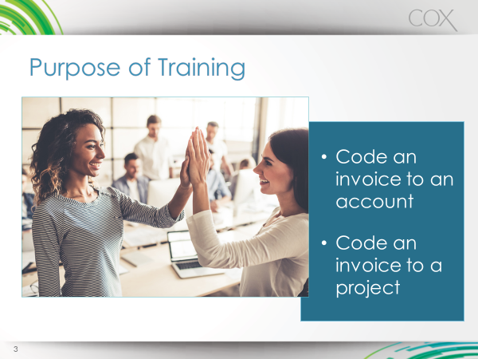
Talking Points | - The purpose of today’s training is to teach you a step you will be using in the OWC process.  - You will receive an overview of the entire process  - Your specific job means you will only really need to master the Coding Form step  - You will know if you are successful if you can code a project and code an account by the end of today’s training.
Flipcharts | Agenda, Requests, I-285
Talking Points | - There are 3 wall-sized post it notes: Agenda, Requests, I-285.  - Agenda sheet shows today’s training agenda.  - The Requests sheet is where I will write any requests you have for the training, such as being shown a particular tool within the Coding application.  - I-285 is for questions or topics we need to address at a later point in time in the training or post-training. Just like when you’re on I-285, it may feel like it’s taking forever to get to where you need to go but we’ll get there eventually.

Lesson 2: Introduction to the OWCI Process – 10 minutes
Slide 4-Animated | 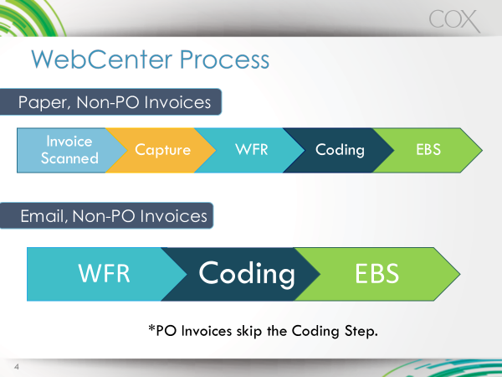
Talking Points | - The OWCI Process is a 2 or 3 step process depending on how invoices are received and also depending on the invoice type.  - Invoices are either PO Invoices  - Or Non-PO Invoices  - Today’s training only covers one of the Coding step, which is for Non-PO invoices.  - It’s important for you to understand how the entire process works  - This way, you can see how coding invoices falls into the big picture
Slide 4: Animation 1 | Paper, Non-PO invoices animation animates the steps
Talking Points | - All invoices need to make their way into the OWCI system electronically. Therefore, if an invoice is mailed via the postal service and is on paper, it will need to be scanned into an application called Capture.  - The Capture application extracts the information needed from the paper invoice and then sends it to the second step.
Slide 4: Animation 2 | Email, Non-PO invoice animation animates the steps
Talking Points | - After an invoice goes through the Capture step, it then proceeds to the second part of the step, the Web Forms Recognition (WFR) step.  - Sometimes people refer to this as the Verifier step  - In this step, the user must verify that the OWCI application captured the correct data from the invoice  - If an invoice is emailed, then the invoice skips the Capture step and goes straight to this step.  - If an invoice is a PO invoice, then it skips the Coding step and goes straight into Oracle E-Business Suite.  - If an invoice is NOT a PO invoice, then it goes to the Coding step in order to be correctly coded to either an account or to a project.  - This step is the step we will focus on for today’s training.  - After you complete coding an invoice, it then goes into Oracle EBS and the workflow ends.
Slide 5 | 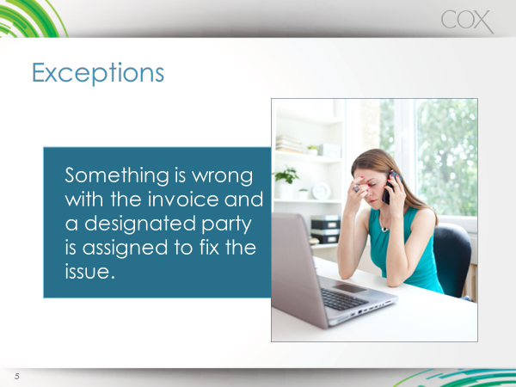
Talking Points | - Sometimes an invoice will have a problem which prevents a user from verifying information or from coding the invoice accurately.  - These invoices are called exceptions. Invoices are marked as Exceptions in the WFR step.  - Certain people are assigned to go into the Exceptions part of the application and fix the problems but that’s not part of the Coding step.  - When you reject an invoice, which will be covered later in the training, it DOES NOT go into the Exception queue. In fact, Coders will not have the ability to mark an invoice as an Exception.

Lesson 3: Coding Basics – 10 minutes
Slide 6 | 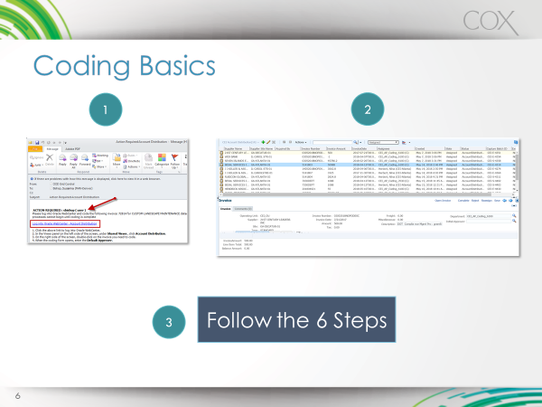
Talking Points | - Here is the process of completing the coding of an invoice:  - Email notification:  - You will receive an email notification telling you that you have an invoice to code  - The email will be sent to you individually or to a group that’s assigned to code (similar to ImageNow, once someone in your group codes the invoice, the invoice is removed from everyone in the group’s queue.)  - You will double-click on an invoice in a list of invoices to code  - You will complete the 6 steps to Coding an invoice  - When you code, you will either code to an Account or to a Project.  - The first time you log in, you will need to change your View settings to save time in the future.
Demo: Access Coding Form and change view settings | The trainer will log into the Coding application and demo for users how to change their view settings. *See Coding Reference Guide pages 4-8 for more details on how to demo this for participants.
Exercise | Users will log into the application and practice changing their View settings.

Lesson 4: Coding Demos and Practice – 45 minutes

Slide 7 | 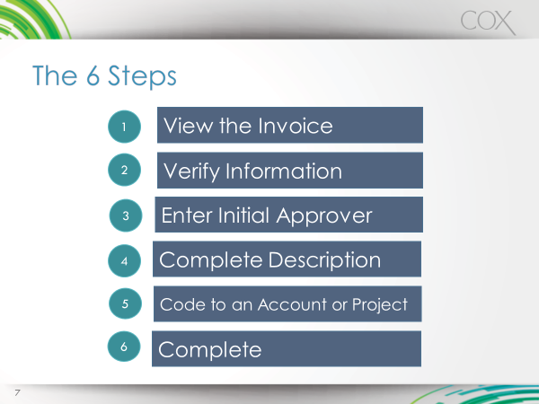
Talking Points | - There are 6 steps to coding an invoice, whether you code to an account or to a project.  - I will demo these steps for you and then you will practice them.
Demo: Code to an Account | The trainer will then show users how to code to an account. *See Coding Reference Guide pages 9-13 for more details on how to demo these steps for participants.
Demo: Code to a Project | The trainer will demo for users how to code to a project. *See Coding Reference Guide pages 14-15 for more details on how to demo these steps for participants.
Exercises | User will complete two exercises: how to code to an account and how to code to a project.

Lesson 5: Other Considerations - 35 minutes

Slide 8
Talking Points | - The way we’ve practiced coding invoices thus far has been pretty straight-forward.  - However, there are times when the invoice you’re coding requires some additional actions  - For example, you may need to split charges.  - For example, there may be times when you want to copy and paste similar pieces of information from one line item to the next.  - Therefore, now we’re going to look at and practice some other invoice considerations.
Activity and Demo: Different Invoice Scenarios | Materials: Scenario Cards.  In this activity, the trainer will present cards to the users. The users will pick a card and then read aloud the scenario. The trainer will then demo for users how to complete the action in the Coding Form.  Scenarios include:  - Sorting Multiple Columns  - Copy and Paste Coding to Multiple Lines  - Split Charges Between Accounts  - Combine Identical Lines  - Reassign an Invoice to Another Coder  - Reject an Invoice  *See Coding Reference Guide pages 15-21 for more details on how to demo these skills for participants.
Exercises | Working in pairs or independently, users will practice completing each exercise demoed in the activity.

Lesson 6: Questions and Closure - 10 minutes
Slide 9
Talking Points | - The trainer will answer any outstanding questions or address any issues not completed from the Requests or I-285 sheet.  - The trainer will present a prize to the winner or winners of BINGO.
Activity | BINGO Prizes  In this activity, any users who have attained BINGO on their BINGO sheets will present their results to the group. Winners will receive a small prize.

