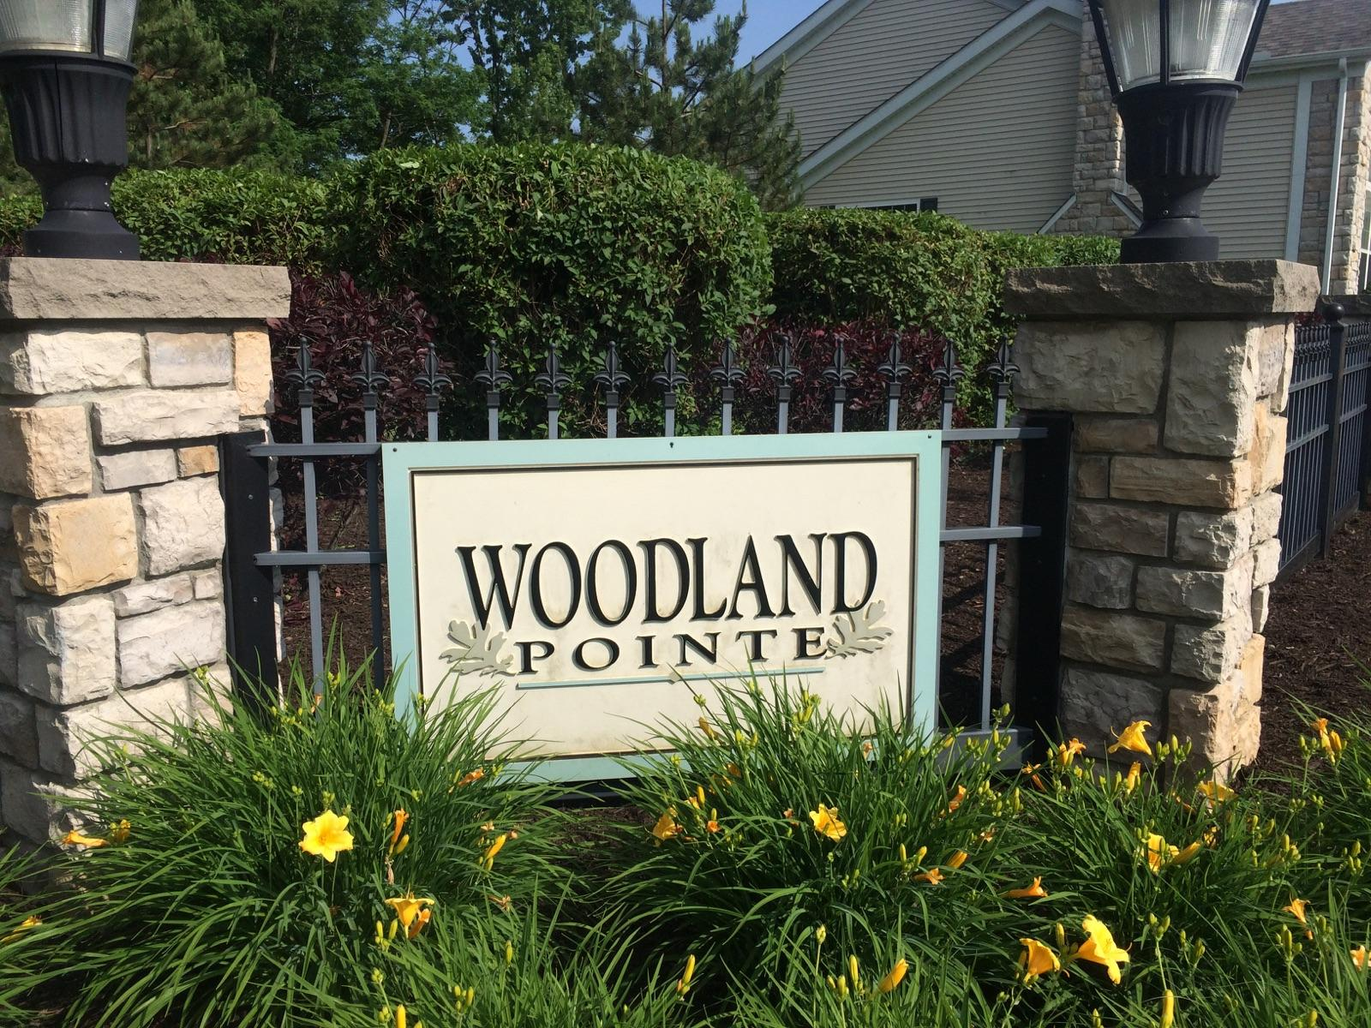
Woodland Pointe Homeowners Association
Collection Policy

1. All assessments, including maintenance fees, are due on the first (1st) day of the month and are considered late if not received by the 15th of the month.
2. An administrative late charge of $13.00 per month shall be incurred for any late payment and on any unpaid balance of the assessment. (Subject to increase upon further notice.)
3. Any payments made shall be applied in the following order:
1. Interest and/or administrative late fees owed to the Association
2. Collection costs, attorney’s fees incurred by the Association
3. Principal amounts owed on the account for common expenses and assessments.
4. Any past due assessments may cause a lien, a suit for money judgment, and/or foreclosure to be filed against the Unit/Lot. Once judgment is obtained, the Association may proceed to post-judgment actions such as foreclosure, bank attachment and/or wage garnishment.
5. Any costs, including attorneys' fees, recording costs, title reports and/or court costs, incurred by the Association in the collection of delinquent assessments shall be added to the amount owed by the delinquent Owner.
6. If any Owner (either by his or her conduct or by the conduct of any occupant) fails to perform any act that he/she is requested to perform by the Declaration, the Bylaws or the Rules and Regulations, the Association may, but shall not be obligated to, undertake such performance or cure such violation and shall charge and collect from said Owner the entire cost and expense, including reasonable attorney fees, of such performing or cure incurred by the Association. Any such amount shall be deemed to be an additional assessment and shall be due and payable immediately following notification of such charge, and the Association may obtain a lien for said amount in the same manner and to the same extent as if it were a lien for common expenses.
7. If any Owner is delinquent in the payment of any fees for more than thirty (30) days, the Board may suspend the privileges of the Owner to vote and/or use any of the amenities.

