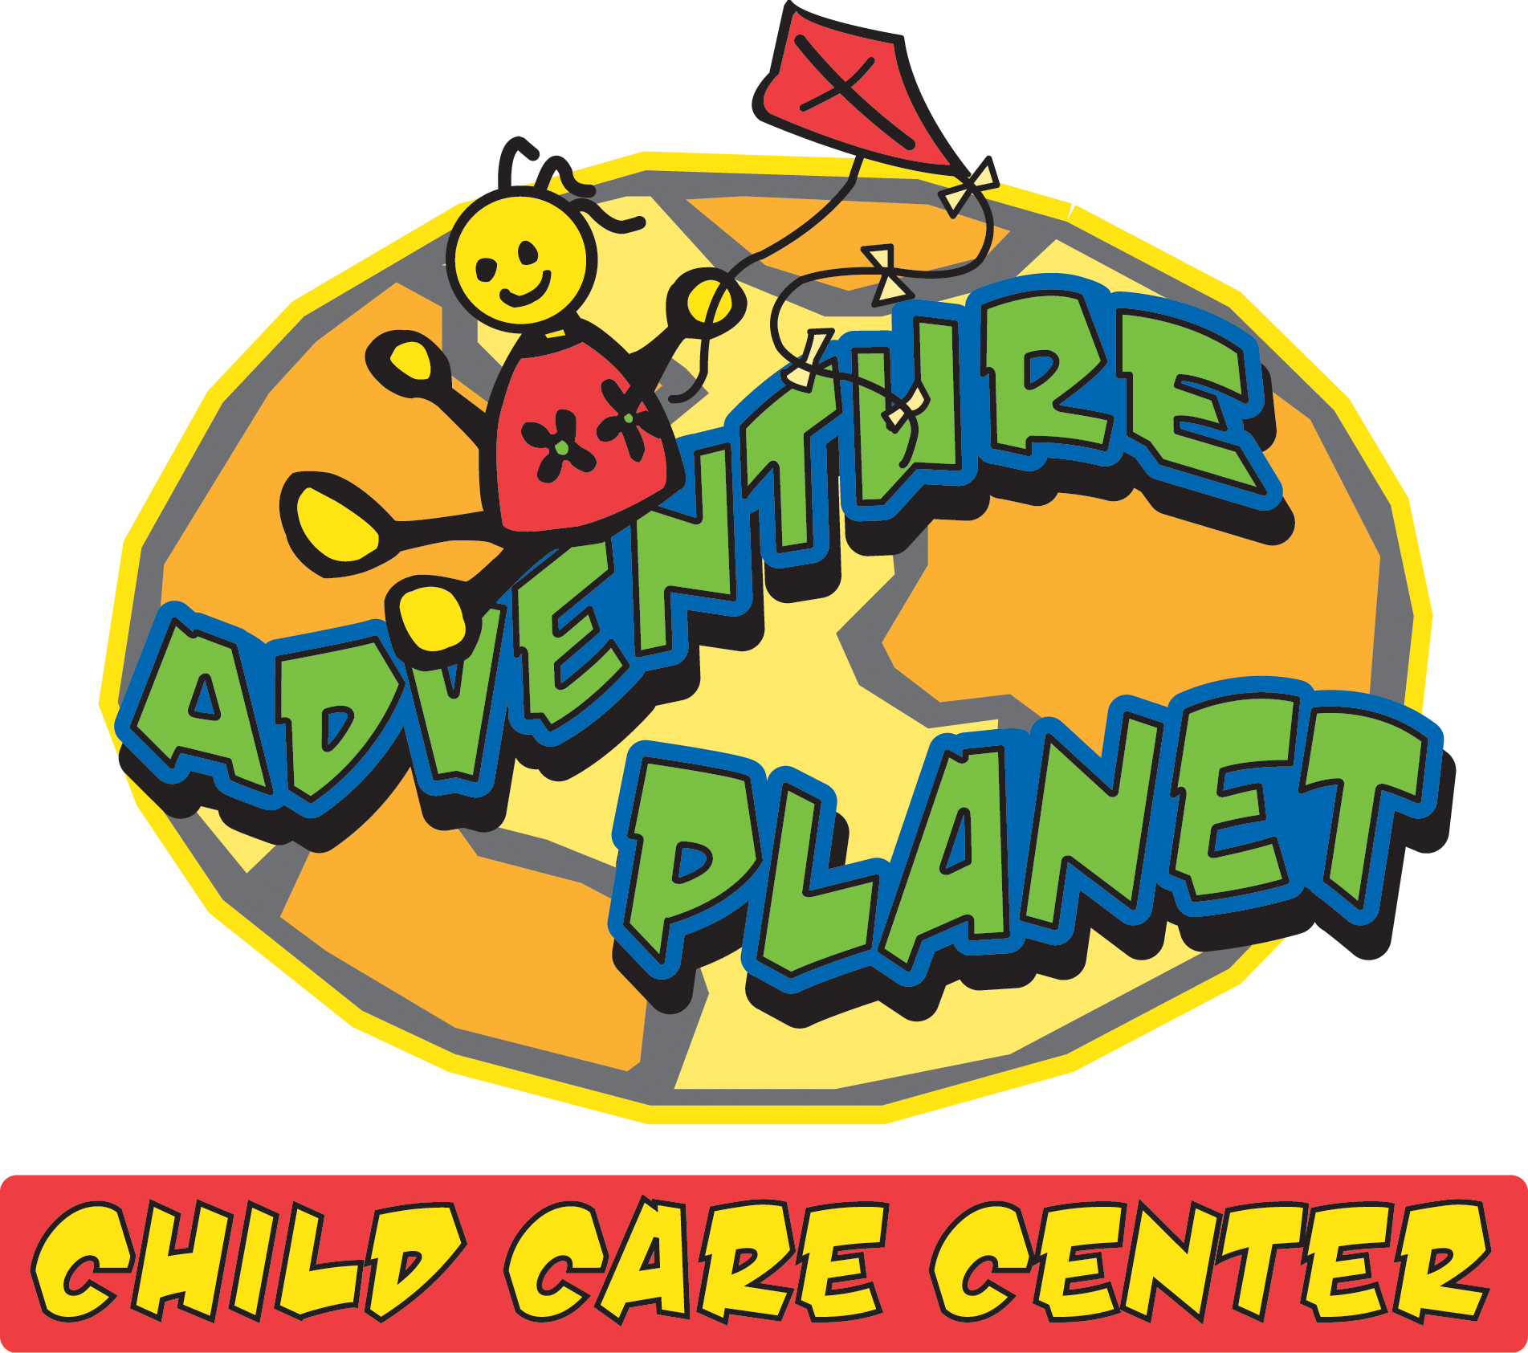

Dear Parents/Guardians:
We welcome you and your child to Adventure Planet. Adventure Planet staff provide a safe, healthy, nurturing environment where each child’s individual development is recognized and supported. Developmentally appropriate activities and enrichments are designed to promote each child’s physical, social, emotional, cognitive and creative self.
Please review this packet and complete the registration information enclosed. A tip sheet is provided below to ensure you have included all of the necessary information to guarantee your child a space in the Adventure Planet Child Chare Center.
Once we receive the registration information in our office we will verify that all of the information required is complete. At this point we will be prepared for your child on the first day at the center.
If you have additional questions or need additional information, please see the contact information below.
Thank you for your interest in Adventure Planet! We look forward to meeting you and your child.
REGISTRATION CHECKLIST
___Registration Form (completed and signed)
___Emergency Medical Release form (witnessed and signed)
___Medical Record form (front and back completed and signed – current immunizations must be written in)
___Health Assessment form (must be completed and signed by your child’s physician)
___ Behavior Guidance Plan (signed)
___Financial Contract (signed)
___Check or Money order for $50 (per child) registration fee

Please send or bring all items to one of our locations:
3059 W. 13th 5226 W. Central
Wichita, KS 67203 Wichita, KS 67212
(316)944-4275 (316)978-9220

Where every child’s a star!

