**THE NEXT WAR is inevitable**

**(WORLD WAR II)**

by

Marguerite dar Boggia

The Spiritual Hierarchy of our planet considers World War I and II as one war. We are told that World War III will be fought on the mental plane and not on the physical plane. We are also told not to blame our leaders. We are the ones who voted for them. Until we realize that we are all a part of the ONE FAMILY OF HUMANITY, in the One World, and until we act in brotherly love, for each other and for our planet, we will suffer the consequences.

On November 27, 2018 Tony Cartalucci wrote: "**Russia has seized three Ukrainian military vessels violating its territory near Russia’s newly completed Crimean Bridge. The incident is a clear provocation carried out by Kiev and possibly engineered by Kiev’s Western sponsors – particularly those in Washington and London."1**

President Vladimir Putin's chart progressed to November 27,2 is as follows:



Progressed MC (26° Libra) signifying the government and its leader, sextiles natal Mars (26° Sag.). It suggests that Putin has taken action (Mars) against the provocation of Ukraine.

To understand the future events, it is necessary to realize how and why the US CREATED THE COUP in Ukraine in 2014 with $5 billion dollars.3

Viktor Yanukovych was elected President of Ukraine in February 2014. The EU handed him a package and an agreement for him to sign in order to become a part of the EU. However, the economic terms offered by the EU were not favorable at all, so when Putin offered better financial terms, he accepted them. That was when ORGANIZED VIOLENCE and shooting on the streets began with snipers on the roofs, killing police, people on the streets and even Neo Nazis. Members of President Yanukovich’s ruling party, the Party of Regions, have been shot, had arrest warrants issued for them, have experienced home invasions and physical threats, and resigned indroves in hopes of saving the lives of themselves and their families. The prosecutor’s office in the Volyn region (western Ukraine) had been ordered by ultra-nationalists to resign en masse. Jewish synagogues and Eastern Orthodox Christian churches were attacked.4 Then the Neo Nazis with their guns, **placed themselves in positions of power in the rada (parliament), security, defense, the armed services, Intelligence, police force,** etc. They had orders to kill everyone in Yanukovych's party. Yanukovich was frightened and fled to Russia on his helicopter. The Crimeans were frightened and asked Vladimir Putin for protection. Putin sent Russian soldiers. Later the Crimeans VOTED to be part of Russia.

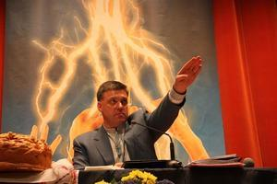 Victoria Nuland, (the United States Assistant Secretary of State for European Affairs) and Senator John McCain admired Oleh Tyahnybok, the Leader of the Neo Nazi Party. When he spoke before 100.000 people, as Hitler did, the audience was mesmerized. This is his picture. The name of the Neo Nazi party was later changed to Svoboda, which means 'freedom.' Today Israel is arming Ukraine.4a

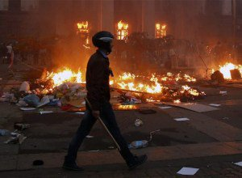 On May 2nd, 2014, the Neo-Nazis, Right Sector Militia and football players burned the Trades Union building in Odessa, causing people inside, to be **BURNED ALIVE**. Those who tried to escape from windows were shot and some were strangled. The U.S. never called for an investigation5. The burning of the Trade Union Building was seen on TV not only in Ukraine, and in Crimea but in Russia. The Nazis were crying "kill all of the Russians". This is a picture of the burning building.

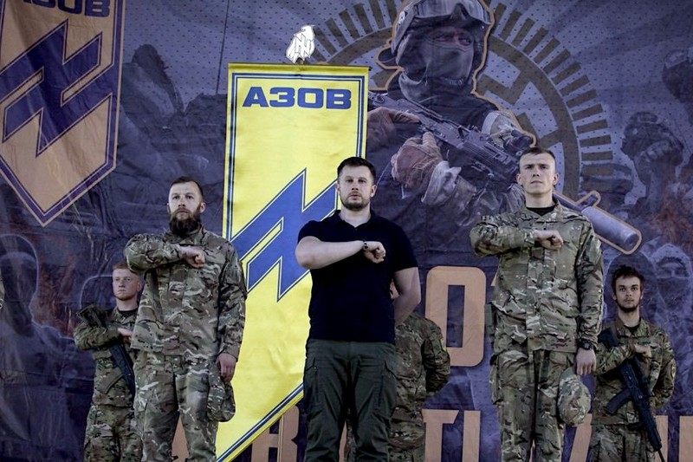 Then there was an election in June 2014, but Eastern Ukraine was NOT represented. Victoria Nuland nominated for the presidency, Petro Poroshenko, the chocolate billionaire. He was elected. He had neo nazis in his cabinet and in his government. They caused the crash of the Malaysian passenger plane MH17.6The crash was later blamed on the Russians.

In 2016 Poroshenko petitioned the Supreme Court of Ukraine to rule that his Administration was a COUP and to restore the previous administration.7 He is a prisoner and victim in his own country. He has to take orders. The mainstream media never reported this, nor the result of Poroshenko's petition. No doubt, it was denied. President Obama also had to take orders.7a

The NATO Nations placed NUCLEAR WARHEADS directed at Russia in Ukraine.8 Poroshenko cannot control the neo-Nazis in his government. He realizes that it will be Ukraine that will be decimated by a nuclear war; and all this, for the purpose of regime change in Russia? Instead of world goodwill, we are promoting a world disaster.

When General Wesley Clark was running for President in 2004, he said on TV that he met with his General friend and the General told him that the Bush Administration is crazy. "**They want to take out seven Islamic countries in five years**: **Iraq, Syria, Libya, Lebanon, Somalia, Sudan, and Iran."**9 What we would like to know is WHO and WHY was this order given? The Forces of Evil feed on hatred and discord in the world.9a

The major Media is controlled by the FINANCIAL/GLOBAL ELITE aka CABAL10 who make the decisions for the world. They work for the Forces of Evil. They are preparing the public, through their Media, for a nuclear war with Russia possibly starting in 2023. They require regime change in Russia for their GLOBAL DOMINATION.10a

The world now has the internet. They see the corruption by money of representatives in their government voting for the bills requiring the public to bail out a failed bank gambling with QUADRILLIONS in derivatives exchange.11

Whenever a negative polarity, i.e. corruption, is predominant, as it is today, it attracts a positive polarity to balance it. That positive polarity is the Head of the spiritual hierarchy of our planet. He is the World Teacher, a Planetary Avatar, whom all religions have been awaiting.

On page 211 of the book *A Treatise on Cosmic Fire*, by Alice A. Bailey, under footnote…the World Teacher…is the following: “. . . **. The Buddha held office prior to the present World Teacher and upon His illumination His place was taken by the Lord MAITREYA whom the Occidentals call the Christ.”12**

In June 1988 the Lord Maitreya suddenly appeared at a healing gathering of thousands of people in Nairobi, Kenya. The editor of the newspaper was present and took this picture of Maitreya.

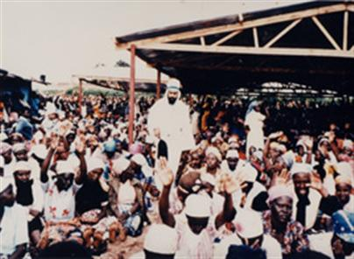

Maitreya spoke in Swahili to the people for 17 minutes. For more information on Maitreya and on miracles happening all over the world, see: [www.share-international.org](http://www.share-international.org)

The major Media conceals this information. The Global Elite does not want economic changes, which the Lord Maitreya will bring for the welfare of all of humanity.

We are destined to have the Golden Age. It will just take longer to manifest. Humanity has so many blessings in store for it as soon as the Lord Maitreya can make His presence known through the major Media. Then, all 49 Ashrams of the Masters which includes their Initiates and disciples, will externalize and live with us once again on the material plane. Their vibrations are so potent. It means that the spiritual Kingdom will now be on earth. In addition great Devas (angels) will teach men how to heal with color and sound, how to nourish the body and to draw from the surrounding ether the necessary food.13

**∆ ∆ ∆**

*Marguerite dar Boggia* formerly served as Secretary and Membership Chairperson of ISAR (the International Society for Astrological Research), the publisher of Kosmos, the ISAR Journal and as Secretary and Director of ISAR and UAC, (the United Astrology Congress). She is a co-founder of UAC. Her articles are published in the ISAR journal and in other publications. They are on her website, which she created at the age of 90**:** [**www.FreePythagorasTeachings.com**](http://www.FreePythagorasTeachings.com)At this time she offers **FREE** of charge **three pages weekly online** of the Ancient Wisdom Teachings as was known by **Pythagoras.** She can be contacted through her website for these esoteric teachings.

References:

### [1](https://www.google.com/url?sa=t&rct=j&q=&esrc=s&source=web&cd=1&cad=rja&uact=8&ved=2ahUKEwi02ZGG86XfAhVLj1QKHZ_VAo4QFjAAegQIChAB&url=https%3A%2F%2Fwilliambowles.info%2F2018%2F11%2F27%2Fukraine-provokes-russia-to-what-end-by-tony-cartalucci%2F&usg=AOvVaw3Yr8IIfMRGtSmv9lZ9cW1J)[Ukraine Provokes Russia to What End? By Tony Cartalucci](https://www.google.com/url?sa=t&rct=j&q=&esrc=s&source=web&cd=1&cad=rja&uact=8&ved=2ahUKEwi02ZGG86XfAhVLj1QKHZ_VAo4QFjAAegQIChAB&url=https%3A%2F%2Fwilliambowles.info%2F2018%2F11%2F27%2Fukraine-provokes-russia-to-what-end-by-tony-cartalucci%2F&usg=AOvVaw3Yr8IIfMRGtSmv9lZ9cW1J)

2Vladimir Putin was born on Oct. 7, 1952 at 9:30 AM (-3 BAT time zone) in St. Petersburg, Russia; 30E18; 59N56. Information is from his Webmaster.

**3**[**American Conquest by Subversion: Victoria Nuland's Admit**](https://www.google.com/url?sa=t&rct=j&q=&esrc=s&source=web&cd=1&cad=rja&uact=8&ved=0ahUKEwjm8py6jLfLAhUP0GMKHUOKCeIQFggcMAA&url=https%3A%2F%2Fcounterinformation.wordpress.com%2F2014%2F02%2F07%2Famerican-conquest-by-subversion-victoria-nulands-admits-washington-has-spent-5-billion-to-subvert-ukraine%2F&usg=AFQjCNHqtlpDw0Qpj9gmd5634arUrTJJfQ&bvm=bv.116636494,d.cGc)s

http://www.globalresearch.ca/american-conquest-by-subversion-victoria-nulands-admits-washington-has-spent-5-billion-to-subvert-ukraine/5367782 Feb 7, 2014 **...** “After three visits to **Ukraine** in five weeks, **Victoria Nuland** explains that in ... has spent five **Billion dollars** ($5,000,000,000) to subvert **Ukraine**, ...

**4**[**Ukrainian Neo-Nazis Declare that Power Comes Out of the ...**](https://www.google.com/url?sa=t&rct=j&q=&esrc=s&source=web&cd=2&cad=rja&uact=8&ved=0CCQQFjABahUKEwjlx4m-kbbHAhXLnYgKHfz-BpM&url=http%3A%2F%2Fwww.globalresearch.ca%2Fukrainian-neo-nazis-declare-that-power-comes-out-of-the-barrels-of-their-guns%2F5371126&ei=UPvUVeXfI8u7ogT8_ZuYCQ&usg=AFQjCNEAV47Qral5p4dbox_wW0Y0uJo6_g)

### [4a](https://www.google.com/url?sa=t&rct=j&q=&esrc=s&source=web&cd=1&cad=rja&uact=8&ved=2ahUKEwjb9_GLwqzfAhWD0VQKHeeWBz0QFjAAegQIABAB&url=https%3A%2F%2Fwww.globalresearch.ca%2Fisrael-is-arming-neo-nazis-in-ukraine%2F5650478&usg=AOvVaw1nb6e5zkIACoSY3xMYgQxJ)[Israel Is Arming Neo-Nazis in Ukraine - Global Research](https://www.google.com/url?sa=t&rct=j&q=&esrc=s&source=web&cd=1&cad=rja&uact=8&ved=2ahUKEwjb9_GLwqzfAhWD0VQKHeeWBz0QFjAAegQIABAB&url=https%3A%2F%2Fwww.globalresearch.ca%2Fisrael-is-arming-neo-nazis-in-ukraine%2F5650478&usg=AOvVaw1nb6e5zkIACoSY3xMYgQxJ)

### 5[Odessa Slaughter: How A Vicious Neo-Nazi Mob Burnt Anti ..](https://www.google.com/url?sa=t&rct=j&q=&esrc=s&source=web&cd=1&cad=rja&uact=8&ved=0CB4QFjAAahUKEwimut-dp7HHAhVRlYgKHV3MAjU&url=http%3A%2F%2Fwww.globalresearch.ca%2Fodessa-slaughter-how-a-vicious-neo-nazi-mob-burnt-anti-government-activists-alive%2F5380403&ei=B3PSVeaaKdGqogTdmIuoAw&usg=AFQjCNFRIX0EQ9Kf6-Jo2m9RsJ46Oh7rGA)

### 6[Evidence Is Now Conclusive: Two Ukrainian Government ...](http://www.globalresearch.ca/evidence-is-now-conclusive-two-ukrainian-government-fighter-jets-shot-down-malaysian-airlines-mh17-it-was-not-a-buk-surface-to-air-missile/5394814)

**7**[**Ukraine's President Poroshenko Says Overthrow of ...**](https://www.google.com/url?sa=t&rct=j&q=&esrc=s&source=web&cd=1&cad=rja&uact=8&ved=0CB4QFjAAahUKEwistZfpi7PHAhXFO4gKHRn4DGs&url=http%3A%2F%2Fwww.globalresearch.ca%2Fukraines-president-poroshenko-says-overthrow-of-yanukovych-was-a-coup%2F5457631&ei=uWLTVez0CcX3oASZ8LPYBg&usg=AFQjCNEn3tUUsgqgp8PT_IMiKrEyL08PFA&bvm=bv.99804247,d.cGU)

[**www.globalresearch.ca/ukraines-president-poroshenko-says.../5457631**](http://www.globalresearch.ca/ukraines-president-poroshenko-says.../5457631)

**7adar Boggia, Marguerite "*John Kerry, The Next President in 2021"* www.FreePythagorasTeachings.com under Articles**.

### [8](https://www.google.com/url?sa=t&rct=j&q=&esrc=s&source=web&cd=4&cad=rja&uact=8&ved=2ahUKEwi5nsn2waffAhXyOn0KHQIKBHQQFjADegQIBxAB&url=https%3A%2F%2Fwww.globalresearch.ca%2Fthe-world-at-the-brink-of-nuclear-war-it-is-only-by-chance-that-the-world-has-avoided-a-nuclear-war%2F5538304&usg=AOvVaw3bW_YyIyy9P7hvKo6Wn18d)[The World, at the Brink of Nuclear War: "It is only by ... - Global Research](https://www.google.com/url?sa=t&rct=j&q=&esrc=s&source=web&cd=4&cad=rja&uact=8&ved=2ahUKEwi5nsn2waffAhXyOn0KHQIKBHQQFjADegQIBxAB&url=https%3A%2F%2Fwww.globalresearch.ca%2Fthe-world-at-the-brink-of-nuclear-war-it-is-only-by-chance-that-the-world-has-avoided-a-nuclear-war%2F5538304&usg=AOvVaw3bW_YyIyy9P7hvKo6Wn18d)

### [https://www.globalresearch.ca/the-world-at-the...nuclear...nuclear.../5538304](https://www.google.com/url?sa=t&rct=j&q=&esrc=s&source=web&cd=4&cad=rja&uact=8&ved=2ahUKEwi5nsn2waffAhXyOn0KHQIKBHQQFjADegQIBxAB&url=https%3A%2F%2Fwww.globalresearch.ca%2Fthe-world-at-the-brink-of-nuclear-war-it-is-only-by-chance-that-the-world-has-avoided-a-nuclear-war%2F5538304&usg=AOvVaw3bW_YyIyy9P7hvKo6Wn18d)

### 9Global Warfare: “We're going to take out 7 countries in 5 years: Iraq

9aWilcock, David, ***Ascension Mysteries*** ,Penguin Random House LLC, pp.430-433

10[World Bank Whistleblower Reveals How The Global Elite ...](https://www.google.com/url?sa=t&rct=j&q=&esrc=s&source=web&cd=1&cad=rja&uact=8&ved=0CB4QFjAAahUKEwjIopzBn7bHAhVIW4gKHa71B_Q&url=http%3A%2F%2Fwww.globalresearch.ca%2Fworld-bank-whistleblower-reveals-how-the-global-elite-rule-the-world%2F5353130&ei=BQrVVYiMEci2oQSu65-gDw&usg=AFQjCNFWFWycs-tAjp9xAZy1b0TE8Uzhfg)

10adar Boggia, Marguerite "***The Secret Space Program***", www.FreePythagorasTeachings.com under Articles.

11[**Russian Roulette: Taxpayers Could Be on the Hook for ...**](http://www.globalresearch.ca/russian-roulette-taxpayers-could-be-on-the-hook-for-trillions-in-oil-derivatives/5420960)

**12Bailey, Alice A. *A Treatise on Cosmic Fire*, Lucis Publishing Co. 1967, P. 211**

**13Bailey, Alice A. *Esoteric Psychology I*, Lucis Publishing Co. N.Y. 1975, p. 124**