REGULAR MEETING
MARCH 21, 2019

A Public Hearing and the Regular Meeting of the Town Board of the Town of Hampton, County of Washington and the State of New York was held at the Town Hall, 2629 State Route 22A, Hampton New York on the 21st day of March 2019.

PRESENT: David K. O’Brien------------Supervisor
Tamme Taran----------------Councilwoman-came at 7:22pm
Donald Sady-----------------Councilman
Andrea Sweeney------------Councilwoman
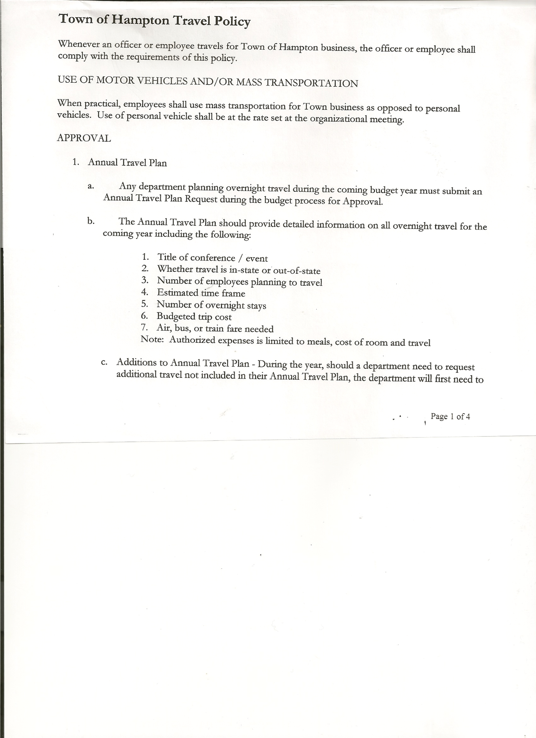
Roger Weeden---------------Councilman
Rebecca Jones---------------Town Clerk
Camilla Shaw----------------Tax Collector/Deputy Town Clerk
Herbert Sady, Jr.-------------Highway Superintendent

Planning Board Member(s): Steve Fernett, Ginny Kinsey and Matthew Pratt

Also present: see attached list

The Public Hearing was called to order by Supervisor O’Brien at 7:15pm

Town Clerk Jones read the Legal Notice of Public Hearing (copy attached), which was published in the Manchester Newspapers (The Granville Sentinel and Whitehall Times) on 02/28/19, on proposed Local Law 1 of 2019 titled “Amending The Town of Hampton Site Plan Review Law”.

Supervisor O’Brien opened the floor for comments.
Steve Fernett, member of the Planning Board explained the changes to the law, which included the addition of the Solar Energy info and the fee schedule change.
Dianne Sofia thanked the present Planning Board for all their hard work on the revised Site Plan Review Law.
Supervisor O’Brien asked three (3) times if there were any more comments. All persons desiring to be heard, having been heard, the Public Hearing was closed at 7:22pm.

REGULAR MEETING
The Regular Meeting was called to order by Supervisor O’Brien at 7:30pm, followed by the Pledge of Allegiance. Location of Fire Exits were given. Quorum of board members present.

RESOLUTION NO. 39-2019
APPROVAL OF THE MINUTES
On a motion of Councilwoman Taran, seconded by Councilman Sady, the following resolution was ADOPTED: Ayes 5 O’Brien, Taran, Sady, Sweeney, Weeden
Nays 0
RESOLVED, that the Regular Town Board Minutes for February 21st, 2019 are approved.

Permits/Subdivision
Cynthia Hollister submitted a Lot Line Adjustment. Looking to increase lot size to 4.71 +/- acres.
RESOLUTION NO. 40-2019

TOWN BOARD MEETING
MARCH 21, 2019 PAGE 2

SHORT ENVIRONMENTAL ASSESSMENT FORM/NEGATIVE DECLARATION
On a motion of Councilman Sady, seconded by Councilman Weeden, the following resolution was ADOPTED: Ayes 5 O’Brien, Taran, Sady, Sweeney, Weeden
Nays 0
RESOLVED, that the Short Environmental Assessment Form for Cynthia Hollister is complete and to adopt a negative declaration and finding that there will be no adverse environmental impacts and to consider it a minor subdivision, therefore waving the public hearing.

RESOLUTION NO. 41-2019
APPROVAL OF SUBDIVISION
On a motion of Councilwoman Taran, seconded by Councilman Weeden, the following resolution was ADOPTED: Ayes 5 O’Brien, Taran, Sady, Sweeney, Weeden
Nays 0
RESOLVED, to approve Cynthia Hollister’s lot line adjustment.

Camilla Shaw, Tax Collector- 618 parcels have been paid so far. Submitted February 2019 report to the Board and also submitted a Bank Statement to the Board for review and signatures.

Larry Carman, Dog Control Officer…no report submitted.
Shelter Agreement for 2019…. Supervisor O’Brien negotiated a lesser fee from $1000.00 to $500.00 for the year with Animal Safe Home & Rehab.

RESOLUTION NO. 42-2019
DOG SHELTER AGREEMENT FOR 2019
On a motion of Councilwoman Taran, seconded by Councilman Sady, the following resolution was ADOPTED: Ayes 5 O’Brien, Taran, Sady, Sweeney, Weeden
Nays 0
RESOLVED, to authorize Supervisor O’Brien to sign the new Dog Shelter Agreement
with Animal Safe Home & Rehab.

Planning Board Report…No March was held.
- Next meeting will be April 10th, 2019 @ 7:00pm at the Town Hall

Herbert Sady, Jr., Highway Superintendent submitted his report, copy of which, is attached.
Herb has spoken with Galusha about a cement based fill that some towns have been using on roads, he may look into using.
Discussion regarding a driveway on Roberts Lane, Highway Superintendent is to be contacted before any driveway is installed.
New Highway Employee has been hired, his name is Edward Langley.

TOWN BOARD MEETING
MARCH 21, 2019 PAGE 3

RESOLUTION NO. 43-2019
APPROVAL OF SUPERVISOR’S MONTHLY REPORT
On a motion of Councilman Sady, seconded by Councilman Weeden, the following resolution was ADOPTED: Ayes 5 O’Brien, Taran, Sady, Sweeney, Weeden
Nays 0
RESOLVED that, the Supervisor’s Monthly report be accepted as submitted for FEBRUARY.
1/31/19 02/28/19
ACCOUNT BALANCE RECEIPTS DISBURSEMENTS BALANCE
General Fund $212,163.84 $121,748.93 $ 8,866.12 $ 81,548.79
Highway Fund $ 11,100.56 $214,895.40 $ 11,189.99 $214,805.97
Equipment Reserve $ 94,152.38 $ 3.61 $ 0.00 $ 94,155.99
Fire #1 $ 0.00 $ 41,616.00 $ 0.00 $ 44,616.00
Fire #2 $ 0.00 $ 7,756.00 $ 0.00 $ 7,756.00
Cemetery $ 1,710.89 $ .54 $ 0.00 $ 1,711.43
Totals $319,127.67 $142,522.62 $ 20,056.11 $441,594.18
All Board Members present signed Supervisor’s Report.

Letter attached from Town Attorney is in response to questions on Town Board’s authority over Elected Highway Superintendent and Elected Town Clerk.

RESOLUTION NO. 44-2019

MOTION BY: Councilman Donald Sady
SECONDED BY: Councilwoman Tamme Taran

RESOLUTION ADOPTING LOCAL LAW
AMENDING THE TOWN OF HAMPTON SITE PLAN REVIEW LAW

WHEREAS, pursuant to Section 10 of Municipal Home Rule Law, the Town Board of the Town of Hampton (the “Town”) has the authority to adopt local laws; and

WHEREAS, pursuant to Town Law Article 16, the Town Board has the power to adopt local laws including site plan review within the Town; and

WHEREAS, the Town currently has a site plan review law; and

WHEREAS, the Town’s planning board has reviewed the Town’s site plan review law and recommended certain updates including but not limited to updates regulating solar energy systems within the Town; and

WHEREAS, the Town Board previously adopted a resolution introducing a local law amending the Town of Hampton site plan review law and has held a public hearing thereon; and

TOWN BOARD MEETING
MARCH 21, 2019 PAGE 4

WHEREAS, the proposal is an “action” under the State Environmental Quality Review Act (SEQRA); and

WHEREAS, the action is an unlisted action under SEQRA and the Town Board will undergo uncoordinated review of same pursuant to SEQRA pursuant to an environmental assessment form provided with the draft local law; and

WHEREAS, the Town Board is desirous of proceeding with the adoption of this proposed Local Law.

NOW, THEREFORE BE IT RESOLVED that the Town Board has reviewed the environmental assessment form and hereby finds that upon consideration of same, the adoption of the proposed local law will not have an adverse impact on the environment and hereby declares and adopts a negative declaration thereon; and be it further

RESOLVED, that the Town Board, upon due deliberation of the proposed Local Law and the comments presented at the public hearing, finds that the adoption of the same shall be in the best interests of the Town; and be it further

RESOLVED, that proposed Local Law 1 of 2019 is hereby adopted as Local Law 1 of 2019; and be it further

RESOLVED, that pursuant to and in accordance with the Municipal Home Rule Law, the Town Clerk is hereby directed to enter Local Law 1 of 2019 into the minutes of this meeting and file the same with the Office of the Secretary of State of the State of New York; and be it further

RESOLVED, that this resolution shall take effect immediately.

DATED: March 21, 2019 Supervisor O’Brien AYE
Councilwoman Taran AYE
Councilman Sady AYE
Councilwoman Sweeney AYE
Councilman Weeden AYE

Hampton Fire Company has declined sharing services regarding the garbage dumpster.
Highway Superintendent Herb Sady will work on getting quotes for garbage removal.

The Town Clerk’s report for February, 2019 was submitted to the Board. The Town Clerk had Board Members review and sign bank reconciliation statements for the Town Clerk Account and Special Town Clerk Account dated February 28th, 2019.

TOWN BOARD MEETING
MARCH 21, 2019 PAGE 5

PUBLIC COMMENTS/COUNCIL COMMENTS
Thank you from Town Clerk, Rebecca Jones for everyone’s thoughts and prayers for her sister Linda Reed who suffered a stroke.

Thank you from Dianne Sofia to Supervisor O’Brien for listening to complaints about the roads.

RESOLUTION NO. 45-2019

AUDIT OF CLAIMS
On a motion of Councilwoman Taran, seconded by Councilman Sady, the following resolution was ADOPTED: Ayes 5 O’Brien, Taran, Sady, Sweeney, Weeden
Nays 0
RESOLVED that the bills have been reviewed by the Town Board and are authorized for payment in the following amounts.
General Fund No. 43 through No. 56 $ 9,765.07
Highway Fund No. 20 through No. 26 $10,495.19
Total both funds $20,260.26

On a motion of Councilwoman Taran, seconded by Councilman Sady, the meeting adjourned at 8:30pm. All in favor Aye.

Respectfully submitted,

Rebecca S. Jones, RMC
Town Clerk

