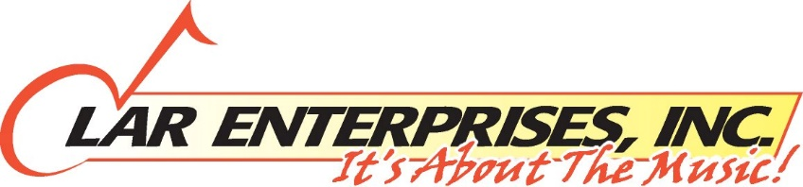
A WEEKEND OF DOO-WOP AND ROCK N’ ROLL
2018 TICKET ORDER FORM
If you would like to purchase tickets, please follow instructions below:

If you would like the same seats you currently have, fill out the information below and choose “YES” to charge your credit card. Your card will be charged starting September 15th by LAR Enterprises.
We will mail your tickets to you.
You can return this form this weekend to us but no later than September 8, 2017.
If you would like to change your current seats and prefer to be notified for our pre-sale, please fill in your e-mail address below. You will be notifided by e-mail with a link to both days and you can then choose your seats on-line 7 days a week or you can call 1-888-718-4253 (Option 1) Mon-Fri 9:00am to 9:00pm EST. After you complete buying your tickets you must PRINT YOUR TICKETS OUT AND BRING THEM TO THE CONCERT(S) ! Our pre-sale is September 24th – October 3rd .
You can return this form this weekend but no later then September 8, 2017.

E-mail Address:_________________________________________________________
Due to revised lower pricing, 2 day discounts and Group pricing rates no longer apply.
Number of Tickets Each Day:

April 21st ________ @ 5:00pm April 22nd_________ @3:00pm Orchestra A-T $65
Orchestra U_Z $55
Mezzanine Name:_________________________________________________ No Extra Charges

Mailing Address:___________________________________________________________

City: ___________________ State:_______________ Zip:________________

Credit Card Type: VISA MASTERCARD AMEX DISCOVER

Card Number:_____________________ Security Number________________

Billing Address (If not the same as mailing address_________________________________

Apt:______ City:____________________________State: __________ Zip__________

Home Phone: ______________________ Cell Phone_______________________________

Current Seating Location: Section:_______ Row:_______ Seat #’s: __________________

Charge My Credit Card: YES:_____ NO:_______
To order by mail, make checks payable to LAR Enterprises, Inc. PO BOX 340 West Islip, NY 11795
For more information, please call (631) 587-3565
All Sales Final. No Refunds or exchanges. Some acts may not contain all original members. Artists are subject to change wihout notice.

