The Prairie Part II, The Formidable Prairie

By Bill Harshbarger

The early Illinois pioneers discovered a beautiful sea of grass that stubbornly resisted their determined efforts to subdue it. Bugs, the wetlands, and the prairie sod, itself, presented substantial challenges.

In August of 1865, thirty years after the first farmers built their log cabins in the Kaskaskia woodlands, after Fillmore had sprung into life and already disappeared, and when the town of Bourbon was only twelve years old, H. H. Moore first saw the little, ten-year-old railroad town that originally called itself “Okaw,” and, then, changed its name to “Arcola.” Moore said, “ I first saw Arcola: two rows of one-story houses, with a few exceptions strung along opposite sides of the Illinois Central railroad track in the center of an apparently boundless prairie stretching out in all directions to the horizon.”—H. H. Moore[1]

The railroad helped farmers conquer the prairie. Before that time, however, the prairie remained a formidable, intimidating opponent that slowly yielded to the settlers’ solutions.

Early visitors misjudged the significance of the inexplicable lack of trees. Many thought that any soil, which could not support trees, could not support crops.[2] This common, anti-prairie—and farfetched—bias began early, as recorded in a 1786 letter from James Monroe to Thomas Jefferson concerning the Northwest Territory which was being organized for settlement:

“A great part of the territory is miserably poor, especially that near Lakes Michigan and Erie, and that upon the Mississippi and the Illinois consists of extensive plains which have not had, from appearances, and will not have, a single bush on them for ages. The districts, therefore, within which these fall, will never contain a sufficient number of inhabitants to entitle them to membership in the confederacy.”[3]

Early settlers needed wood; the lack of wood was critical.[4] Before the discovery of coal and before the building of the railroads starting in the 1850s, wood provided fuel and raw materials for constructing homes, barns, and fences. During the winter, it protected settlers from the harsh prairie winds. The woodland also housed many animals and plants needed for survival.[5] The first settlers built cabins in the forests that straddled the prairie rivers and planted their first crops among the stumps, as they had done back east.[6] “Many an old settler toiled and labored almost incessantly, day and night, for months, to prepare a few acres of woodland for cultivation, when, within a stone's throw of his cabin, lay the rich, fertile prairie, inviting him to reap a rich harvest for the mere sowing.”[7] Very few pioneers aspired to live on the prairie. Most clung to the protection and familiarity of the woods.

Up through the mid-nineteenth century, the unexpected, hidden wetlands caused an exaggerated fear of the prairie as a dangerous place to be avoided. The fear was overstated,[8] but the location of these unpleasant places was difficult to detect in the prairie-grass sea. Charles Dickens, while traveling in the prairie area in 1842, realized that prairie promoters had misled the public. To balance the account, he wrote a “lurid description” of the land. He called the land around Cairo, Illinois as “a hotbed of disease, an ugly sepulcher, a grave un-cheered by any gleam of promise….”[9] The wetlands were not as widespread as some feared; but, those who blundered into the wetlands found their horses mired in muck. In time, prairie travelers left traces in the grass to guide others around the swamps.

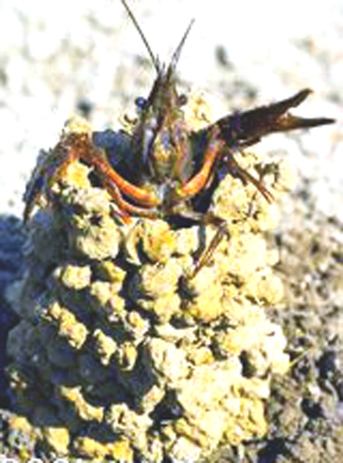

Crawfish mound. Found in the wetlands of the early prairie.

Before it was a town, Arcola was a swamp. According to M. F. Breeden, one of the first settlers in Douglas County, who arrived in 1856, much of the county was a swamp. In 1909 he wrote his account of first seeing the land:

““On the 17th day of August 1856, I first saw the light of day in Douglas County. On that Wednesday morning, as well as I can recollect, everything looked new to me…. What was Douglas County 53 years ago? It was a swamp. In those days, it was called by travelers, “God’s forsaken country,” and they thought that the Almighty had set apart this country for the wild geese and ducks, and for the crawfish, where they could convert their little mounds of sand into towers where the frogs could climb up on them in the bright moonlight and sing their sweet songs.”[10]

The wetlands were not just inconvenient; they also brought disease. Because malaria, or the dreaded shaking disease they called “ague,” sprung from the wetlands, the prairie earned a reputation for being dangerous and unhealthy.[11] Sickness was common among the new arrivals. A noxious gas called “miasma” emerged from deteriorating plants in the wetlands. Many blamed the gas for the flu-like or malarial symptoms that sapped the strength of whole families. The sickness prevented families from being properly prepared for fall and winter. “Pioneers joked that newcomers weren’t really settled until they had suffered their first case of swamp flu.”[12] Writing in 1900, John Gresham said, “To have a severe case of malarial fever or several season’s run of the ague was expected by each new-comer, and none were considered as having been fully inducted into all the mysteries of citizenship until they had had the regular malarial experience.”[13]

Drawing from Kristina Blatchford, “Pioneer Women on the Illinois Frontier,” *Illinois History,* December 1992. The ague or malaria severely limited women’s work—a wide variety of unending chores—causing hardship for the whole family.

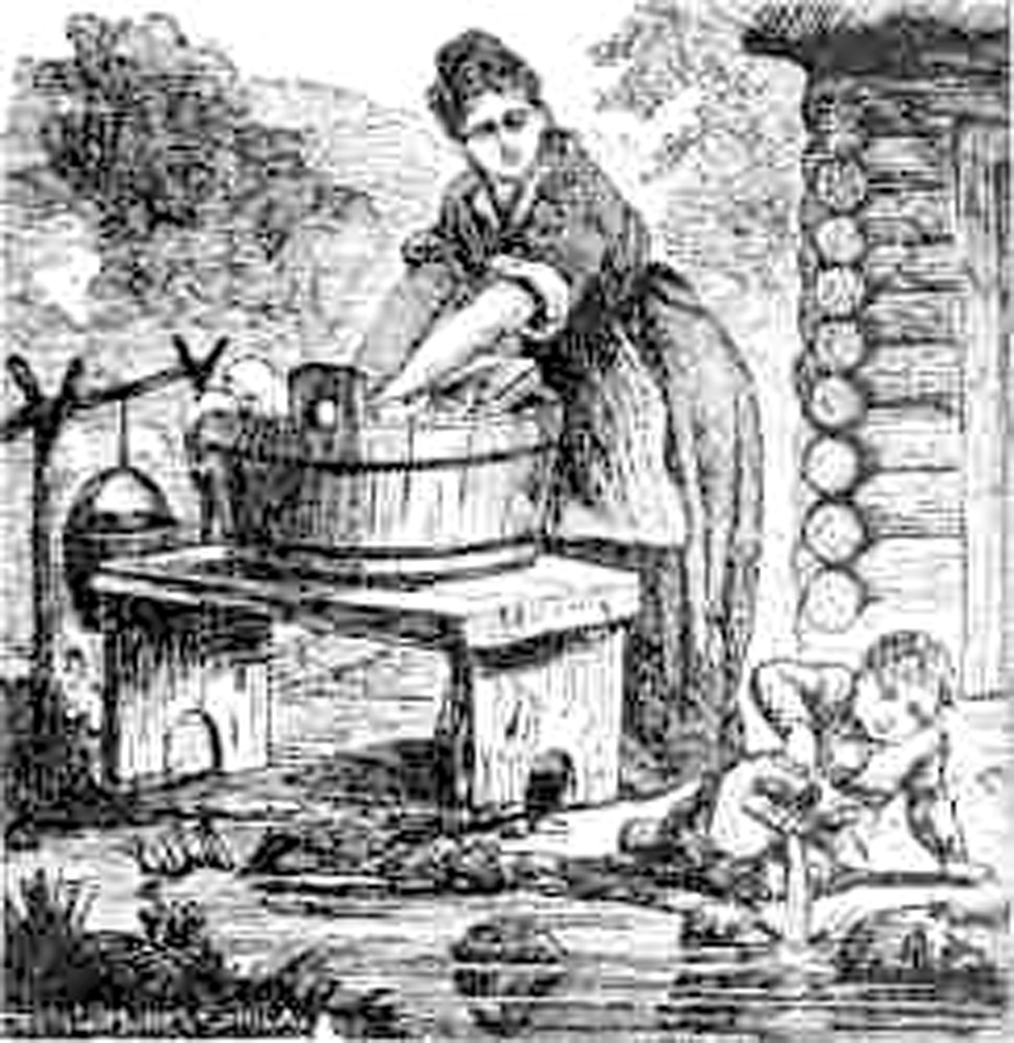

According to Michael Urban, malaria was the number one killer in Illinois until the 1850s.[14] One physician termed the Grand Prairie in the 1840s “a giant emporium of malaria,” and settlers were often “preoccupied with malaria as the primary characteristic associated with the area”.[15] J. H. Battle gave the following description of the situation in Douglas County on the Embarrass River: “During a considerable part of the year, the almost stagnant water of the sluggish streams filled the air with a miasmatic poison that hung in dense fog over stream and grove like a destroying spirit. The difficulty experienced in securing good water often rendered it necessary for the farmers to drink from stagnant pools, frequently blowing off the scum and straining the wigglers from the sickening, almost boiling, fluid through the teeth.”[16]

In 1825, Henry Schoolcraft described the unhealthy appearance of residents of central Illinois: They displayed “pale and emaciated countenances; females shivering with ague, or burning with intermittent fever, unable to minister to their children, and sometimes, every member of a numerous family suffering from the prevailing malady at the same time.”[17] John Reynolds, governor of Illinois during the 1830s complained that sickness was so connected to the state that many—including newspaper men and writers of emigrant guide books—had the idea that “Illinois was a graveyard.” [18] So common was the mosquito related illness among locals that they said of newcomers who displayed the chills and intermittent fever that “He’s not sick, he’s only got the ager.”[19] As farmers expanded and improved their techniques to drain the land, the incidence of ague declined.

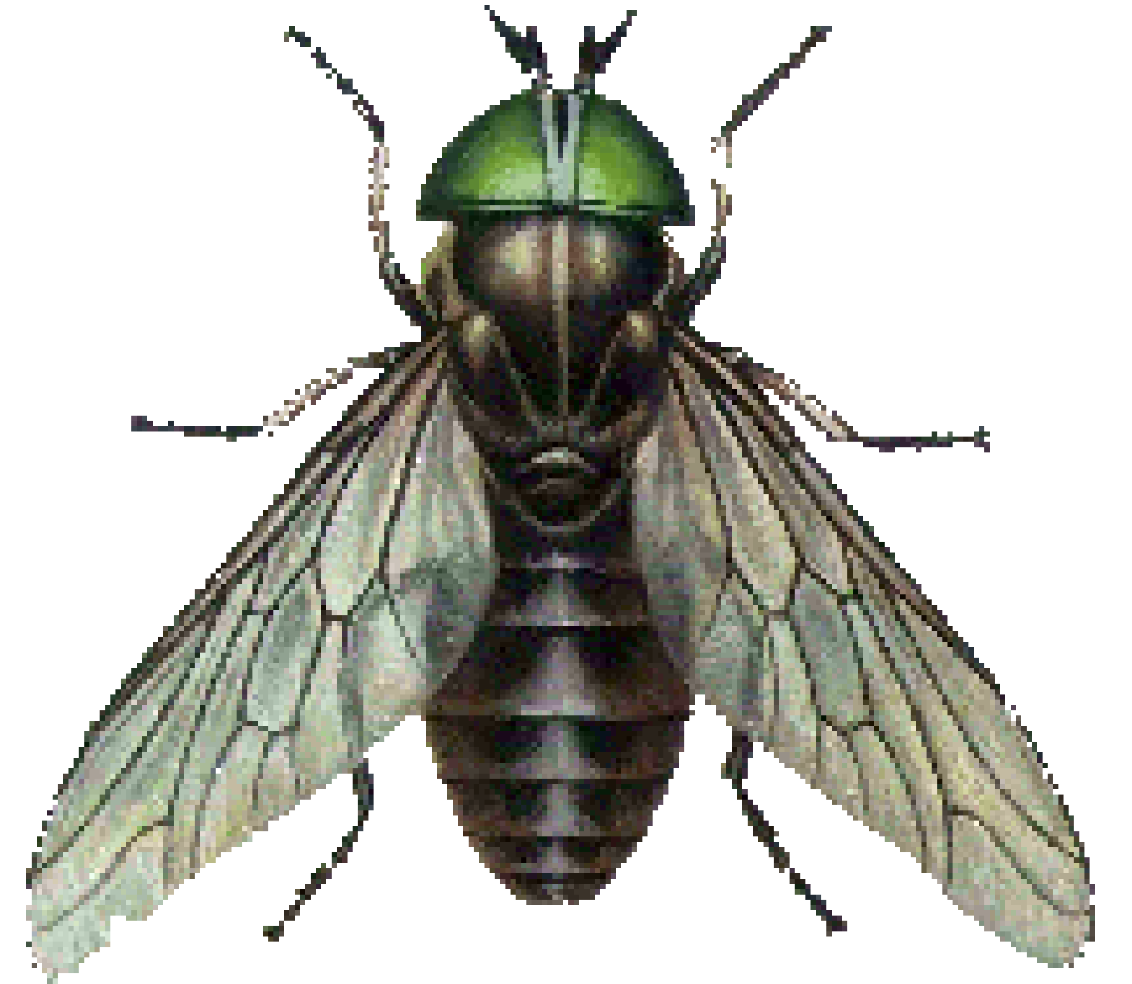

Green-headed Horse Fly. Common in the wet areas of the prairie before settlement.

**Bugs**

Large, green-headed bugs inhibited settlement. In 1822-1823, Capt. William Blane, an Englishman, traveling on the prairie, recorded that the horse flies were “larger than a hornet.” The flies forced the riders to dismount, light a fire, and stand in the smoke for hours. Even then, the apprehensive horses strongly resisted being moved. During the day, the flies covered the horses, got into their nostrils, and tormented them. Capt. Blane wondered how long it might take for the loss of blood to lead to death. In fact, the flies killed some horses.[20] In 1879, W. H. Perrin and others, who wrote the History of Coles County, told the story of a pioneer named Poorman who, like others, would take his wheat grain to a mill owned by a man named True. They had to travel across the twelve miles of prairie at night in order to avoid the “annoyance of the flies.”[21] In 1821, Samuel Burton recounted stories about flies covering horses so completely that they had to be “skinned off with a knife” leaving the horses covered in blood.[22]

In 1824, Mr. Heline claimed 160 acres and built a cabin near Coon’s Spring north of Monticello, Illinois. During that first year, they successfully cleared and planted 20 acres of corn, but, then, the flies struck. “All but one of the five horses they brought with them died from the effects of fly and mosquito bites. They tried everything within their environment to destroy or keep off these dreaded insects. Fires were built, near the horses with the hopes that the smoke would keep them away, and the horses were sometimes seen to roll in the very midst of the coals of fire. After the loss of the horses, oxen were used instead.”[23]

Harvey Lee Ross wrote about one episode with horseflies when he was about eight years old and responsible for cutting hay from the “Smith’s Prairie,” raking it with a wooden hand-rake and pitchfork, and stacking it on a brush sled. “A small bushy tree would be cut down and some of the limbs cut off so as to make a sort of flat surface; and the hay would then be piled on top; a horse would be hitched to the contrivance by a chain or rope, and so the hay would be hauled to the place where it was to be stacked. And that was what we called a "brush sled." Many a hot summer day I have rode the old horse to haul hay on the Smith Prairie, where the Rices, W. W. Smith, Samuel Campbell, J. Wertman, W. C. Harrison, the Lawses, Rileys and Chapins now live.

“One time the green-head flies attacked my old horse so bad that he ran away. My strength was not sufficient to hold him; after he had run about half a mile I jumped off but did not jump far enough to miss the brush top that he was dragging, so I was caught under the brush sled, and was so badly bruised that I was laid up for repairs for several days. The old horse never stopped running until he got home.”[24]

Solon Justice Buck, writing in 1818, confirmed the dreadful effects of flies. Cattle and horses, he wrote, did very well by the middle of June. But after that, the swarms of flies prevented them from feeding in the heat of the day. The flies made it impossible to travel from the middle of June until the first of September unless the horses were covered with blankets. “I have seen white horses red with blood….” He also noted that as the country became settled the flies disappeared.[25]

Mosquito bites also intimidated surveyors. Surveyors in Michigan in 1821 recalled that both men and horses were weak from loss of blood and want of sleep.[26] John Tipton worked with a group surveying the Illinois-Indiana state line in 1821. He wrote that in a “dreadful swamp” bordering the Kankakee River the “muscheteer” attack almost darkened the sky.[27]

Early Illinois explorers discovered the beauty of the prairie—a delightful rose—but, they also discovered the thorn. The wetlands, the disease, the mosquitoes, and the horseflies chastised the first, brave pioneers, making them pay a price for daring to carve out a future in the untamed grasslands. When they began to farm the prairie, they discovered other obstacles.

Part III describes other obstacles.

1. Cain, Angelique and Brandi Hymer, *Murder and Mayhem in Old Arcola,* United States of America: United Graphics, 1956, 11-15.
2. Urban, Michael A., “An Uninhabited waste: Transforming the Grand Prairie in Nineteenth Century Illinois, USA,” *Journal of Historical Geography,* 31 (2005) 662; Ernst, Ferdinand. *Travels in Illinois in 1819. Translation from the German Original.* In *Pub. No. 8 of the Ill. Hist. Lib.* pp. 150-65. *Springfield, Ill.: Phillips Bros.*, 1904, 162.
3. Boggess, Arthur Clinton, *The Settlement of Illinois, 1778-1830,* Chicago: Chicago Historical Society’s Collection, Vol. V, 1908, 87-88; note 224, p. 87, Hamilton, “Writings of James Monroe,” 1786 letter from Monroe to Jefferson. I., 117.
4. Pooley, William Vipond. *The Settlement of Illinois from 1830 to 1850.* Ann Arbor, MI, 1968, originally published Madison, (Reprinted from the Bulletin of the University of Wisconsin History Series, Vol. I, pp. 287-595) Wisconsin: University of Wisconsin, May 1908, 540, Note 3 on p. 540, Henderson, *History of the Sangamon Country,* 174.
5. Gresham, John. *Historical and Biographical Record of Douglas County, Illinois*. Logansport, IN: Wilson, Humphreys & Co., 1900, 40; Korling, Torkel, *The Prairie Swell and Swale , What is a Prairie?* By Robert F. Betz, Dundee, Illinois, 1972. <http://plantconservation.us/Betz1972.pdf> , 5; Harding, Benjamin, *A Tour through the Western country Published for the use of Emigrants.* London: British Library, Historical Print Edition, 1819, 8-9.
6. *Op. Cit.,* Bogess, *Settlement of Illinois*, 154.
7. Le Baron’s*, History of Coles County,* Chicago: Wm. Le Baron, Jr. & Co., 1879, 491.
8. Prince, Hugh, *Wetlands of the American Midwest: A Historical Geography of Changing Attitudes.* Chicago: University of Chicago Press, Ltd. 1997, 119-133.
9. *Ibid.,* Prince, *Wetlands,* 121; note 20, Charles Dickens, *American notes for general circulation,* ed., John S. Whitley and Arnold Goldman (1842); Penquin Classics, Hamondsworth (1985), 215-16.
10. Breeden, M. F., “Historical Letter from M. F. Breeden,” Letter from Los Angeles, California, July 25, 1909. “Oldest Resident Writes of Early Days in the Vicinity of Arcola,” *The Weekly* *Arcolian*, Vol 11, no. 33 July 29, 1909, p. 6
11. *Op. Cit.,* Urban, “Uninhabited waste,” 661-662; Ernst, Ferdinand. *Travels in Illinois in 1819. Translation from the German Original.* In *Pub. No. 8 of the Ill. Hist. Lib.* pp. 150-65. Springfield*,* Ill*.: Phillips Bros.*, 1904, 158;
12. *Op. Cit.,* Cain, *Murder and Mayhem*, 5.
13. Gresham, John, *Historical and Biographical Record of Douglas County, IL* Logansport, IN: Wilson, Humphreys and Company, 1900, 17-18.
14. Urban, Michael A., “An Uninhabited waste: Transforming the Grand Prairie in Nineteenth Century Illinois, USA,” *Journal of Historical Geography,* 31 (2005) 653; See note 55 p. 654, Rawlings, *Rise and Fall of Disease in Illinois*, 35.
15. *Ob. Cit..* Urban, “Uninhabited Waste,” 653; see note 56 on p. 654: C. Lindsay, Excerpts from ‘The prairies of the Western States their advantages’, *The Illinois Farmer* 5 (1860) 208; Winsor, Environmental Imagery, 394.; The remarkable Christina Tillson relays her husband’s experience with the ague in Tillson, Christina Holmes, *A Woman’s Story of Pioneer Illinois*, Milo Milton Quaife, Chicago: R. R. Donnelly and Sons Company, 1919, 27-28; See also, Piatt, Emma, *History of Piatt County: together with a Brief History of Illinois from the Discovery of the Upper Mississippi to the Present Time,* Chicago: Shepard & Johnston Printers, No Date, pp. 127-128.
16. *Op. Cit.,* Urban, “Uninhabited Waste,” 653; See note 57 on p. 654: J.H. Battle, *County of Douglas, Illinois*, Chicago, 1884, np; See also, Buck, Solon Justice, *Illinois in 1818.* 2nd. Ed., revised. Illinois Centennial Commission, Clarence Walworth Alvord, ed., Chicago: A. C. McClurg & Co., 1918, pp. 160-161; See also, Flower, George, *History of the English Settlement in Edwards County Illinois founded in 1817 and 1818 by Morris Birkbeck and George Flower*. Chicago: Fergus Printing Company, 1882, 122-123; For more on disease see: Reynolds, John, *The Pioneer History of Illinois*: *Containing the Discovery in 1673, and the History of the Country to the year 1818.* Chicago: Fergus Printing Co., 1887, pp. 313-314; for the Piatt County area see, McIntosh, Charles, associate Editor*, Past and Present of Piatt County, Illinois, together with Biographical Sketches of Many Prominent and Influential Citizens*., Chicago: S. J. Clark Publishing Co. 1903, 13.
17. *Op. Cit.,* Urban, “Uninhabited waste,” 653; note 58 p. 654,H.R. Schoolcraft, *Travels in the Central Portion of the Mississippi Valley*, New York, NY, 1825, 300.
18. *Op. Cit.,* Urban, “Uninhabited waste,” 653-654; note 59 on p. 654; J. Duffy, *The Sanitarians: A History of American Public Health*, Urbana, IL, 1990, 63; Pooley, William Vipond. *The Settlement of Illinois from 1830 to 1850.* Ann Arbor, MI, 1968, originally published Madison, (Reprinted from the Bulletin of the University of Wisconsin History Series, Vol. I, pp. 287-595) Wisconsin: University of Wisconsin, May 1908, pp. 542-543.
19. *Op. Cit.,* Urban, “Uninhabited waste,” 654; see note 63 on p. 654, M.E. Pickard and R.C. Buley, *The Midwest Pioneer, His Ills, Cures and Doctors*, Crawfordsville, IN, 1945, 16.
20. Blane, Capt. William N. ,*An Excursion through the United States and Canada During the Years 1822-23 by an English Gentleman*, London: Baldwin, Craddock, and Joy, 1824, 185-186; see also Wilson, Charles Edward, *History of Coles County, Illinois, Chapter I*, Township History, 1905, transcribed by Judy Anderson for Illinois Genealogy Trails, no page; For killing horses see also: McIntosh, Charles, associate Editor*, Past and Present of Piatt County, Illinois, together with Biographical Sketches of Many Prominent and Influential Citizens*., Chicago: S. J. Clark Publishing Co. 1903, 13.
21. Perrin, W. H., A. A. Graham and D. M. Blair, and Judge William E. Adams., *History of Coles County,* Chicago: Wm. Le Baron, Jr. & Co., 1879, 472; See also, *Op. Cit.,* McIntosh, *Piatt County*, 13.
22. *Op. Cit.,* Urban, “Uninhabited waste,” 651; citing in note 37, D. R. McManis, *The Initial Evaluation and Utilization of the Illinois Prairie, 1815-1840,* Chicago, 1964, 59.
23. *Op. Cit.*, Piatt, *History of Piatt County,* 217.
24. Ross, Harvey Lee. *The Early Pioneers and Pioneer Events of the State of Illinois,* Chicago: Eastman Brothers, 1899; Also reprinted by Ruth M. Davis, Avon, Illinois, 1970: Astoria, IL: Stevens Publishing Company, 64-65.
25. Buck, Solon Justice, *Illinois in 1818.* 2nd. Ed., revised. Illinois Centennial Commission, Clarence Walworth Alvord, ed., Chicago: A. C. McClurg & Co., 1918, 141-142.
26. *Ibid.,* Urban, “Uninhabited Waste,”, 652; note 38, *Op. Cit.,* Prince, *Wetlands*, 141.
27. *Ibid.,* Urban, “Uninhabited Wates,” 652, note 39, Tipton, *John Tipton Papers,*  261-262.