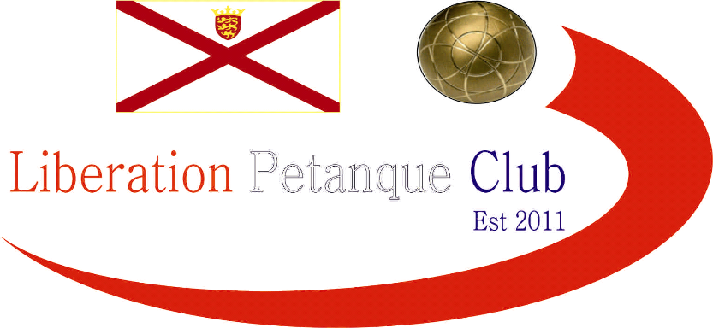

Liberation
Charity Triples Open
2015

With only 4 teams taking part this year and at a new venue (Millbrook Park) Toby, Brian and Ross were hoping to make it a hatrick of wins in the competition.

The charities chosen were Ronald McDonald House charities and Holidays for Hero’s

The current champions started off well beating Pat, Teresa and Bob 13 – 4 as they eased into their stride.

Matt Ryan replaced Matt Pinel teaming up with Callum and Andrew. They started off with a win over James, Dawn and Geoffroy 13 – 7.

These results meant certain results could mean a 3 way tie for 2nd place.

Matt, Callum and Andrew again handed a heavy defeat to Pat, Teresa and Bob 13 – 2, but Toby, Brian and Ross fought out a tough match, just beating James, Dawn and Geoffroy 13 – 10.

So with just 4 teams it was decided it would be a best of 3 matches for the final and 3rd/4th place play off.

Matt, Callum and Andrew won the first match against Toby, Brian and Ross 13 – 9, but the second one went even closer 13 – 11 to Toby, Brian and Ross to go to a deciding match.

End to end in the final match but Matt, Callum and Andrew lived to rue a number of big opportunities to seal the title. The 3rd successive win was sealed by Brian Harris firing with so much spin on his boule, it was a perfect carreaux that span on its spot after hitting the target boule for about 20 seconds. 13 – 12 win and three straight titles.

James, Dawn and Geoffroy took 3rd place after beating Pat, Teresa and Bob 13 – 9 twice.

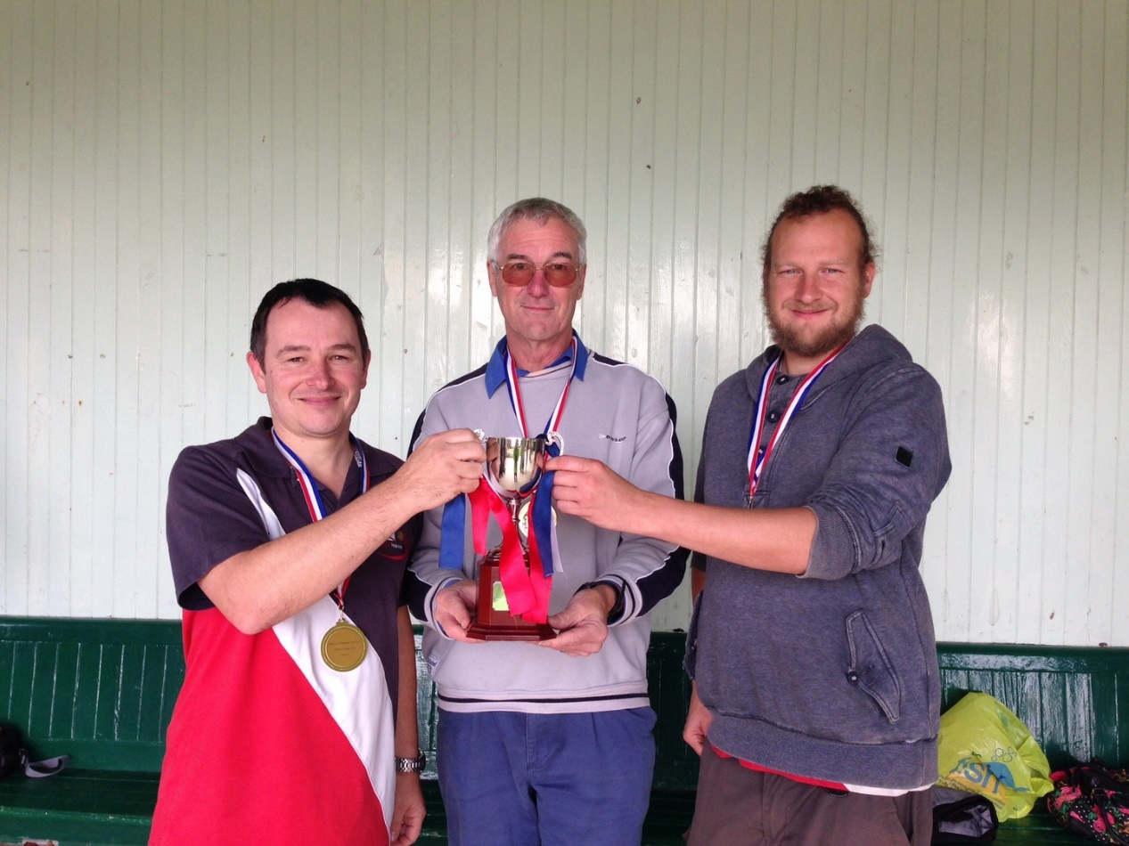

An enjoyable day in the park and 2 very good causes benefitting from the competition.

Kind Regards
Toby Northern
Chairman
Liberation Petanque Club

