

# Summer 2018 Season

# Week 11 – 06.06.18

# Singles League Report

# 

**Remember if you cannot play on the scheduled fixture date; please try to play in advance.**

**You MUST inform the club if you are not playing on the scheduled date and the New Date the match has been rearranged for when this has been agreed.**

**Liberation Doubles Cup (Members Only – Free)**

**Wednesday 20th June 2018**

**Still Time to Enter**

**Super 6 Results**

**Coming Up in July – New Monthly Prize?**

**Limited Edition Liberation Merchandise?**

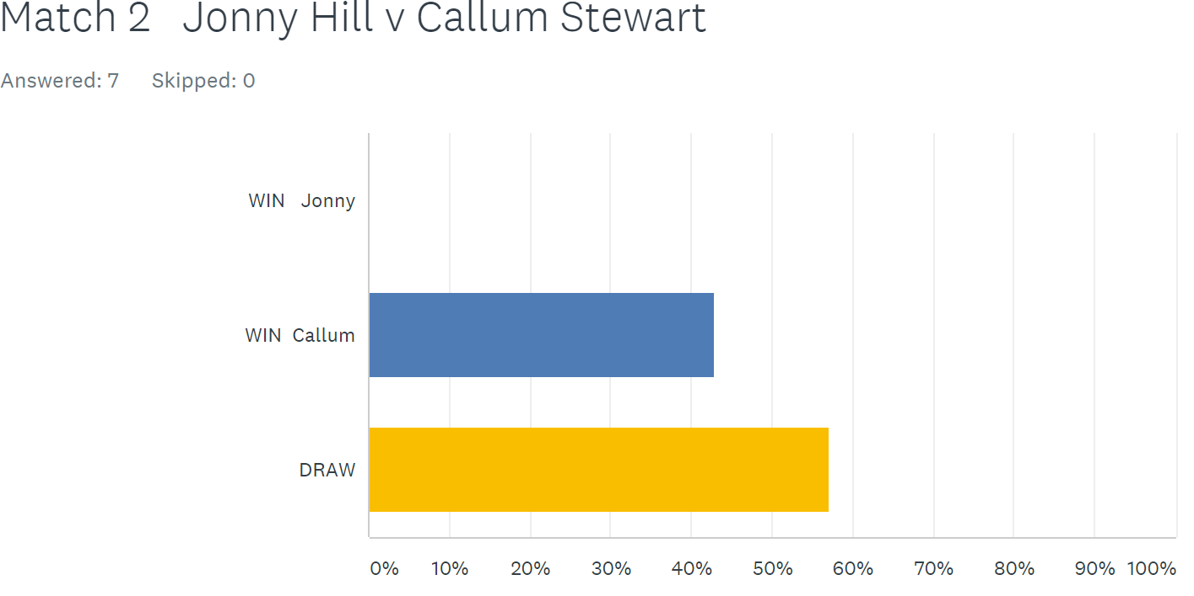

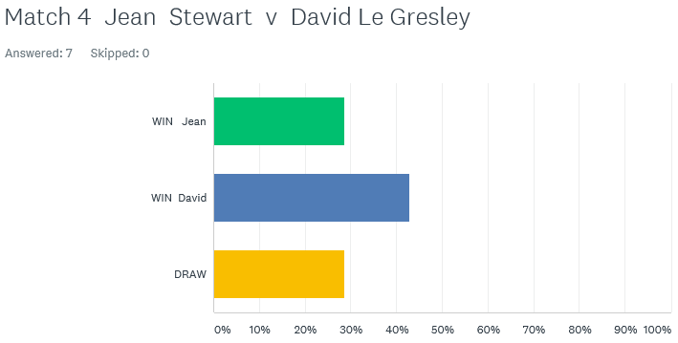

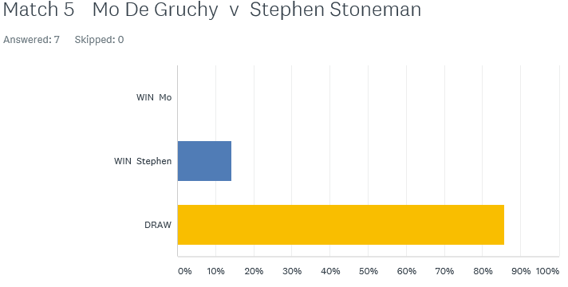

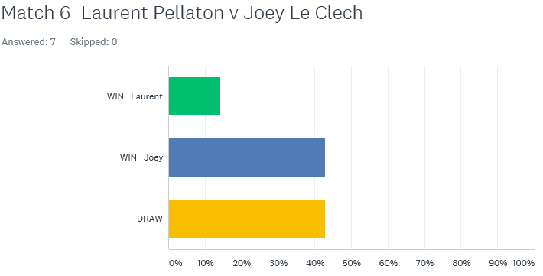

Just two matches played in the Premier League. The bottom two players in the league, Jonny Hill and Callum Stewart played each other knowing a win could make a massive difference to survival. Jonny won comfortably in game one before Callum fought back to gain a valuable draw.

Father and daughter Alice and David also played each other, with every point counting. One game went to 13-12 and it was a decisive win for Alice in game two as she took the win to move above David and out of the bottom three as a result.

Division 1 saw the two form players play each other as Laurent Pellaton on three straight wins played Joey Le Clech, league leader and title favourite. The first game was a close as expected with Laurent taking in 13-12, from 11-2 down! Joey though regained composure to win 13-5 in the second for a draw.

Two other players undefeated were Richard Williams and John McGaw also in with a shout for the title and promotion. The result John’s sixth draw out of seven matches this season and with one win still with a shout of a top three place. Richard moved into third above Laurent after also drawing a catch up match with David Le Gresley.

Newcomer Stephen Stoneman took on his doubles partner Mo De Gruchy with both players looking for valuable points. Another draw as they shared the spoils.

As we move into the second half of the singles season wins were needed for Cassie Stewart and Harrison Marie if any hopes of promotion were to stay alive. Cassie handed Harrison a heavy defeat 13-3, 13-2 moving Cassie up to fifth just two points off the top three.

Alex Stewart looking for back to back promotions to the top flight took on undefeated Brigitte Ibitson, also looking for promotion. A close match with the second game going 13-12 in Alex favour for a big win. Alex followed this up with two more wins in catch up matches against Matt Hutchings, which included a 13-0, and a win over David Le Gresley.

This means Alex Stewart now tops the league on 19 points, 5 points above second place Joey Le Clech.

In a very close league, Matt Hutchings and Paul Bell played each other also looking to make the move up the league. Paul handed Matt his first defeat of the season. An ever improving Jean Stewart taking on experience David Le Gresley, with a good draw resulting in Jean moving out of the bottom three.

**Best of Luck to everyone playing in England this weekend and the Carrefour Singles.**

***NEXT WEEK***

**13th June – Doubles League – Week 4**

**WEBSITE** [**www.liberationpetanque.co.uk**](http://www.liberationpetanque.co.uk)

**EMAIL** [**liberationpc@gmail.com**](mailto:liberationpc@gmail.com)

**Kind Regards**

**Toby Northern**

**Chairman**

**Liberation Petanque Club**

# SPONSORED BY

# http://nebula.wsimg.com/135a1bd6338e1b589a50cdec98bd84d1?AccessKeyId=C6E923731F1A482DD910&disposition=0&alloworigin=1