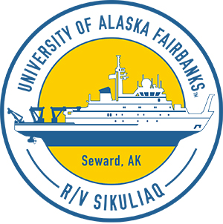
Beaufort Shelf Break Ecology—Plankton, Fish,
and Belugas (2018)
  - Carin Ashjian (cashjian@whoi.edu), Woods Hole Oceanographic Institution, and colleagues

Research questions
- Why are beluga whales found along the shelf break in the Beaufort Sea?
- Do winds from the east produce good feeding conditions (lots of Arctic cod) for belugas along the shelf break?

Why we should care
Historically, beluga whales are often seen along the shelf break and deeper, but are not typically found further inshore on the shallow shelf where bowhead whales are usually seen. We think it is because the belugas can find high numbers of their arctic cod prey along the shelf break but not as many elsewhere.

What we will measure
We will measure plankton and fish distribution and abundance, fish diet, plankton nutritional value, temperature, salinity, and currents, and will observe marine mammal and bird occurrence from the bridge.

General 2018 cruise plan
We will pick up 4 oceanographic moorings (anchored to the seafloor) that have recorded marine mammal calls as well as temperature, salinity, currents, and zooplankton and fish distributions for a year. We will put back out two moorings to collect another year of data. We will sample the metrics listed above at locations that run from the shallow shelf (about 30 miles offshore) north across the shelf break into deeper water. We will sample at some locations several times. We need to sample during many types of wind conditions and especially during strong winds from the east.

Timeline
August 3: Leave Nome, Alaska
August 3–5 or 6: Transit to Beaufort Shelf
August 6–24: Work along Beaufort Shelf Break in study area
August 24–27: Transit back to Nome
August 27: Arrive in Nome

Cruise track
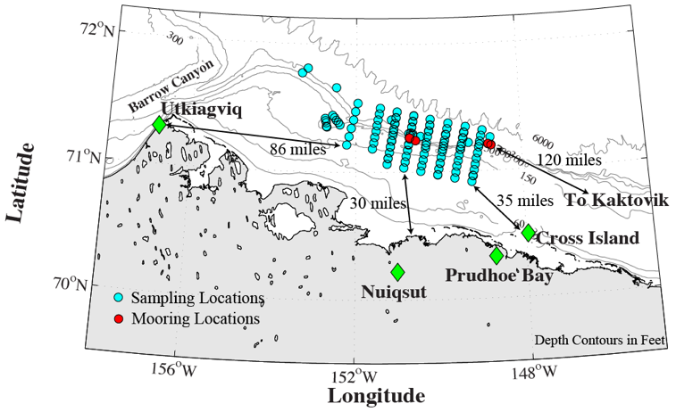

Daily science updates and additional information
We will have a community observer on board as part of our science party. Science updates will be sent out by Carin Ashjian; let her know at cashjian@whoi.edu if you want to be on the list. The project will be on Facebook, Instagram and Twitter. R/V Sikuliaq will be in regular communication with local communities.

