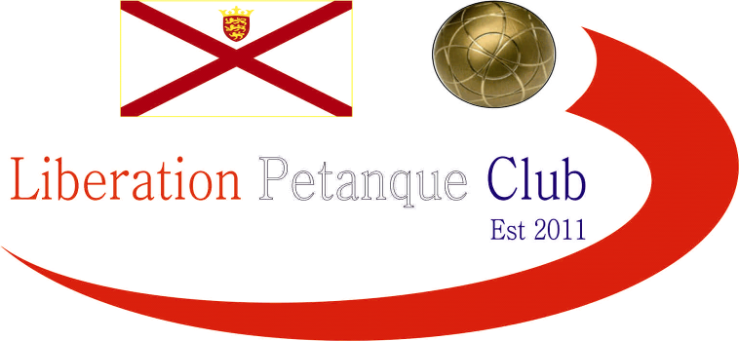

2019
CHARITY TRIPLES OPEN
(In Aid of Jersey Children’s Charity)

Nine teams took part this year as last year champions Andrew & Lorna Limbrick & Alan Lahiffe unfortunately had to pull out at the last minute.

Favourites for the title were Matt Pinel, Mark Nicol & Richard Nevitt and they started off well winning 13 – 3 over Toby Northern, Matt Buesnel & James Rondel.

The was a big win for Paul Bell, Neil Selby & Ross Payne over Martin & Teresa Koradi and Hayden Maguire 13 – 2.

There were some close matches though as Brian & Paul Harris and Judy Dove just beat Helene Retrosi, Geoffroy Buffetrille and Matt Hutchings 13 – 10 and Callum, Cassie and Jean Stewart won 13 – 9 against Wendy Ritzema, Colin Myers & Richard Sowerby.

Chris Romeril, Stephen Leathem and Dawn Buckley got a win thanks to a bye in round 1.

Ross, Neil and Paul’s big win in round 1 was almost wiped out as they lost 13 – 3 to Chris, Stephen and Dawn and despite losing a 5 on one end Toby, James & Matt beat Martin, Teresa and Hayden 13 – 8.

Wendy, Colin & Richard got off the mark with a win over Brian, Paul & Judy and Matt, Mark & Richard made it two wins in a row 13 – 5 over Helene, Geoffroy and Matt. Callum & Cassie & Jean getting the bye putting them on two wins.

In round three an impressive performance gave Toby, James & Matt a big win 13 – 5 over Callum, Cassie and Jean to give them an outside chance of making the top 4.

Wendy, Colin & Richard just beat Helene, Geoffroy and Matt 13 – 11 as time ran out to make it back to back wins.

Chris, Stephen and Dawn handed out a certificate to Brian, Paul & Judy a 13 – 0 defeat to move top on points difference after Martin, Teresa and Hayden almost beat Matt, Mark and Richard with the final result 13 – 10 in favour of the latter.

Ross, Neil and Paul got a win thanks to a bye to make it two wins for them.

So the final qualifying round saw most teams in with a chance of the top four.

Chris, Stephen and Dawn won heavily against Helene, Geoffroy and Matt 13 – 3 to finish top with 4 wins + 39. Matt, Mark and Richard also won thanks to a bye ending on 4 wins +27.

Ross, Neil and Paul got a third win over Callum, Cassie and Jean 13 – 4 and this was enough to make third place with 3 wins + 16.

With Toby, James & Matt losing to Brian, Paul & Judy 13 – 5, this left the door open for Wendy, Colin & Richard who just beat Martin, Teresa and Hayden 13 – 11 to take 4th place with 3 wins +5.

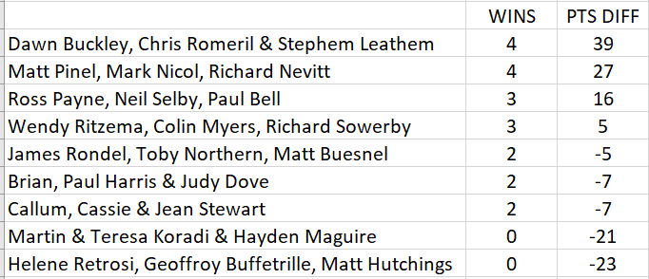

So straight into the Semi-Finals

1st Chris, Stephen and Dawn v Wendy, Colin & Richard 4th

2nd Matt, Mark and Richard v Ross, Neil and Paul 3rd

The first semi-final was close but with all three of Chris, Stephen and Dawn placing exceptionally well, despite some good shooting by Colin it wasn’t to be as Chris, Stephen and Dawn made the final.

In the second semi-final Ross, Neil and Paul just could not match Matt, Mark and Richard who looked on top all the way.

Third place went to Wendy, Colin & Richard who won by the closest of margins 13 – 12 to get their bronze medals.

The final swung back and forth with Chris, Stephen and Dawn leading 6 – 2 before going behind 9 – 6 to Matt, Mark and Richard and they looked like taking the title before a spirited come back from Chris, Stephen and Dawn saw them win 13 – 11 to be crowned this year’s Charity Triples Open Champions.

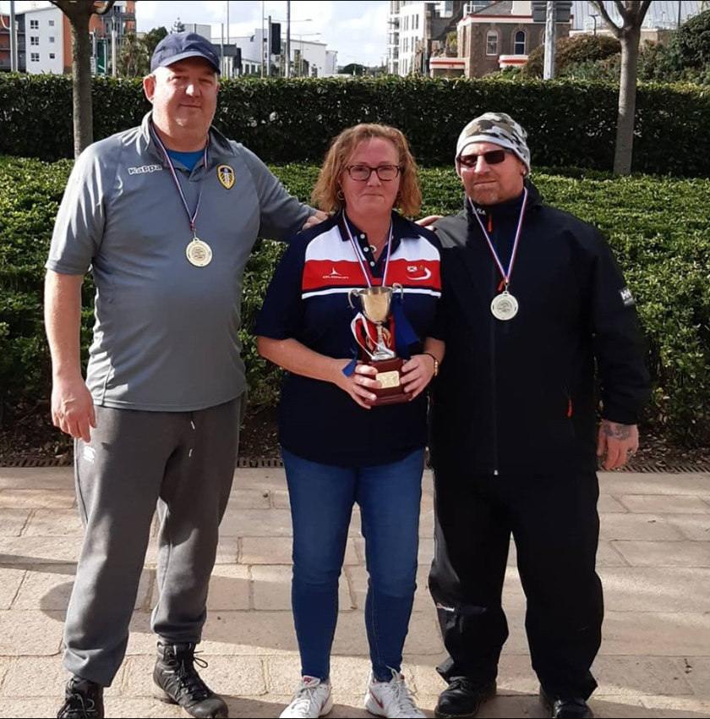

Thanks to all those who played and donated your support for the charity is greatly appreciated.

Club email address - liberationpc@gmail.com

Club Website - www.liberationpetanque.co.uk

Kind Regards

Toby Northern

Chairman

Liberation Petanque Club

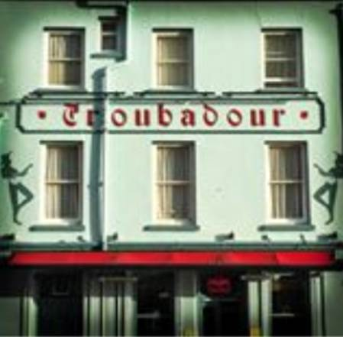
SPONSORED BY

