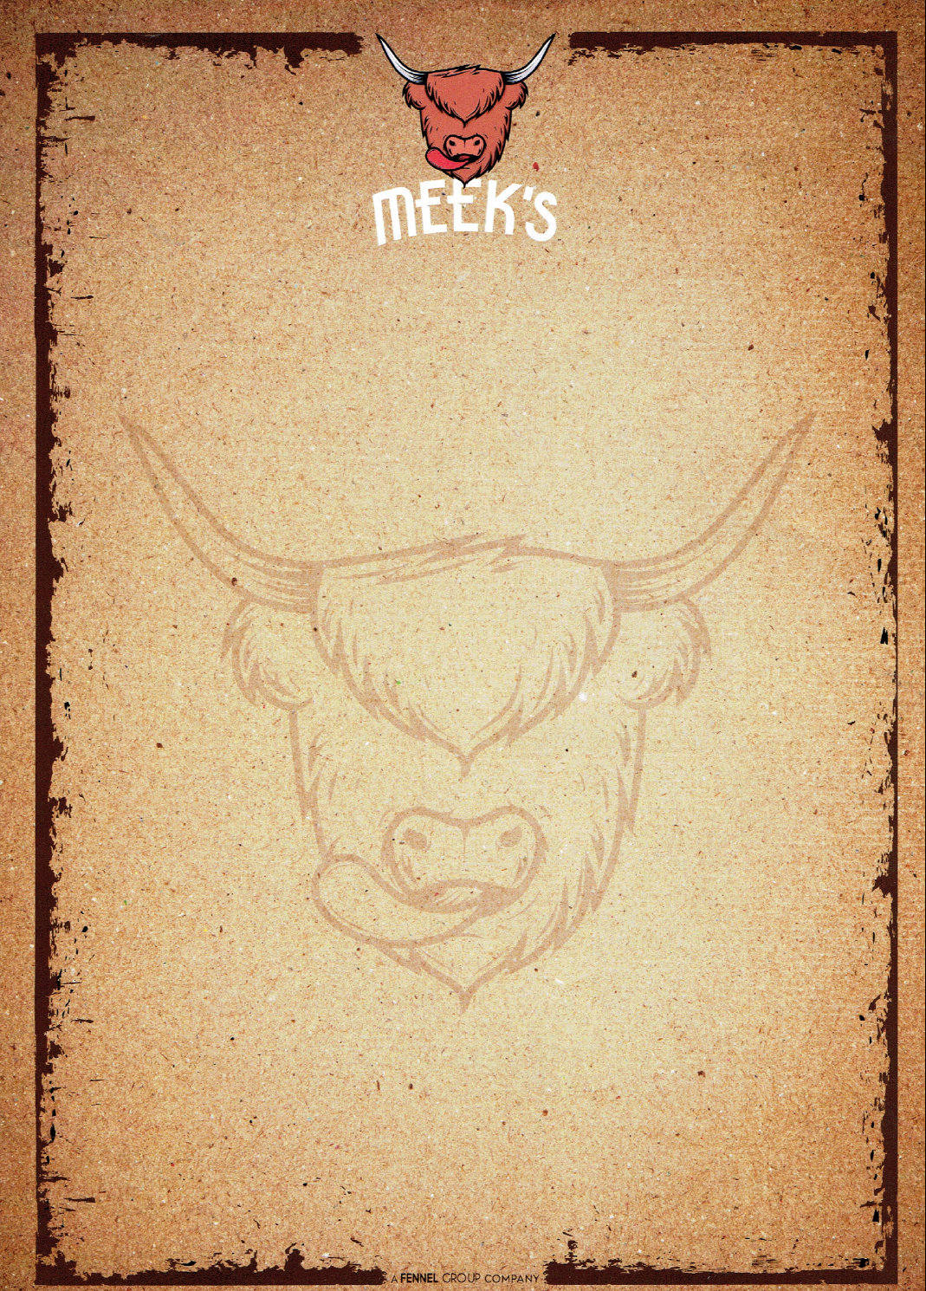

BURGERS
All served with hand-cut chips
CLASSIC £9.95
Beef burger, bacon, smoked cheese, lettuce, tomato, red onion, gherkin, brioche bun
SOUTHERNER £9.95 Cajun breaded chicken burger, cheddar, coleslaw, lettuce, tomato, red onion, brioche bun
CHILLI PORK £9.95 Chilli & coriander spiced pork burger, cheddar cheese, brioche bun, pineapple salsa
PEPPER PAKORA £9.95
Grilled pepper in pakora batter, toasted sour dough bun, lettuce, onion, chilli jam (vegan)

BIG YIN £12.95
Beef burger, cheddar cheese, bacon, brioche bun, onion rings, pulled pork

LOADED FRIES
Peri peri, bacon, cheese £5
Beef chilli, cheese & sour cream £5

SMALL PLATES
Pulled pork or Chilli beef nachos, jalapeños, salsa, sour cream £6
Peri peri chicken wings, garlic mayo £6

SIDES
Wok fried, salt and pepper chips £3
Beer battered onion rings £3
Macaroni and cheese £3
Home-cut chips £3
Dressed salad £3

