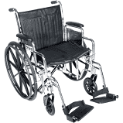[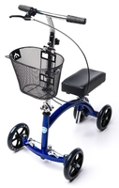](http://wholesalekneewalker-eu.com/kneecycle-deluxe-knee-walker/)[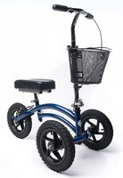](http://wholesalekneewalker-eu.com/kneerover-all-terrain-knee-walker/)[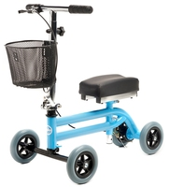](http://wholesalekneewalker-eu.com/knee-walker-jr-pediatric-scooter/)

**Want to Learn More?**

Call (817) 874-7165 to speak directly to a mobility specialist

Visit [www.ExpressHomeMedical.com](http://www.ExpressHomeMedical.com) to learn more about our rental program

Free Delivery throughout DFW

Available for Purchase

Visa, Mastercard and AMEX accepted

No Prescription required

**Wheelchairs**

Weight Capacity: 350 lb  
Elevated Leg Rests available  
Several sizes available  
$85 / Monthly Rental

Weight Capacity: 350 lb  
Height Range: 4’11” to 6’6”  
Several models available  
$75 / Monthly Rental

**Standard Knee Scooters**

**DFW’s Premier Mobility Equipment Provider**

**EMAIL: CustomerService@ExpressHomeMedical.com PHONE: (817) 874-7165 WEBSITE: www.ExpressHomeMedical.com FAX: (817) 290-2202**

**All-Terrain Knee Scooters**

Weight Capacity: 350 lb  
Height Range: 5’6” to 6’8”  
Ideal for heavy outdoor use  
$125 / Monthly Rental

Weight Capacity: 160 lb  
Height Range: 3’6” to 5’4”  
Very lightweight at only 18 lbs  
$85 / Monthly Rental

**Pediatric Knee Scooters**

**EXPRESS HOME MEDICAL**