SPECIAL MEETING
OCTOBER 29, 2020

Four (4) Public Hearings and a Special Meeting of the Town Board of the Town of Hampton, County of Washington and the State of New York was held at the Town Hall and via Zoom, 2629 State Route 22A, Hampton, New York on the 29th day of October 2020.

Due to the Corona Virus, occupancy inside the Town Hall is limited at this time. Supervisor O’Brien did provide a link to join the meeting via Zoom.

PRESENT: David K. O’Brien------------Supervisor
Tamme Taran----------------Councilwoman
Donald Sady-----------------Councilman
Andrea Sweeney------------Councilwoman
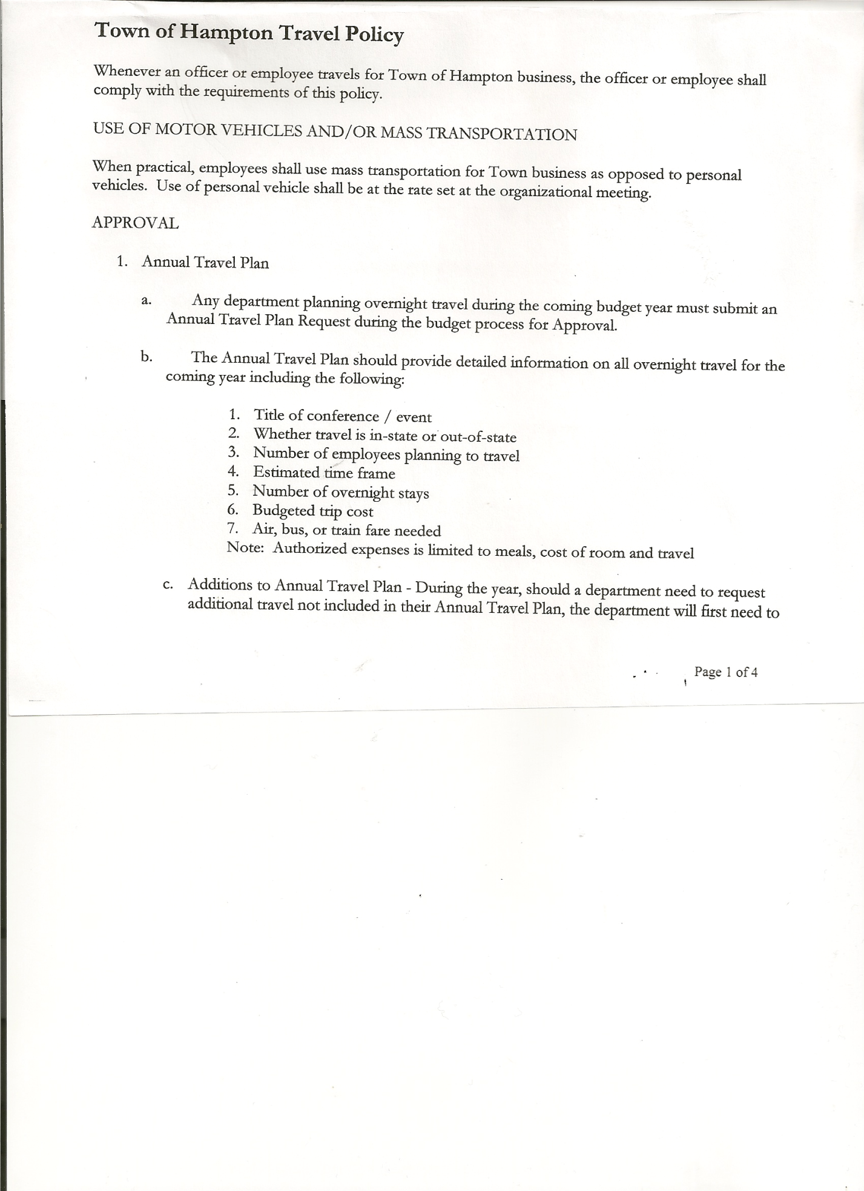
Michael Pietryka------------Councilman
Rebecca Jones---------------Town Clerk
Camilla Shaw--------------- Tax Collector/Deputy Town Clerk
Herbert Sady, Jr.-------------Highway Superintendent

Planning Board Member(s): Bonnie Hawley (via Zoom)
Others present at the Town Hall: Tom Edwards, Richard Cole and Leonard Reed

Others viewing by Zoom: Bob Johnson, Matthew Pratt, Arthur Pratt, Elizabeth Gildea, Jane Coburn, Martha Hurlbut, Stuart and Lois Griffin.

The FIRST Public Hearing was called to order by Supervisor O’Brien at 7:13 pm.

Town Clerk Jones read the Legal Notice of Public Hearing (copy attached), which was published in the Manchester Newspapers to discuss the proposed contract with Hampton Fire Protection District 1. A 2% increase was given for a total of $43,297. Comments: Are the districts going to be combining? Not at this time.

All persons desiring to be heard, having been heard, the Public Hearing was closed at 7:16 pm.

The SECOND Public Hearing was called to order by Supervisor O’Brien at 7:17 pm.

Town Clerk Jones read the Legal Notice of Public Hearing (copy attached), which was published in the Manchester Newspapers to discuss the proposed contract with Hampton Fire Protection District 2. A 2% increased was given for a total of $10,200. No comments.

All persons desiring to be heard, having been heard the Public Hearing was closed at 7:19 pm.

The THIRD Public Hearing was called to order by Supervisor O’Brien at 7:20p.m.

Town Clerk Jones read the Legal Notice of Public Hearing (copy attached), which was published in the Manchester Newspapers for the Preliminary Budget for 2021.

There is a 4.94 % increase because of the increase cost of maintaining the roads.

SPECIAL TOWN BOARD MEETING
OCTOBER 29, 2020 PAGE 2

Comments: Tom Edwards asked about the reassessment. It is expected to be complete by the 1st part of next year, to take effect July 1, 2021.

Bob Johnson asked if there were any grants available due to COVID-19 for the highways. No funds for that and even FEMA payments have been cut back.

Richard Cole questioned why there is an increase at this time when so many are out of work? The proposed increase was reduced from the original of 11% which was projected last year to bring the highway needs up where they need to be for the future.
CHIPS money is the main source of road repairs. There was a 20% reduction this year. Also, the Emergency weather and Pave NY were reduced by 20%. This was over $12,000 from previous years.
Bob Johnson asked how many miles of roads Hampton has. Approximately 18 miles, 14 paved, 4 dirt.
Tom Edwards asked about bonds. They are costly to repay, town avoids them.

All persons desiring to be heard, having been heard, the Public Hearing was closed at 7:36 pm

The FOURTH Public Hearing was called to order by Supervisor O’Brien at 7:37 pm.

Town Clerk Jones read the Legal Notice of Public Hearing (copy attached), which was published in the Manchester Newspapers to discuss the proposed local law to override the tax levy limit. . There is an increase of 4.94% for the 2021 Budget.
Comments: $6,880 is a 4.94% increase. There has not been increase in pay for officials for 6 years.

All persons desiring to be heard, having been heard, the Public Hearing was closed at 7:41 pm

SPECIAL MEETING
The Special Meeting of the Town Board was called to order by Supervisor O’Brien at 7:42 pm, followed by the Pledge of Allegiance. Location of Fire Exits were given. Quorum of board members present.

Highway employee update: Todd Mason will help during storms. Ben Corey will help if needed also. Tyler’s Dad has been helping get plows and sanders ready. There was discussion about starting a new person at a higher rate and giving Tyler an increase as well to attract more qualified applicants.

RESOLUTION NO. 90 -2020

MOTION BY: Councilwoman Tamme Taran
SECONDED BY: Councilman Donald Sady

RESOLUTION ADOPTING A LOCAL LAW TO OVERRIDE THE TAX LEVY LIMIT ESTABLISHED IN GENERAL MUNICIPAL LAW SECTION 3-C

WHEREAS, pursuant to Section 3-c(5) of the New York State General Municipal Law, the Town Board (the “Board”) of the Town of Hampton (the “Town”) has the authority to adopt

SPECIAL TOWN BOARD MEETING
OCTOBER 29, 2020 PAGE 3

a local law to override the real property tax levy limit as defined in General Municipal Law §3-c; and

WHEREAS, a budget has been prepared for the Town of Hampton for fiscal year beginning January 1, 2021 and ending December 31, 2021 that exceeds the tax levy limit as defined in General Municipal Law §3-c; and

WHEREAS, a local law to override the tax levy limit in accordance with the provisions of General Municipal Law §3-c has been prepared; and

WHEREAS, the Board scheduled a public hearing to be held before the Town Board on October 29, 2020 at the Offices of the Town of Hampton, 2629 State Route 22A, Hampton, New York 12837, to hear all interested parties regarding the adoption of the proposed Local Law; and

WHEREAS, notice of said public hearing was duly posted and then published in the Manchester Newspapers (The Granville Sentinel/The Whitehall Times), the official newspaper of the Town of Hampton pursuant to and in conformance with Section 20 of the Municipal Home Rule Law; and

WHEREAS, said public hearing was duly held and all parties in attendance were permitted an opportunity to speak on behalf of or in opposition to the proposed Local Law.

NOW, THEREFORE BE IT RESOLVED by the Town Board of the Town of Hampton as follows:

Section 1. The Town Board finds that the proposed Local Law is required pursuant to General Municipal Law section 3-c and is in the best interests of the residents, inhabitants and guests of the people of the Town of Hampton.

Section 2. The proposed Local Law, copies of which are attached hereto and made a part hereof, is hereby adopted.

Section 3. The Law shall take effect immediately upon its filing in the Office of the Secretary of State.

Section 4. This resolution shall take effect immediately.

DATED: October 29, 2020 Supervisor O’Brien AYE
Councilwoman Taran AYE
Councilman Sady AYE
Councilwoman Sweeney AYE
Councilman Pietryka AYE

SPECIAL TOWN BOARD MEETING
OCTOBER 29, 2020 PAGE 4

RESOLUTION NO. 91-2020
APPROVAL OF THE 2021 BUDGET
On a motion of Councilman Sady, seconded by Councilwoman Sweeney, the following resolution was ADOPTED:
By Roll Call Vote: Supervisor O’Brien AYE
Councilman Sady AYE
Councilwoman Taran AYE
Councilman Pietryka AYE
Councilwoman Sweeney AYE
RESOLVED, that the 2021 Town Budget for the Town of Hampton is adopted.

RESOLUTION NO. 92-2020
MEETING ADJOURNED
On a motion of Councilman Sady, seconded by Councilwoman Sweeney the following resolution was ADOPTED:
By Roll Call Vote: Supervisor O’Brien AYE
Councilman Sady AYE
Councilwoman Taran AYE
Councilman Pietryka AYE
Councilwoman Sweeney AYE
RESOLVED that the meeting adjourned at 8:11pm.

Respectfully submitted,

Rebecca S. Jones, RMC
Town Clerk
Assisted by Camilla Shaw,
Deputy Town Clerk

