SPECIAL MEETING/
PUBLIC HEARING
NOVEMBER 7, 2013

A Public Hearing and a Special Meeting of the Town Board of the Town of Hampton, County of Washington and the State of New York was held at the Town Hall, 2629 State Route 22A, Hampton, New York on the 7th day of November 2013.

PRESENT: David K. O’Brien----------Supervisor
Tamme Taran--------------Councilwoman
Herbert Sady, Jr.-----------Councilman
David Perry-----------------Councilman
David Jensen----------------Councilman
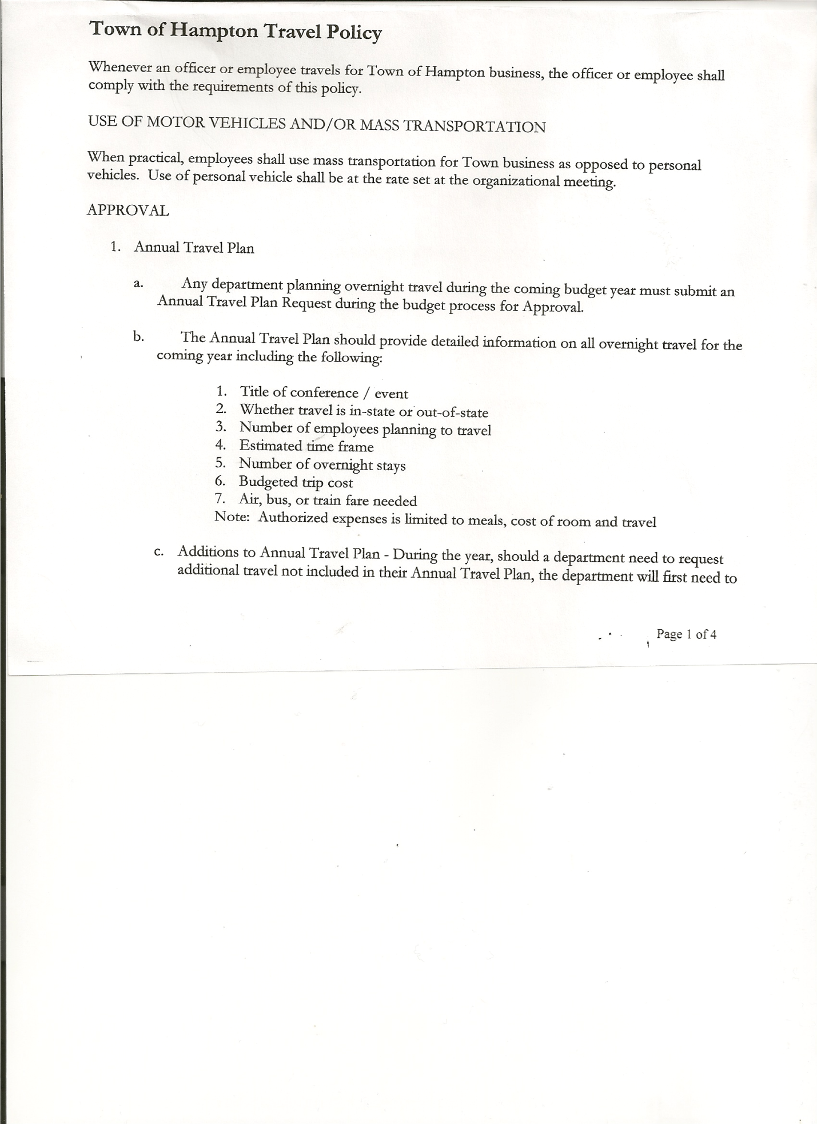
Rebecca Jones--------------Town Clerk
Francis Baker---------------Highway Superintendent

Also present: Kim Perry, Budget Officer; Derek Liebig, Whitehall Times Reporter;
Gavin Boule, Eric Mead, Joe Mead, Leonard Reed and Donald Sady (came at 8:31pm)

The Public Hearing was called to order by Supervisor O’Brien at 7:30 pm followed by the Pledge of Allegiance. Locations of Fire Exits were given.

Town Clerk Jones read the Legal Notice of Public Hearing on proposed Local Law 1 of 2013 to override the tax levy limit.

All persons desiring to be heard, having been heard, the Public Hearing was closed at 7:34pm.

SPECIAL MEETING
The Special Meeting of the Town Board was called to order by Supervisor O’Brien at 7:34 pm.

Supervisor O’Brien read the proposed Local Law 1 of 2013.

RESOLUTION NO. 98-2013

MOTION BY: COUNCILWOMAN TAMME TARAN
SECONDED BY: COUNCILMAN DAVID JENSEN

TITLE: RESOLUTION ADOPTING A LOCAL LAW TO OVERRIDE THE
TAX LEVY LIMIT ESTABLISHED IN GENERAL MUNICIPAL
LAW SECTION 3-C

WHEREAS, pursuant to Section 3-c(5) of the New York State General Municipal Law, the Town Board (the “Board”) of the Town of Hampton (the “Town”) has the authority to adopt a local law to override the real property tax levy limit as defined in General Municipal Law §3-c; and

TOWN BOARD MEETING
NOVEMBER 7, 2013 PAGE 2

WHEREAS, a budget has been prepared for the Town of Hampton for fiscal year beginning January 1, 2014 and ending December 31, 2014 that exceeds the tax levy limit as defined in General Municipal Law §3-c; and

WHEREAS, a local law to override the tax levy limit in accordance with the provisions of General Municipal Law §3-c has been prepared; and

WHEREAS, the Board scheduled a public hearing to be held before the Town Board on November 7, 2013 at the Offices of the Town of Hampton, 2629 State Route 22A, Hampton, New York 12837, to hear all interested parties regarding the adoption of the proposed Local Law; and

WHEREAS, notice of said public hearing was duly posted and then published in The Granville Sentinel and The Whitehall Times, the official newspapers of the Town of Hampton pursuant to and in conformance with Section 20 of the Municipal Home Rule Law; and

WHEREAS, said public hearing was duly held and all parties in attendance were permitted an opportunity to speak on behalf of or in opposition to the proposed Local Law.

NOW, THEREFORE BE IT RESOLVED by the Town Board of the Town of Hampton as follows:

Section 1. The Town Board finds that the proposed Local Law is required pursuant to General Municipal Law section 3-c and is in the best interests of the residents, inhabitants and guests of the people of the Town of Hampton.

Section 2. The proposed Local Law, copies of which are attached hereto and made a part hereof, is hereby adopted.

Section 3. The Law shall take effect immediately upon its filing in the Office of the Secretary of State.

Section 4. This resolution shall take effect immediately.

Roll Call Vote:
Ayes : 4
Noes: 1
Supervisor, Dave O’Brien AYE
Councilwoman, Tamme Taran AYE
Councilman, Herbert Sady, Jr. AYE
Councilman, Dave Jensen AYE
Councilman Dave Perry NAY

TOWN BOARD MEETING
NOVEMBER 7, 2013 PAGE 3

RESOLUTION 99-2013
APPOINTMENT OF PLANNING BOARD - Francis Baker
On a motion of Councilwoman Taran, seconded by Councilman Perry, the following resolution was ADOPTED
Ayes 5 O’Brien, Taran, Sady, Perry, Jensen
Nays 0
RESOLVED, the resignation of Timothy Johnson is accepted and that Francis Baker, former Alternate on Planning Board be appointed as a full member to the Planning Board to fill the unexpired term of Timothy Johnson.

Discussed accepting Credit Cards…County presently uses Systems East….Muncipiality would be charge $10.00 a month for maintenance/customers would be charged a convenience fee(2.85%). Question regarding how many accounts are covered for the $10.00. Board Members will discuss further at future meeting.

Budget Discussion….Eric Mead, President of Hampton Fire Department said after talking with other members and going over the Fire Departments books that they would have to decline the 15% increase offer, would like to have an increase of 20%. Fire Department is opting to directly deal with Town Board and not go thru their Attorney Bradley Pinsky. After further discussion between Town Board and Fire Dept. Members….Board Members felt increase was too high/Supervisor felt they should go ahead with the additional increase….the County Budget will be voted on November 15th, 2013….it was decided to wait and see what the County Tax Increase would be before finalizing approval/disapproval of Fire Department request and the Budget for 2014.

RESOLUTION 100-2013
REGULAR MEETING - TIME CHANGE
On a motion of Councilwoman Taran, seconded by Councilman Sady, the following resolution was ADOPTED
Ayes 5 O’Brien, Taran, Sady, Perry, Jensen
Nays 0
RESOLVED, that the Regular Meeting to be held on November 20th, 2013 start at 7:00pm instead of 7:30pm.

On a motion of Councilwoman Taran, seconded by Councilman Jensen the meeting adjourned at 9:23 pm. All in favor Aye.

Respectfully submitted,

Rebecca S. Jones, RMC/Town Clerk

