CELEBRATION OF WORSHIP December 26, 2021

Prelude "O How He Loves You and Me” Kaiser
Welcome and Announcements

Opening Ourselves to God

Call to Worship Psalm 119:25-32

*Hymn # 3 "Holy, Holy, Holy! Lord God Almighty"

Confession of Sin
Merciful God, We confess that we have sinned against you in thought, word, and deed, by what we have done, and by what we have left undone. We have not loved you with our whole heart and mind and strength. We have not loved our neighbors as ourselves. In your mercy, forgive what we have been, help us amend what we are, and direct what we shall be, that we may delight in your will and walk in your ways, to the glory of your holy name.

*Affirmation of Faith (The Apostle Creed)
I believe in God the Father almighty, maker of heaven and earth; and in Jesus Christ his only Son, our Lord; who was conceived by the Holy Ghost, born of the Virgin Mary, suffered under Pontius Pilate, was crucified, dead, and buried; he descended into hell; the third day he rose again from the dead; he ascended into heaven, and sitteth on the right hand of God the Father almighty; from thence he shall come to judge the quick and the dead. I believe in the Holy Ghost; the holy catholic church; the communion of saints; the forgiveness of sins, the resurrection of the body; and the life everlasting. Amen

*Gloria Patri “Glory Be to the Father”
Glory be to the Father, and to the Son, and to the Holy Ghost; As it was in the beginning is now and ever shall be, world without end. Amen, Amen.

Giving of Tithes and Offerings

Offertory “The Love of God” Lehman

*Doxology
Praise God from whom all blessings flow. Praise Him all creatures here below. Praise Him above ye heavenly host. Praise Father, Son, and Holy Ghost. Amen

*Hymn # 11 “Come,Thou Fount of Every Blessing”

Prayer of Thanksgiving

Hearing God’s Word
Scripture Readings:
New Testament “1 Peter 1:13-25” Pg. 282 NRSV

Sermon “Head & Heart”

*Hymn # 718 “Day by Day”

Prayers of the People
Lord’s Prayer
Our father who art in Heaven, hallowed be Thy Name, Thy kingdom come, thy will be done on earth as it is in heaven. Give us this day our daily bread, and forgive us our debts, as we forgive our debtors; and lead us not into temptation but deliver us from evil; for thine is the kingdom, and the power, and the glory forever. Amen.

*Choral Benediction "Bind Us Together”
Bind us together Lord; Bind us together with cords that cannot be broken. Bind us together, Lord; Bind us together, Lord, Bind us together with love. There is only one God. There is only one King. There is only one body, that is why we can sing.

Postlude "His Name is Wonderful" Mieir
*Congregation Stands (All who are able may stand)

December 26, 2021

Sunday School: 9:30 Worship: 11:00
Lunch Bunch: (TBA) - All are welcome!
******************************************************************

We welcome all visitors who are worshipping with us today. If you are not regularly attending another church, we invite you to make this your church home. Please sign our Fellowship Pad (found on pew near the center aisle) as it is passed and please give us your phone number. Thanks for visiting with us. If you are interested in joining this congregation, you may do so by 1) profession of faith, 2) transfer of letter of membership from any Christian congregation, or 3) re-affirmation of faith when you meet with the Session. Please ask our Pastor or one of our Elders for additional information.
Nursery Provided, Please ask an Usher.

LET US JOIN IN PRAYER FOR
Church Members: Kathleen Kircher, Sid Jenkins, Rose Stallins, Rose Owens, Sally Teer, Dixie Retherford, Geneva Porter

St. Andrew’s Friends: Sue Denman, Judy Burd, Patsy Moates, Mary Lou Douglas, Mary Ann Riddle, Marsha Lucas, Peder and Jan Carlson

Village Church of
St Andrews
Established September 13, 1886
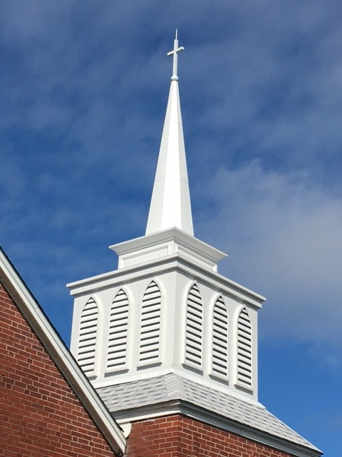

Where a warm welcome awaits you!
3007 West 14th Street, Panama City, Florida 32401.
Phone 850/785-8358 standrewspresch@knology.net
Worship Leader Heath Dennison
Music Director Wanda Sherman
December 26, 2021

