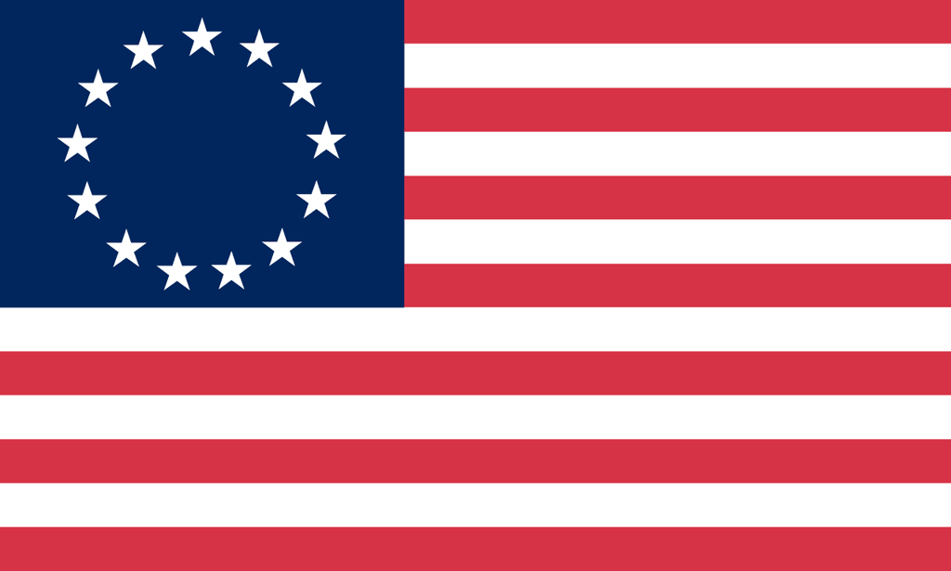U.S. History with Mr. Brown Name _______________________________ Period _____
13 Colonies Book Preview ch4

Directions: Find the answers to the following questions in Chapter 4 of the text book beginning on page 90.
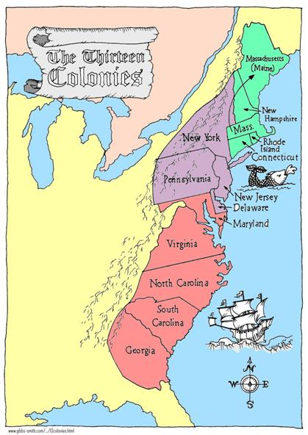
1) In what year did the population of the English colonies break the one million mark?

2) What was the main type of farming done in the New England Colonies?

3) When one New England settler said, “There is a great pasture where our children’s grandchildren will go for bread.” What is the settler referring to?

4) What were the “most valuable articles of trade” in New England?

5) Why were the Middle Colonies called the “Breadbasket Colonies”?

6) The excellent harbors along the coasts of the Middle Colonies were ideal sites for ______________________.

7) What economic activity occurred in the cities of the Middle Colonies?

8) Why did southern plantations turn to African slave labor?

9) What class of people took over political and economic power in the south?

10) What happened to the slaves involved in the Stono Rebellion?

Just for Fun Bonus from section 4 The Backcountry

(+5 points)
What is the origin of the currency term “Buck”?

