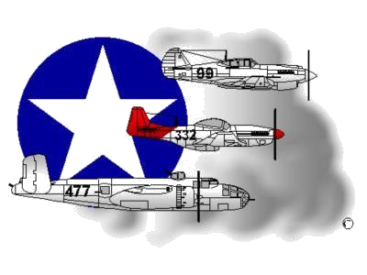
BIOGRAPHY
__________________________________________________________
A DOCUMENTED ORIGINAL TUSKEGEE AIRMAN

Tuskegee Airmen Inc. Public Relations, P.O. Box 830060
Tuskegee, AL 36083

Mr. Thomas W. Newton

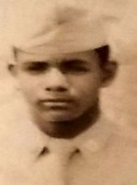
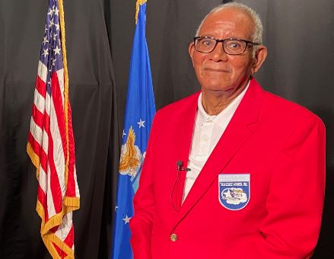
Thomas Wood Newton was born January 3, 1928, in Tarboro, North Carolina to William Newton and Maggie W. Wood. He is the third of four children and survives his Sister, Helen N. Knight and Brothers William M. and James V. Newton. Mr. Newton is married to Mary Birth Newton and has three adult children. His two Sons are Stevie Carmack (eldest) and Tarvick Linder and his Daughter is Tara Battle.

After graduating from High School, Mr. Newton joined the U.S. Army Air Corps on January 31, 1946. Upon completing Basic Training and Clerk Typist School, he was assigned to the 99th Fighter Squadron, 332nd Fighter Group and stationed at Lockbourne Army Air Base, Columbus, Ohio. As Squadron Supply Clerk, Mr. Newton rose to the rank of Sergeant and was awarded the Good Conduct Medal and the World War II Victory Medal. He was honorably discharged on January 31, 1949.

After serving his country, Mr. Newton returned home in New York City and briefly attended Fordham University, Bronx, New York, to study Accounting. From 1954 to 1985, Mr. Newton was employed by the New York City Postal Service working his way up to a Supervisory position which he held for 17-years. He was promoted to Station Manager during the last 5-years of his career where he supervised 63-station personnel. Mr. Newton retired from the Postal Service in 1985 after 31-years of dedicated service. From New York City, Mr. Newton moved to Silver Spring, Maryland and now resides in Chesapeake, Virginia with his wife Mary. In October 2019, Mr. Newton joined the Tidewater Chapter Tuskegee Airmen Inc. organization.

To learn more about SGT Thomas Newton and/or the Tidewater Chapter’s Speakers Bureau and other activities that he participates in, please visit the Tidewater Chapter’s Website at the following location: www.TAI-TidewaterChapter.Com.

