The 1997 Maine Coon Breed Council Article

https://web.archive.org/web/20160317072332/http://cfa.org/Breeds/BreedsKthruR/MaineCoon/MCArticle.aspx

Maine Coon as Native: https://web.archive.org/web/20041121022105/http://www.geocities.com/heartland/7528/tintervw.html (Beth and Mike Hicks (Tanstaafl Maine Coons) and Rick Branham conduct a candid interview with the late Don Shaw, TICA Allbreed Judge, geneticist and outspoken genetics editor of "Cats" Magazine)

Maine Coon Breed Council (2003):
https://web.archive.org/web/20041014004909/http://www.mainecoonbc.org/nw-1993.html
(Play Around Visiting Successful Show Stock & Catteries)
NATIONAL WINNERS 1981-1982
GC, NW TUFPAWS ROSETTE, CFA's 19th Best Cat in Championship
BR: Mark and Fran Bejcek; OW: Mark and Fran Bejcek
https://web.archive.org/web/20040722085442/http://www.mainecoonbc.org/pdf/dm83-04.pdf
(Line History Cont./See the Distinguished Merit)
https://web.archive.org/web/20040207101204/http://www.geocities.com/Heartland/7528/tarchive.html (Past Maines)
https://web.archive.org/web/20040206122209/http://www.tricks.demon.nl/Links.htm (Breed Links & More: Good for Breeders & Enthusiasts)
https://web.archive.org/web/20041209064305/http://absolutelycats.tripod.com/23MaineCoon.html (Line Tracing World-Wide Catteries)
The Maine Coon Heritage Site:
https://web.archive.org/web/20031207144800/http://bowen1.home.mindspring.com/mchs/home.htm
https://web.archive.org/web/20031009014733/http://bowen1.home.mindspring.com/mchs/introduction.htm#topfive (the top 5 & the Clones)
https://web.archive.org/web/20031218010828/http://bowen1.home.mindspring.com/mchs/foundationlist.htm (List of Foundation Maine Coon Cat Stock)
https://web.archive.org/web/20030820001204/http://bowen1.home.mindspring.com/mchs/methuselah.htm (Longevity in Maine Coon Lines): 15+
https://web.archive.org/web/20031215191024/http://bowen1.home.mindspring.com/mchs/geneticreport.htm (Why 10 Gens is Important)
https://web.archive.org/web/20031003102828/http://bowen1.home.mindspring.com/mchs/articles/maineorig.htm (Article on Breed Origins, 1998; pulled from 1903 Book of the Cat)
https://web.archive.org/web/20031003192118/http://www.maine-coon-cats.de/polycoon/Polycoon01/polyinfo-english.htm (Polydactyl Maine Coons in Foundation Stock)
For Buyers:
https://web.archive.org/web/20031003101717/http://bowen1.home.mindspring.com/mchs/articles/findkitten.html#How%20to%20Find%20a%20Maine%20Coon%20Kitten (Article on Good Questions to Ask a Breeder, Stormwatch)
https://web.archive.org/web/20031013024808/http://bowen1.home.mindspring.com/mchs/articles/salesagreement.htm (Sample of an Old Sales Contract)
For Breeders:
https://web.archive.org/web/20031013024631/http://bowen1.home.mindspring.com/mchs/articles/ulrikain.htm (Inbreeding Effects On Recessive Defective Gene Frequency, Ulrika Olsson
https://web.archive.org/web/20030811131838/http://bowen1.home.mindspring.com/mchs/articles/lorimer.htm (Inbreeding and Its Effects on the Immune System, Dr. Heather E. Lorimer)
https://web.archive.org/web/20031003204740/http://www.netpets.com/dogs/reference/genetics/diversity.html (Genetic Diversity-- The Dark Side of Inbreeding)
Raw Feeding Calculators: https://web.archive.org/web/20040205154009/http://www.dataweb.nl/~sham/nutrient/index.html

Maine Coon Ancestors & Breeders:
https://web.archive.org/web/20031003012057/http://www.fogcitycat.com/ancestors.html

1903 Maine Coon Cat Article from Book of the Cat (1903)
https://web.archive.org/web/20031008112754/http://www.pawpeds.com/article4.html
late 1890s Maine Coons at Show
“About 1895 or 1896 the cat fad struck the Middle West. The time was ripe for its development. The high, the low, the rich, the poor have all felt its force, as the real love of animal pets is no respecter of persons, and this fancy has made the whole world kin.
A few people who had never seen a cat show in their native land "go across," attend a cat show, or pick up a cat at a bargain on the streets of London ; They "fetch" it home, and, lo! their neighbour has seen something very like it while at their summer home on the coast of Maine. The fad is contagious, and if they have the fever running very high they send back east to their "handy-man" to get them a long-haired cat, and these cats become popular. Clubs are formed to discuss points and exchange knowledge, shows become a necessity, large premiums are offered, numerous valuable specials become a feature, cats must be found to fit them, the home market at a low figure is looked over, many Attic treasures are brought out, and have often tipped the scales in favour of the Yankee cat. We all turn green with envy. Before another show we must import a ready-made winner at any cost! In the meantime, the demand for the home-grown article is increasing, and prices are getting much inflated, the dealers in large cities keeping their buyers busy in the New England field during the fall and winter months. But the stock of kittens has been looked over by the summer residents or visitors ; the real cream disappeared with the first frost to some winter homes in the big cities ; the dealers get what is left at almost any price they please to pay, many of the specimens being indifferent, and some, no doubt, mongrels.
In the last few years I have known less of the Maine cats, except through the shows and a few that I have owned myself, which have not been shown much or proved remarkable in any way ; but among the gems that have shown out with more or less brilliancy when on the bench we find "Cosie,'' a brown tabby, taking first and special for best cat in show in New York, 1895. Mrs. Lambert brings out "Patrique" in New York in 1896 - blue, and a nice one.
"King Max" - first brought out by Mrs. Taylor - won in Boston first in 1897-98 99, only to be beaten by his sire "Donald" in 1900.
Mrs. Mix has shown a fine Persian type from Maine called the "Dairy Maid." I believe she has also "Imogene," from the same place - a tortoiseshell.
Mrs. Julius Copperberg's "Petronius," of whom we all expected great things, was from a line of creams coming well down from a fine cream brought from some Mediterranean port by one Captain Condon about fifteen years ago. I have secured for friends several kittens from his cat's descendants, which are now somewhat scattered, but all showing great strength, form, bone, and sinew.
Mrs. Chapman's "Cusie Maxine" - a fine type of brown tabby, dam of "Young Hamlet," who won over his sire "Prince Rupert" - was also a Maine cat. Mr. Jones, of The Cat Journal, has from time to time had some fine brown tabbies of the Maine stock, winners at some of the larger shows.
A fair representative of the whites, who has acquitted himself well at the various shows in competition with large classes, is "Swampscott,'' owned by Mrs. F. E. Smith, of Chicago. He comes from Mrs. Georgia Thomas's white cats at Camden, Maine, his maternal great-grandsire coming from France.
“In writing of her own cat, the mother of "Swampscott,'' she says: - I cannot tell you much about my cat's pedigree - only that her great-grandfather was brought to Rockport, Maine, from France ; he was a blue-eyed white.'' This line of whites, while in the same locality, are quite distinct and unrelated to the first whites mentioned, of which "Dot" was given as a type. But her reference to her early exploits with Manx cats clears the air as to how these different varieties first got root in Maine. This instance is only one in many where pets of every variety were bought in foreign ports to amuse the children on shipboard ; otherwise, as in one case I can call to mind, the children would make pets of the live stock carried to supply the captain's table with fresh meals - chickens, lambs, etc. - until it would be impossible to eat the little dears after they were served by the cruel cook.”
"Midnight" - a younger black cat, winning second it Cincinnati to a cat from New Hampshire in better coat, and second in Chicago in 1901 in large classes - has since become a gelding and pet of Mrs. J. J. Hooker, of Cincinnati. He comes from a line of blacks owned by a retired sea-captain named Ryan, who had at one time four generations of black cats. They loved their cats like babies, and for years looked for people suitable to give their kittens to. I have been the flattered recipient three times in the last dozen years of these beautiful black diamonds.”

"Antonio,'' a gelding, now owned by Mrs. A. B. Thrasher, of Cincinnati, Ohio, is also a fine representative of this stock. See photograph. In the last few years, since cats there are at such a premium and old age getting nearer every day, these good people have hardened their hearts, and now sell like others to the highest bidder.
I can also think of "Peter the Great," a neuter cream and white, owned by Mrs. Carl Schmidt, shown at Detroit, Michigan, 1901. Also "Black Patti" - originally owned by Miss Ives - and "Rufus," both Maine cats, now owned in Detroit, and winners in some of the Middle West shows ; and many, many other winners whose place of nativity is a sacred secret with their owners, which we will not wilfully expose to public gaze until our native cats have been accorded the place that is due to them.
I would like to tell you of some of the handsome geldings in Maine. No cat is too good for a pet with them. They may be seen on nearly every lawn or stoop ; but as that is a little out of the province of this story I will only describe one - a beautiful smoke owned by Dr. and Mrs. E. A. Wilson at their beautiful home in Belfast, Maine. He is now ten years old ; his mask and feet are black, or nearly so ; his hair is very dark, rather brownish at the tip, but as white as snow at the skin. I have begged them to show him at Boston or New York. The answer is always the same: "Not for any amount of money or prizes. 'Tags' wouldn't like it ; he would be unhappy. Wouldn't you, 'Tagsie'?
The smokes have not been well developed there yet. In a letter lately received in regard to that variety, I am told that one of the regular agents said he found only about one in 200. The silvers and chinchillas are not common. The strong coloured predominate, whites, blacks, blues, orange, and creams, tabbies also being well divided and distributed along the coast, and for quite a distance back, perhaps sixty miles or more ; but I have not known of their appearing to any extent in the northern portion of the State, which is less thickly settled.
Having had this fancy from my infancy and before it became a fashion, I took kindly to all the new developments. I have since had some experience with imported and kennelbred cats, and from time to time had opportunities of seeing the best we have in our shows, and I fully believe that cats that have their freedom, as most of the Maine cats have for the greater part of their lives, are healthier than kennel cats can be. The cool climate and long winters, with clean air full of ozone, is what is needed to develop their best qualities, and, with a few years of careful breeding for types, they would be able to compete quite successfully in an international cat show.
F. R. PIERCE.
Common Health Issues:
Loose Stool: https://web.archive.org/web/20031002193552/http://meowerpower.virtualave.net/monitor.htm
Kitten Calendar:
https://web.archive.org/web/20040203022302/http://www.dataweb.nl/%7Esham/misc8.html
(Stay on track with your kittens)
Original CFA Stud Books: vol. 1-28
https://web.archive.org/web/20040501192153/http://www.loxly.com/studbooks/studbook.html
Additional Reading:
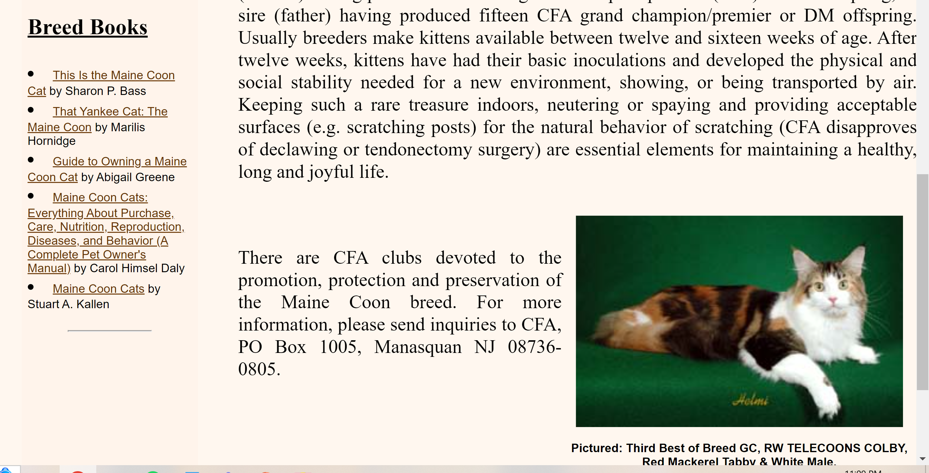

Foundational Reading:
Marilis Hornidge’s The Yankee Cat (1986): https://archive.org/details/thatyankeecatmai0000horn/page/18/mode/2up

